Lab 05 Chinese Zodiac

Bradley Grose

# Problem

In this lab we will take the users inputted year of birth and find their approximant Chinese Zodiac signs. We can only determine the sign if they are born on or after 1924, if they are born before we must tell the user we can’t determine. The zodiac sign is determined using the remainder from the years from 1924%12.

# Solution

For my code, I have the user input the year they were born. If the year is before 1924, I will have the code display an error message and stop the code telling the user it can’t determine that value. If the year is 1924 or after, the code will then run an algorithm that calculates the years since 1924, and then takes the mod value of that number. The value of that equation is stored in remainder. Then using a set of 12 if, else if statements, I have the code look for the remainder that corresponds with the correct Zodiac sign. Once the code finds a match for the remainder, it will output the zodiac sign of the user.

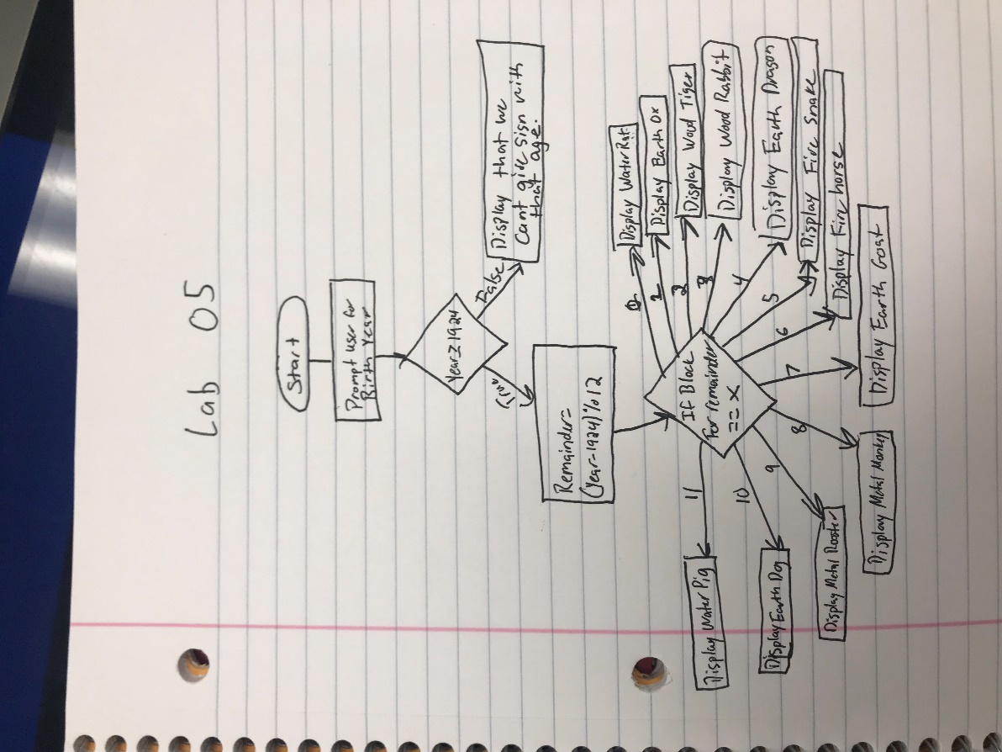

# Implementation Problems Encountered

I did not encounter any problems in this lab.

# Lab Report Questions

1. Flow Chart was included in the solution section.
2. The equivalent Boolean expression is

(a==b)&&(b<=c)