Lab 17 Bunch of Lines

Bradley Grose

# Problem

This code must utilize a driver that will print out multiple lines onto a graphic by providing x and y coordinates. The lines that need to be drawn are sloped line, exponential line, sine line, saw line, and a staircase line.

# Solution

For my solution, I first made an interface that has the method getYpoint. That is then inherited by 5 classes to signify each type of line. Each of these classes have accessors and mutators that will check for correct values, if needed, and also return values for each of the slopes and such. There is also default constructors for each class. They each have their own instance variable to calculate out the y values. The main difference between the 5 are the gettYoint functions. They all return a double value. For Sloped line, it multiplies the given slope by the x values. For the exponent value it takes the x value and raises it to the imported exponent. For the SineLine, it uses the sine wave function of multiplying the amplitude times the sin of the x value and the frequency. The Saw Line function takes x and then takes the mod by the mod value given. Finally, the staircase line will return the value of x value and returns it using integer division and then multiplying it by the height wanted.

# Implementation Problems Encountered

There were no problems that I encountered in the code.

# Lab Report Questions

1. 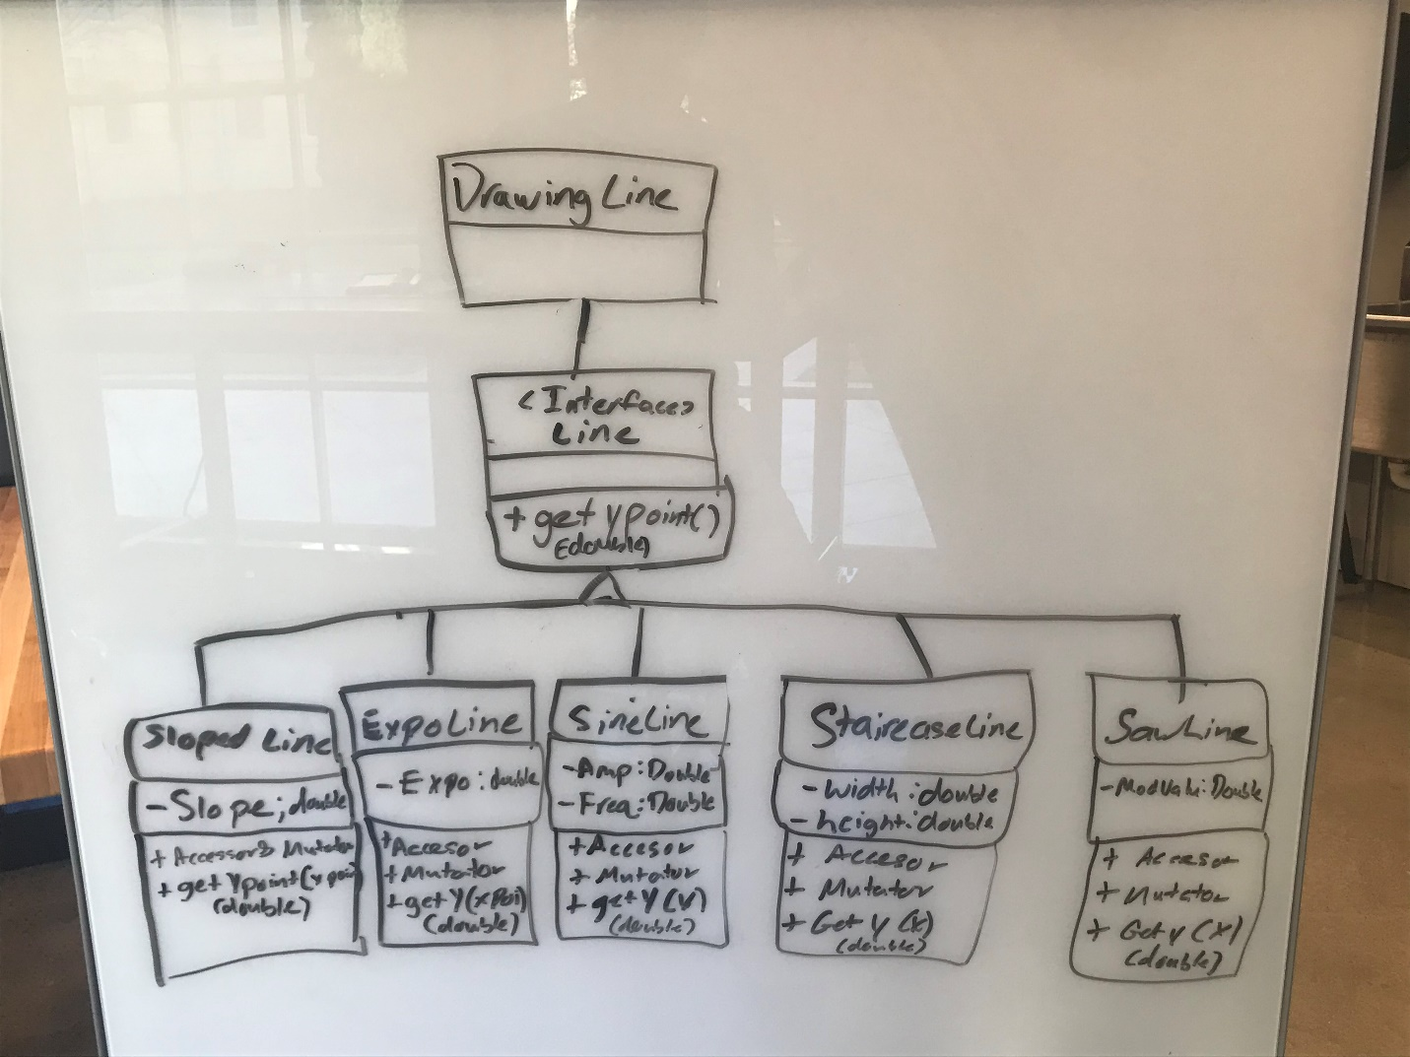
2. Polymorphism is something that can have many forms. For example, in this lab there is polymorphism because all of the lines drawn derive from the interface line. They are all polymorphism from that line file.