Lab 06 Date Checker

Bradley Grose

# Problem

In this code, we will have the user input a date value. The code will then return a value if the date is a valid date, using date, leap year, and month rules that are preset, such as some months have 30 days or 28. The user will be alerted if it is a valid or invalid date

# Solution

First the user is prompted to give a date. The date is stored as a string. After the date is stored, using parse functions and finding the index of the “/”, I separated the date into 3 variables, day, month and year. Those values were integer values, not string values.

The first check I did was the general range check. If the month was not between 1-12, it displayed an invalid date message. If it met that, it was then checked to make sure the date was between 1-31, the most amount of days in a month. If that failed, it displayed an invalid date message. However, if it passed it went into a month sorter.

If the month was then 4, 6, 9, or 11, if checked to see if there was 30 days in the month, as April, June, September and November all have 30 days. If the month was 2, the process of February took place. However, if it was neither of those months, it displayed it as a valid date as there was a 31 day check already.

For the February process, In then checks for leap year rules. The first rule is if the year can be evenly divided by 400, the date is between 1-29. If it is the message displays valid date, and invalid if it is not. Then, if that condition isn’t met, if the year can evenly be divided by 100, the month should have 1-28 days. If it is the message displays valid date, and invalid if it is not. If that condition isn’t met, If the year can be evenly divided by 4, then the month can have 1-29 days. If it is the message displays valid date, and invalid if it is not. Finally, if none of those conditions are met, it checks to see if the day is between 1-28. If it is the message displays valid date, and invalid if it is not

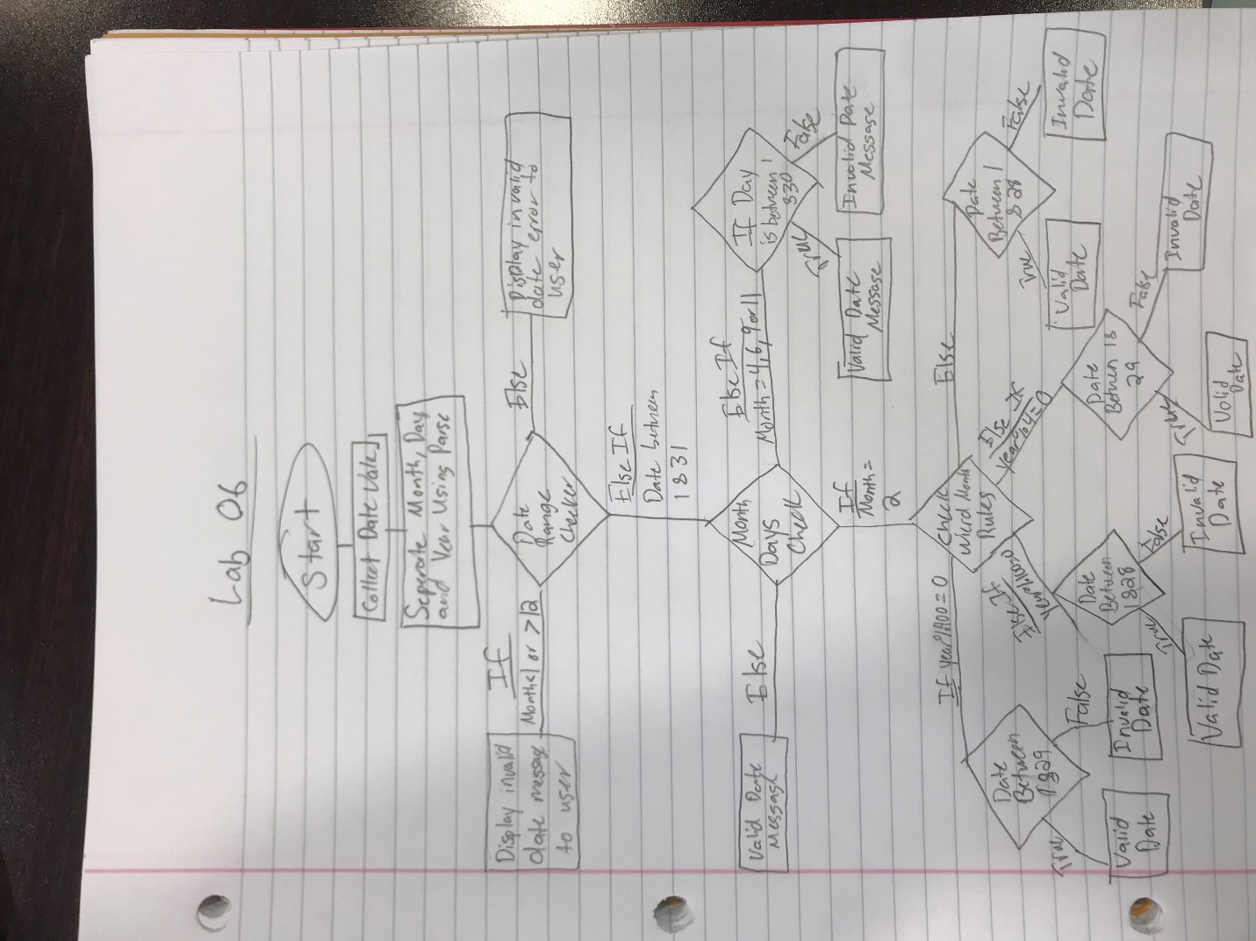

# Implementation Problems Encountered

There were no problems encountered in the code.

# Lab Report Questions

1. Flow chart is included
2. (a<=b)&&((b>c)||(b<c))