The de.NBI project de.NBI-epi 4 – The epigenetic workbench

*The de.NBI-epi 4 project at the University of Freiburg offers tools, services and training for the analysis of epigenetic modifications.*



**

Björn Grüning, Project leader

*University of Freiburg*

*gruening[@informatik.uni-freiburg.de](mailto:backofen@informatik.uni-freiburg.de)*

Joachim Wolff, Project co-worker

*University of Freiburg*

*wolffj[@informatik.uni-freiburg.de](mailto:gruening@informatik.uni-freiburg.de)*

**Collection of tools and services offered by de.NBI-epi 4:**

* Integration, development and maintenance of deepTools
* Development, maintenance and services around Galaxy
* Development and services around the bioconda build system
* Containerization (Docker, rkt) with layer-donning and BioDocker
* Maintenance and support for the Galaxy Docker Project and Galaxy flavors
* A tool library for the analysis of bisulfite sequencing data and ChIP-seq
* Galaxy Workflows and ready-to-use pipelines including QC, normalization and visualization
* Galaxy tours as new technique for scalable and interactive training
* 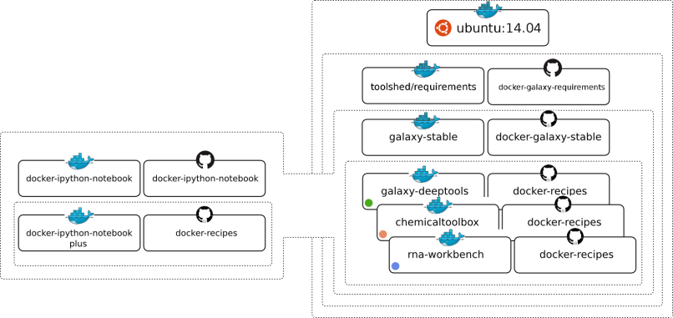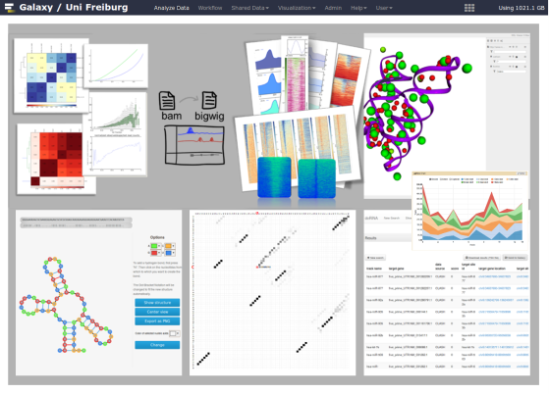Training courses and training material on data analysis of epigenetic modifications in close cooperation with GTN and GOBLET

Customized, scalable, production-ready workbenches powered by Galaxy flavors.

Data analysis from QC to visualization in Galaxy.