The de.NBI project RBC 1 –Analysis of RNA interactions

*The RBC 1 project at the Freiburg of University offers tools, services and training for the analysis of RNA-RNA and RNA-protein interactions.*

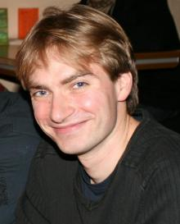



Björn Grüning, Project deputy

*University of Freiburg*

[*gruening@informatik.uni-freiburg.de*](mailto:gruening@informatik.uni-freiburg.de)

Rolf Backofen, Project leader

*University of Freiburg*

[*backofen@informatik.uni-freiburg.de*](mailto:backofen@informatik.uni-freiburg.de)

**Collection of tools and services offered by RBC 1:**

* **Freiburg Galaxy Server** – the largest Galaxy instance in Germany with currently 370 users and more than 800 tools. 500 tools out of 3000 world-wide have been integrated by the RBC
* **IntaRNA** – fast and accurate prediction of RNA-RNA interactions
* **CopraRNA** – prediction of small RNA target networks and interaction domains
* **GraphProt** – modeling binding preferences of RNA-binding proteins
* **GraphClust** – fast alignment-free structural clustering of local RNA secondary structures
* **BlockClust** – efficient clustering and classification of ncRNAs from RNA-seq profiles
* **LocaRNA** – Global and local alignment of RNAs
* **ExpaRNA-P** – simultaneous exact pattern matching and folding of RNAs
* **Training courses** on HTS data analysis, genome annotation, and Galaxy

CopraRNA: Interacting regions plot for the sRNA GcvB showing accessible regions R1 and R2 in 8 homologs (Wright *et al.* PNAS 2013)

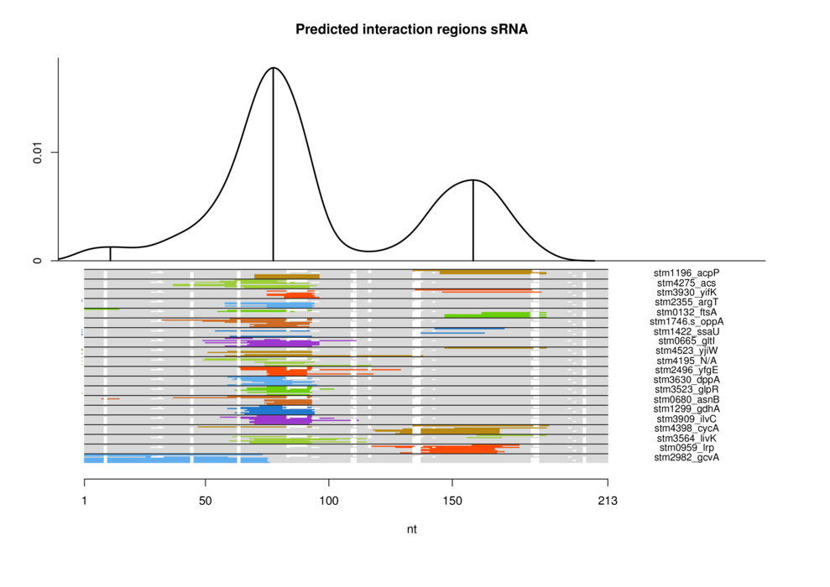

GraphProt: Encoding of a region identified by CLIP. The secondary structure is represented as a graph and encoded by graph-kernel features (Maticzka *et al.* Genome Biology 2014)

