The de.NBI project RBC 2 – Analysis of non-coding RNAs

*The project RBC 2 at the University of Leipzig offers tools, services and training for the analysis of non-coding RNAs specializing on advanced secondary structure analysis.*



Sebastian Will

Deputy

Bioinformatics

*University of Leipzig*

*will*[*@bioinf.*](mailto:jens.stoye@uni-bielefeld.de)*uni-leipzig.de*



Jörg Fallmann

Deputy

Bioinformatics

*University of Leipzig*

*fall*[*@bioinf.*](mailto:jens.stoye@uni-bielefeld.de)*uni-leipzig.de*



Peter Stadler

Project leader

Bioinformatics

*University of Leipzig*

*stadler*[*@bioinf.*](mailto:jens.stoye@uni-bielefeld.de)*uni-leipzig.de*

**Tools and services offered by the RBC 2:**

* **Vienna RNA package** – RNA secondary structure prediction and analysis (implementing many folding variants: free energy minimization, partition function folding, local folding, folding of alignments, and suboptimal folding)
* **LocARNA package** – Multiple comparative analysis of RNAs (comprising LocARNA for RNA alignment and folding, LocARNA-P for predicting reliabilities, SPARSE for even faster alignment, and ExpaRNA-P for matching and folding)
* **RNAz** – genome-wide de-novo prediction of non-coding RNAs
* **CARNA** – Alignment and folding of RNA ensembles and pseudoknotted RNAs
* **RNAplex** – fast screening for RNA-RNA interactions
* **Kinwalker** – prediction of the co-transcriptional folding kinetics of large RNAs
* **snoSTRIP** – analysis of small nucleolar RNAs (snoRNAs) in fungi
* **PLEXY** – predicting interactions of C/D-box snoRNAs with target RNAs
* **MITOS** – annotation of metazoan mitochondrial genomes
* **tRNAdb** – a comprehensive database of tRNAs
* **DARIO** – analysis of short RNAs from high-throughput sequencing data
* **Segemehl** – Next generation sequencing (NGS) read mapping with high accuracy and advanced variant calling
* **metilene** – Differential methylation analysis for NGS
* **Sierra** **Platinum** – peak calling for NGS data with advanced quality control
* **Blockbuster** – detection of read blocks in NGS mapping data
* **ViennaNGS** – tools for next generation sequencing analysis

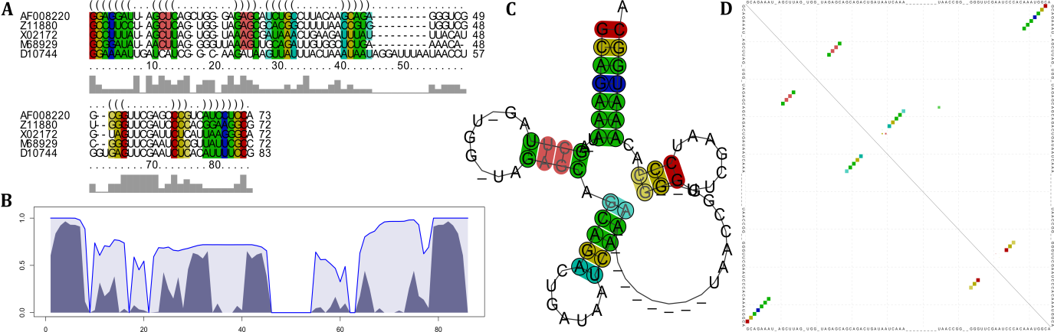**Vienna RNA and LocARNA package:** Example results from selected tools. **A)** multiple structure-based alignment of five tRNAs by LocARNA. **B)** sequence and structure reliability plot of the alignment (STAR plot) of Subfigure A by LocARNA-P. **C)** Optimal structure of the alignment by RNAalifold and **D)** probability dot plot of the alignment by partition function folding of RNAalifold.