* The de.NBI project de.NBI-epi 3 – Epigenomics data integration and analysis

*The de.NBI-epi 3 project at Max Delbrück Center offers tools, services and training for the epigenomics data integration and analysis.*



Altuna Akalin, Project leader

*Max Delbrück Center*

[*altuna.akalin@mdc-berlin.de*](mailto:altuna.akalin@mdc-berlin.de)

**Collection of tools and services offered by RBC5:**

* **methylKit** – A toolkit for analysis of DNA modifications from bisulfite-sequencing data
* **Chromosome segmentation algorithms** – Application of various algorithms for segmentation of epigenomic profiles.
* **Genomation** - Epigenomic data integration and visual summaries

MethylKit: Visualization of methylKit analysis result for leukemia samples of different subtypes (Akalin *et al.* Plos Genetics 2012)

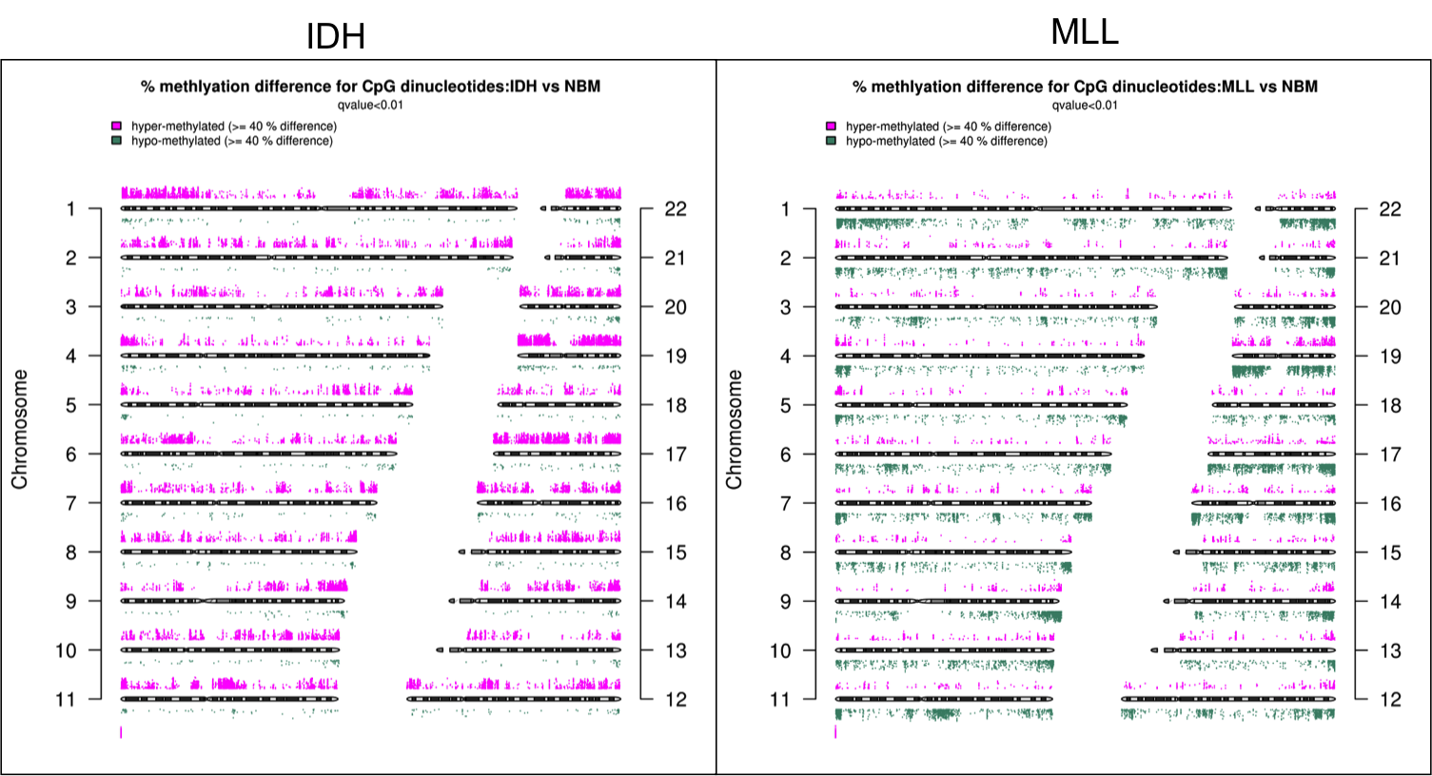

Genomation: Integration of different ChIP-seq datasets using R (Akalin *et al.* Bioinformatics 2015).

