The de.NBI project de.STAIR 3 – Customized Workflow development and data integration concepts for RNA-Sequencing

**

*“We offer services for the analysis of RNA sequencing data.*

*We specialize in tailor-made workflows and training for their use.”*

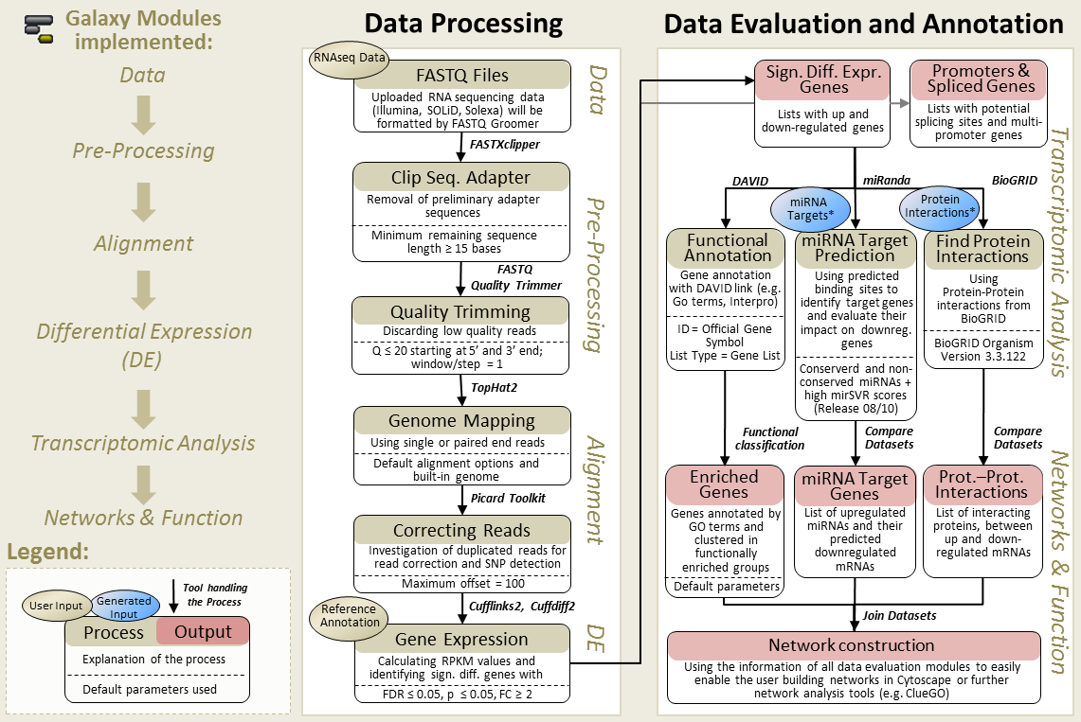

*The TRAPLINE workflow (Wolfien et al., BMC Bioinformatics, 2016).*

Collection of services and training courses offered by de.STAIR 3:

|  |  |  |  |
| --- | --- | --- | --- |
| * Guidance for the design of RNA-sequencing experiments * Workflow design and technical integration into the RBC workbench * Providing alternative workflow solutions, like Docker containers * Evaluation of preprocessing modules for sequencing data analysis | | * Facilitating the annotation and characterization of transcripts * Data retrieval interfaces for knowledge-base integration in Galaxy * Training courses for structural data integration and workflow development * Deployment of interactive Galaxy tours for our developed workflows | |
| Olaf Wolkenhauer  Project leader *SBI, Rostock* | Andrea Bagnacani  *SBI, Rostock* | | Markus Wolfien  Project deputy *SBI, Rostock* |

[*www.sbi.uni-rostock.de*](http://www.sbi.uni-rostock.de)