The de.NBI Service Center RBC – The Center for RNA Bioinformatics

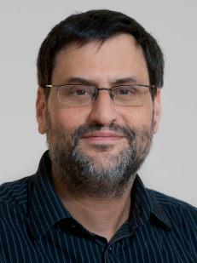*The RBC Service Center offers tools, services and training covering all aspects of RNA bioinformatics, meta-transcriptomics and epigenetic research.*

The RBC Service Center establishes an integrated, easily accessible scientific workbench based on GALAXY covering a wide range of RNA-related and epigenetic analysis tasks. The workbench can be used on a local cluster or deployed on any HPC-like environment. The RBC Service Center is equipped with extended compute clusters and participates in the de.NBI Cloud.

**The topics of the RBC service centers:**

* Ready-to-use pipelines for the analysis of RNA-related high-throughput sequencing (HTS) data

Rolf Backofen, Coordinator

*University of Freiburg*

[*backofen@informatik.uni-freiburg.de*](mailto:backofen@informatik.uni-freiburg.de)

* RNA-protein interactions: advanced approaches for the analysis of genome-wide protein-RNA interaction experiments.
* 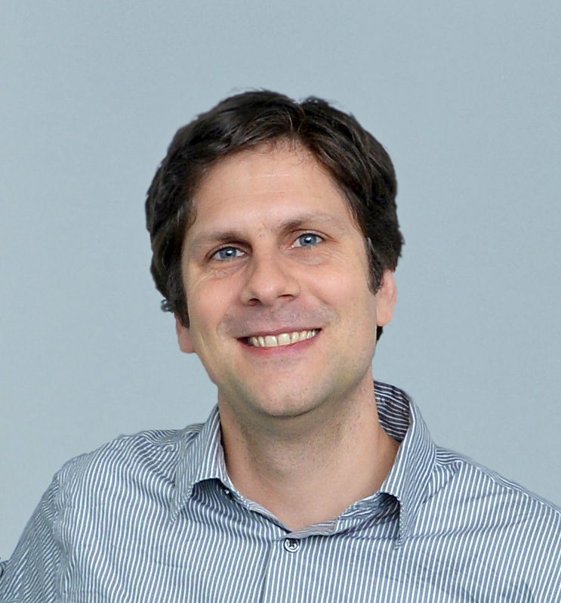Analysis of high-throughput data related to epigenetic modifications.

**Training courses carried out by RBC in 2015 (examples):**

* Galaxy Workshop on HTS data analysis
* Computational Genomics hands-on workshop

**Current projects:**

* RBC 1 at University of Freiburg: Analysis of RNA interactions
* RBC 2 at University Leipzig: Analysis of non-coding RNAs
* RBC 3&4 at MDC Berlin: RNA-binding proteins and post-transcriptional regulation

Uwe Ohler, Deputy coordinator

*MDC Berlin*

[*Uwe.Ohler@mdc-berlin.de*](mailto:Uwe.Ohler@mdc-berlin.de)

* de.STAIR 1 at University Leipzig: Alternative splicing and differential expression
* de.STAIR 2 at University of Freiburg: Regulatory RNA and data
* de.STAIR 3 at University of Rostock: Customized workflows
* de.NBI-epi 3 at MDC Berlin: Epigenomics data integration and analysis
* 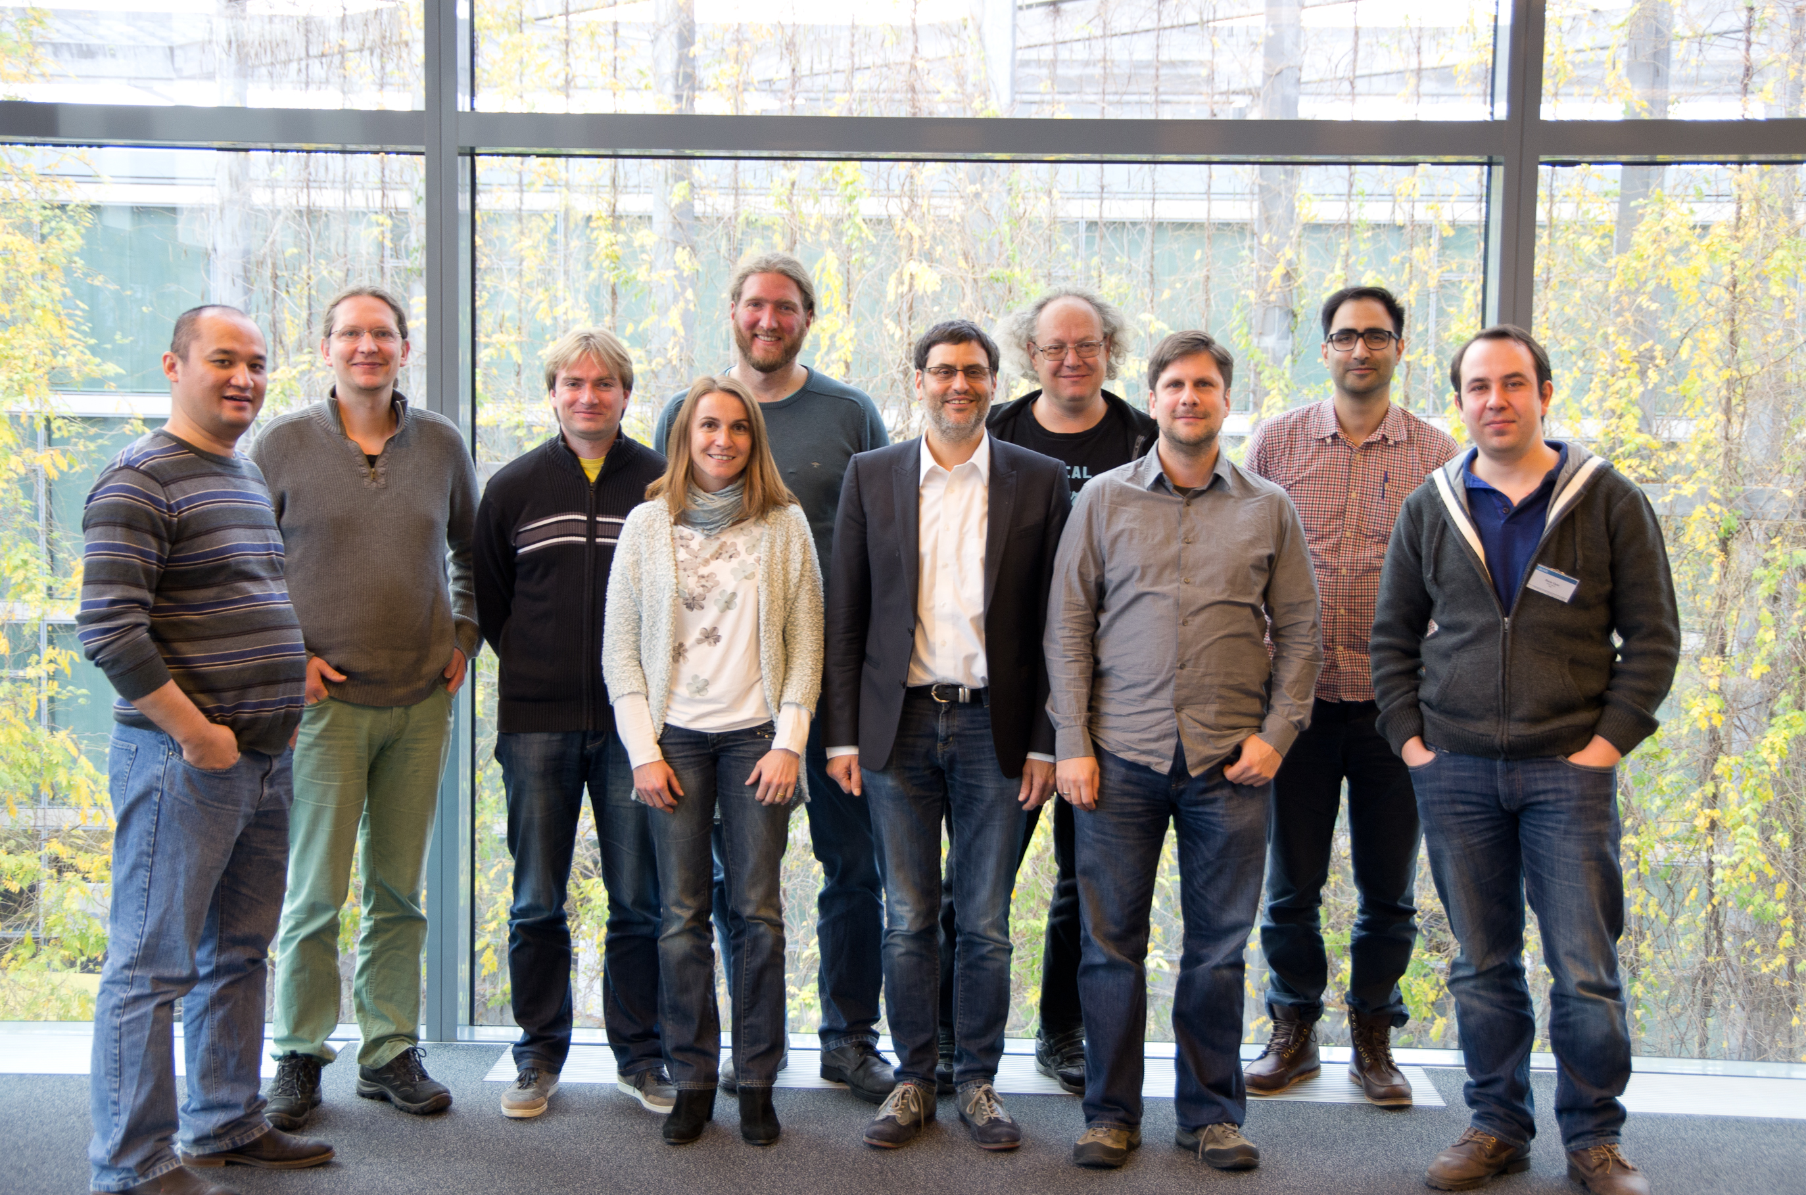de.NBI-epi 4 at University of Freiburg: The epigenetic workbench

*Members of the Service Center RBC (2015). From left to right: Dilmurat Yusuf, Sebastian Will, Björn Grüning, Anika Erxleben, Torsten Houwaart, Rolf Backofen, Peter Stadler, Uwe Ohler, Altuna Akalin, Bora Uyar*