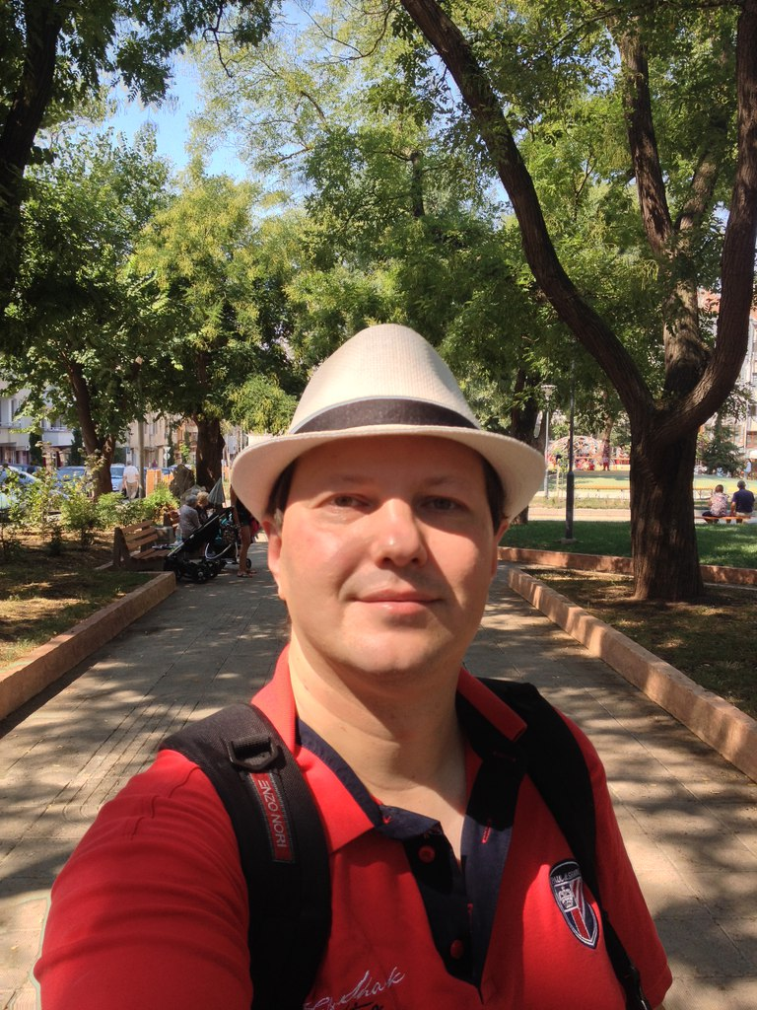 Ilya A. Shlyakhovoy  
  
Makedoniya 81, Burgas 8000, Bulgaria

+359.886977198 • [bulgarus@inbox.ru](mailto:bulgarus@inbox.ru)

**Personal Profile**

Full-stack web developer, good with PHP, Erlang, JavaScript, ActionScript, databases, with constant desire to self-improvement.

I have EU permantent residence, can easy relocate to anywhere.

**Career Objective**

To be a professional and to utilize my skill and knowledge

**Achievements**

Started webdev work in BBDO Moscow as software engineer, built many russian flash sites, worked in the part of biggest russian web-studio Art.Lebedev, last years work as freelancer.

My experience includes but is not limited to the following:

Programming languages: PHP, Python, Perl, Erlang, C/C++, Delphi, Clarion, Assemby, Forth, ActionScript, Java, JavaScript, Node.JS. Good knowedge of React , React Native and Mobx

Databases: MySQL, MongoDB, PostgreSQL

Good knowledge of web technologies, including cross-platform mobile applications.

Fluent english, good russian and bulgarian, basic spanish.

Mobile and easily can relocate to anywhere.

**Education and Training**

**1993 – 2000 Computer science**

**Moscow State University of Electronics and Mathematics**

Engineer degree

**Employment**

**2000-2001 Software developer BBDO Moscow**

Development of backends and Flash frontends :

**2001-2002 CTO Teleport internet club**

Administrative and technical control

**2002-2004 Web developer** **TMU Consulting**

Development of Flash frontends :

**2004-2006 Web developer**

**TeleType web studio (part of Art.Lebedev web group)**

Development of backends and Flash frontends :

**2006-2009 Web developer Freelance**

Freelance web-dev

**2009-2016 Owner and CEO BulgaRus BG**

Management of software development company

**2017-now JavaScript developer Loqus Fleet LLC**

React and Node.JS development

**Skills**

**Technical:**

* React
* React Native
* Node.JS
* PHP
* MySQL
* PHP frameworks
* HTML5
* JavaScript
* jQuery
* Node.JS
* React
* MySQL
* PostgreSQL
* AJAX
* Python
* Machine Learning
* Data Science
* Perl
* X86 Assembly
* Assembly
* Elixir (Erlang)
* Erlang/Otp
* JSON
* XML
* MongoDB
* Git/Svn
* ActionScript
* Adobe AIR
* Adobe Flex
* Forth
* Java
* J2EE
* Clarion
* Delphi
* Object Pascal
* LAMP
* Nginx
* Software Architecture
* Information Architecture
* Project Management

**Hobbies and interests**

Photography, reading, shooting