# 02020930_综合研究研究报告

## 1

（1）写一个C程序，打印int、long、 double型变量所占的字节数、地址、各个字节的地址和内容。

int ia = 6;  
long la = 7;  
double da = 8;  
main() {  
 int i;  
 printf("int %d ,address %lx,size %d\n", ia, (long)&ia,  
 sizeof(int));  
 for (i = 0; i < sizeof(int); ++i) {  
 printf("address %lx ", (long)&ia + i);  
 printf("value %d ", *((&ia) + i));  
 }  
 printf("\n");  
  
 printf("long %ld ,address %lx,size %d\n", la, (long)&la,  
 sizeof(long));  
 for (i = 0; i < sizeof(long); ++i) {  
 if (i % 2 == 0)  
 printf("\n");  
 printf("address %lx ", (long)&la + i);  
 printf("value %ld ", *((&la) + i));  
 }  
 printf("\n");  
 printf("double %lf,address %lx,size %d\n", da, (long)&da, sizeof(double));  
 for (i = 0; i < sizeof(double); ++i) {  
 if (i % 2 == 0)  
 printf("\n");  
 printf("address %lx ", (long)&da + i);  
 printf("value %lf ", *((&da) + i));  
 }  
}

* 结果
* 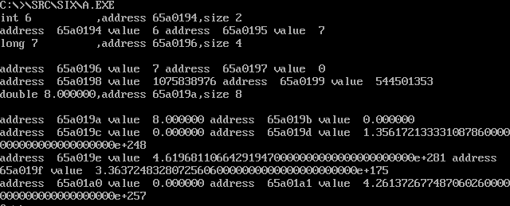

## 2

（2）写一个C程序，打印stu型变量所占的字节数、地址、各数据项地址、内容和各个字节的内容。

typedef struct  
 {  
 int num；  
 unsigned char c；  
 unsigned char osi  
 unsigned char masm；  
 char name［20］  
 }stu；

提示:研究 sizeof的用法；可将任何一个变量的存储空间，看做一个数组。

typedef struct {  
 int num;  
 unsigned char c;  
 unsigned char os;  
 unsigned char masm;  
 char name[20];  
} stu;  
  
main() {  
 int i = 0;  
 stu s;  
 s.num = 9;  
 s.c = '1';  
 s.os = '2';  
 s.masm = '3';  
 s.name[0] = 'L';  
 s.name[1] = 'i';  
 s.name[2] = 'L';  
 s.name[3] = '\0';  
  
 printf("size: %d,address: %lx\n", sizeof(s), (long)&s);  
 printf("num : %d,address: %lx\n", s.num, (long)&(s.num));  
 for (i = 0; i < sizeof(int); ++i) {  
 printf("address %lx ", (long)&(s.num) + i);  
 printf("value %d ", *(&(s.num) + i));  
 }  
 printf("\n");  
 printf("c : %c,address: %lx\n", s.c, (long)&(s.c));  
 for (i = 0; i < sizeof(char); ++i) {  
 printf("address %lx ", (long)&(s.c) + i);  
 printf("value %c ", *(&(s.c) + i));  
 }  
 printf("\n");  
 printf("os : %c,address: %lx\n", s.os, (long)&(s.os));  
 for (i = 0; i < sizeof(char); ++i) {  
 printf("address %lx ", (long)&(s.os) + i);  
 printf("value %c ", *(&(s.os) + i));  
 }  
 printf("\n");  
 printf("masm: %c,address: %lx\n", s.masm, (long)&(s.masm));  
 for (i = 0; i < sizeof(char); ++i) {  
 printf("address %lx ", (long)&(s.masm) + i);  
 printf("value %c ", *(&(s.masm) + i));  
 }  
 printf("\n");  
 printf("name: %s,address: %lx\n", s.name, (long)&(s.name));  
 /* printf("%d", sizeof(char *)); */  
 for (i = 0; i < 20; i++) {  
 printf("address %lx ", (long)&(s.name) + i);  
 printf("value %c ", *((*(&s.name)) + i));  
 }  
 printf("\n");  
}

* 结果
* 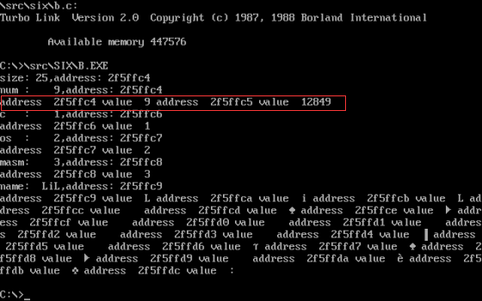

## 3

（3）写一个程序，这个程序的运行结果反映如下主题参数的存储空间与局部变量的存储空间，在函数运行后收回。

long *f(int a);  
long res[2];  
long p;  
long l;  
main() {  
 long *a = f(5);  
 p = a[0];  
 l = a[1];  
  
 printf("parm %d ,address %lx\n", *(long *)a[0], p);  
 printf("local %d ,address %lx\n", *(long *)a[1], l);  
}  
  
long *f(int parm) {  
 int local = 1;  
 local += parm;  
 printf("parm %d address %lx\n", parm, (long)&parm);  
 printf("local %d address %lx\n", local, (long)&local);  
  
 res[0] = (long)&parm;  
 res[1] = (long)&local;  
  
 /* printf("parm %d ,address %lx\n", *(long *)res[0], res[0]);  
 printf("parm %d ,address %lx\n", *(long *)res[1], res[1]); */  
 return res;  
}

* 结果
* 