* Tick size

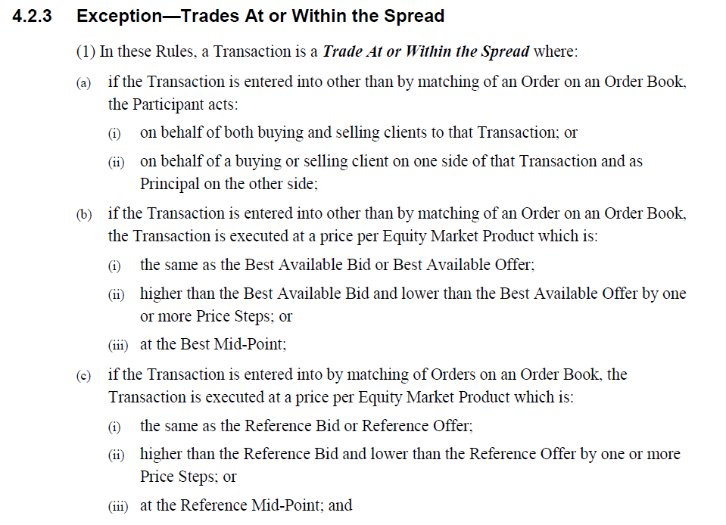

* ASIC Market integrity rules shows that off-market trade must be on the price steps, except for best mid-point or reference mid-point.