**Timestamp of Off-Market Trade (including crossing)**

1. If the order is executed on normal trading hours, then reported immediately (includes crossing system). Crossing system is well integrated with ASX trading platform, hence it is (very close to) real time. If not through crossing system, then it may not be real time.

Case Example on the CLSA crossing system:

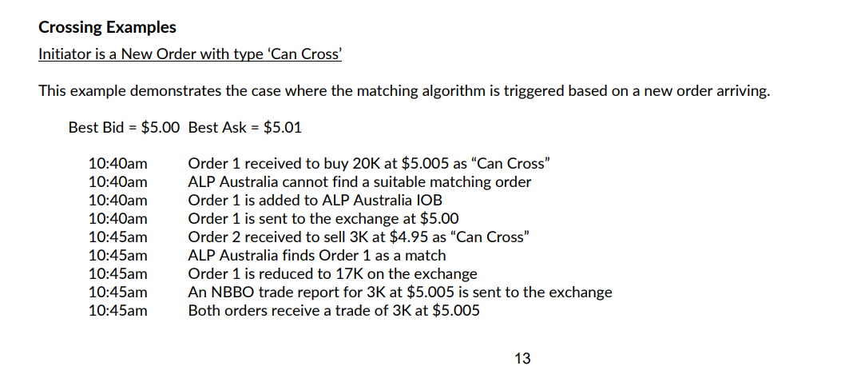

1. If the order is executed outside normal trading hours, then does not have to be immediately

1. Large trade, eg. block trade, portfolio trade: as soon as practicable (not immediately)

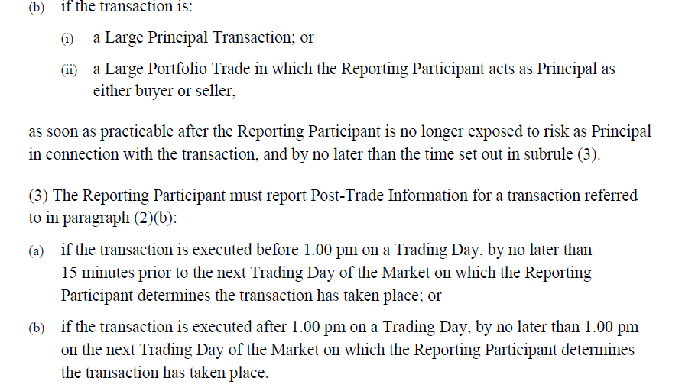

**Extras**

All off-market trades that are reported to exchange are showed up on the trading data?

* ASX has trade reporting facility (TRF), supports the reporting of **all** off-market and administrative trades by participant.

