Name: Brian Guadron
Date: 10/24/2026
Module 1.2 Assignment – GitHub Repository Setup

1 - Link to your GitHub repository - https://github.com/bguadron1717/csd-310

Terminal Screenshot showing directory and module 1

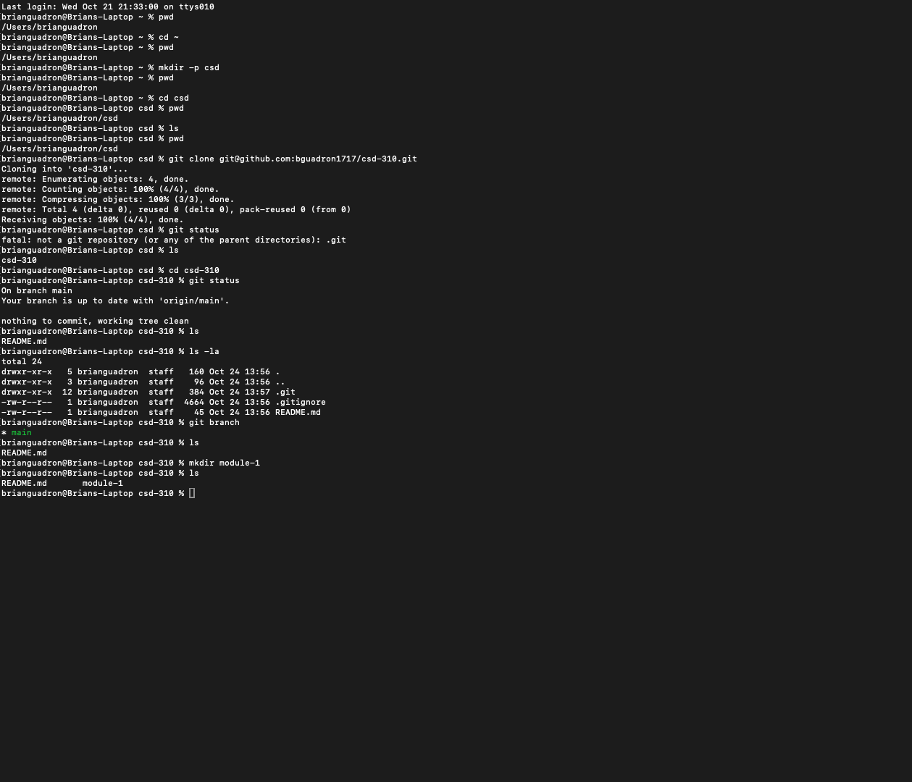

GitHub’s screenshot repository showing the committed and pushed document
