Name: Brian Guadron
Date: 10/31/2026
Module 2.3 Assignment – Data Models

ERD for Module 2.3 Assignment – Data Model for USER, ROLES and DEPENDENTS

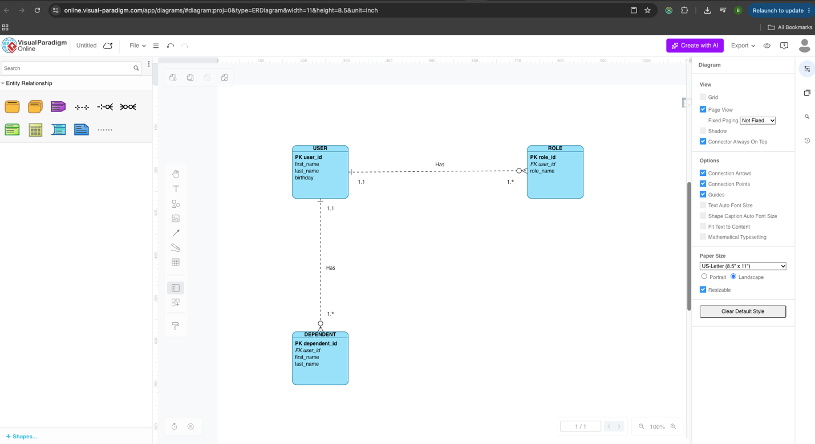

ERD converted into NoSQL Data Structure


