Market Research Agent Architecture
  - Project 3A Competitor Analysis
MVP1 | Version 1.0 | October 31 2026

Purpose and decision
Build a personal web application that compares one company with three competitors using a stateful multi-agent research workflow. This document defines the implementation boundary, system components, evidence contracts, financial calculations, and verification plan before application coding begins.
The agreed product combines competitive intelligence with a small financial panel. The first demonstration compares Hershey (HSY) with Mondelez (MDLZ), Kraft Heinz (KHC), and General Mills (GIS). Company inputs remain configurable.

Product boundary
Included in MVP1 | Deferred
Company resolution and three-competitor discovery; user confirmation | Accounts, saved report library, and cross-session memory
Products, brands, positioning, pricing evidence, and recent news | Scheduled monitoring, follow-up chat, and external publishing
Annual revenue, revenue growth, and operating margin | Live share prices, valuations, forecasts, and broad financial terminals
Four-company dashboard, charts, citations, and live progress | PDF export and production multi-user infrastructure

Decision status
User-confirmed: Next.js plus FastAPI; LangChain plus LangGraph; Nebius model credits; Tavily research; target plus three competitors; financial panel; no accounts or saved reports. Engineering defaults in this document are proposed for implementation, including local-first delivery, SEC financial sourcing, temporary state, retention, and resource limits.

Success definition
A user confirms four companies and receives a sourced, usable comparison in one browser workflow. The demo must show tool use, agent delegation, graph state, a human approval pause, and recovery from a failed source. Target completion is under 15 minutes excluding human review; this is a validation goal, not a measured result.
Reading guide: system design on page 2; agent control flow on page 3; contracts on pages 4 and 6; financial rules on page 5; user experience on page 7; reliability on page 8; operations on page 9; delivery and references on page 10.

2 System design
The browser renders the interface; FastAPI owns research execution and secrets. LangGraph coordinates bounded agent work. Financial tools fetch and calculate metrics independently of model-generated narrative. External integrations are accessed from the backend only.
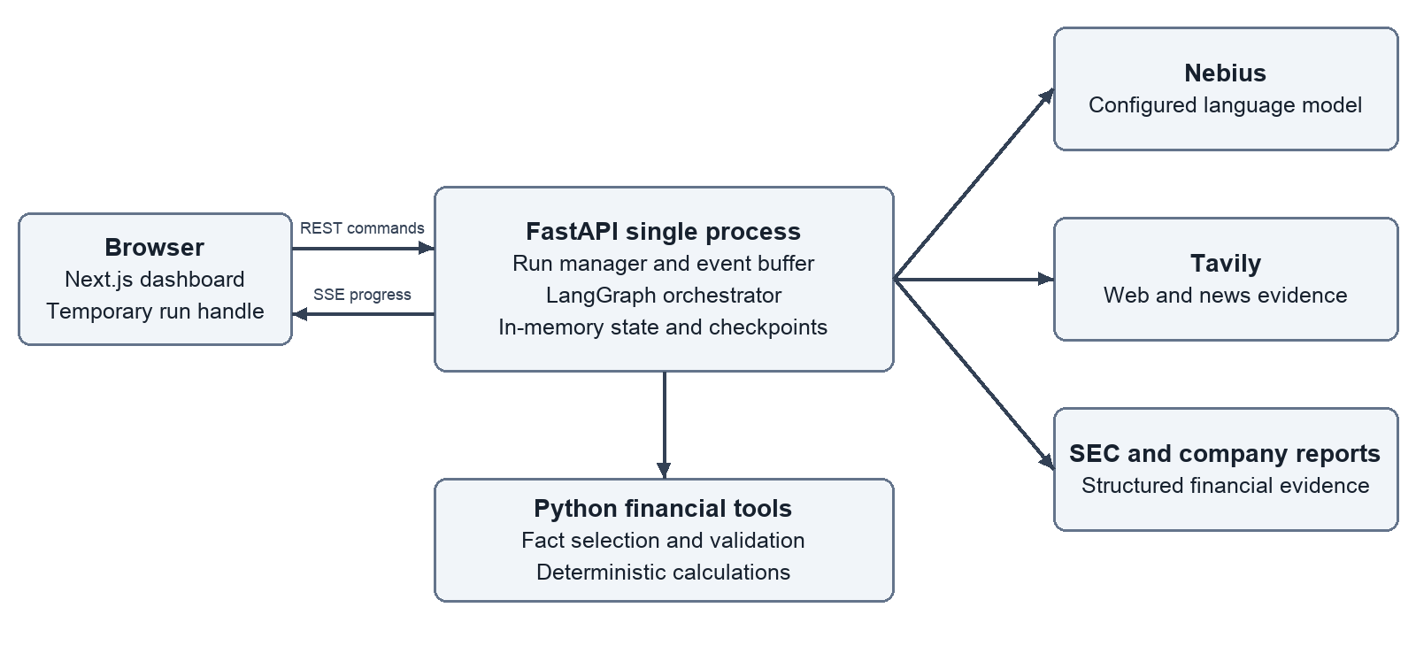
Component | Choice | Responsibility
Web interface | Next.js and TypeScript | Company inputs, approval, progress, results
UI and charts | Tailwind, shadcn/ui, Recharts | Responsive comparison and accessible charts
Application API | FastAPI and Pydantic | Validation, run lifecycle, event stream
Agent runtime | LangChain and LangGraph | Tools, typed state, branches, interrupts
Language model | Nebius Token Factory | Discovery, evidence analysis, synthesis
External evidence | Tavily and SEC EDGAR | Web research and structured financial facts
Temporary storage | Process memory | Run state, events, evidence, checkpoints

Boundaries and deployment
MVP1 runs one Next.js process and one FastAPI process on localhost. FastAPI uses one worker because run state is process-local. A small in-process async task registry owns active graph runs; HTTP handlers do not wait for research to finish. No Redis, Celery, database, vector store, or managed agent service is required.
Nebius is the inference provider. An OpenAI-compatible client may be used with the Nebius endpoint, key, and configured model ID; this does not use OpenAI billing. Compatibility, structured output, and tool calling must pass integration checks before the model is selected. [3]

3 Agent workflow and control
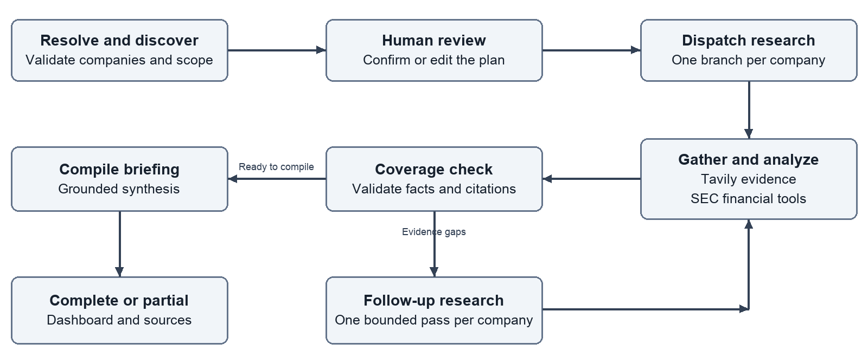
Role | Autonomous decisions | Boundaries
Orchestrator | Dispatch work, inspect coverage, request follow-up, synthesize briefing | Graph enforces budgets, transitions, and cancellation
Discovery agent | Resolve entities and explain competitor relevance; propose three peers when requested | Preserve supplied peers until user edits them
Research agent | Choose focused web/news queries and pages to extract | Use approved companies, bounded tools and sources
Analysis agent | Extract evidence-backed findings; identify gaps and conflicts | No invented facts or financial arithmetic
Financial tools | Select and validate filing facts; calculate metrics | Deterministic Python, with source provenance

Execution semantics
The same research and analysis agent definitions are instantiated per company; these are specialized agent roles, not separate hosted services. Start with at most two concurrent company branches. The orchestrator uses structured coverage decisions inside a deterministic graph rather than an unrestricted supervisor loop.
When competitors are supplied, discovery still verifies identities and relevance. When omitted, it uses Tavily to propose three. Duplicate entities or unresolved identities block confirmation. Weak competitive overlap produces a warning and an explanation for the user to accept or edit.
LangGraph pauses at plan review using an interrupt and resumes with the confirmed plan. Changes are accepted only while awaiting review; execution then uses a fixed plan version. Successful company results survive failures in other branches. One follow-up pass per company is allowed within the global budget. [2]

4 State and evidence contracts
Pydantic models define both provider outputs and public API responses. Each report has a schema version. Parallel company branches return results keyed by company ID; explicit reducers merge results without overwriting another branch.
Record | Required fields
ResearchRequest | target; competitors[0 or 3]; discovery_mode; geography; focus; news_lookback_days
CompanyIdentity | company_id; legal_name; aliases; website; ticker and CIK when available; resolution evidence
ResearchState | run_id; plan_version; status; confirmed_plan; per-company results; evidence; errors; budgets; timestamps
EvidenceSource | source_id; company_id; URL; title; publisher; source_type; published_at or null; retrieved_at; excerpt
Finding | field; statement; source_ids; observed or inferred; evidence_status; limitations
FinancialFact | concept; value; unit; period_start/end; fiscal_year; form; filing_date; accession; source_url
FinancialMetric | metric; value or null; unit; period; input_fact_ids; formula_version; status; reason
AnalysisReport | schema_version; as_of; confirmed companies; briefing; company analyses; financial series; news; sources; warnings

Evidence policy
Prefer company product pages, investor relations, filings, and official announcements for factual claims. Use reputable reporting to add context and competing perspectives. Tavily is the primary research gateway; SEC is a separate structured financial source. Stockrow is a UX reference, not an assumed data feed. [4, 5, 6]
Material factual claims link to stored source IDs. A link alone is insufficient: validation checks that the cited excerpt supports the statement. Distinguish observed facts from analysis. Evidence status is supported, conflicting, missing, or not applicable; avoid uncalibrated numerical confidence scores.
Normalize and deduplicate URLs and repeated announcements. News has an event date when known, a publication date, and a retrieval date. Undated pages may support company background but must not be presented as recent news. Conflicting claims remain visible with both sources.

Financial and narrative separation
Report synthesis receives validated financial metrics as read-only inputs. It can explain them but cannot replace their values. Chart payloads are derived directly from metric records, not extracted from prose. Excerpts and tool outputs are bounded in size before being passed to the model.

5 Financial data design
The initial financial adapter supports US-listed SEC filers. Resolve ticker to CIK, fetch submissions and Company Facts from the backend, then select consolidated annual facts. SEC provides these APIs without authentication and warns that fiscal calendars differ. [4]

Selection and normalization
Use an explicit concept mapping for revenue or net sales and operating income. Candidate tags include RevenueFromContractWithCustomerExcludingAssessedTax, SalesRevenueNet, Revenues, and OperatingIncomeLoss. Validate meaning and coverage for each company; do not select tags solely because names look similar. Custom concepts require a verified mapping or remain unavailable.
Retrieve at least four annual periods to calculate three years of growth. Select annual income-statement durations, not quarter or year-to-date facts and not instant balance-sheet values. Deduplicate using concept, units, period, and filing provenance. Prefer the latest valid restated disclosure available at the research cutoff, while retaining the original filing reference and restatement metadata.
Metric | Calculation | Validation
Revenue | Reported consolidated annual revenue or net sales | Same concept basis across the series; retain source currency
Revenue growth | 100 × (current revenue / prior revenue − 1) | Adjacent fiscal years, same currency and scope; positive prior revenue
Operating margin | 100 × operating income / revenue | Same period, entity scope and currency; revenue greater than zero

Comparability rules
Default charts use the latest three completed fiscal years per company. Display each company's fiscal-year end and each point's exact period in tooltips and the companion table. Latest-year bars explicitly compare latest reported fiscal years, not a shared calendar period. No TTM, annual-versus-quarter mixing, or automatic foreign-exchange conversion is included.
Use reported operating income, not adjusted operating income. Permit negative operating margin; treat zero or invalid denominators as missing. Flag 52/53-week years, period-length changes, acquisitions, disposals, or accounting changes when documented. Such flags qualify interpretation rather than silently adjusting reported figures.

Gaps and verification
If SEC facts are absent or ambiguous, search the official annual report. A model may propose a fact and exact excerpt; deterministic checks must verify value, scale, period, and source before chart inclusion. Otherwise return an unavailable metric. A financial failure must not prevent the competitive briefing from completing.
Before the HSY demo, manually reconcile all four companies' selected revenue and operating-income series to annual reports. Fixtures retain filing provenance and an as-of date; they are not presented as live research.

6 API and run lifecycle
Method and route | Contract
POST /api/v1/runs | Create a run from ResearchRequest; return 202 with run_id, run token, status, expiry, and plan version. Accept Idempotency-Key.
GET /api/v1/runs/{id} | Return current status, review payload, warnings, usage, and last event sequence.
POST /api/v1/runs/{id}/confirm | Submit confirmed identities, scope, and expected plan_version; resume the paused graph once.
GET /api/v1/runs/{id}/events | Stream SSE events with monotonically increasing event IDs and heartbeat messages.
GET /api/v1/runs/{id}/report | Return a complete or partial report; return 409 while it is not ready.
POST /api/v1/runs/{id}/cancel | Request cooperative cancellation; safe to repeat.
GET /health and /ready | Process health and configuration readiness; do not expose credentials or call paid APIs.

States and commands
Normal progression: queued → resolving → awaiting_review → researching → validating → synthesizing → completed. Terminal alternatives are partial, failed, cancelled, and expired. A result is partial when useful evidence exists but required coverage is missing. It is failed when there is no usable result or configuration prevents execution.
Confirmation uses optimistic plan-version checks and an atomic state transition. Repeated confirmation of the accepted version returns the existing outcome; conflicting or late commands return 409. Repeated creation with the same idempotency key and payload returns the existing run; a different payload returns 409.

Events and reconnects
Event payloads contain run_id, sequence, UTC timestamp, type, company_id when relevant, stage, and a safe user-facing message. Event types include stage_started, company_updated, review_required, warning, usage_updated, and run_finished. They expose task progress rather than hidden model reasoning.
The UI uses fetch-based SSE so the opaque run token can be sent in an authorization header. Last-Event-ID enables replay from the bounded event buffer. If replay is no longer available, the client fetches a status snapshot. Disconnecting the browser does not cancel research. The token and run ID may remain in sessionStorage to reconnect within the same browser tab.

Errors and retention
Validation errors return 422; missing or unauthorized run handles return a generic 404; capacity limits return 429. Expired authorized runs return 410 during a short tombstone window. Provider failures use sanitized error codes and retryability metadata. Never send raw upstream errors to the browser.
Proposed retention: expire paused runs after 60 minutes; retain terminal results for 60 minutes, then remove evidence and checkpoints. Process restarts lose all runs. No restart recovery or saved-report promise is made in MVP1.

7 Interface and chart behavior

Research setup
The initial screen contains a target-company field, three competitor fields, and an alternative Discover competitors action. The HSY demo preset fills HSY, MDLZ, KHC, and GIS. Geography, research focus, and news lookback are optional. The default news lookback is 90 days; all scope choices are visible before submission.

Plan review
Show resolved legal names, tickers, websites, and a short explanation of overlap. The user can correct identities or replace competitors before confirming. Warn that selected peers may overlap with only part of the target's business. Preserve the requested companies after confirmation and carry relevance caveats into the report.

Progress view
Display an overall stage and a status row for each company. Surface source failures and retry progress without flooding the screen. Keep cancellation available. If the user reloads the same tab, recover the temporary run handle and request the latest snapshot. On restart or expiry, explain the loss and offer to start a new run.
Dashboard area | Display and interaction
Executive briefing | Short comparative synthesis, material differences, opportunities and risks; citations on factual claims
Comparison matrix | Four company columns; products, brands, audiences, positioning, geography and pricing evidence
Financial panel | Three-year revenue chart plus latest annual revenue-growth and operating-margin bars
Recent developments | Company filters, dated items, source links, and event versus publication dates
Evidence drawer | Supporting excerpts, publishers, URLs, retrieval dates, and conflicting evidence
Limitations | Coverage gaps, fiscal-period differences, source failures, and research cutoff

Chart semantics
Assign stable, distinguishable company colors and preserve them across charts. Revenue uses clearly labeled currency and scale; percentages use percentage axes. Missing values are gaps, never zero. Avoid dual axes, truncated bar baselines, and ungrounded competitive scores. Tooltips show the fiscal period, exact value, and source.
A text table accompanies each chart for accessibility and verification. Revenue lines align by fiscal-year label with an explicit warning that fiscal-year end dates differ; no calendar alignment is implied. Suppress a cross-company currency comparison when units differ and show the underlying values separately.

Responsive layout
Use a restrained dashboard layout with an overview followed by research, financials, and evidence. On smaller screens, charts stack and the comparison matrix scrolls horizontally with company labels retained. Loading, partial, empty, error, and cancelled states are first-class interface states.

8 Reliability and resource controls
Every external operation has a timeout and a finite retry policy. Retry transient timeouts, 429s and eligible 5xx responses with exponential backoff and jitter, honoring Retry-After. Do not retry invalid credentials, malformed requests, or unsupported model capabilities without changing the request.
Failure | Required behavior
Tavily returns no useful evidence | Reformulate once within budget; mark unresolved fields missing
Page extraction fails | Use another relevant source; do not imply the page was read
SEC data is unavailable | Use verified official-report fallback or show unavailable financials
Malformed model output | Validate schema; allow one repair attempt within the model-call cap
One company branch fails | Retain successful companies and compile a partial report
Budget or deadline reached | Stop new paid calls; compile available evidence when usable
Browser disconnects | Continue run; reconnect using snapshot and event replay
Cancellation or shutdown | Stop scheduling new work; discard late results from cancelled tasks

Initial engineering limits
Proposed defaults: one active research run; two concurrent company branches; 10-minute active-execution deadline excluding the approval pause; maximum 24 Tavily search attempts and 20 extracted URLs; 60 estimated Tavily credits reserved per run; one follow-up pass per company. Retries consume the same global limits.
Reserve estimated credits before dispatching calls and reconcile available usage afterward. Search depth and extraction depth are explicit; disable automatic depth escalation. These local controls are conservative estimates, not authoritative provider billing limits. Tavily currently charges by search depth and successful extraction volume. [5]
Model limits start at 28 calls, 60,000 cumulative estimated input tokens, and 12,000 output tokens per run. Reject oversized evidence or reduce it before dispatch. Select and tune the Nebius model using measured quality, latency, and usage rather than assuming one model is best. Exact library versions are pinned after the integration spike.

Observability and validation
Structured logs include run ID, stage, provider, duration, safe error code, attempts, estimated credits, and token usage where available. Record coverage and citation checks. Do not log credentials or full prompts by default. LangSmith is an optional development aid and remains disabled unless explicitly configured; the app must work without it.
Use deterministic mocks for most tests and a small controlled live integration suite. Success metrics include source coverage, financial reconciliation, time to complete, partial-result recovery, and actual credits consumed. The proposed limits are tuning inputs, not measured performance claims.

9 Security operations and code boundaries

Local use and secrets
Bind both services to localhost for MVP1. Store NEBIUS_API_KEY and TAVILY_API_KEY in backend-only environment variables. Keep secrets out of Next.js public variables, browser bundles, API payloads, logs, fixtures, and Git. Supply placeholders in .env.example. NEBIUS_MODEL, NEBIUS_BASE_URL and SEC_USER_AGENT are explicit configuration.
An opaque per-run token limits access to temporary run data; it is not an account system or a substitute for deployment authentication. CORS permits only configured local origins. If hosted later, require access control, HTTPS, rate limits, and a durable run architecture before exposing paid research endpoints publicly.

Untrusted sources and network access
Treat website text and search results as evidence, never instructions. Agents cannot change application policy, reveal secrets, run shell commands, or publish content in response to retrieved text. Validate tool arguments and render extracted content as escaped text or sanitized Markdown.
Validate user URLs and every redirect. Allow only HTTP or HTTPS destinations; block loopback, private, link-local, and metadata addresses, including after DNS resolution. Avoid a generic arbitrary-URL proxy. Limit response size and content types. SEC requests use a declared identifying User-Agent, caching, and conservative throttling consistent with fair-access guidance. [7]

Repository organization
Path | Responsibility
apps/web/ | Next.js screens, components, chart adapters, API client
apps/api/ | FastAPI routes, lifecycle commands, SSE delivery
apps/api/research/ | Graph, agent roles, state models, budgets and validators
apps/api/integrations/ | Nebius, Tavily, SEC, URL validation and timeouts
apps/api/financials/ | Fact mappings, fiscal-period selection and calculations
tests/ and fixtures/ | Unit, contract, workflow and controlled integration tests
docs/ | Architecture, setup, design decisions and demo notes

Extension path
Provider adapters separate model configuration from business logic. Public report schemas are versioned. Add a durable checkpoint store, persistent run repository and job queue together when multi-worker hosting or restart recovery is required. Add accounts and report ownership before saved history. Add new financial providers behind the same provenance-aware metric contract.
Application implementation has not started. This document specifies the intended architecture; integration behavior and performance remain subject to the milestone checks on page 10.

10 Delivery plan and review gates
Milestone | Required evidence before proceeding
1 Design and contracts | Review this architecture; agree dashboard wireframe and report schema
2 Integration spike | Nebius tool and schema checks; Tavily usage measurement; SEC identity and annual-fact reconciliation
3 Backend workflow | Discovery and supplied-peer paths; approval resume; four branches; bounded follow-up and partial results
4 Browser workflow | Inputs, review, SSE reconnect, cancellation, dashboard, accessible charts and citations
5 Submission package | Repeatable HSY demo, sample briefing, setup guide, project documentation, and demo recording script

Acceptance scenarios
Happy path: HSY, MDLZ, KHC, and GIS resolve correctly; the user confirms the plan; four analyses and the financial panel render with sources. Discovery path: entering a target alone yields three researched competitor suggestions and an approval pause. No source-derived instruction changes the confirmed scope.
Financial tests cover annual-versus-quarter selection, duplicate facts, restatements, concept changes, unit scaling, 52/53-week periods, zero denominators, and mismatched fiscal years. Manually verify the demo series against filings. API tests cover duplicate creation, stale confirmation, event replay, expiry, and cancellation races.
Recovery tests simulate a Tavily timeout, unavailable SEC facts, malformed model JSON, exhausted budgets, and one failed company branch. The result must disclose limitations, retain usable work, and avoid invented numbers. A backend restart must yield an honest expired or missing-run experience.

Review items and assumptions
Local-first delivery is assumed; hosting is not selected. SEC is proposed for the financial adapter and needs a configured identifying contact. The Nebius model, exact dependency versions, financial tag mappings, and per-run limits will be finalized through integration checks. No additional paid financial subscription is assumed.

References
1 Course brief and Project 3A requirements
https://docs.google.com/document/d/1ixizY2Bd-FUkT6nhYPNRVbtP-LFGqUWHP9tB9HgcH6Q/edit
2 LangGraph interrupts and checkpoint requirements
https://docs.langchain.com/oss/python/langgraph/interrupts
3 Nebius Token Factory official integration examples
https://github.com/nebius/token-factory-cookbook
4 SEC EDGAR APIs and fiscal-period considerations
https://www.sec.gov/search-filings/edgar-application-programming-interfaces
5 Tavily credits and pricing
https://docs.tavily.com/documentation/api-credits
6 Stockrow comparison reference
https://stockrow.com/compare/HSY-vs-MDLZ
7 SEC developer resources and fair access
https://www.sec.gov/about/developer-resources

