Bianca Guimaraes Barros Leal Santos
Professor Benjamin J. Taylor
CTS 1155C Introduction to Customer Service & Help Desk
25 February 2026
Project 3
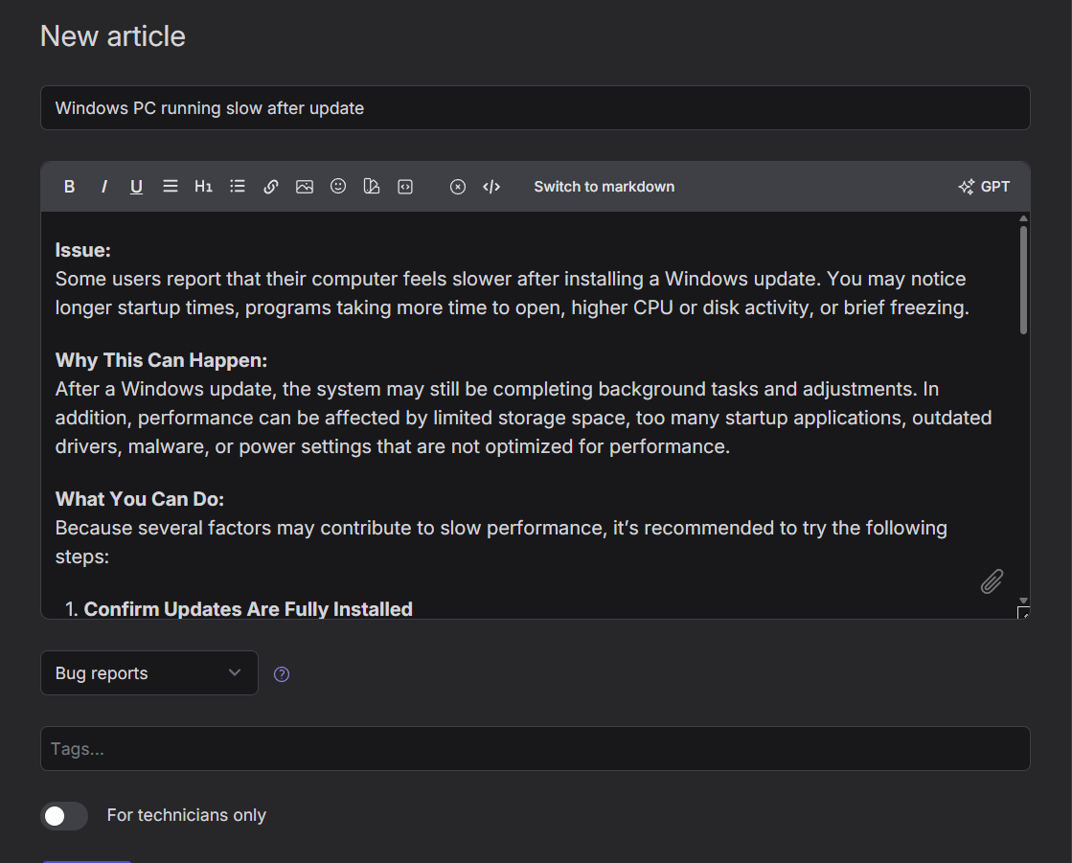Figure 1: Knowledge Base article created for Windows PC performance issue.

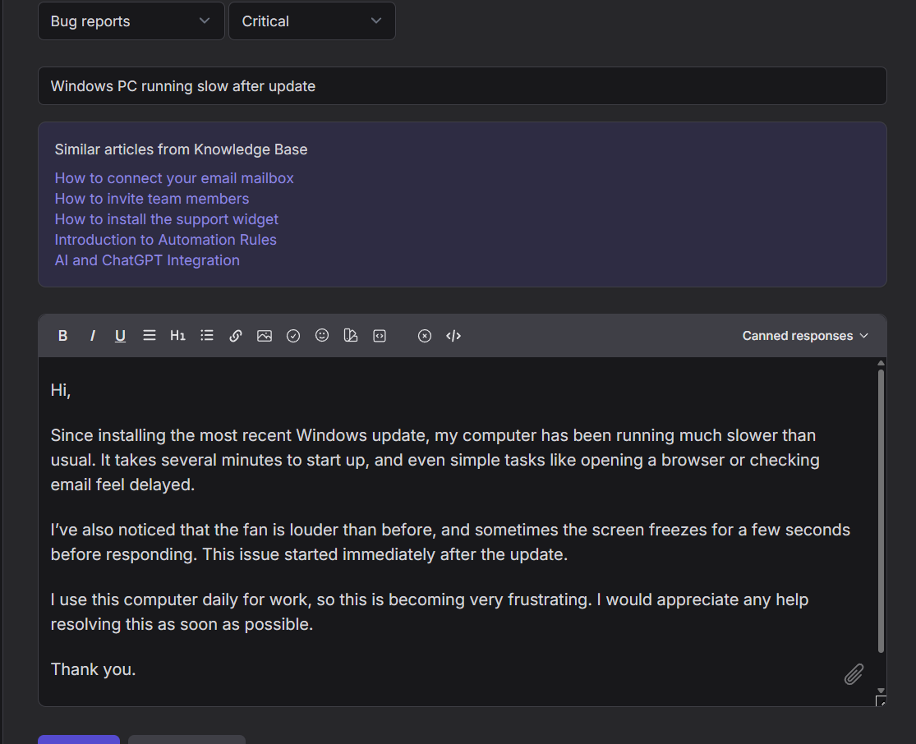
Figure 2: New ticket submitted with critical priority.

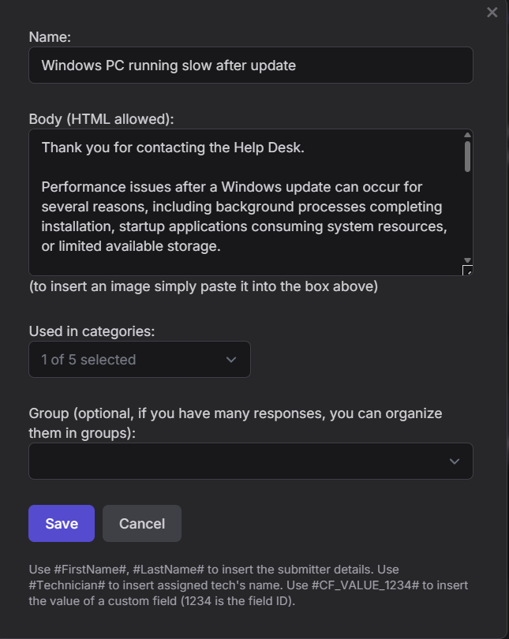
Figure 3: Canned response created for common performance issue.
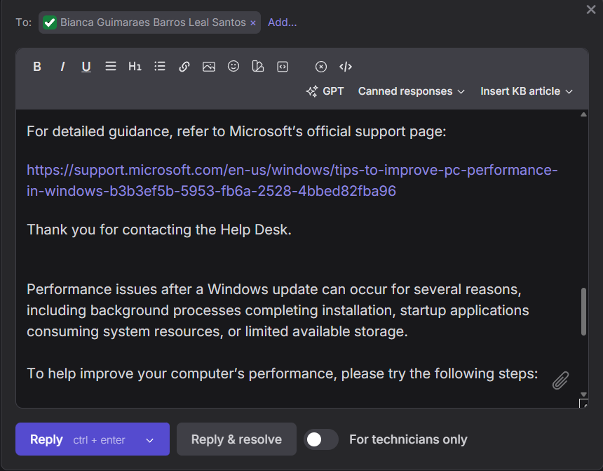
Figure 4: Final reply including Knowledge Base article and canned response.

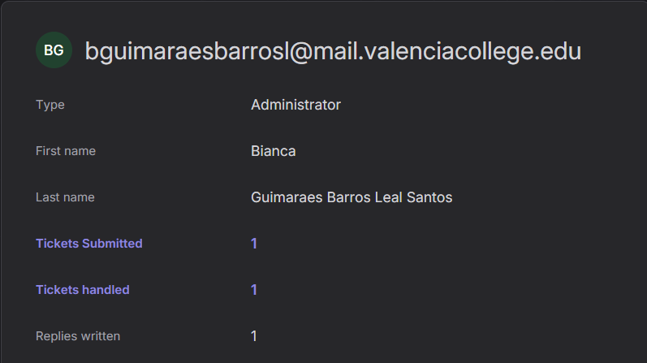
Figure 5: Technician statistics report showing ticket activity.

A manager could use the technician statistics report to better understand how the help desk team is performing. By looking at how many tickets each technician has submitted, handled, and replied to, the manager can see who is managing more work and how efficiently issues are being resolved. In a real company with several help desk agents, this information would help ensure that the workload is distributed fairly. It could also help identify if someone might need extra support or training. Overall, reports like this help management make better decisions and improve both team performance and customer satisfaction.
After using Jitbit, I found it very simple and easy to use. The system is clear, and everything is organized in a way that makes sense. Since it is web-based, it is convenient because you can access it from anywhere without installing anything. LBE Helpdesk is different because it must be installed on a computer. It feels more traditional and less modern than Jitbit. However, because it is installed locally, it may give the company more control over its data and system settings.
One difference is that Jitbit’s free version focuses mainly on basic features like tickets, canned responses, knowledge base articles, and reports. It works well, but it does not offer many advanced customization options in the trial version. LBE Helpdesk seems to offer more detailed configuration and possibly more control over system settings and internal data management. These features could be useful for companies that need more advanced control.
I believe the free version of Jitbit would be enough for a small company with simple help desk needs. It allows users to create tickets, respond to customers, store solutions in the knowledge base, and generate reports. However, if a company needs advanced reporting, asset tracking, or more complex customization, the free version may not be sufficient. In that case, a more advanced system or paid version would be a better option.
In conclusion, both systems have strengths depending on the needs of the organization. Jitbit is simple and convenient, especially for small teams, while LBE Helpdesk may offer more technical control. The best choice would depend on the company’s size, budget, and required features.

