Warfarin Pharmacy Dosing Service Analysis

Brian Gulbis, PharmD, BCPS

June 2016

Table of Contents

## Service Utilization

### Annual Warfarin Utilization

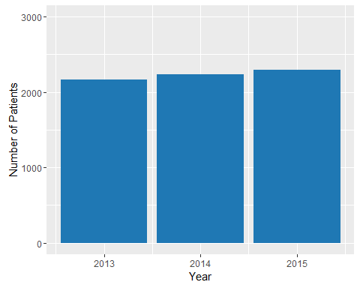

Number of Patients Receiving Warfarin at MH-TMC, 2013-2015

### Utilization of Pharmacy Dosing Service

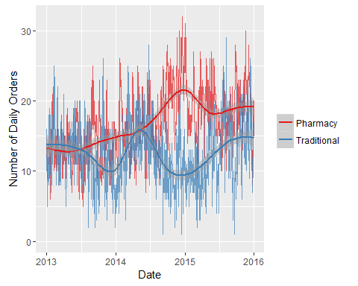

Daily Warfarin Orders Managed by Pharmacy and Traditional

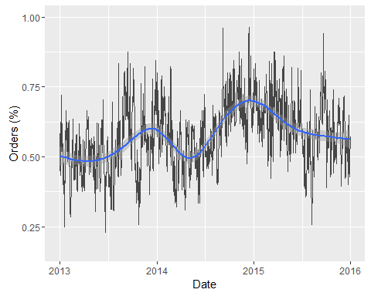

Percent of Daily Warfarin Orders Managed by Pharmacy Dosing Service

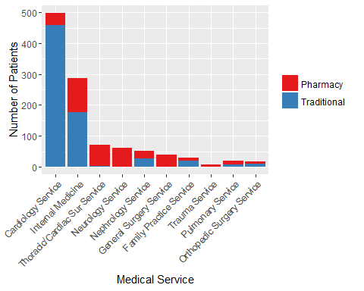

Warfarin Dosing Service Utilization Among Top 10 Medical Services Ordering Warfarin

## Comparison

* Group 1 - Pharmacy Dosing Service
  + Consult placed within 48 hours of warfarin initiation
  + At least 60% of warfarin doses placed by pharmacist
* Group 2 - Traditional Dosing

#### Inclusion

* January 1, 2015 to December 31, 2015
* Age 18 years or greater
* Received at least 3 doses of warfarin
* Baseline INR < 1.5

#### Exclusion

* Concurrent DTI or TSOAC
* Liver dysfunction
  + AST and ALT > 5x ULN (concurrently)
  + ALT > 10x ULN
  + T.Bili > 3x ULN
* Missing goals of therapy data
* Readmission encounters

### Results

Demographics

|  |  |  |  |
| --- | --- | --- | --- |
|  | pharmacy | traditional | p |
| n | 402 | 285 |  |
| Age (median [IQR]) | 58.00 [42.25, 68.75] | 64.00 [54.00, 72.00] | <0.001 |
| Sex = Male (%) | 240 (59.7) | 182 (64.1) | 0.279 |
| BMI (median [IQR]) | 28.48 [24.40, 33.54] | 29.32 [25.18, 33.68] | 0.277 |
| Race (%) |  |  | 0.096 |
| - African American | 104 (28.4) | 74 (27.9) |  |
| - Asian | 12 ( 3.3) | 1 ( 0.4) |  |
| - Native Am. | 0 ( 0.0) | 1 ( 0.4) |  |
| - Other | 78 (21.3) | 59 (22.3) |  |
| - White/Caucasian | 172 (47.0) | 130 (49.1) |  |
| Length of Stay (median [IQR]) | 12.10 [7.71, 19.83] | 13.71 [8.04, 24.17] | 0.103 |
| Therapy = New/Previous (%) | 270/132 (67.2/32.8) | 143/142 (50.2/49.8) | <0.001 |

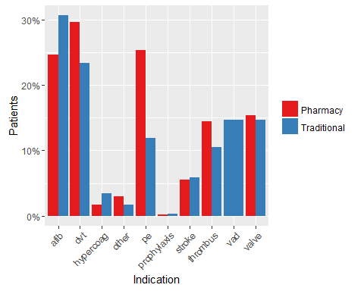

Indications for warfarin use

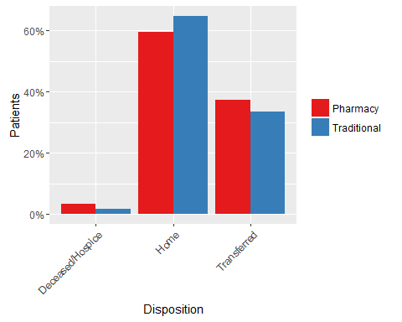

Disposition on discharge

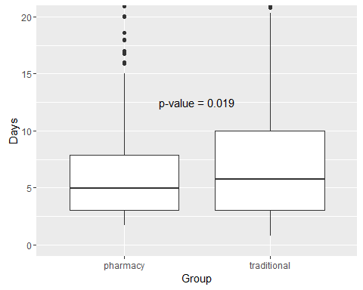

Inpatient Dosing Days

### Efficacy Endpoints

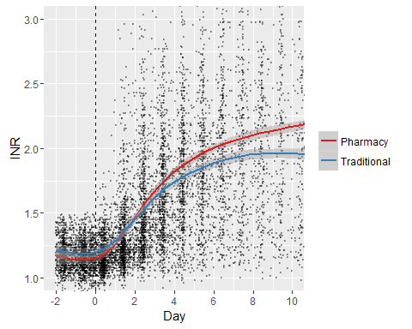

INR response after starting warfarin

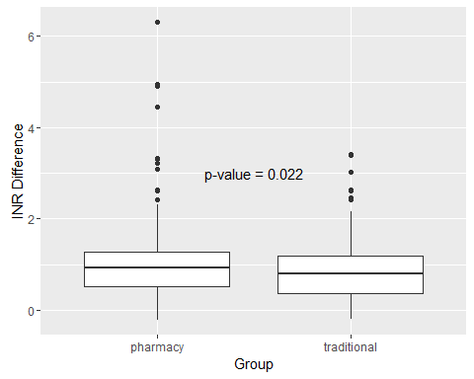

Change in INR

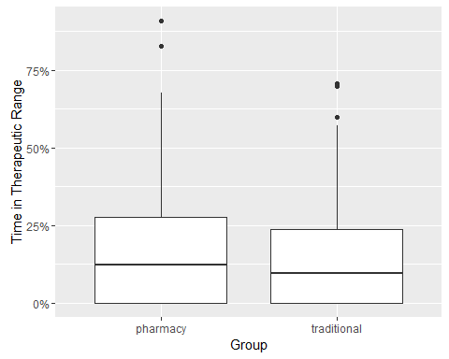

Percent of time INR is within therapeutic range

### Safety Endpoints

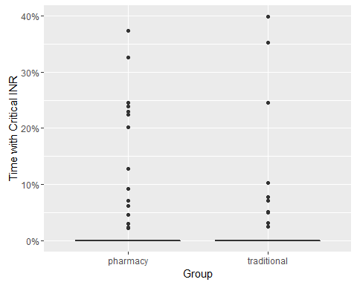

Percent of time INR is critical (above 4)

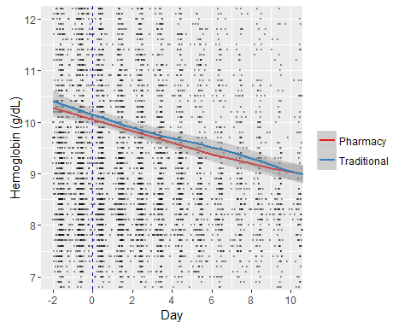

Change in hemoglobin after starting warfarin

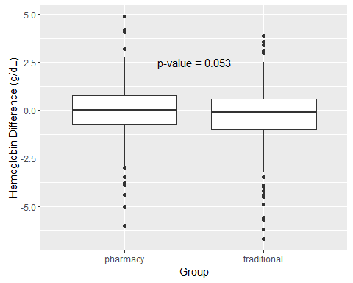

Change in Hemoglobin

## Historical Comparison

* Pharmacy Dosing Service 2015 vs. 2013-2014
* Same inclusion and exclusion criteria

Demographics

|  |  |  |  |
| --- | --- | --- | --- |
|  | current | historical | p |
| n | 402 | 866 |  |
| Age (median [IQR]) | 58.00 [42.25, 68.75] | 59.00 [46.00, 71.00] | 0.048 |
| Sex = Male (%) | 240 (59.7) | 505 (58.3) | 0.685 |
| BMI (mean (sd)) | 29.95 (8.50) | 29.90 (9.26) | 0.926 |
| Race (%) |  |  | 0.189 |
| - African American | 104 (28.4) | 245 (31.2) |  |
| - Asian | 12 ( 3.3) | 15 ( 1.9) |  |
| - Latin American | 0 ( 0.0) | 1 ( 0.1) |  |
| - Other | 78 (21.3) | 133 (16.9) |  |
| - White/Caucasian | 172 (47.0) | 392 (49.9) |  |
| -Length of Stay (median [IQR]) | 12.10 [7.71, 19.83] | 11.85 [7.38, 18.62] | 0.172 |
| Therapy = New/Previous (%) | 270/132 (67.2/32.8) | 604/262 (69.7/30.3) | 0.390 |

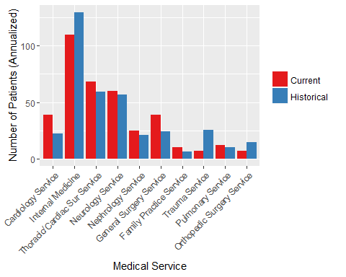

Warfarin Dosing Service Utilization Among Top 10 Medical Services Ordering Warfarin

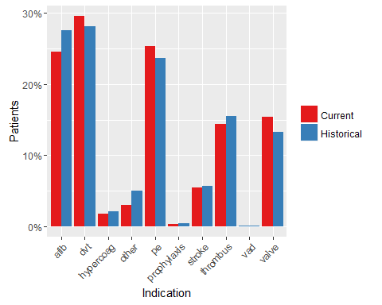

Indications for warfarin use

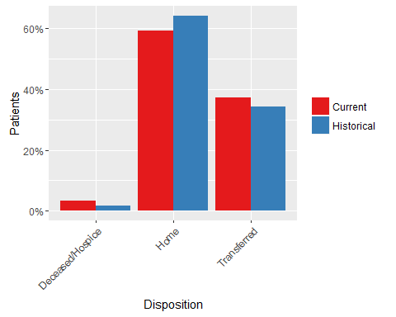

Disposition on discharge

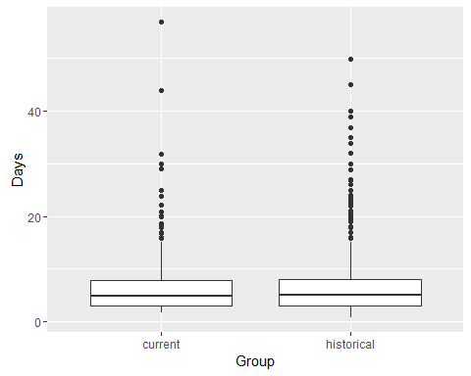

Inpatient Dosing Days

### Efficacy Endpoints

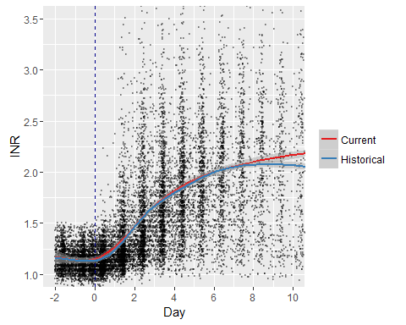

Change in INR after starting warfarin

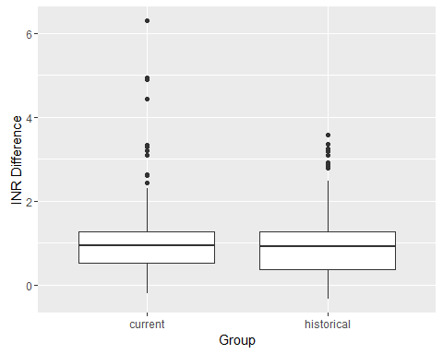

Change in INR

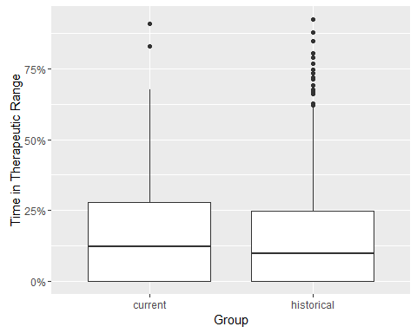

Percent of time INR is within therapeutic range

### Safety Endpoints

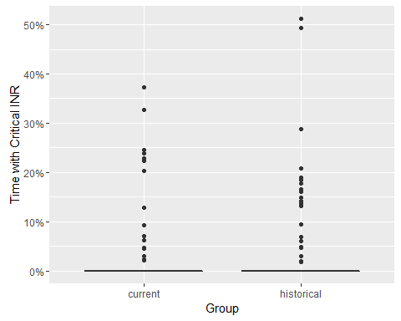

Percent of time INR is critical (above 4)

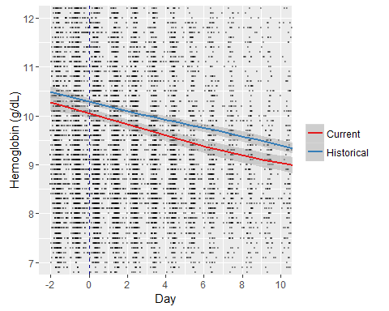

Change in hemoglobin after starting warfarin

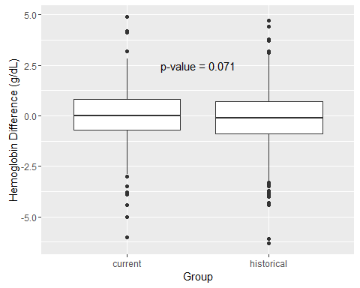

Change in Hemoglobin