Breathe – Pink Floyd

CM7/G Bm7
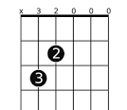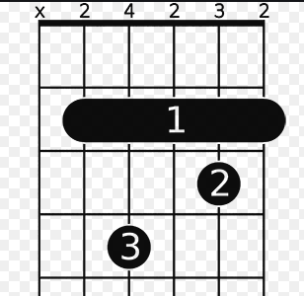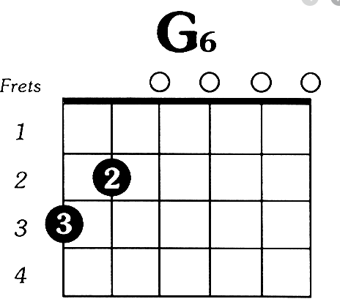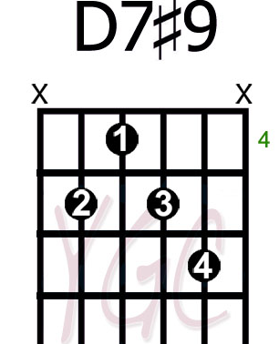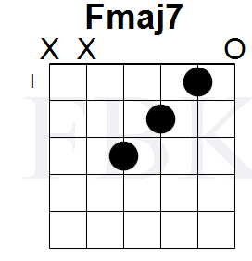

dddduuududu

Em A
Breathe, breathe in the air
Em A
Don't be afraid to care
Em A
Leave but don't leave me
Em A
Look around and choose your own ground

CM7/G
For long you live and high you fly
Bm7
And smiles you'll give and tears you'll cry
FM7
And all you touch and all you see
G6 D7#9 Em
Is all your life will ever be

Run, rabbit, run
Dig that hole, forget the sun
And when at last the work is done
Don't sit down, it's time to dig another one

For long you live and high you fly
But only if you ride the tide
And balanced on the biggest wave
You race towards an early grave

