Shes Leaving Home - The Beatles
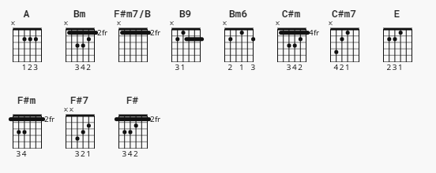

[Intro]
| E | % | % | % |

[Verse]
E Bm F#m C#m F#7
Wednesday morning at five o'clock as the day begins
F#m7/B B9
Silently closing her bedroom door
F#m7/B B9
Leaving the note that she hoped would say more
E Bm F#m C#m F#7
She goes downstairs to the kitchen clutching a handkerchief
F#m7/B B9
Quietly turning the backdoor key
F#m7/B B9
Stepping outside she is free

[Chorus]
E
She (We gave her most of our lives.)
E
Is leaving (Sacrificed most of our lives.)
E Bm6
Home (We gave her everything money could ^ ^ ^
C#m F#7 C#m F#7
She's leaving home after living alone for so many years
buy

[Verse]
E Bm F#m C#m F#7
Father snores as his wife gets into her dressing gown,
F#m7/B B9
Picks up the letter that's lying there.
F#m7/B B9
Standing alone at the top of the stairs,
E Bm F#m C#m F#7
She breaks down and cries to her husband "Daddy our baby's gone!"
F#m7/B B9
Why would she treat us so thoughtlessly?
F#m7/B B9
How could she do this to me?

[Chorus]
E
She (We never thought of ourselves.)
E
Is leaving (Never a thought for ourselves.)
E Bm6
Home (We struggled hard all our lives to get ^ ^ ^
C#m F#7 C#m F#7
She's leaving home after living alone for so many years
by

[Verse]
E Bm F#m C#m F#7
Friday morning at nine o'clock she is far away
F#m7/B B9
Waiting to keep the appointment she made
F#m7/B B9
Meeting a man from the motor trade

[Chorus]
E
She (What did we do that was wrong?)
E
Is having (We didn't know it was wrong.)
E Bm6
Fun (Fun is the one thing that money can't
C#m F#7 C#m F#7
Something inside that was always denied for so many years
buy

CODA
C#m7 F# A E
She's leaving home (bye bye)

