

CANZIM FinTrack

Financial Management System
System Overview & User Guide

Climate Action Network Zimbabwe (CAN Zimbabwe)

1. Project Overview

Project Name
CANZIM FinTrack — Financial Management & Accounting System

Overview
CANZIM FinTrack is a web-based Enterprise Resource Planning (ERP) and Financial Management System developed specifically for Climate Action Network Zimbabwe (CAN Zimbabwe). It provides a centralised platform for managing all financial activities — from project budgeting and expense tracking to donor management, cash flow monitoring, and regulatory reporting.
The system is designed to serve up to 50 staff members across three distinct user roles, ensuring that the right people have access to the right information and controls. All financial data is managed in USD$ and the system enforces strict role-based access controls throughout every module.

Technology Stack
Component | Technology
Application Type | Single Page Application (SPA)
Backend Framework | Laravel 12 (PHP 8.2) + MySQL
Frontend Framework | Vue.js 3 + Pinia + Tailwind CSS v4
API Architecture | RESTful API (versioned: /api/v1/)
Authentication | Laravel Sanctum (token-based)
PDF Generation | DomPDF
Charts & Analytics | Chart.js (via Vue wrappers)

User Roles & Access Control
The system implements three distinct roles with fine-grained permissions enforced via server-side policies:
Role | Description
Programs Manager | Full system administrator — organisation-wide financial overview, user management, settings, and all approvals.
Finance Officer | Financial operations — manages expenses, cash flow, purchase orders, bank accounts, and reports.
Project Officer | Project-level access — submits expenses, manages project documents, and views project budgets.

2. Main Features & Modules

The following sections describe each module of CANZIM FinTrack in detail. Each module section includes one or more screenshot placeholders where images can be manually inserted.
MODULE 1 — Authentication & Session Security

Overview
The authentication module provides secure, token-based login and session management for all users. It incorporates multiple layers of protection including brute force prevention, session locking, and IP tracking.

Screenshot — Login / Landing Page
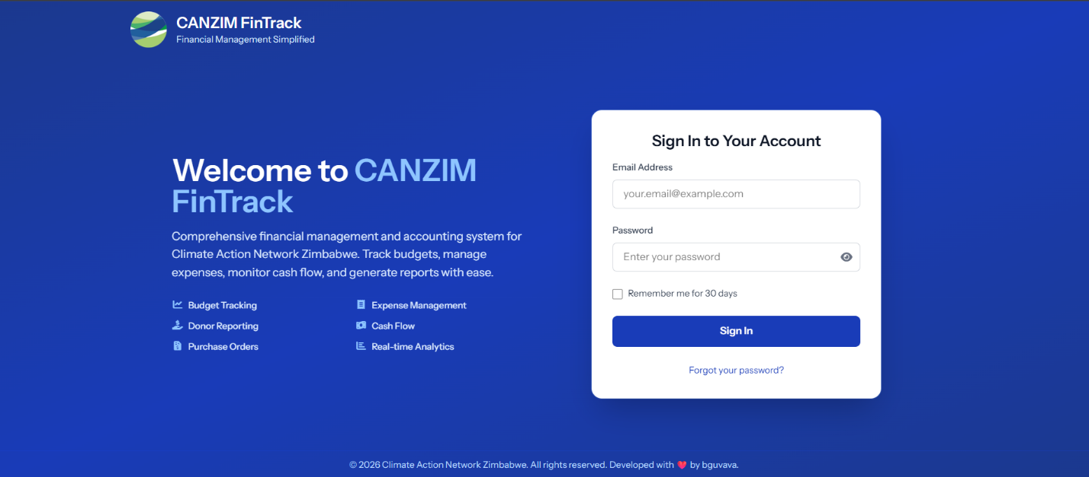

Session Lock Screen - Session lock screen appearing after 5 minutes of inactivity
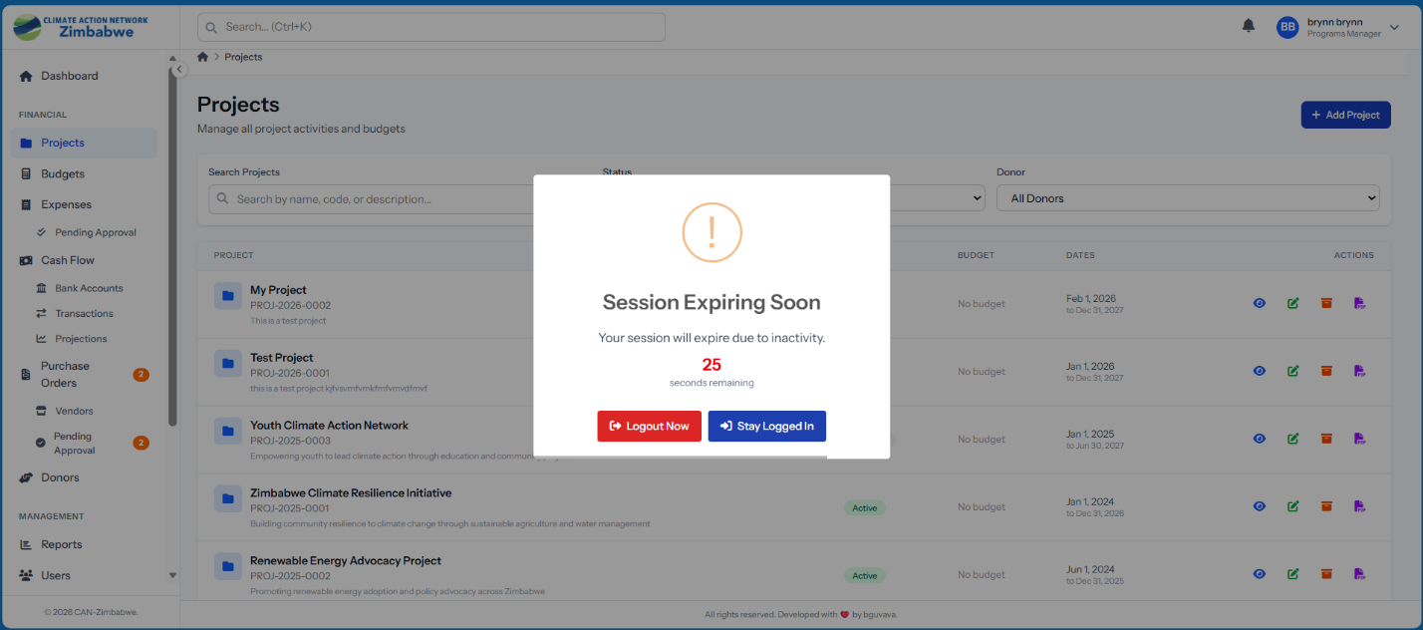

Key Features
- Token-based authentication via Laravel Sanctum
- Password reset via email link (token-based, time-limited)
- Account lockout after configurable number of failed login attempts
- Session timeout — 5-minute inactivity timer with a 30-second countdown warning
- Session locking — locks screen without logging out; user re-enters password to unlock
- IP address tracking — records login IP and captures IP on every activity log entry
- Role validation on page load — ensures only authorised roles can access the system
- Persistent sessions — token and user state preserved across page refreshes
- Password verification endpoint for sensitive operations

Security Controls
Security Control | Implementation
Brute Force Protection | Account lockout with configurable threshold and lockout duration
Session Inactivity | 5-minute auto-lock (configurable in system settings)
API Authentication | Sanctum bearer token required on every /api/v1 request
Authorization | Laravel Policies enforced on every model operation
Input Validation | Form Request validation classes for all data mutations
HTTPS | Enforced as a production deployment requirement

MODULE 2 — Dashboard

Overview
The Dashboard is the central hub of CANZIM FinTrack. It provides a role-aware overview of key performance indicators (KPIs), interactive charts, recent activity, and system notifications — all tailored to the permissions and responsibilities of the logged-in user.

Dashboard - Role-aware dashboard with KPI cards, interactive charts, activity feed, and notification panel
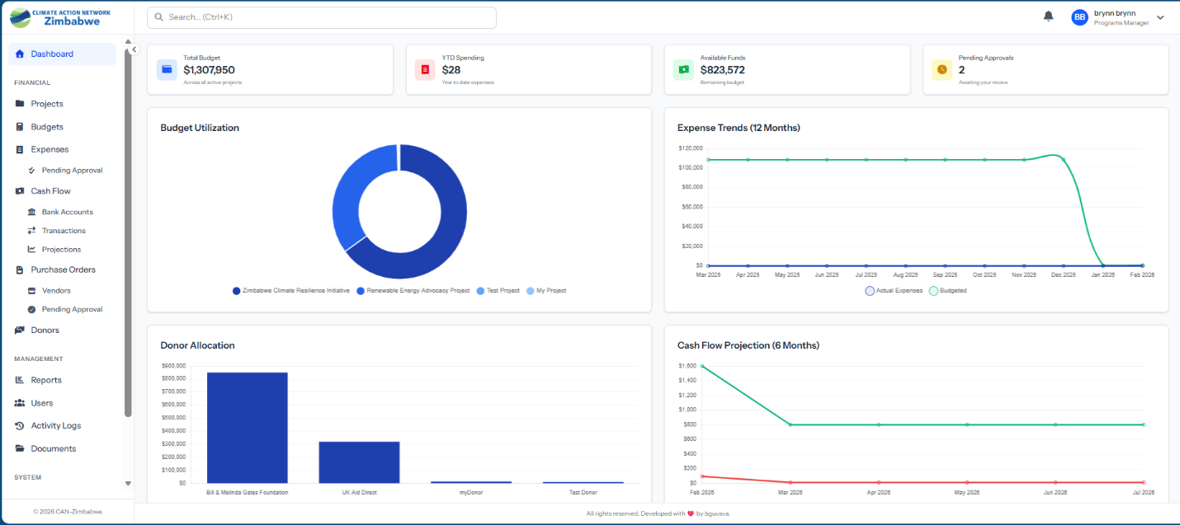

Programs Manager Dashboard
KPI Cards: Total Budget (sum across all active projects), YTD Spending (year-to-date approved expenses), Active Projects count, and Pending Approvals (expenses + POs awaiting action). Charts: Budget vs Actual spending by project (bar chart), monthly cash flow trend (line chart), expense category breakdown (doughnut chart), and project status distribution (pie chart). Activity Feed: Recent expense submissions, budget utilisation alerts, new project creations, and approval decisions.

Finance Officer Dashboard
- Cash balance aggregated across all bank accounts
- Pending expenses count and total value
- This month's total outflows
- Outstanding purchase orders
- Cash flow inflows vs outflows chart (monthly) and expense status pipeline chart

Project Officer Dashboard
- Total budget for assigned projects
- Expenses submitted this month by the current user
- Projects currently in progress
- Pending approvals for own submissions
- Real-time notifications panel with read/unread state per notification

MODULE 3 — Project Management

Overview
The Project Management module provides a complete lifecycle management solution for all organisational projects — from initial planning through active delivery to archiving. It tracks budgets, teams, donors, and all associated documents and expenses.

Add / Edit Project - Project creation form showing project code, dates, budget, office location, and team assignment fields
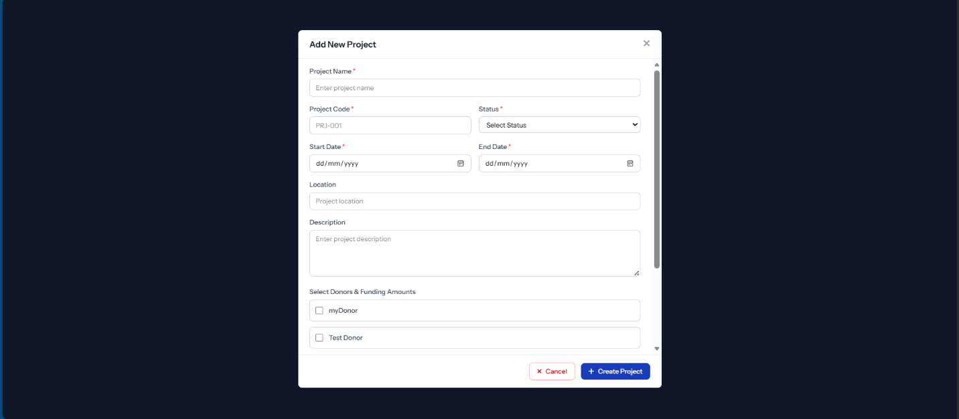

Key Features
- Full project CRUD — create, view, edit, and soft-delete projects
- Unique project codes auto-assigned (e.g. PRJ-2025-001)
- Status lifecycle tracking: Planning to Active to Completed to Archived
- Date management — start and end dates with validation
- Budget integration — total budget displayed with live utilisation percentage
- Team member assignment — assign multiple staff with role context per project
- Donor linkage — projects linked to donors with funding amount and restriction flags
- Office location assignment — ties projects to specific branches
- Archive function — soft-archives completed projects while preserving all records
- PDF project report generation
- Project statistics endpoint providing aggregate counts by status

MODULE 4 — Budget Management

Overview
The Budget Management module enables Finance Officers to create structured budgets for each project, broken down into categorised line items. Budgets go through an approval process before becoming active, and the system continuously tracks utilisation against allocated amounts.

Budget Management - Budget management with line items, utilisation percentages, and approval status
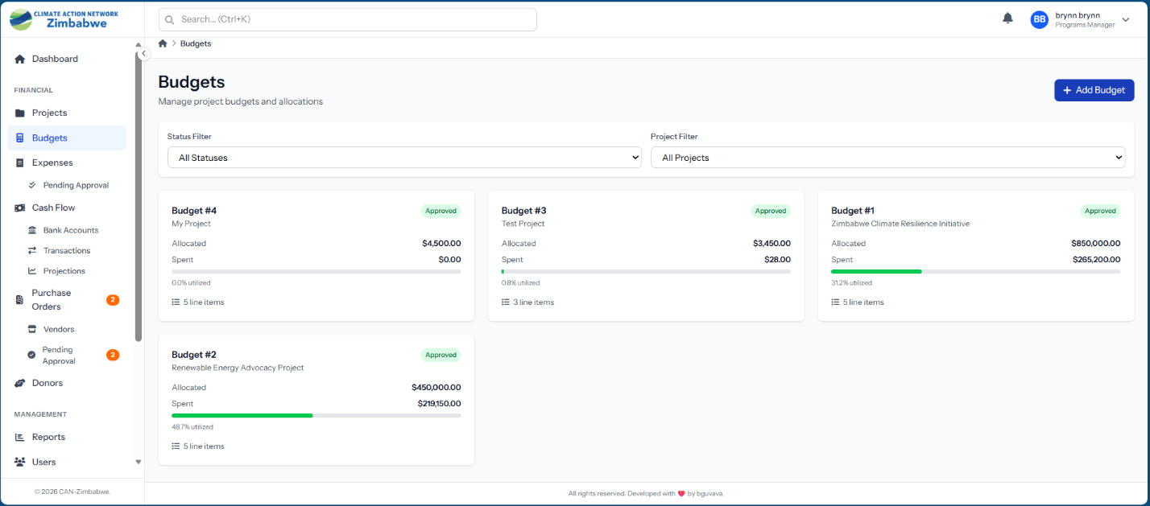

Key Features
- Budget creation per project per fiscal year
- Detailed budget line items with categorised allocated amounts
- Approval workflow: Draft to Approved (Programs Manager approval required)
- Budget reallocation — request transfers between budget items (requires approval)
- Live utilisation metrics: total allocated, total spent, remaining, and utilisation %
- Predefined expense category management
- Budget alerts — automatic notifications when utilisation exceeds a configurable threshold
- Soft deletes on both budgets and individual line items

Budget Utilisation Metrics
Metric | Calculation
Total Allocated | Sum of all budget item allocated amounts
Total Spent | Sum of all approved expenses against budget line items
Total Remaining | Total Allocated minus Total Spent
Utilisation % | (Total Spent / Total Allocated) x 100

MODULE 5 — Expense Management

Overview
The Expense Management module implements a structured, multi-stage approval pipeline for all organisational expenses. Every expense moves through a defined workflow from draft submission to final payment, with notifications sent at each stage.

Expense List / Approval Queue - Expense approval with multi-step pipeline, pending review queue, and approval actions
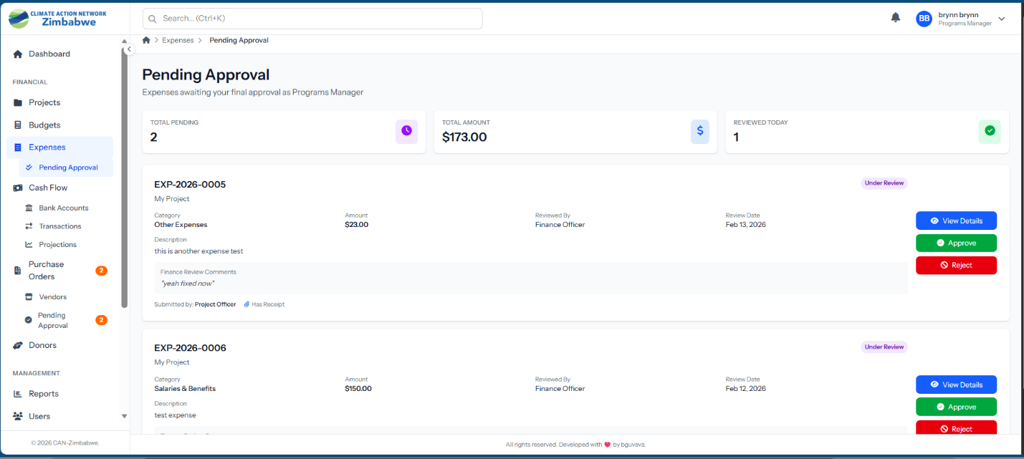

Approval Workflow
All expenses follow a clearly defined 5-stage pipeline:
Stage | Status | Description
1 | Draft | Created by any user; fully editable before submission
2 | Pending Review | Submitted and locked; Finance Officer notified for review
3 | Pending Approval | Reviewed; awaits Programs Manager final approval
4 | Approved / Rejected | Approved (submitter notified) or rejected with reason and returned
5 | Paid | Payment reference, method, and date recorded

Key Features
- Auto-generated expense numbers (EXP-YYYY-NNN)
- Project and budget item linkage for accurate cost attribution
- Configurable expense categories
- Secure receipt upload (PDF/image) stored privately
- Optional Purchase Order linkage for PO-backed expenses
- Role-filtered views: My Expenses, Pending Review, Pending Approval, All Expenses
- Individual and bulk expense PDF exports
- Email and in-app notifications at every stage of the approval pipeline

MODULE 6 — Cash Flow Management

Overview
The Cash Flow Management module provides real-time visibility into the organisation's cash position across all bank accounts. It records all inflows and outflows, supports reconciliation, and generates forward-looking cash flow projections.

Cash Flow Dashboard - Cash flow screen showing bank accounts, inflow/outflow transactions, and reconciliation status
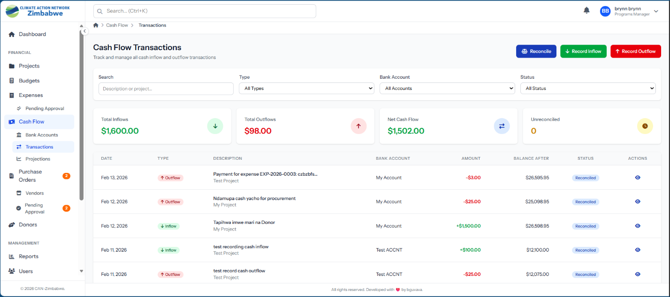

Cash Flow Projections - 6-month projection chart showing projected inflows vs outflows trend line
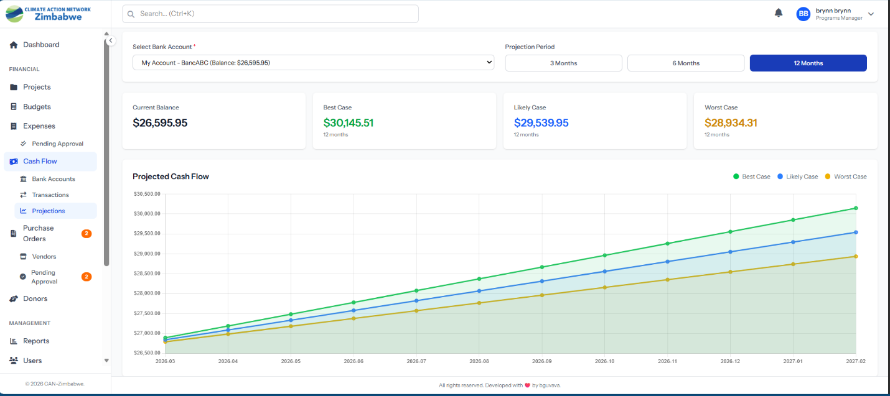

Bank Account Management
- Create and manage multiple bank accounts with full account details
- Activate or deactivate accounts as needed
- Per-account reconciliation report available as a PDF export

Transaction Recording
- Record inflows — donor receipts, grants received, and other income
- Record outflows — expense payments, transfers, and disbursements
- Running balance tracking with balance-before and balance-after fields
- Link transactions to specific projects and donors
- Link outflow transactions to approved expense records

Reconciliation & Projections
- Mark individual transactions as reconciled or unreconciled
- Track reconciliation date and the user who performed reconciliation
- 6-month forward cash flow projection based on historical patterns
- Visual line chart showing projected inflows vs outflows
- Summary statistics: total inflows, total outflows, and current cash position

MODULE 7 — Purchase Order Management

Overview
The Purchase Order module manages the full procurement lifecycle — from vendor profiles and PO creation through to approval, goods receipt, and completion. All purchase orders are tracked with auto-generated reference numbers and are available as PDF documents.

Vendor Management - Vendor management panel showing vendor profiles, contact details, and activity summary
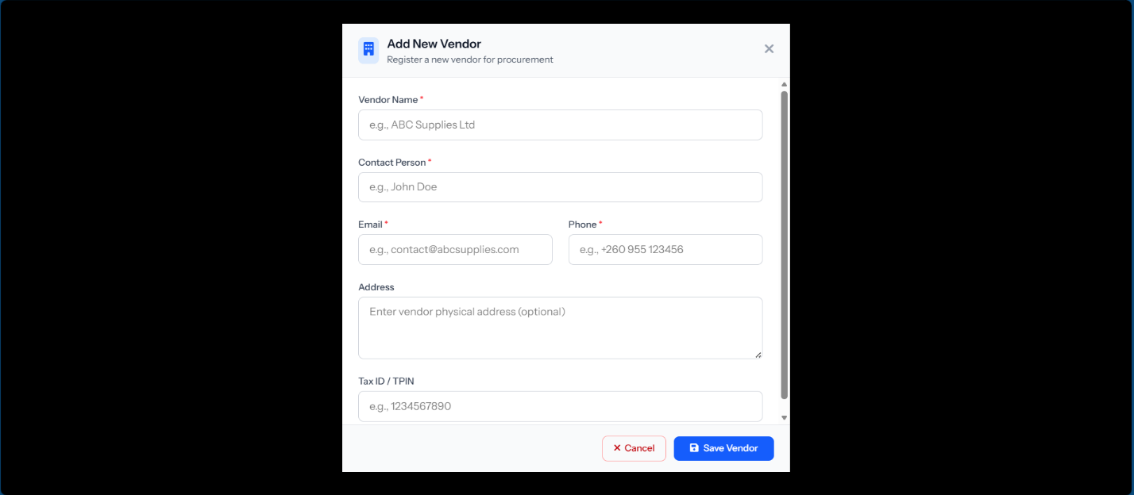

PO Workflow Stages
Stage | Description
Draft | PO created and editable before submission
Pending Approval | Submitted for review; Programs Manager notified
Approved | Approved and ready to send to vendor
Received | Goods/services received; linked to expense records
Completed | Fully fulfilled and closed
Cancelled / Rejected | PO rejected or cancelled with reason captured

Key Features
- Vendor profile CRUD — full contact details, tax ID, and payment terms
- Activate/deactivate vendors and view per-vendor summary statistics
- Auto-generated PO numbers (PO-YYYY-NNN)
- Multi-line item PO creation with quantity, unit price, and subtotals
- Tax amount and total amount calculations
- Project linkage for budget attribution
- PDF PO document generation for sending to vendors
- Link delivered POs to corresponding expense records
- Pending approval queue view for Programs Manager

MODULE 8 — Donor Management

Overview
The Donor Management module provides a comprehensive system for tracking all funding sources. It manages donor profiles, project funding assignments, restricted and unrestricted funding classification, in-kind contributions, and a full communications history with each donor.

Donor Management - Donor management module showing donor profiles, project assignments, funding analytics, and communication history
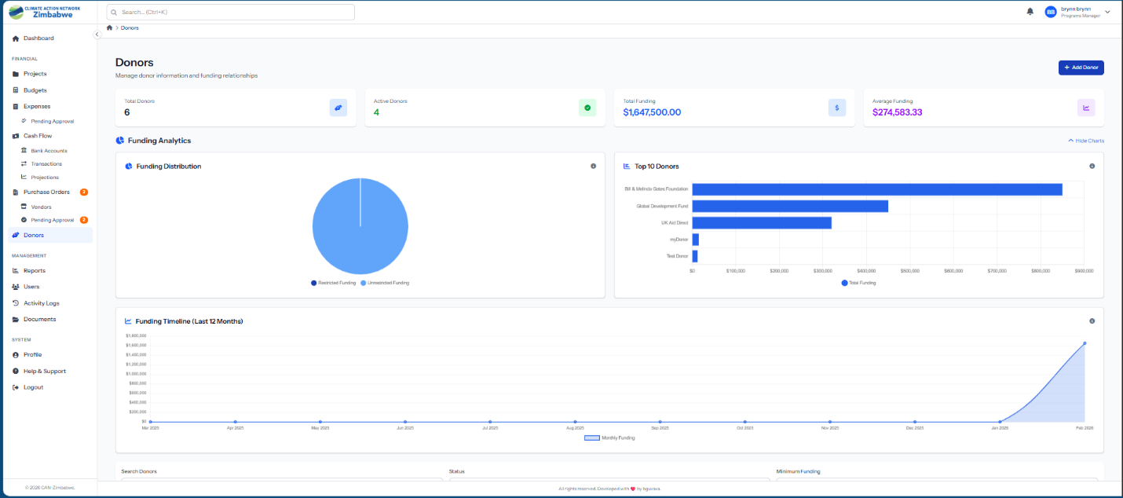

Donor Profiles & Project Assignment
- Full donor profile management: name, contact person, email, phone, address, website
- Active/inactive status management with soft delete and restore capability
- Link donors to multiple projects with per-assignment funding details
- Funding period start and end dates per assignment
- Restricted vs unrestricted funding classification per allocation
- Aggregated funding analytics: total funding, restricted, unrestricted, and in-kind totals
- Funding timeline chart showing monthly contribution history

In-Kind Contributions & Communications
- Record non-cash donations: equipment, services, or goods with estimated value
- Track all donor communications — emails, meetings, and calls
- Date, subject, content, and communication type per communication entry
- Communications linked to both donor profiles and individual projects

Reports & Statistics
- Donor financial report and contribution history PDF exports
- Top donors by contribution (chart data for dashboard)
- Total donors, active/inactive counts, and total funding summary

MODULE 9 — Reports & Analytics

Overview
The Reports & Analytics module enables users to generate structured financial reports, export them as professionally formatted PDF documents, and access a history of all previously generated reports. A custom report builder provides flexible data exploration beyond the standard report types.

Reports Module - Reports module showing report type selection, filters, generated report preview, and PDF export button
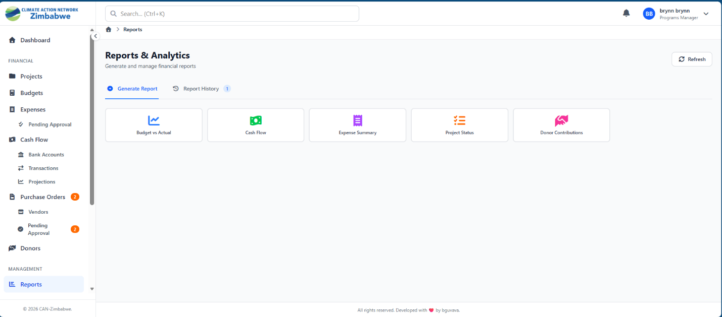

Available Report Types
Report Type | Description
Budget vs Actual | Compares allocated budgets against actual spending per project and category
Cash Flow Report | Inflows and outflows over a selected time period with running balance trend
Expense Summary | Breakdown of expenses by category, project, status, and reporting period
Project Status Report | Progress overview of all projects including budget utilisation metrics
Donor Contributions | Funding received by donor with project allocation and restriction details
Custom Report | Flexible builder — select data source, apply filters, and choose output columns

Key Features
- Generate reports by selecting type, date range, and project or donor filters
- Report history — list of all previously generated reports with full metadata
- PDF export — download any report as a formatted, print-ready document
- Custom report builder — select from Projects, Expenses, Budget, or Cash Flow data sources
- All generated reports saved with type, parameters, and generated-by user
- Delete outdated reports from history

MODULE 10 — Document Management

Overview
The Document Management module provides a centralised repository for all organisational documents, with support for polymorphic attachment to any record type, version control, category organisation, and secure file access.

Document Management - Document management screen with document list, categories, upload area, and version history
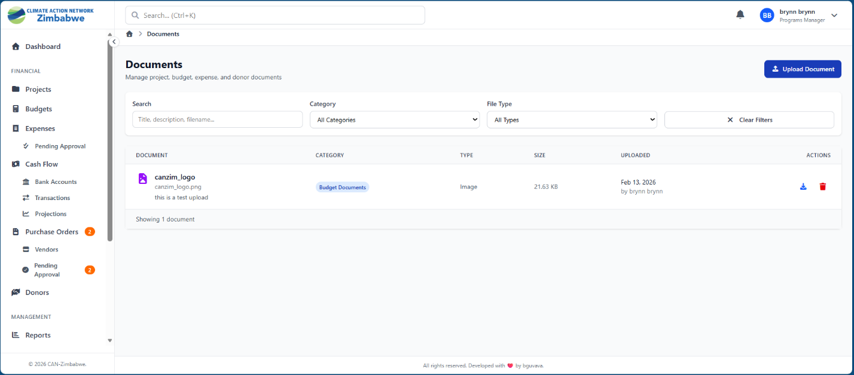

Key Features
- Polymorphic document linking — attach documents to Projects, Expenses, Donors, or store standalone
- Configurable document category taxonomy (Contracts, Reports, Receipts, etc.)
- Version control — every new upload creates a version while preserving full history
- File metadata: title, description, file name, type, size, and version number
- Secure file access — downloads served via signed URLs; files stored outside the public web root
- Search and filter by category, file type, and date range
- Inline viewing for PDFs and images directly in the browser
- Drag-and-drop file upload with progress indicator
- Soft deletes — documents are never permanently removed

Version Tracking
Each document maintains a complete version history. Every time a file is replaced or updated, a new version record is created capturing the version number, new file path, the uploading user, and the upload timestamp. Previous versions remain accessible for audit and reference purposes.

MODULE 11 — Comments System

Overview
The Comments System provides a contextual discussion and collaboration layer across the entire application. Users can add comments — with file attachments — to any record type, enabling threaded conversations directly on expenses, projects, purchase orders, and more.

Key Features
- Polymorphic comments — attach to any record type: Expenses, Projects, Purchase Orders, etc.
- Threaded discussions — contextual comment threads displayed directly on the relevant record
- File attachments — files can be attached to individual comments and stored securely
- Secure attachment downloads via signed download links
- Full CRUD — users can create, read, update, and delete their own comments
- Authorization controls — Programs Managers can moderate all comments

3. Conclusion

CANZIM FinTrack represents a comprehensive, purpose-built financial management solution for Climate Action Network Zimbabwe. By centralising all financial operations — from project budgeting and expense tracking to donor management, cash flow monitoring, and regulatory reporting — into a single, secure, web-based platform, the system empowers CAN Zimbabwe staff to work more efficiently and with greater financial transparency.
The system's role-based access control ensures that each staff member has precisely the level of access they need, while robust audit trails and approval workflows maintain accountability at every step. Real-time dashboards and analytics give leadership an immediate view of organisational financial health, while module-level tools give operational staff the practical capabilities they need day-to-day.
With 17 fully implemented and tested modules, CANZIM FinTrack is a production-ready platform that can scale with the organisation's growth and evolving reporting requirements. The system's architecture supports future enhancements and integrations, making it a long-term asset for CAN Zimbabwe's financial governance and accountability.

CANZIM FinTrack v1.1.0
Developed for Climate Action Network Zimbabwe | canzimbabwe.org.zw
Developed by bguvava | blaxium.com

