**Mini Project Report**

**on**

Replicate Traffic Light using Arduino

**(CSE-CE Iv Semester)**

2021-2022

**Submitted to: Submitted by:**

Dr. Mahesh Kumar  
Mr. Arnav Kotiyal Yogendra Bharadwaj

Roll. No.: 2017787

CSE-CE-Iv-Sem

Session: 2021-2022

**DEPARTMENT OF COMPUTER SCIENCE AND ENGINEERING**

**GRAPHIC ERA (DEEMED TO BE) UNIVERSITY, DEHRADUN**

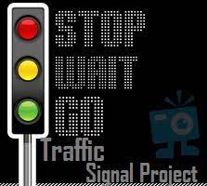

**REPORT**

**TABLE OF CONTENTS Page No.**

1. ABSTRACT 3
2. PROJECT INTRODUCTION AND GOAL 4
3. CIRCUIT DIGRAM 5
4. COMPONANT REQUIRED 6-8
5. SAMPLE CODE (Screenshot) 9
6. CONCLUSION (Adv. Limitation) 10
7. REFRENCE 11



The purpose of this paper is to design and implement a low-cost system intended in terms of hardware and software, to make a street traffic light for cars. This system will be built using the Arduino Uno development platform, and programming will be done using the LabVIEW graphical programming. Hardware resources that will be used in the paper are: Arduino Uno, a red, yellow and green LED, a breadboard, 3 x suitable resistors for the LEDs you have (probably 220 Ohms is fine) and connecting wires. The results will be displayed through the serial interface on the

1. **PROJECT INTRODUCTION AND OBJECTIVE**



Traffic lights are used all over the world to control the flow of traffic. The first traffic light was installed in London in 1868, before cars were created, to control the movement of horse carriages in the area, so pedestrians could safely cross the road. These original traffic lights had only two colours, red for stop and green for go. The three coloured traffic lights we know today weren’t introduced till 1920.



Of course, over the years, traffic signals have evolved significantly to accommodate a wide variety of more particular uses. As neighbourhoods and roadways expand to cover more areas and weave through more of where we live, more specific and detailed traffic signals become necessary.

That might seem absurd, right? A traffic light is a traffic light, isn’t it? Yes and no. In many cases, there’s a fairly homogeneous traffic light system in place, but in some cases, more specialized equipment makes sense



In 1997, the Department of the Environment, Transport and the Regions (DETR), together with the Traffic Director for London, launched the Urban Traffic Management and Control (UTMC) initiative. This paper presents the Policy-sensitive traffic signal control project, which began in March 1997 and was conducted in this context. The project's overall objective was to



This simple little project uses an Arduino and some LEDs to replicate a traffic light. It uses code as an internal timer and continues to run until you cut the Arduino's power supply.

Okay. The materials are here as follows:

1. Arduino UNO….

](javascript:openLightBox('a73d9fec40',%200);)

2. Breadboard

](javascript:openLightBox('81db41acbb',%200);)

3. Jumper Wires

[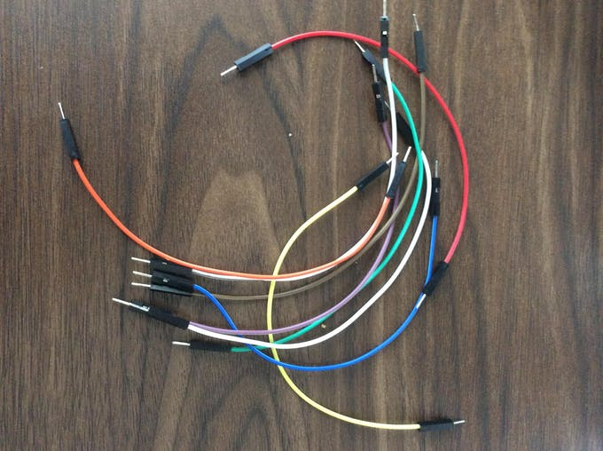](javascript:openLightBox('09c0428e42',%200);)Male to Male AND MALE TO FEMALE

4. Red, Yellow, and Green LED lights

[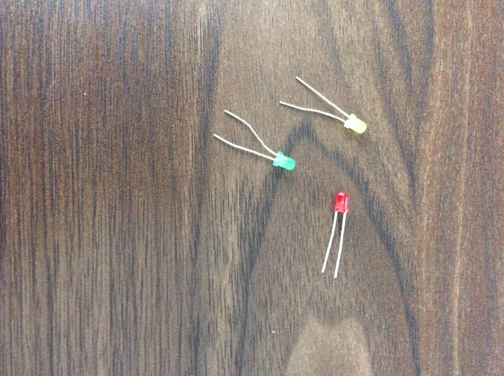](javascript:openLightBox('062aa55721',%200);)

5. Arduino USB 2.0 Cable

](javascript:openLightBox('c056d732a0',%200);)



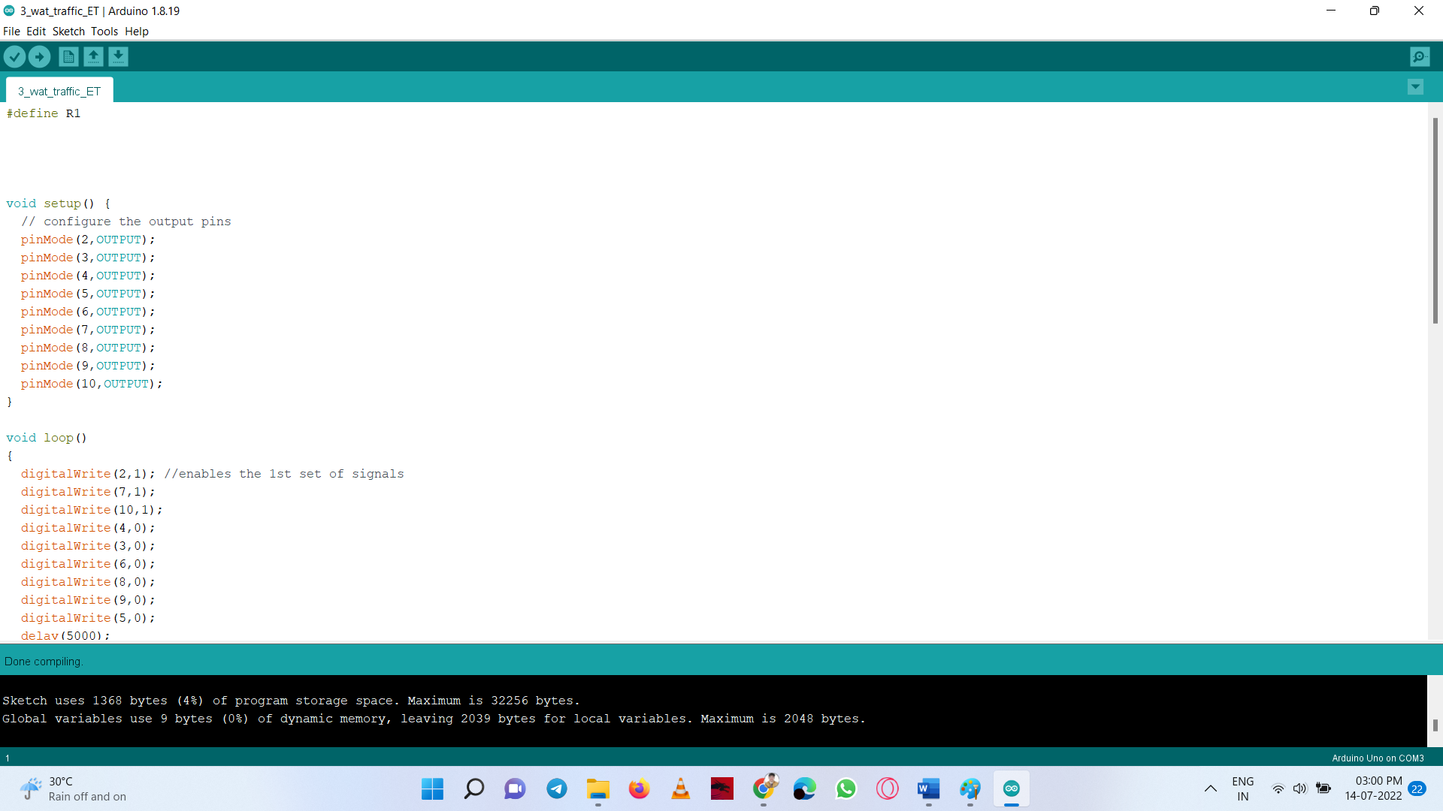





Signals offer maximum control at intersections. They relay messages of both what to do and what not to do. The primary function of any traffic signal is to assign right-of-way to conflicting movements of traffic at an intersection. This is done by permitting conflicting streams of traffic to share the same intersection by means of time separation. By alternately assigning right of way to various traffic movements, signals provide for the orderly movement of conflicting flows. They may interrupt extremely heavy flows to permit the crossing of minor movements that could not otherwise move safely through an intersection.

When properly timed, a traffic signal increases the traffic handling capacity of an intersection, and when installed under conditions that justify its use, a signal is a valuable device for improving the safety and efficiency of both pedestrian and vehicular traffic.

**Limitations of Traffic Light In INDIA:**

While they do help manage the flow of vehicular traffic, one of the other disadvantages of traffic signals is that they can cause traffic delay. Waiting for a traffic light to turn green or waiting for a car in a turn lane to safely cross an intersection can result in long wait periods.

Conclusion ……..

6.3 Conclusion

In this project I have implemented switching based, counter based. Traﬃc Light control

system. The hardware equipment is tested, and result is obtained. This project is cost

eﬀective. Implementation of this project in present day will eﬀectively solve the traﬃc

congestion which is a severe problem in many modern cities all over the world.

Automatic Traﬃc control system is based on a very eﬀective way of optimizing traﬃc,

with redeﬁnition of threshold values for a real time application. This works to control

traﬃc on four-way roads according to traﬃc control barricades which is functioned by

ICs. This proposed system will be able to build a developed country with less traﬃc

jams and it will also help the emergency vehicle to reach in time to the destination. So,

this intelligent system will help us to control traﬃc in more autonomous way.



Arduino Create https://create.arduino.cc/

Arduino Uno [https://store.arduino.cc/usa/ar duino-uno-rev3](https://store.arduino.cc/usa/ar%20duino-uno-rev3)

Arduino Reference https://www.arduino.cc/referen ce/en/