Name: Ben Holmes

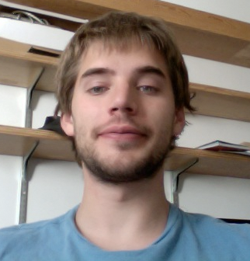

Email: bh0085@gmail.com

Year: 2015

Major: Computational Biology

1. Academic background:

Bio: Some microbial evolution and genetics. Biochemistry.
CS: Machine learning/machine vision. GUIs, python, some web.
Expertise: Physics.

2. My previous research experience.
Some lab work in biology related to protein production, purification and crystallization. Also, computer/optics work with the spitzer space telescope and mesoscale weather analysis on Saturn.

3. Areas of computational biology that interest me most:
Evolutionary genomics. Regulation.

4. Preferred type of project:
Something evolution related. Biologically more so than computationally focused.

