Name: Ben Holmes

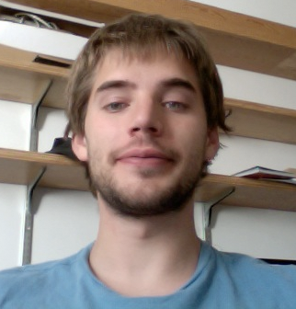

Email: bh0085@gmail.com

Year: 2015

Major: Computational Biology

1. Academic background:

Bio: Some microbial evolution and genetics. Biochemistry.
CS: Machine learning/machine vision. GUIs, python, some web.
Expertise: Physics.

2. My previous research experience.
Some lab work in biology related to protein production, purification and crystallization. Also, computer/optics work with the spitzer space telescope and mesoscale weather analysis on Saturn. I worked on the Mars Rover project briefly at Cornell and enjoyed coloring in Martian landscapes immensely.

3. Areas of computational biology that interest me most:
Evolutionary genomics. Regulation. I am most interested in plotting our regulatory networks and discovering the ways in which these are changed and preserved by the operations of evolution. How do regulatory networks form? How does their structure and connectedness once they have formed determine the subsequent path of evolution.

4. Preferred type of project:
Something evolution related. Biologically more so than computationally focused. I would like to work on a project that has puzzled biologists before the advent of computers and have a few in mind.

