Project Title: Online Car Rental Platform

Project Objective:
Build an online car rental platform using Object-Oriented Programming in Python.

Problem Statement:
A car rental company has requested you to build an online car rental platform where customers should be able to view the available cars that can be rented on an hourly, daily, or weekly basis. The company can display the available inventory and confirm requests by checking the available stock. Customers will receive an auto-generated bill when they return the car.

For simplicity, let’s assume that:
- Customers can rent cars from any one of the following options—hourly, daily, or weekly rental.
- Customers are free to choose any number of cars they want, provided the number of available cars is more than the number of requested cars.

You must use the following tools:
Jupyter Notebook: To create the module and main project files

Instructions to Perform:

- Create a module (.py file) for car rental and import the built-in module DateTime to handle the rental time and bill.
- Create a class for renting the cars and define a constructor in it.
- Define a method for displaying the available cars. Also, define methods for renting cars on an hourly, daily and weekly basis, respectively.
- Inside these methods, make sure that the number of requested cars is positive and lesser than the total available cars.
- Store the time of renting a car in a variable, which can later be used in the bill while returning the car.
- Define a method to return the cars using rental time, rental mode (hourly, daily, or weekly), and the number of cars rented.
- Inside the return method; update the inventory stock, calculate the rental period, and generate the final bill.
- Create a class for customers and define a constructor in it.
- Define methods for requesting the cars and returning them.
- Next, create the main project (.ipynb) file and import the car rental module in it.
- Define the main method and create objects for both car rental and customer classes.
- Inside the main method, take the customer’s input as a choice for displaying car availability, rental modes, or returning the cars.
- Use the relevant method for the customer’s input and print relevant messages.
- Run the main method to start your project.

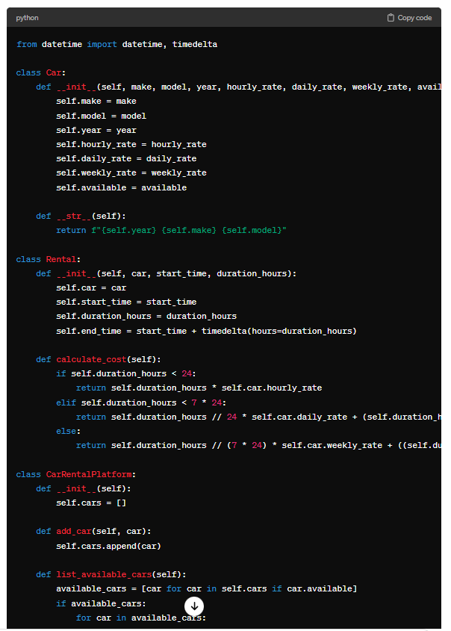
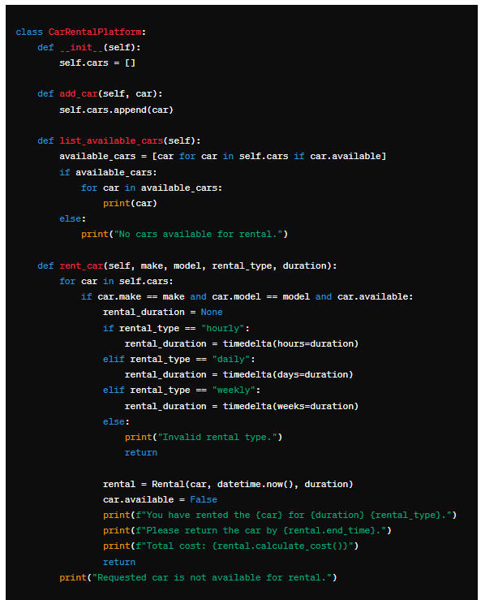
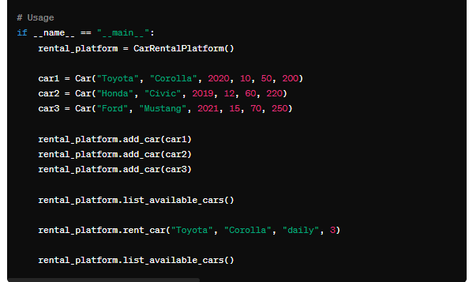

Prompt used to get above code:

Build an online car rental platform using Object-Oriented Programming in Python based on the following details: A car rental company has requested you to build an online car rental platform where customers should be able to view the available cars that can be rented on an hourly, daily, or weekly basis. The company can display the available inventory and confirm requests by checking the available stock. Customers will receive an auto-generated bill when they return the car. 1. Customers can rent cars from any one of the following options—hourly, daily, or weekly rental. 2. Customers are free to choose any number of cars they want, provided the number of available cars is more than the number of requested cars.

Copy & Paste:

Build an online car rental platform using Object-Oriented Programming in Python based on the following details:
ChatGPT
ChatGPT
Sure, here's a simplified example of how you could structure an online car rental platform using Object-Oriented Programming (OOP) principles in Python:
class Car:
def __init__(self, make, model, year, mileage, available=True):
self.make = make
self.model = model
self.year = year
self.mileage = mileage
self.available = available

def __str__(self):
return f"{self.year} {self.make} {self.model}"

class CarRentalPlatform:
def __init__(self):
self.cars = []

def add_car(self, car):
self.cars.append(car)

def list_available_cars(self):
available_cars = [car for car in self.cars if car.available]
if available_cars:
for car in available_cars:
print(car)
else:
print("No cars available for rental.")

def rent_car(self, make, model):
for car in self.cars:
if car.make == make and car.model == model and car.available:
car.available = False
print(f"You have rented the {car}. Enjoy your ride!")
return
print("Requested car is not available for rental.")

# Usage
if __name__ == "__main__":
rental_platform = CarRentalPlatform()

car1 = Car("Toyota", "Corolla", 2020, 5000)
car2 = Car("Honda", "Civic", 2019, 7000)
car3 = Car("Ford", "Mustang", 2021, 3000)

rental_platform.add_car(car1)
rental_platform.add_car(car2)
rental_platform.add_car(car3)

rental_platform.list_available_cars()
rental_platform.rent_car("Toyota", "Corolla")
rental_platform.list_available_cars()

This code sets up a basic car rental platform where you can add cars, list available cars, and rent a car by specifying its make and model.

You
Build an online car rental platform using Object-Oriented Programming in Python based on the following details: A car rental company has requested you to build an online car rental platform where customers should be able to view the available cars that can be rented on an hourly, daily, or weekly basis. The company can display the available inventory and confirm requests by checking the available stock. Customers will receive an auto-generated bill when they return the car. 1. Customers can rent cars from any one of the following options—hourly, daily, or weekly rental. 2. Customers are free to choose any number of cars they want, provided the number of available cars is more than the number of requested cars.
ChatGPT
ChatGPT
from datetime import datetime, timedelta

class Car:
def __init__(self, make, model, year, hourly_rate, daily_rate, weekly_rate, available=True):
self.make = make
self.model = model
self.year = year
self.hourly_rate = hourly_rate
self.daily_rate = daily_rate
self.weekly_rate = weekly_rate
self.available = available

def __str__(self):
return f"{self.year} {self.make} {self.model}"

class Rental:
def __init__(self, car, start_time, duration_hours):
self.car = car
self.start_time = start_time
self.duration_hours = duration_hours
self.end_time = start_time + timedelta(hours=duration_hours)

def calculate_cost(self):
if self.duration_hours < 24:
return self.duration_hours * self.car.hourly_rate
elif self.duration_hours < 7 * 24:
return self.duration_hours // 24 * self.car.daily_rate + (self.duration_hours % 24) * self.car.hourly_rate
else:
return self.duration_hours // (7 * 24) * self.car.weekly_rate + ((self.duration_hours % (7 * 24)) // 24) * self.car.daily_rate + ((self.duration_hours % (7 * 24)) % 24) * self.car.hourly_rate

class CarRentalPlatform:
def __init__(self):
self.cars = []

def add_car(self, car):
self.cars.append(car)

def list_available_cars(self):
available_cars = [car for car in self.cars if car.available]
if available_cars:
for car in available_cars:
print(car)
else:
print("No cars available for rental.")

def rent_car(self, make, model, rental_type, duration):
for car in self.cars:
if car.make == make and car.model == model and car.available:
rental_duration = None
if rental_type == "hourly":
rental_duration = timedelta(hours=duration)
elif rental_type == "daily":
rental_duration = timedelta(days=duration)
elif rental_type == "weekly":
rental_duration = timedelta(weeks=duration)
else:
print("Invalid rental type.")
return

rental = Rental(car, datetime.now(), duration)
car.available = False
print(f"You have rented the {car} for {duration} {rental_type}.")
print(f"Please return the car by {rental.end_time}.")
print(f"Total cost: {rental.calculate_cost()}")
return
print("Requested car is not available for rental.")

# Usage
if __name__ == "__main__":
rental_platform = CarRentalPlatform()

car1 = Car("Toyota", "Corolla", 2020, 10, 50, 200)
car2 = Car("Honda", "Civic", 2019, 12, 60, 220)
car3 = Car("Ford", "Mustang", 2021, 15, 70, 250)

rental_platform.add_car(car1)
rental_platform.add_car(car2)
rental_platform.add_car(car3)

rental_platform.list_available_cars()
rental_platform.rent_car("Toyota", "Corolla", "daily", 3)
rental_platform.list_available_cars()

Created two files : Car.py & CarRentalPlatform.py

Car.Py file

#*.py file for Car rental with Built-in DateTime Module
# Steps 1 -7 on Project
#1. Create a module (.py file) for car rental and import the built-in module DateTime to handle the rental time and bill.
#2. Create a class for renting the cars and define a constructor in it.
#3. Define a method for displaying the available cars. Also, define methods for renting cars on an hourly, daily and weekly basis, respectively.
#4. Inside these methods, make sure that the number of requested cars is positive and lesser than the total available cars.
#5. Store the time of renting a car in a variable, which can later be used in the bill while returning the car.
#6. Define a method to return the cars using rental time, rental mode (hourly, daily, or weekly), and the number of cars rented.
#7. Inside the return method; update the inventory stock, calculate the rental period, and generate the final bill.

# Car rental platform for cars to rent hourly, daily, weekly and availability of cars
from datetime import datetime

class CarRental:
def __init__(self, available_cars):
self.available_cars = available_cars

def display_available_cars(self):
print("Available cars for rental:")
for car, quantity in self.available_cars.items():
print(f"{car}: {quantity}")

def rent_hourly(self, car, num_cars):
return self.rent(car, num_cars, "hourly")

def rent_daily(self, car, num_cars):
return self.rent(car, num_cars, "daily")

def rent_weekly(self, car, num_cars):
return self.rent(car, num_cars, "weekly")

def rent(self, car, num_cars, rental_mode):
if car in self.available_cars and self.available_cars[car] >= num_cars and num_cars > 0:
now = datetime.now()
print(f"{num_cars} {car}(s) have been rented {rental_mode} at {now}")
return now
else:
print("Sorry, the requested number of cars is not available for rental.")
return None

def return_cars(self, car, rental_time, rental_mode, num_cars):
rental_periods = {"hourly": 1, "daily": 24, "weekly": 168}
if rental_mode in rental_periods and car in self.available_cars:
rental_period = (datetime.now() - rental_time).seconds / 3600 / rental_periods[rental_mode]
bill = rental_period * rental_periods[rental_mode] * num_cars
print(f"{num_cars} {car}(s) have been returned. Your bill is ${bill}")
self.available_cars[car] += num_cars
else:
print("Invalid rental mode or car.")

CarRentalPlatform.py

#8. Create a class for customers and define a constructor in it.
#9. Define methods for requesting the cars and returning them.
class Customer:
def __init__(self, name):
self.name = name

def request_cars(self, rental, car, num_cars, rental_mode):
if rental_mode == "hourly":
return rental.rent_hourly(car, num_cars)
elif rental_mode == "daily":
return rental.rent_daily(car, num_cars)
elif rental_mode == "weekly":
return rental.rent_weekly(car, num_cars)

def return_cars(self, rental, car, rental_time, rental_mode, num_cars):
rental.return_cars(car, rental_time, rental_mode, num_cars)

