package com.java.cdac.Exception;

import java.util.Scanner;

/*

Q1. Room Volume Calculation

Design a class named Room with three data members: height, width, and breadth. Include a method

volume() to compute and return the volume of the room. Create a separate class RoomDemo that

creates instances of the Room class and displays the volume for each instance.

*/

class Room{

double height;

double width;

double length;

//double volume;

public Room() {

}

public Room(double height, double width, double length) {

this.height = height;

this.width = width;

this.length = length;

}

public double volume() {

double volume = height* width*length;

return volume;

}

public void displayVolume() {

double volume = volume();

System.***out***.println(" Volume of Room = "+volume +" Cubic Units");

}

}

public class RoomDemo {

public static void main(String[] args) {

Scanner sc = new Scanner(System.***in***);

System.***out***.println("Enter the height of your room =");

double height = sc.nextDouble();

System.***out***.println(" height of your room ="+height);

System.***out***.println("Enter the Width of your room =");

double width = sc.nextDouble();

System.***out***.println(" width of your room ="+width);

double length = sc.nextDouble();

System.***out***.println("Enter the height of your room =");

System.***out***.println(" height of your room ="+length);

Room room = new Room(height,width,length);

room.displayVolume();

}

}

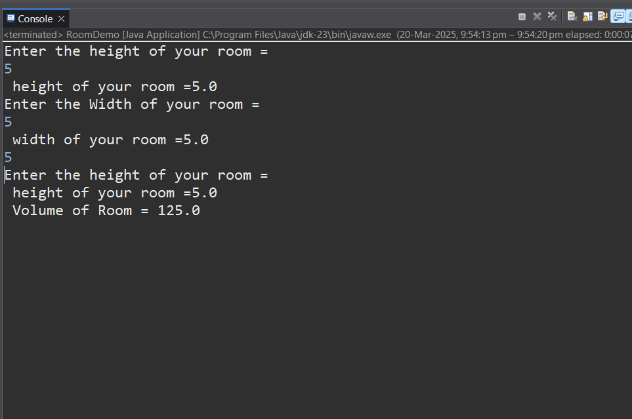

package com.java.cdac.Exception;

import java.util.Scanner;

/*

Q2. Student Marks and Average

Create a class Student with the following members:

● Name of the student

● Marks in three subjects

● A method to assign initial values

● A method to compute the total and average marks

● A method to display the student’s name and total marks

Write a main() method to demonstrate the functionality of the class.

*/

class Student{

String name;

double sub1marks;

double sub2marks;

double sub3marks;

public Student() {

}

public Student(String name, double sub1marks, double sub2marks, double sub3marks) {

this.name = name;

this.sub1marks = sub1marks;

this.sub2marks = sub2marks;

this.sub3marks = sub3marks;

}

public double avgmarks() {

double avg =(sub1marks+sub2marks+sub3marks)/3;

return avg;

}

void display() {

double avg =avgmarks();

System.***out***.println("Name of student = "+name);

System.***out***.println("Average marks of student = "+avg);

}

}

public class StudentQ2 {

public static void main(String[] args) {

Scanner sc = new Scanner(System.***in***);

System.***out***.println("Enter the name of student:");

String name = sc.nextLine();

System.***out***.println("Name of student ="+name);

System.***out***.println("Enter subject 1 marks : ");

double sub1marks = sc.nextDouble();

System.***out***.println(" subject 1 marks is : "+sub1marks);

System.***out***.println("Enter subject 2 marks : ");

double sub2marks = sc.nextDouble();

System.***out***.println(" subject 2 marks is : "+sub2marks);

System.***out***.println("Enter subject 3 marks : ");

double sub3marks = sc.nextDouble();

System.***out***.println(" subject 1 marks is : "+sub3marks);

Student st = new Student(name, sub2marks, sub2marks, sub3marks);

st.display();

}

}

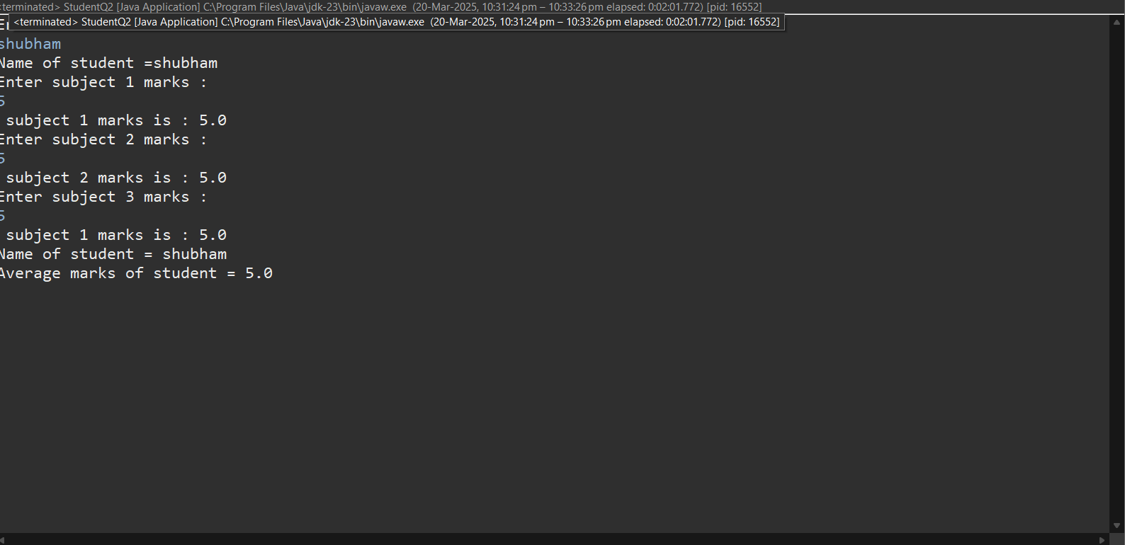

package com.java.cdac.Exception;

/*

Q3. Box Area and Volume

Write a class Box with three member variables: height, width, and breadth. Include appropriate

constructors to initialize these variables. Also, implement two methods:

● getVolume() to return the volume of the box

● getArea() to return the surface area of the box

Create two instances of the Box class and display their volumes and surface areas

*/

import java.util.Scanner;

class Box{

double height;

double width;

double length;

//double volume;

public Box() {

}

public Box(double height, double width, double length) {

this.height = height;

this.width = width;

this.length = length;

}

public double getVolume() {

double volume = height* width*length;

return volume;

}

public double getArea() {

//2(lw + lh + wh)

//double getArea = 2*(length*width + length* height + width* height);

return 2*(length*width + length* height + width* height);

}

public void display() {

double sufraceArea = getArea();

double volume = getVolume();

System.***out***.println(" Volume of box = "+sufraceArea);

System.***out***.println(" Volume of box = "+volume +" Cubic Units");

}

}

public class Q3 {

public static void main(String[] args) {

Scanner sc = new Scanner(System.***in***);

System.***out***.println("Enter the height of your box =");

double height = sc.nextDouble();

System.***out***.println(" height of your box ="+height);

System.***out***.println("Enter the Width of your box =");

double width = sc.nextDouble();

System.***out***.println(" width of your box ="+width);

double length = sc.nextDouble();

System.***out***.println("Enter the height of your box =");

System.***out***.println(" height of your box ="+length);

Box box = new Box(height,width,length);

box.display();

}

}

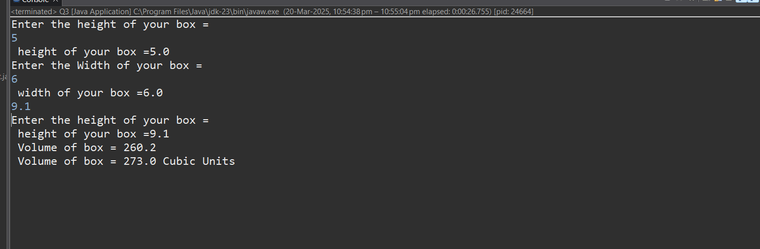

5

package com.java.cdac.Exception;

/*

Design a Java program to implement a BMI (Body Mass Index) calculator. The program should

consist of a class named BMICalculator with the following specifications:

Class: BMICalculator

Fields

● height (double): To store the height of the person in meters.

● weight (double): To store the weight of the person in kilograms.

Constructors

● A parameterized constructor to initialize the height and weight fields.

Methods

● Getter and Setter methods for both height and weight.

● double calculateBMI(): This method calculates and returns the BMI using the formula:

BMI=weight(height×height)\text{BMI} = \frac{\text{weight}}{(\text{height} \times

\text{height})}BMI=(height×height)weight

Main Program : Write a separate class containing the main() method to

1. Create an object of the BMICalculator class.

2. Prompt the user to enter their height and weight.

3. Use setter methods to assign these values to the object.

4. Call the calculateBMI() method to compute the BMI.

5. Print the calculated BMI to the console

*/

import java.util.Scanner;

class BMICalculator{

private double height;

private double width;

//double volume;

public BMICalculator() {

}

public BMICalculator(double height, double width) {

this.height = height;

this.width = width;

}

// Getter and Setter

public double getHeight() {

return height;

}

public void setHeight(double height) {

this.height = height;

}

public double getWidth() {

return width;

}

public void setWidth(double width) {

this.width = width;

}

double calculateBMI() {

double BMI=width/(height*height);

return BMI;

}

}

public class Q5BMICalculator {

public static void main(String[] args) {

BMICalculator cal =new BMICalculator();

Scanner sc = new Scanner(System.***in***);

System.***out***.println("Enter the height of your box =");

double height = sc.nextDouble();

System.***out***.println(" height of your box ="+height);

System.***out***.println("Enter the Width of your box =");

double width = sc.nextDouble();

System.***out***.println(" width of your box ="+width);

cal.setHeight(height);

cal.setWidth(width);

double result =cal.calculateBMI();

System.***out***.println(result);

}

}

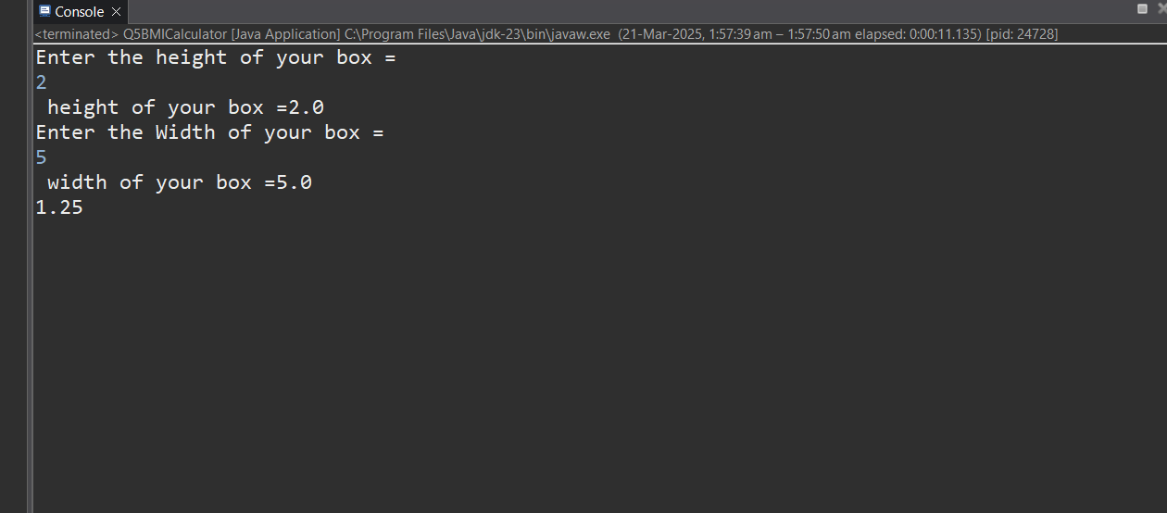

package com.java.cdac.Exception;

import java.util.Scanner;

/*

Design a Java program to calculate the electricity bill for a customer based on the number of units

consumed. Implement a class named ElectricityBill with the following specifications:

Class: ElectricityBill

Instance Variables

● customerName (String): Name of the customer

● unitsConsumed (double): Number of electricity units consumed

● billAmount (double): The calculated bill amount

Constructor

● A parameterized constructor to initialize the customerName and unitsConsumed fields.

Method

● void calculateBillAmount(): This method calculates the electricity bill amount based on the

following tariff rules:

○ First 100 units: Rs. 5 per unit

○ Next 200 units (i.e., 101 to 300): Rs. 7 per unit

○ Remaining units (above 300): Rs. 10 per unit

Main Program

In the main() method:

1. Create an object of the ElectricityBill class.

2. Set the customerName and unitsConsumed values (can be taken from user input or

hardcoded).

3. Call the calculateBillAmount() method to compute the bill.

4. Display the customer's name, units consumed, and final bill amount

*/

class ElectricityBill{

String customerName;

double unitsConsumed;

double billAmount;

public ElectricityBill() {

}

public ElectricityBill(String customerName, double unitsConsumed) {

this.customerName = customerName;

this.unitsConsumed = unitsConsumed;

}

void calculateBillAmount() {

if(unitsConsumed <= 100) {

billAmount = unitsConsumed * 5;

}

else if(unitsConsumed <= 30) {

billAmount = unitsConsumed * 7;

}

else {

billAmount = unitsConsumed * 10;

}

}

void displayBill() {

System.***out***.println("Customer Name : "+customerName);

System.***out***.println("Units Consumed : "+unitsConsumed);

System.***out***.println("Total Amount : "+billAmount);

}

}

public class Q5ElectricityBill {

public static void main(String[] args) {

Scanner sc = new Scanner(System.***in***);

System.***out***.println("Enter name of customer : ");

String name = sc.nextLine();

System.***out***.println("Enter electricity unit of customer : ");

double unit = sc.nextInt();

ElectricityBill eb = new ElectricityBill(name, unit);

eb.calculateBillAmount();

eb.displayBill();

}

}

