Worqference 2023

Systematically start Web Load Testing using Apache JMeter

**Instructor**: Sandeep Garg

Prerequisites

***Java and OS*:**

<https://jmeter.apache.org/usermanual/get-started.html>

<https://cwiki.apache.org/confluence/display/JMETER/JMeterAndOperatingSystemsTested>

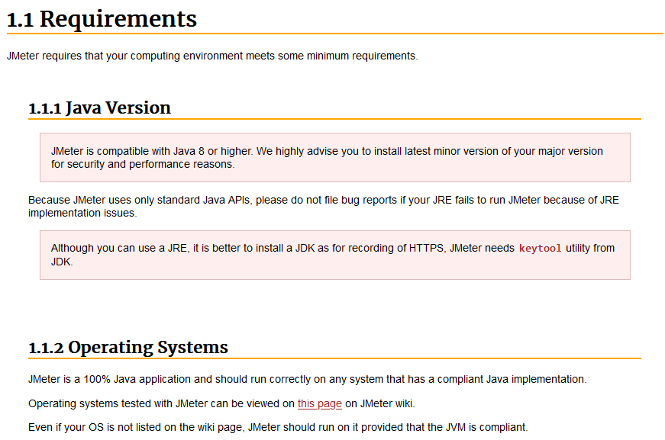

[Java Downloads for All Operating Systems](https://java.com/en/download/manual.jsp) : JMeter 5.5 requires Java 8+

***Is Java installed?*** Please check using Command Line e.g.

C:\Users\TestUser>java -version

and the results would be something like below.

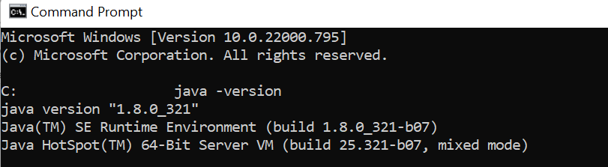

***JMeter 5.5 Download***- Windows and Mac:

<https://jmeter.apache.org/download_jmeter.cgi> > <https://dlcdn.apache.org//jmeter/binaries/apache-jmeter-5.5.zip>

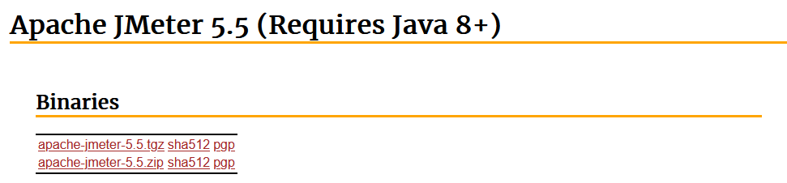

**Other Requirements** – Please refer to [this](https://octoperf.com/blog/2018/03/29/jmeter-tutorial/#system-requirements) but don’t worry if your machine configurations (on which JMeter is extracted) don’t exactly match the configurations as it is. This is a hands-on workshop covering simple load simulations.

***JMeter Running - Command Line Execution***

**Go to the *bin subdirectory* in the main directory where JMeter 5.5 is extracted and run the *jmeter.bat* file**

**C:\Users\TestUser\WQF2023\Apache_JMeter_5.5\bin\jmeter.bat**

*If everything goes well, you must see a screen like below showing JMeter GUI running. If not, please troubleshoot.

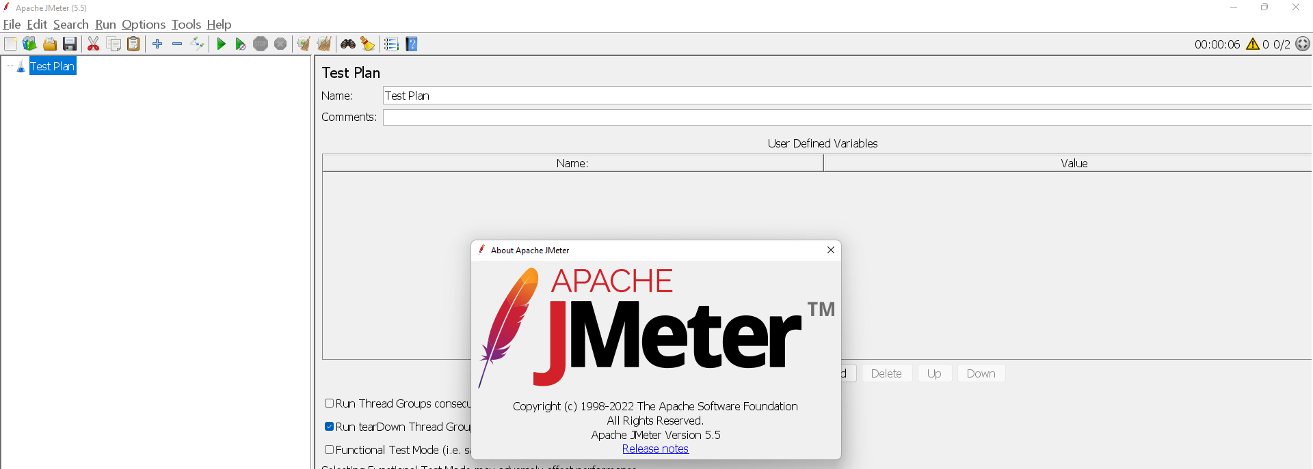

**Add** BlazeMeter Chrome Extension from [here](https://chrome.google.com/webstore/detail/blazemeter-the-continuous/mbopgmdnpcbohhpnfglgohlbhfongabi)  **[Optional]**

**Web Browsers:** Firefox [Preferred] and Chrome *[Most updated versions]*

**Postman:** <https://www.postman.com/downloads/> **[Optional]**

***Other supporting information for the session:***

1. Please have a running internet connection [15-20 MBPS to the least as it should be sufficient for a smooth communication].
2. Please be camera ready and test your microphones as well as this will be an interactive session.
3. The instructor will use a Windows 11 | 16 GB RAM, machine and **Apache** **JMeter 5.5** for the necessary hands-on for this workshop.