Worqference 2023

Systematically start Web Load Testing using Apache JMeter

**Instructor**: Sandeep Garg

Setting-Up Proxy

JMeter HTTP(S) Test Script Recorder ***Port***

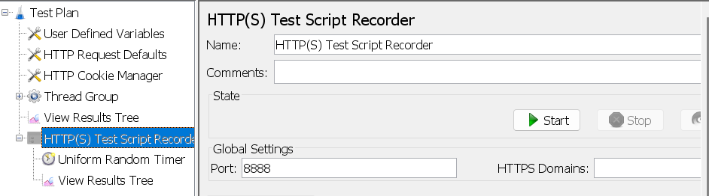

**First and foremost, find the IP Address of your machine using ipconfig command on the Command Prompt**

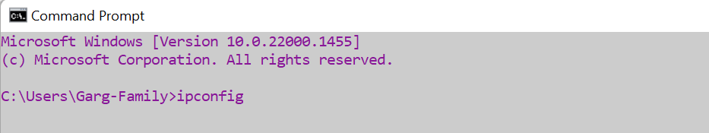

**Firefox:** Open browser and type ***about:preferences*** in the address bar.

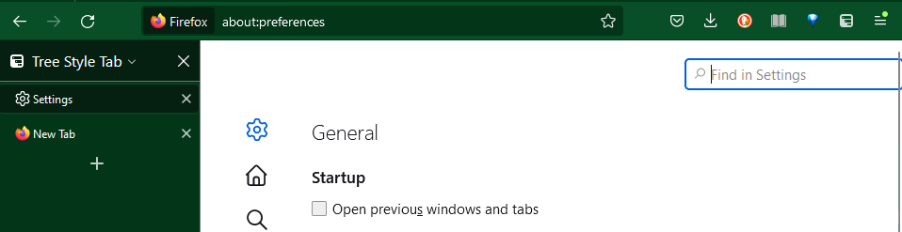

Type ***proxy*** in the ‘Find in Settings’ box

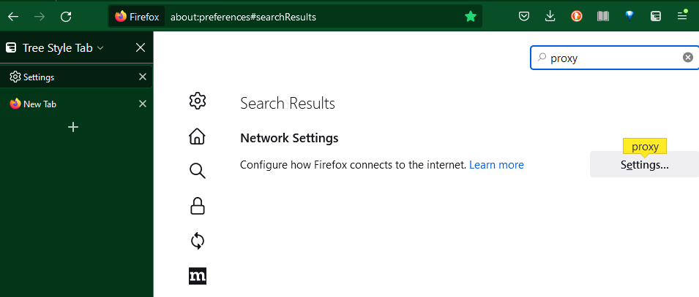

**Use the IP Address and port 8888 as shown below**

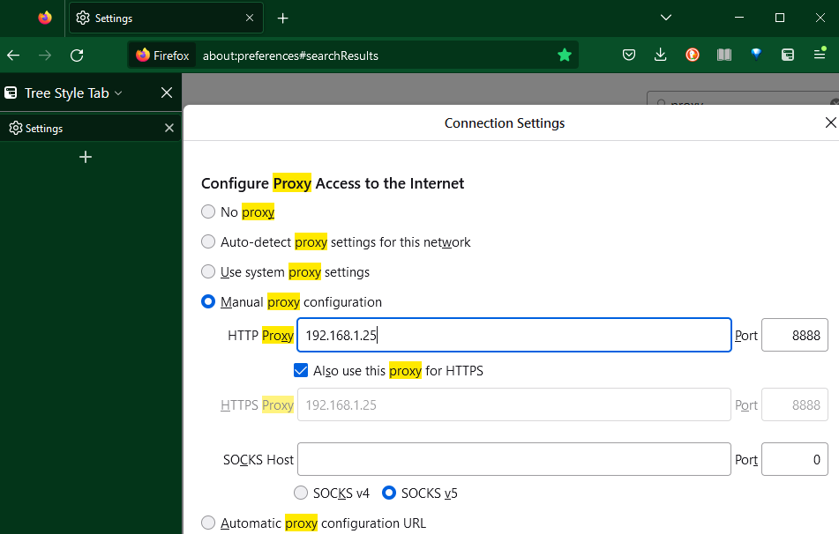

**Postman: Use the IP Address and port 8888 as shown below**

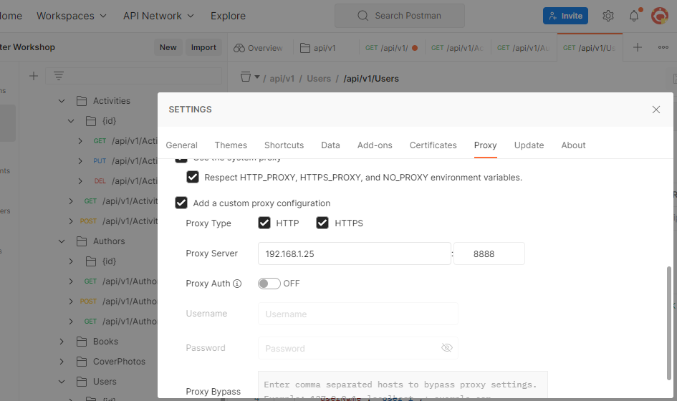

**Chrome**

: Open browser and type ***chrome://settings/system*** in the address bar

Then hit, *Open your computer’s proxy settings* **->** Manual proxy setup **->** Set up

