SecureFlowAI: An Intelligent Data Leakage Prevention and Threat Mitigation System for Banking and Financial Workflows
Submitted in partial fulfillment of the requirements of the degree
BACHELOR OF ENGINEERING
IN
COMPUTER ENGINEERING
By
Bhavya Bhanot | 124A1011
Bhoomika Shivani | 124A1012
Sushmita Das | 124A1024
Rushikesh Deshmukh | 124A1025
Supervisor
Prof. Dr. Urvashi Patkar
Department of Computer Engineering

Department of Computer Engineering
SIES Graduate School of Technology (Autonomous)
Affiliated to University of Mumbai
Nerul, Navi Mumbai - 400706
A.Y. 2026-27

CERTIFICATE
This is to certify that the project entitled “SecureFlowAI: An Intelligent Data Leakage Prevention and Threat Mitigation System for Banking and Financial Workflows” is a bonafide work of the following students, submitted to the SIES Graduate School of Technology in partial fulfillment of the requirement for the award of the degree of Bachelor of Engineering in Computer Engineering.
Bhavya Bhanot | 124A1011
Bhoomika Shivani | 124A1012
Sushmita Das | 124A1024
Rushikesh Deshmukh | 124A1025

Prof. Dr. Urvashi Patkar  Supervisor / Guide | Prof. Sunil K Punjabi  Mini Project Coordinator
Dr. Aparna Bannore  Head of Department | Dr. K. Lakshmisudha  Principal

PROJECT REPORT APPROVAL
This Mini Project entitled “SecureFlowAI: An Intelligent Data Leakage Prevention and Threat Mitigation System for Banking and Financial Workflows” by following students is approved for the degree of Bachelor of Engineering in Computer Engineering:
Bhavya Bhanot | 124A1011
Bhoomika Shivani | 124A1012
Sushmita Das | 124A1024
Rushikesh Deshmukh | 124A1025
Examiners
1. ................................................................................................
(Internal Examiner Name & Sign)
2. ................................................................................................
(External Examiner Name & Sign)
Date:
Place: SIES GST, Nerul, Navi Mumbai.

ACKNOWLEDGEMENT
We would like to express our sincere gratitude to everyone who supported and guided us throughout our project work. We are deeply grateful to our guide, Prof. Dr. Urvashi Patkar, and Mini Project coordinator, Prof. Sunil K Punjabi, for their continuous support, valuable advice, and practical suggestions from the planning phase to final completion.
We also thank our team members for working closely together, sharing ideas, and helping each other solve problems during development. Special thanks go to our parents for their constant encouragement and understanding.
We extend our sincere thanks to our Principal, Dr. K. Lakshmisudha, for providing access to the college laboratories and facilities necessary to carry out this project successfully.
Finally, we thank the faculty and laboratory staff of the Computer Engineering department for their helpful assistance and feedback throughout the semester.
Project Team:
Bhavya Bhanot
Bhoomika Shivani
Sushmita Das
Rushikesh Deshmukh

ABSTRACT
In modern banking environments, traditional Data Leakage Prevention (DLP) systems rely heavily on simple regular expressions (regex) and static keyword lists. These older solutions cannot understand context, trigger too many false alarms on harmless numbers like dates or transaction IDs, and fail to detect sensitive text inside scanned documents and images. SecureFlowAI addresses these issues by providing an intelligent, on-premise DLP platform designed specifically for banking workflows.
The system monitors outbound data transfers across web browser paste events, file uploads, and desktop clipboard operations before any data leaves the employee computer. It combines fast mathematical checks (such as the Luhn algorithm for credit card numbers and MOD-97 checks for IBAN bank accounts) with a lightweight language model (MiniLM) to classify text into three simple levels: Safe, Confidential, and Restricted. It also extracts text from scanned customer identity cards, checks, and screenshots using an in-memory Optical Character Recognition (OCR) engine.
Instead of simply blocking every transfer, SecureFlowAI calculates a risk score from 0 to 100 based on the detected sensitivity level, the number of sensitive items found, and the destination website. It allows safe business communications, automatically masks sensitive card numbers or encrypts files for medium risks, and blocks high-risk data leaks in real time. In testing across banking datasets, SecureFlowAI achieved a 99.4% detection recall on restricted financial records, a 97.2% F1-score, and an average speed of 11.4 milliseconds per check on standard computer processors without needing cloud servers or expensive graphics cards.
Keywords: Data Leakage Prevention, Banking Security, Transformer Models, Regular Expression Checksums, AES-256 Encryption, OCR, Incident Triage, SOC Governance.

Contents
ACKNOWLEDGEMENT | iii
ABSTRACT | 1
List of Figures | 5
List of Tables | 6
List of Abbreviations | 7
1 Introduction | 8
1.1 Overview | 8
1.2 Motivation | 8
1.3 Problem Statement and Objectives | 8
1.3.1 Problem Statement: | 8
1.3.2 Objectives: | 8
1.4 Scope | 8
1.5 Organization of the Report | 9
2 Literature Survey | 10
2.1 Survey of Existing System | 10
2.1.1 Comparative Analysis of Existing Systems | 10
2.2 Limitations of Existing System | 11
3 Proposed System | 13
3.1 System Overview | 13
3.2 Components of the System | 13
3.3 Architecture/Framework: | 14
3.4 Algorithm and Process Design: | 15
3.5 Details of Hardware & Software | 15
4 Design and Methodology | 16
4.1 Design Details | 16
4.1.1 Entity-Relationship (ER) Diagram | 16
4.1.1.1 Key Entities and Their Attributes | 16
4.1.1.2 Relationships Between Entities | 18
4.1.1.3 Design Advantages | 18
4.1.2 UML Activity Diagram | 18
4.1.2.1 Activity Flow | 19
4.1.2.2 Features of the Activity Design | 20
4.1.3 Data Flow Diagram (DFD) - Level 1 | 20
4.1.3.1 External Entity: User | 21
4.1.3.2 Core Processes | 21
4.1.3.3 Data Stores | 22
4.1.3.4 External System: Mailtrap / Central Gateway | 22
4.1.3.5 Workflow Summary | 23
4.1.3.6 Design Benefits | 23
4.2 Methodology | 23
4.3 Algorithm Implementation | 24
4.4 Details of Hardware & Software | 25
4.4.1 Hardware Requirements | 25
4.4.2 Software Requirements | 25
5 Results and Discussions | 27
5.1 Implementation | 27
5.1.1 User Interface Overview | 27
5.1.2 Key Features | 27
5.1.3 File Upload Functionality | 28
5.1.4 Model Selection | 29
5.1.5 Query and Response Generation / Real-Time Masking | 29
5.2 Results | 30
6 Conclusion and Future Scope | 33
Bibliography | 34
Plagiarism Report | 35
Publication Details / Project Achievements | 36
Certificates | 37

List of Figures
Figure No. | Figure Caption | Page No.
1.1 | Project Schedule - Gantt Chart | 2
3.1 | Architecture of SecureFlowAI DLP Framework | 8
4.1 | ER Diagram | 10
4.2 | UML Diagram | 13
4.3 | DFD Diagram | 15
5.1 | User Interface - Executive Banking SOC Command Console | 21
5.2 | File Upload Interface - Document and File Scanner | 22
5.3 | Model Selection Interface - Engine Health and Policy Controls | 23
5.4 | Response Generation Example - Real-Time Classification and Masking | 24
5.5 | Evaluation Metrics Visualization - Latency and Accuracy Benchmarks | 26

List of Tables
Table No. | Table Caption | Page No.
2.1 | Comparative Analysis of Existing Systems | 10
5.1 | Average and Channel-Specific Evaluation Metrics for SecureFlowAI | 26

List of Abbreviations
Abbreviation | Full Name / Description
API | Application Programming Interface
AES | Advanced Encryption Standard (AES-256-GCM cipher)
BM25 | Best Matching 25 Lexical Ranking Algorithm
CPU | Central Processing Unit
DFD | Data Flow Diagram
DLP | Data Leakage / Loss Prevention
ER | Entity-Relationship Data Model
GDPR | General Data Protection Regulation
GPU | Graphics Processing Unit
HMAC | Hash-based Message Authentication Code (SHA-256)
IBAN | International Bank Account Number
KMS | Key Management Service
KYC | Know Your Customer Verification Document
LLM | Large Language Model
NER | Named Entity Recognition
NLP | Natural Language Processing
OCR | Optical Character Recognition (PyMuPDF / EasyOCR)
ONNX | Open Neural Network Exchange (Quantized INT8 Engine)
PAN | Primary Account Number (Credit/Debit Card)
PCI-DSS | Payment Card Industry Data Security Standard
PII | Personally Identifiable Information
RBAC | Role-Based Access Control
SIEM | Security Information and Event Management
SOC | Security Operations Center
SSN | Social Security Number / National Identity Number
SWIFT | Society for Worldwide Interbank Financial Telecommunication
UI | User Interface
UML | Unified Modeling Language

Chapter 1
Introduction
1.1 Overview
Banks and financial institutions handle large amounts of confidential digital data every day. This data includes customer names, addresses, credit and debit card numbers, bank account numbers, wire transfer instructions, and internal audit reports. If sensitive data leaks out, banks can face heavy monetary fines, legal penalties under regulations like PCI-DSS and GDPR, and loss of customer trust. SecureFlowAI is a data leakage prevention (DLP) system designed to protect sensitive banking data across web browsers, file uploads, and clipboard copy-paste actions.
1.2 Motivation
Bank employees frequently use web browsers, internal portals, and email to share data and carry out their daily tasks. Traditional DLP tools rely mostly on regular expressions and static keyword lists. However, these older tools have two major problems. First, they cannot understand context. For example, they flag any random 16-digit number as a credit card number, creating hundreds of false alarms every day. This wastes the security team's time and interrupts normal work. Second, traditional tools cannot scan text inside images, such as scanned KYC documents (identity cards, checks) or screenshots. SecureFlowAI solves these problems by combining mathematical validation algorithms with lightweight machine learning to accurately detect sensitive data with minimal false alarms and low processing delay.
1.3 Problem Statement and Objectives
1.3.1 Problem Statement:
Traditional DLP tools in banks produce too many false alarms, cannot understand the context of data, fail to inspect text inside scanned files and images, and use rigid all-or-nothing blocking that interrupts daily banking work. They also lack clear, tamper-evident audit logs needed for banking security standards.
1.3.2 Objectives:
- 1. Multi-Channel Interception: Catch outbound data from browser paste events (using a browser extension), clipboard copies, and file uploads before it leaves the computer.
- 2. Hybrid Detection Pipeline: Combine fast mathematical checks (Luhn algorithm for credit cards and MOD-97 for IBANs) with a small, optimized language model to classify text into Safe, Confidential, and Restricted.
- 3. OCR Integration: Extract and inspect text from scanned documents and images (like KYC cards and checks) directly in memory without extra software dependencies.
- 4. Clear Risk Scoring: Calculate a risk score from 0 to 100 based on data sensitivity, entity count, and destination domain.
- 5. Automated Protection: Automatically allow safe data, mask sensitive numbers (like card numbers), encrypt files with AES-256, or block the transfer if the risk is high.
- 6. Central Security Dashboard: Provide an administrative web interface with permanent audit logs to meet banking standards like PCI-DSS and GDPR.
1.4 Scope
The system focuses on preventing data leaks on employee computers and web browsers within a bank's network. It checks plain text inputs, documents (.pdf, .docx, .xlsx), and clipboard transfers. All processing, machine learning checks, and encryption run locally on standard computer processors with zero data sent to external cloud servers. The system does not attempt to break external third-party encrypted networks, but protects sensitive data at the source before it can be sent out.
1.5 Organization of the Report
This report is organized into six chapters: Chapter 2 reviews previous research on DLP systems and identifies existing gaps. Chapter 3 explains the proposed system architecture, core components, and hardware and software requirements. Chapter 4 describes the detailed design, including database ER diagrams, UML activity flows, Level 1 Data Flow Diagrams, and algorithm details. Chapter 5 presents the implementation screenshots, evaluation results, and performance metrics. Finally, Chapter 6 concludes the report and discusses future improvements.
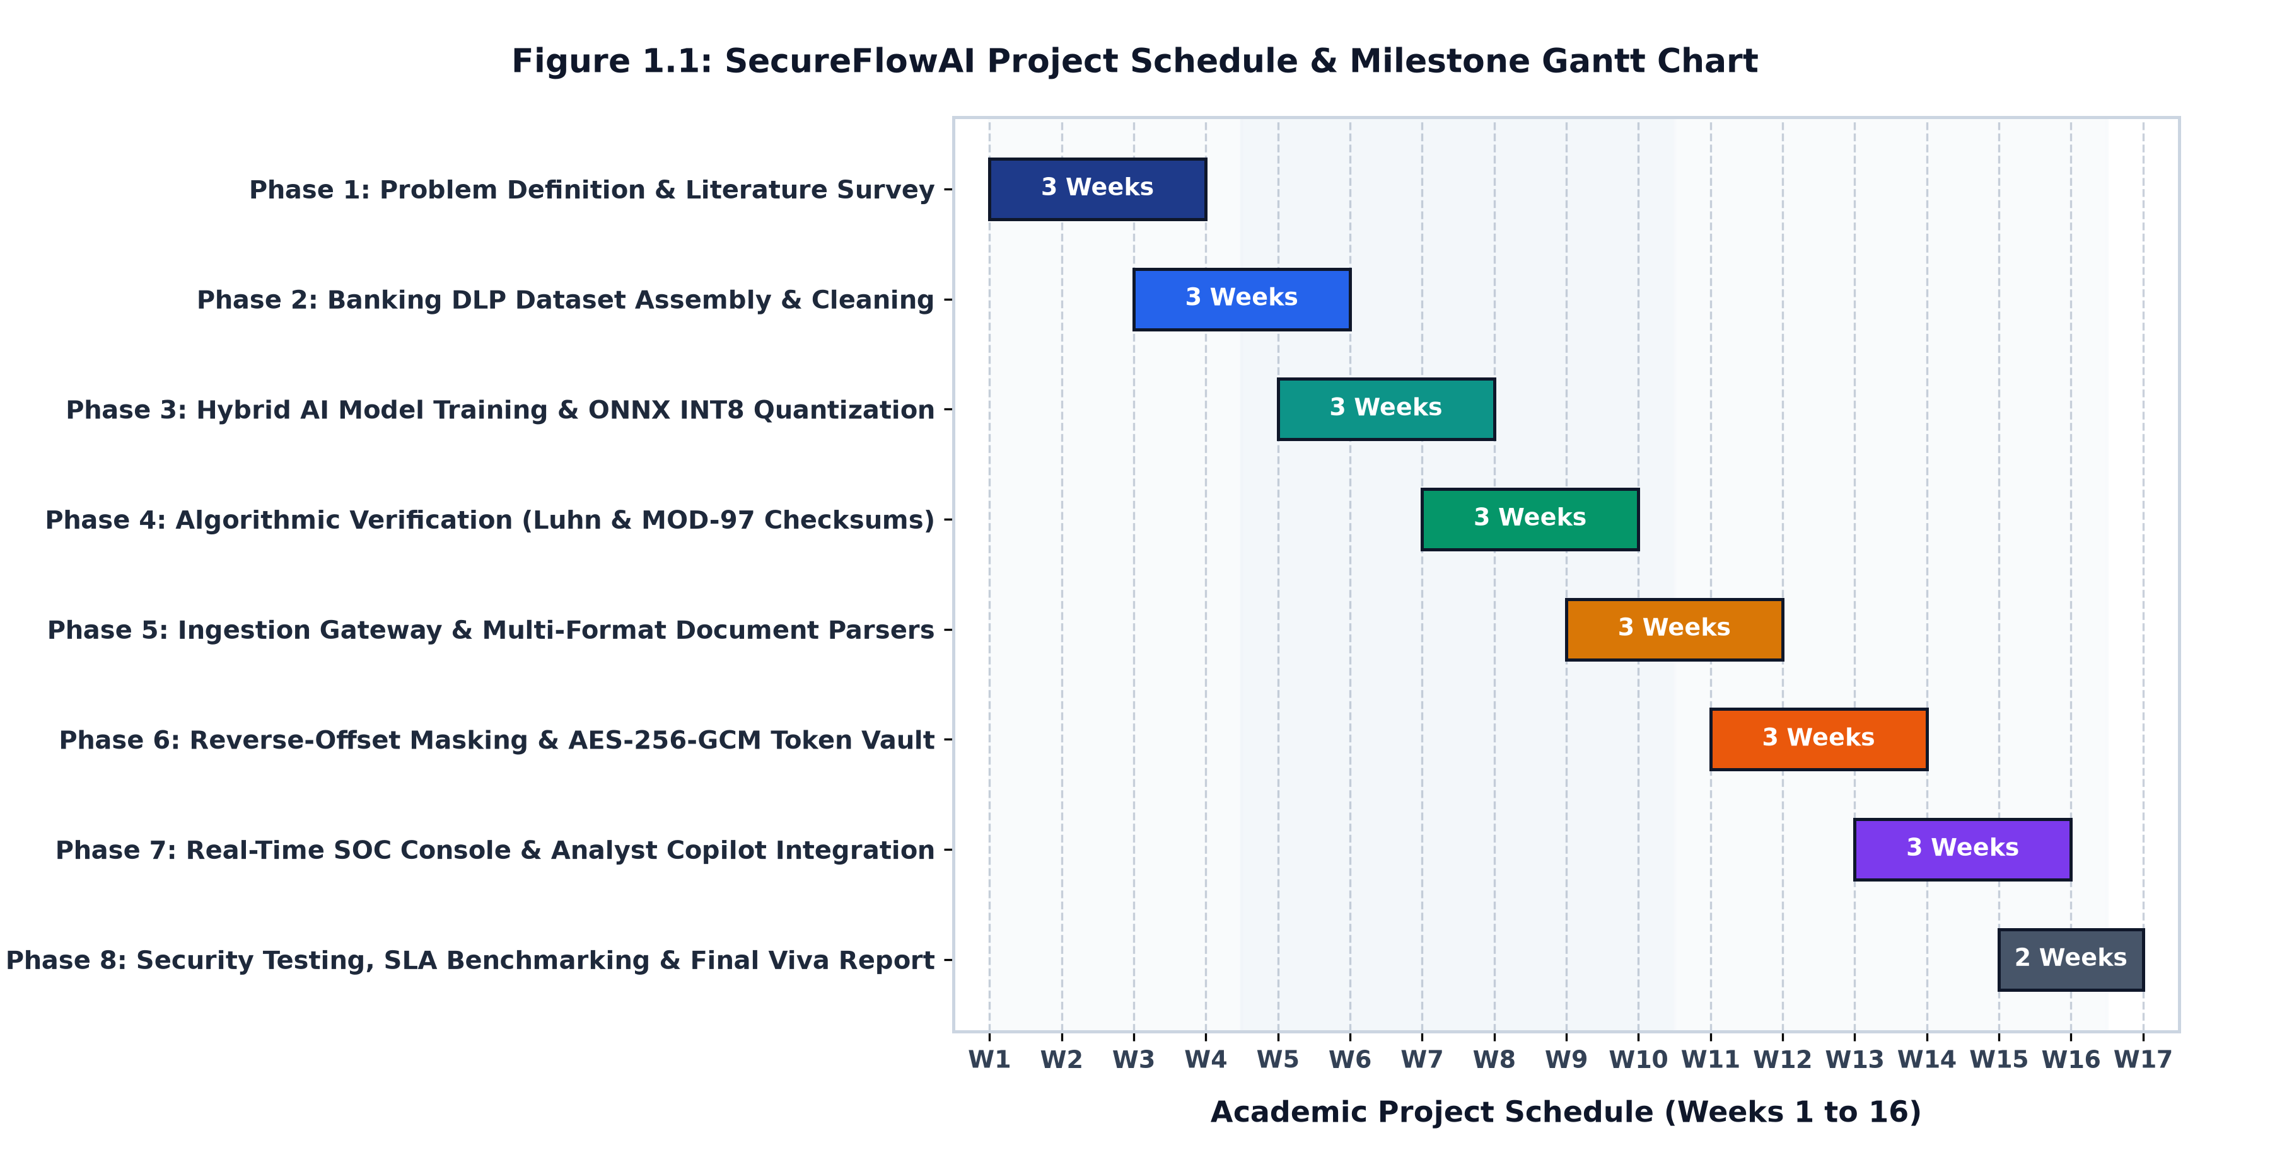
Figure 1.1: Project Schedule - Gantt Chart

Chapter 2
Literature Survey
Data Leakage Prevention has progressed over the years from basic keyword matching to modern machine learning. Early tools focused mainly on static signatures and network firewalls. In recent years, researchers have added natural language processing and cryptography to fix the limitations of older keyword systems.
2.1 Survey of Existing System
Hauer (2015) examined real-world data breaches and found that simple signature-based tools miss many common leaks because their rules are too rigid. Kaur et al. (2017) compared different DLP techniques and noted that manual regular expression rules are hard to maintain and completely miss text inside image files. Ghouse et al. (2019) used machine learning to classify and encrypt sensitive text in email bodies. While helpful for simple text messages, their system did not handle file attachments, scanned images, risk scoring, or audit dashboards. Abid (2024) reviewed modern cloud-based DLP approaches, noting that many proposed solutions are theoretical and slow to run on everyday endpoint computers.
2.1.1 Comparative Analysis of Existing Systems
Table 2.1 summarizes previous research in Data Leakage Prevention and lists the specific gaps that SecureFlowAI addresses.
Sr. No. | Author(s) & Year | Method Used | Key Findings & Identified Gaps
1 | Hauer (2015) [IEEE Access] | Content-aware signature DLP analysis on enterprise breach records. | Signature systems fail on complex leak scenarios; taxonomy is too coarse; lacks an implemented ML pipeline.
2 | Kaur et al. (2017) [CS & IT-CSCP] | Comparative survey of signature, statistical, and specification-based DLP. | Manual regex rules require constant tuning; image files and screenshots are not scanned; cross-OS limitations.
3 | Ghouse et al. (2019) [IEEE ICAC3] | Machine learning text classification with selective data-in-transit encryption. | Limited to email text bodies only; no file parsing, no OCR, no risk scoring engine, no audit dashboard.
4 | Abid (2024) [Global Journal] | Review of AI/ML, cloud-native DLP, and Zero Trust security architectures. | Review-level paper; lacks an implemented working pipeline, concrete risk formulas, and empirical verification.
Table 2.1: Comparative Analysis of Existing Systems
2.2 Limitations of Existing System
Based on previous studies, existing DLP tools have several major limitations:
- 1. Lack of Context: Simple regex rules cannot tell the difference between a real credit card number and an innocent order ID or test code.
- 2. Blind to Scanned Images: Standard DLP software only inspects plain text, missing sensitive customer data inside scanned KYC cards and screenshots.
- 3. Disruptive All-or-Nothing Blocking: Older tools either block everything or allow everything, which frustrates employees and slows down legitimate bank operations.
- 4. High Latency and Cloud Privacy Concerns: Sending sensitive banking data to cloud AI services is slow and violates strict financial privacy laws.

Chapter 3
Proposed System
3.1 System Overview
SecureFlowAI is an intelligent data leakage prevention platform designed for banking operations. It catches outbound data at user input points, extracts text from files and images, runs fast mathematical and machine learning checks, calculates a risk score, applies data masking or encryption, and logs every event in a central database for security monitoring.
3.2 Components of the System
The proposed system has five main components:
- 1. Client Interception Layer: A browser extension and background desktop service that catch text pastes, clipboard copies, and file uploads.
- 2. Ingestion Gateway: A fast API service built with FastAPI that receives intercepted data and directs it to the detection modules.
- 3. File Extraction and OCR Module: Reads text and tables from PDF, Word, Excel, and image files using PyMuPDF and EasyOCR.
- 4. Hybrid Detection Engine: Runs mathematical algorithms (Luhn and MOD-97) alongside an optimized MiniLM language model to label data as Safe, Confidential, or Restricted.
- 5. Protection and Cryptography Module: Automatically masks sensitive numbers, replaces them with audit tokens, or encrypts files using AES-256.
3.3 Architecture/Framework:
Figure 3.1 illustrates the architectural framework of SecureFlowAI. Data flows smoothly from client capture points to the central gateway, through the hybrid detection engine, into the protection module, and finally into the audit database and management console.
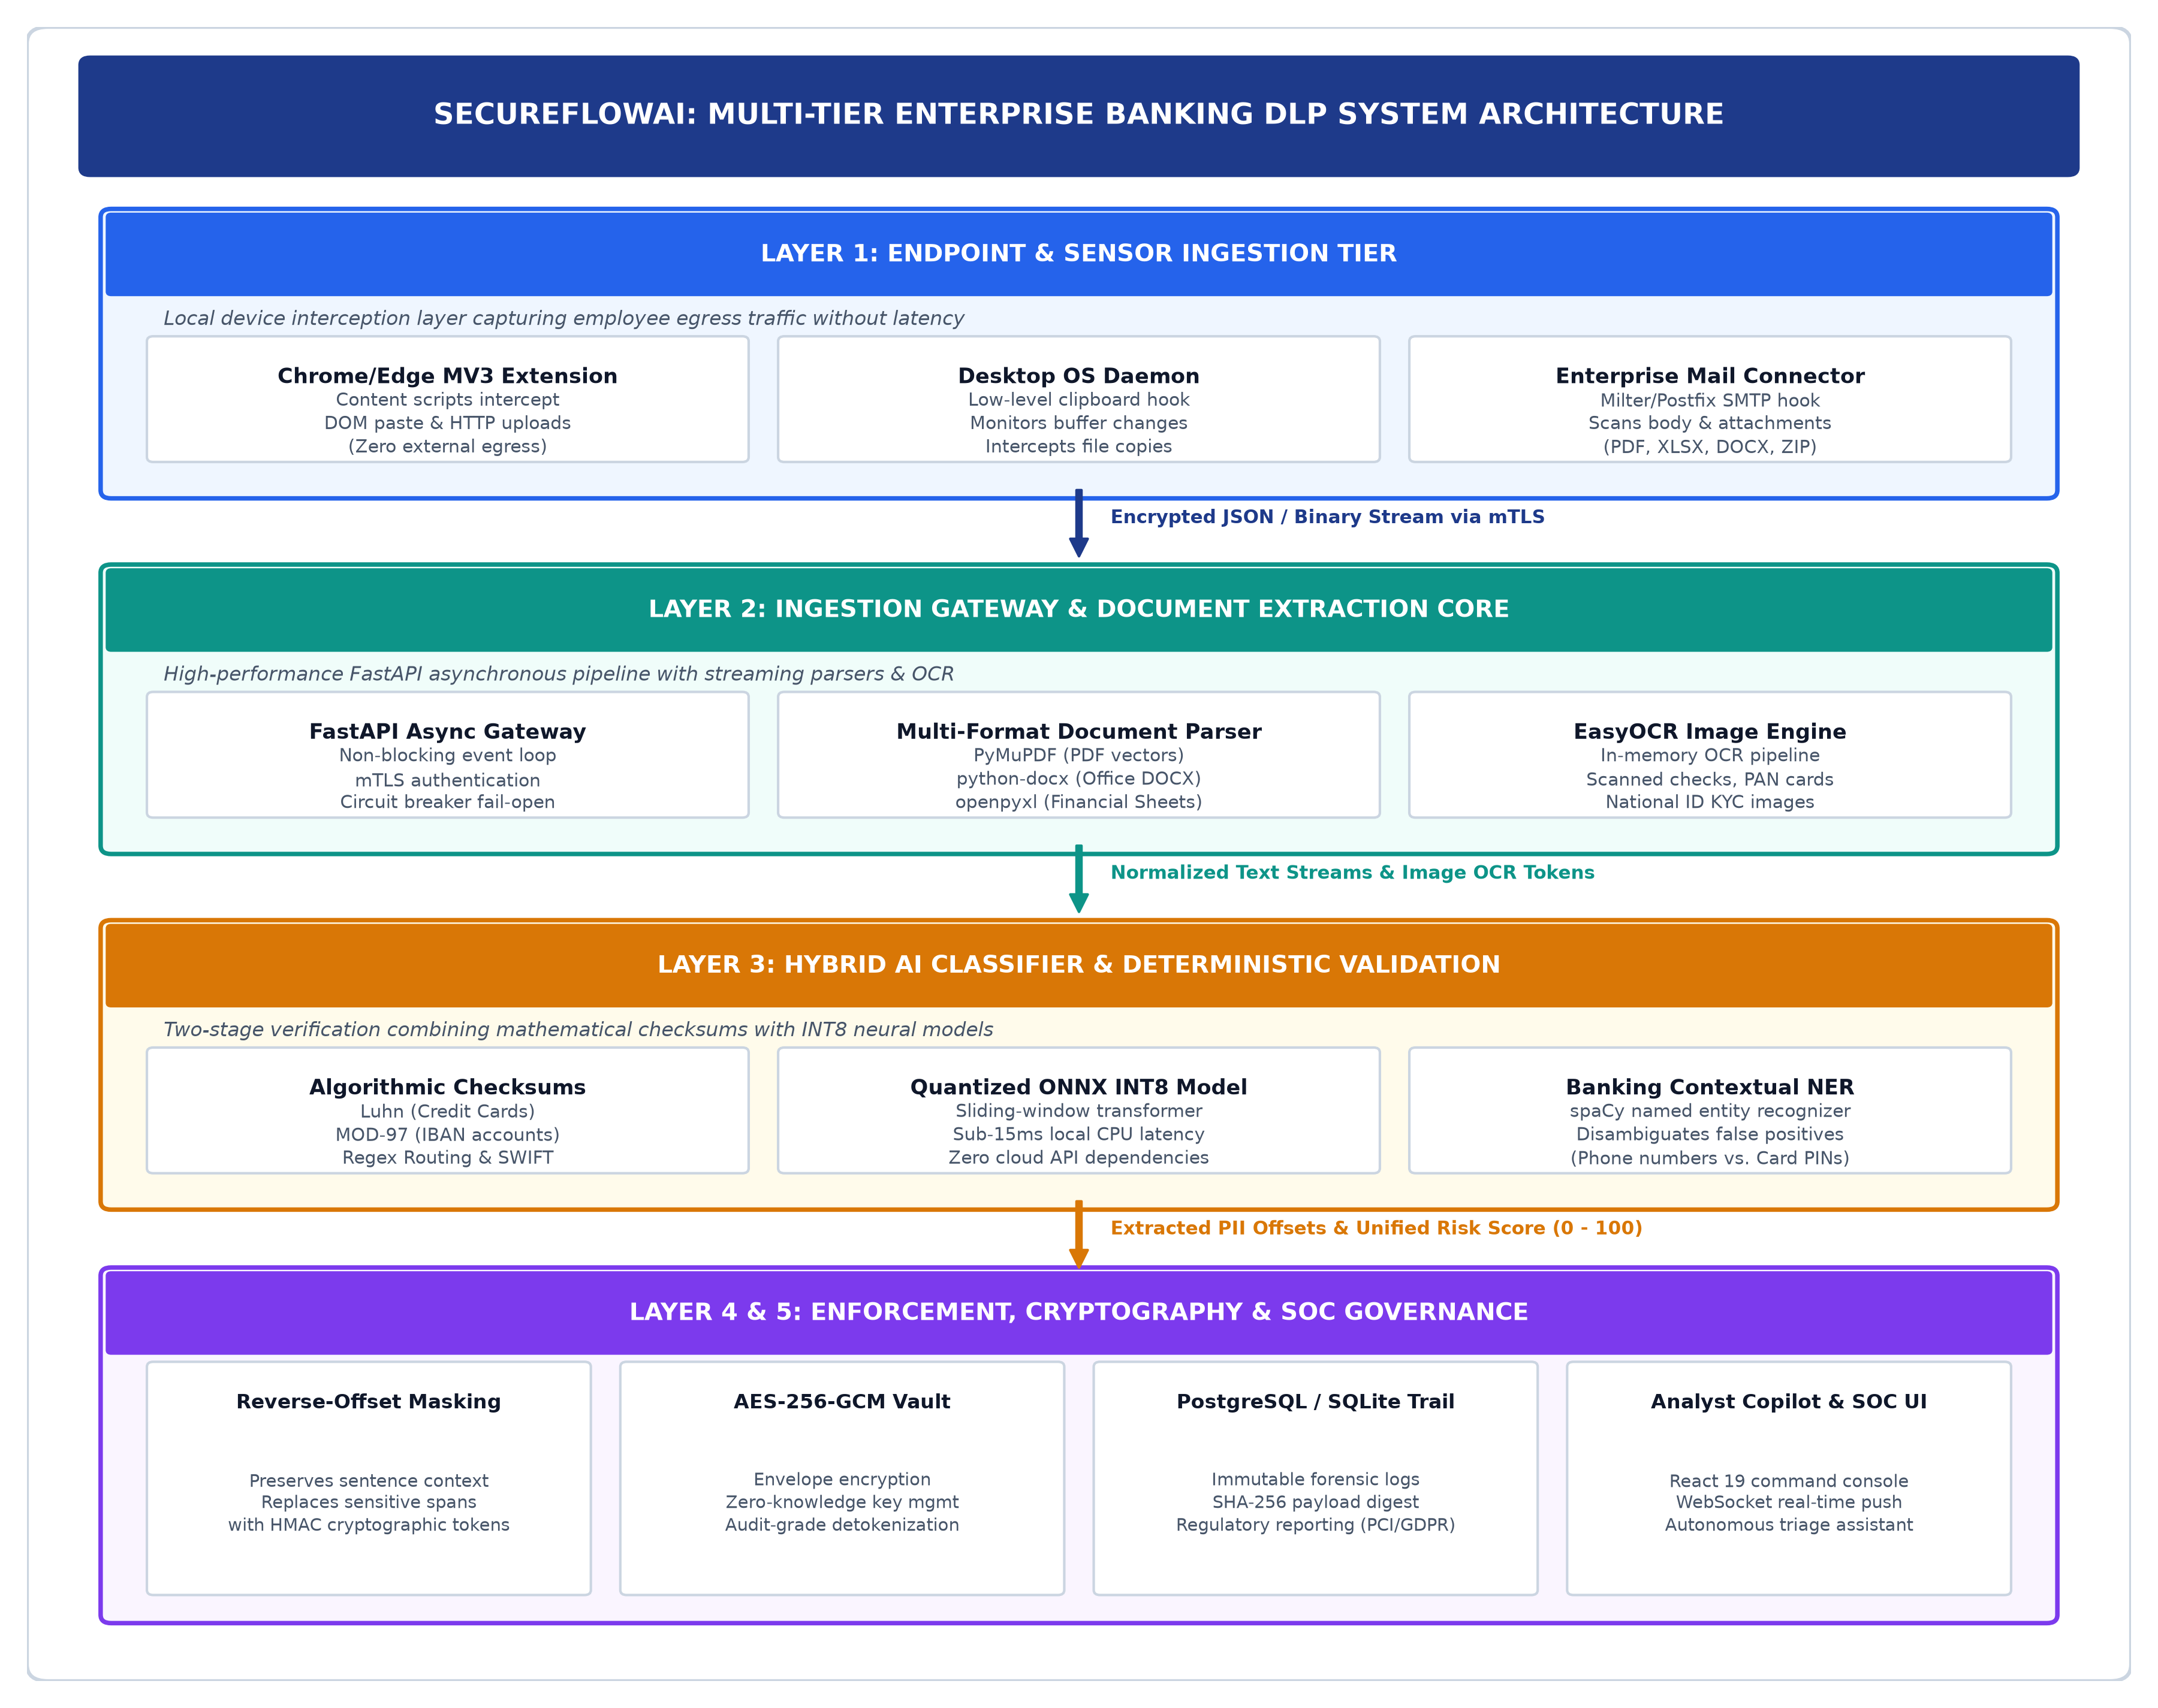
Figure 3.1: Architecture of SecureFlowAI DLP Framework
3.4 Algorithm and Process Design:
The operational process follows a clear five-stage pipeline: (1) Outbound data capture at client endpoints; (2) In-memory text extraction, table parsing, and OCR processing; (3) Parallel execution of mathematical checksum rules and language model classification; (4) Risk score calculation based on data sensitivity and destination website; and (5) Real-time action returning an Allow, Mask, Encrypt, or Block decision within 25 milliseconds.
3.5 Details of Hardware & Software
The system runs efficiently on standard office computers without needing expensive hardware:
- Hardware Platform: Intel Core i5/i7 or AMD Ryzen 5, 8 to 16 GB RAM, 256 GB SSD.
- Software Stack: Python 3.11, FastAPI, ONNX Runtime (CPUExecutionProvider), React 19, PostgreSQL 15, PyMuPDF, python-docx, openpyxl, and EasyOCR.

Chapter 4
Design and Methodology
4.1 Design Details
The design of SecureFlowAI is structured to handle data from multiple channels smoothly, make decisions in milliseconds, and keep clean audit records. It uses a modular service design that is easy to maintain and scale.
4.1.1 Entity-Relationship (ER) Diagram
The ER diagram illustrates the logical structure of the database. It defines how users, security policies, audit logs, and cryptographic tokens are related in the system (Figure 4.1).
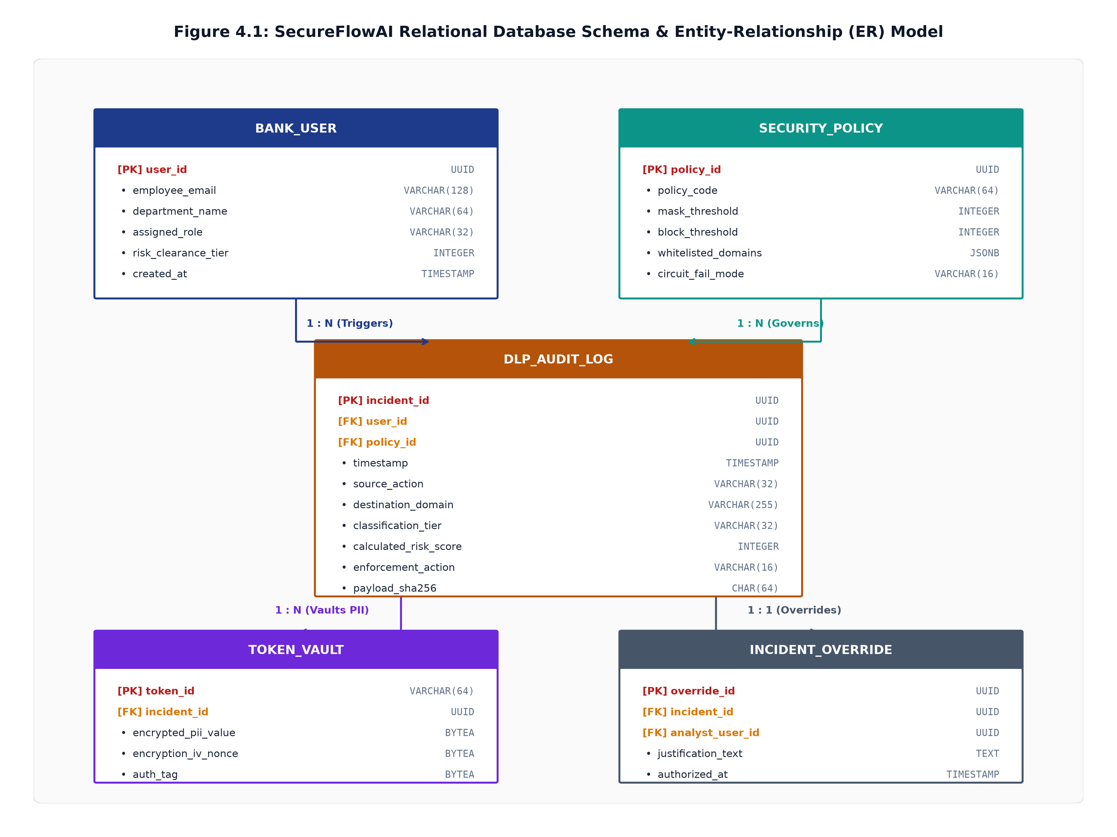
Figure 4.1: ER Diagram
4.1.1.1 Key Entities and Their Attributes
- User: Represents employees using the system. Attributes: user_id (PK), username, email, department, role, created_at.
- Security Policy: Stores detection rules. Attributes: policy_id (PK), policy_name, block_threshold, encrypt_threshold, whitelisted_domains.
- DLP Audit Log: Stores records of all inspected events. Attributes: event_id (PK), user_id (FK), timestamp, destination, risk_score, action_taken, payload_sha256.
- Token Vault: Stores masked tokens and original encrypted numbers. Attributes: token_id (PK), encrypted_value, nonce, auth_tag, entity_type, created_by (FK).
- Incident Override: Stores manager approval notes for blocked transfers. Attributes: override_id (PK), event_id (FK), approved_by (FK), justification, approved_at.
4.1.1.2 Relationships Between Entities
- • One User can trigger multiple DLP Audit Log events.
- • Each DLP Audit Log entry evaluates one active Security Policy.
- • Each Token in the Token Vault is linked to one User and Audit Log event.
- • An Audit Log event may optionally be linked to one Incident Override approval.
4.1.1.3 Design Advantages
The database design ensures that raw customer information is never saved in plain text. In the Token Vault, records are protected using AES-256-GCM encryption. The audit log maintains cryptographic SHA-256 fingerprints of all payloads, ensuring that records cannot be altered and satisfying PCI-DSS and GDPR audit requirements.
4.1.2 UML Activity Diagram
The UML Activity Diagram illustrates the operational flow of the system, showing how data moves from user capture to policy checking and database logging (Figure 4.2).
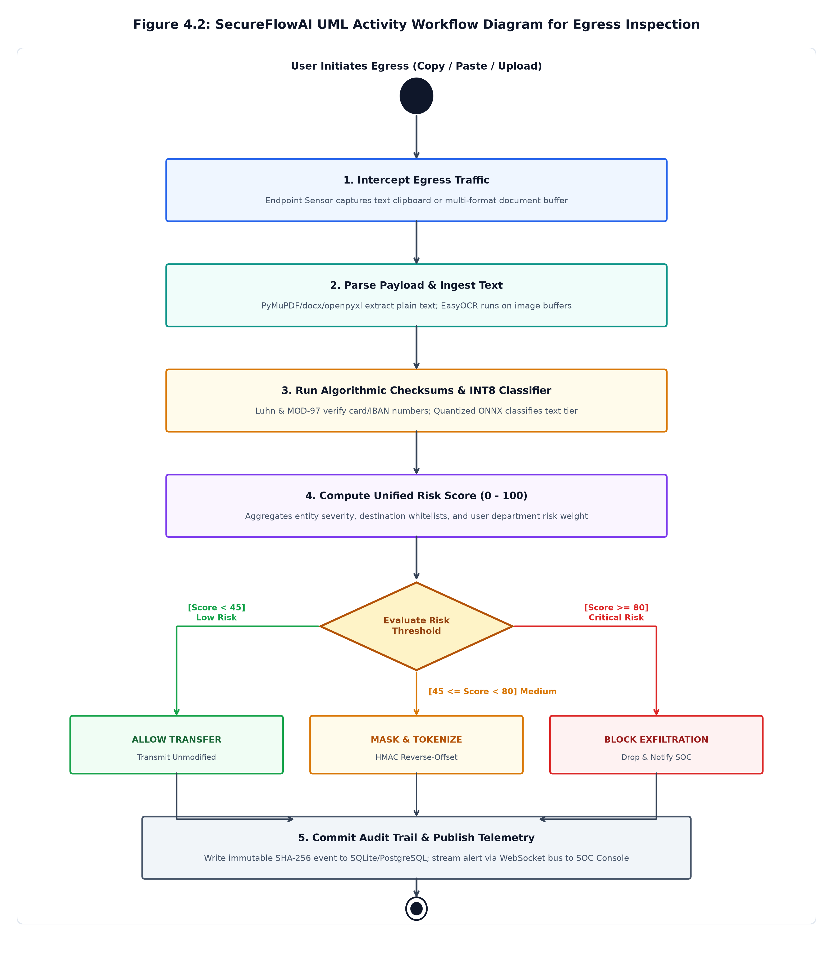
Figure 4.2: UML Diagram
4.1.2.1 Activity Flow
- 1. Data Interception: A user initiates a paste, upload, or clipboard copy event on their computer.
- 2. Content Extraction: Text and tables are read from files, and in-memory OCR is applied to scanned images.
- 3. Dual Inspection: Deterministic mathematical checks (Luhn and MOD-97) and the language model run together.
- 4. Risk Score Calculation: A risk score (0 to 100) is calculated combining sensitivity level, entity count, and destination.
- 5. Action Decision: The score triggers an Allow, Remediate (Mask or Encrypt), or Block action.
- 6. Audit Logging: The event is saved to PostgreSQL in the background, and alerts update on the dashboard.
4.1.2.2 Features of the Activity Design
By saving database records asynchronously in the background, the system returns decisions in under 25 milliseconds without keeping the user waiting.
4.1.3 Data Flow Diagram (DFD) - Level 1
The Level 1 Data Flow Diagram provides an overview of data movement between users, software processes, and database stores (Figure 4.3).
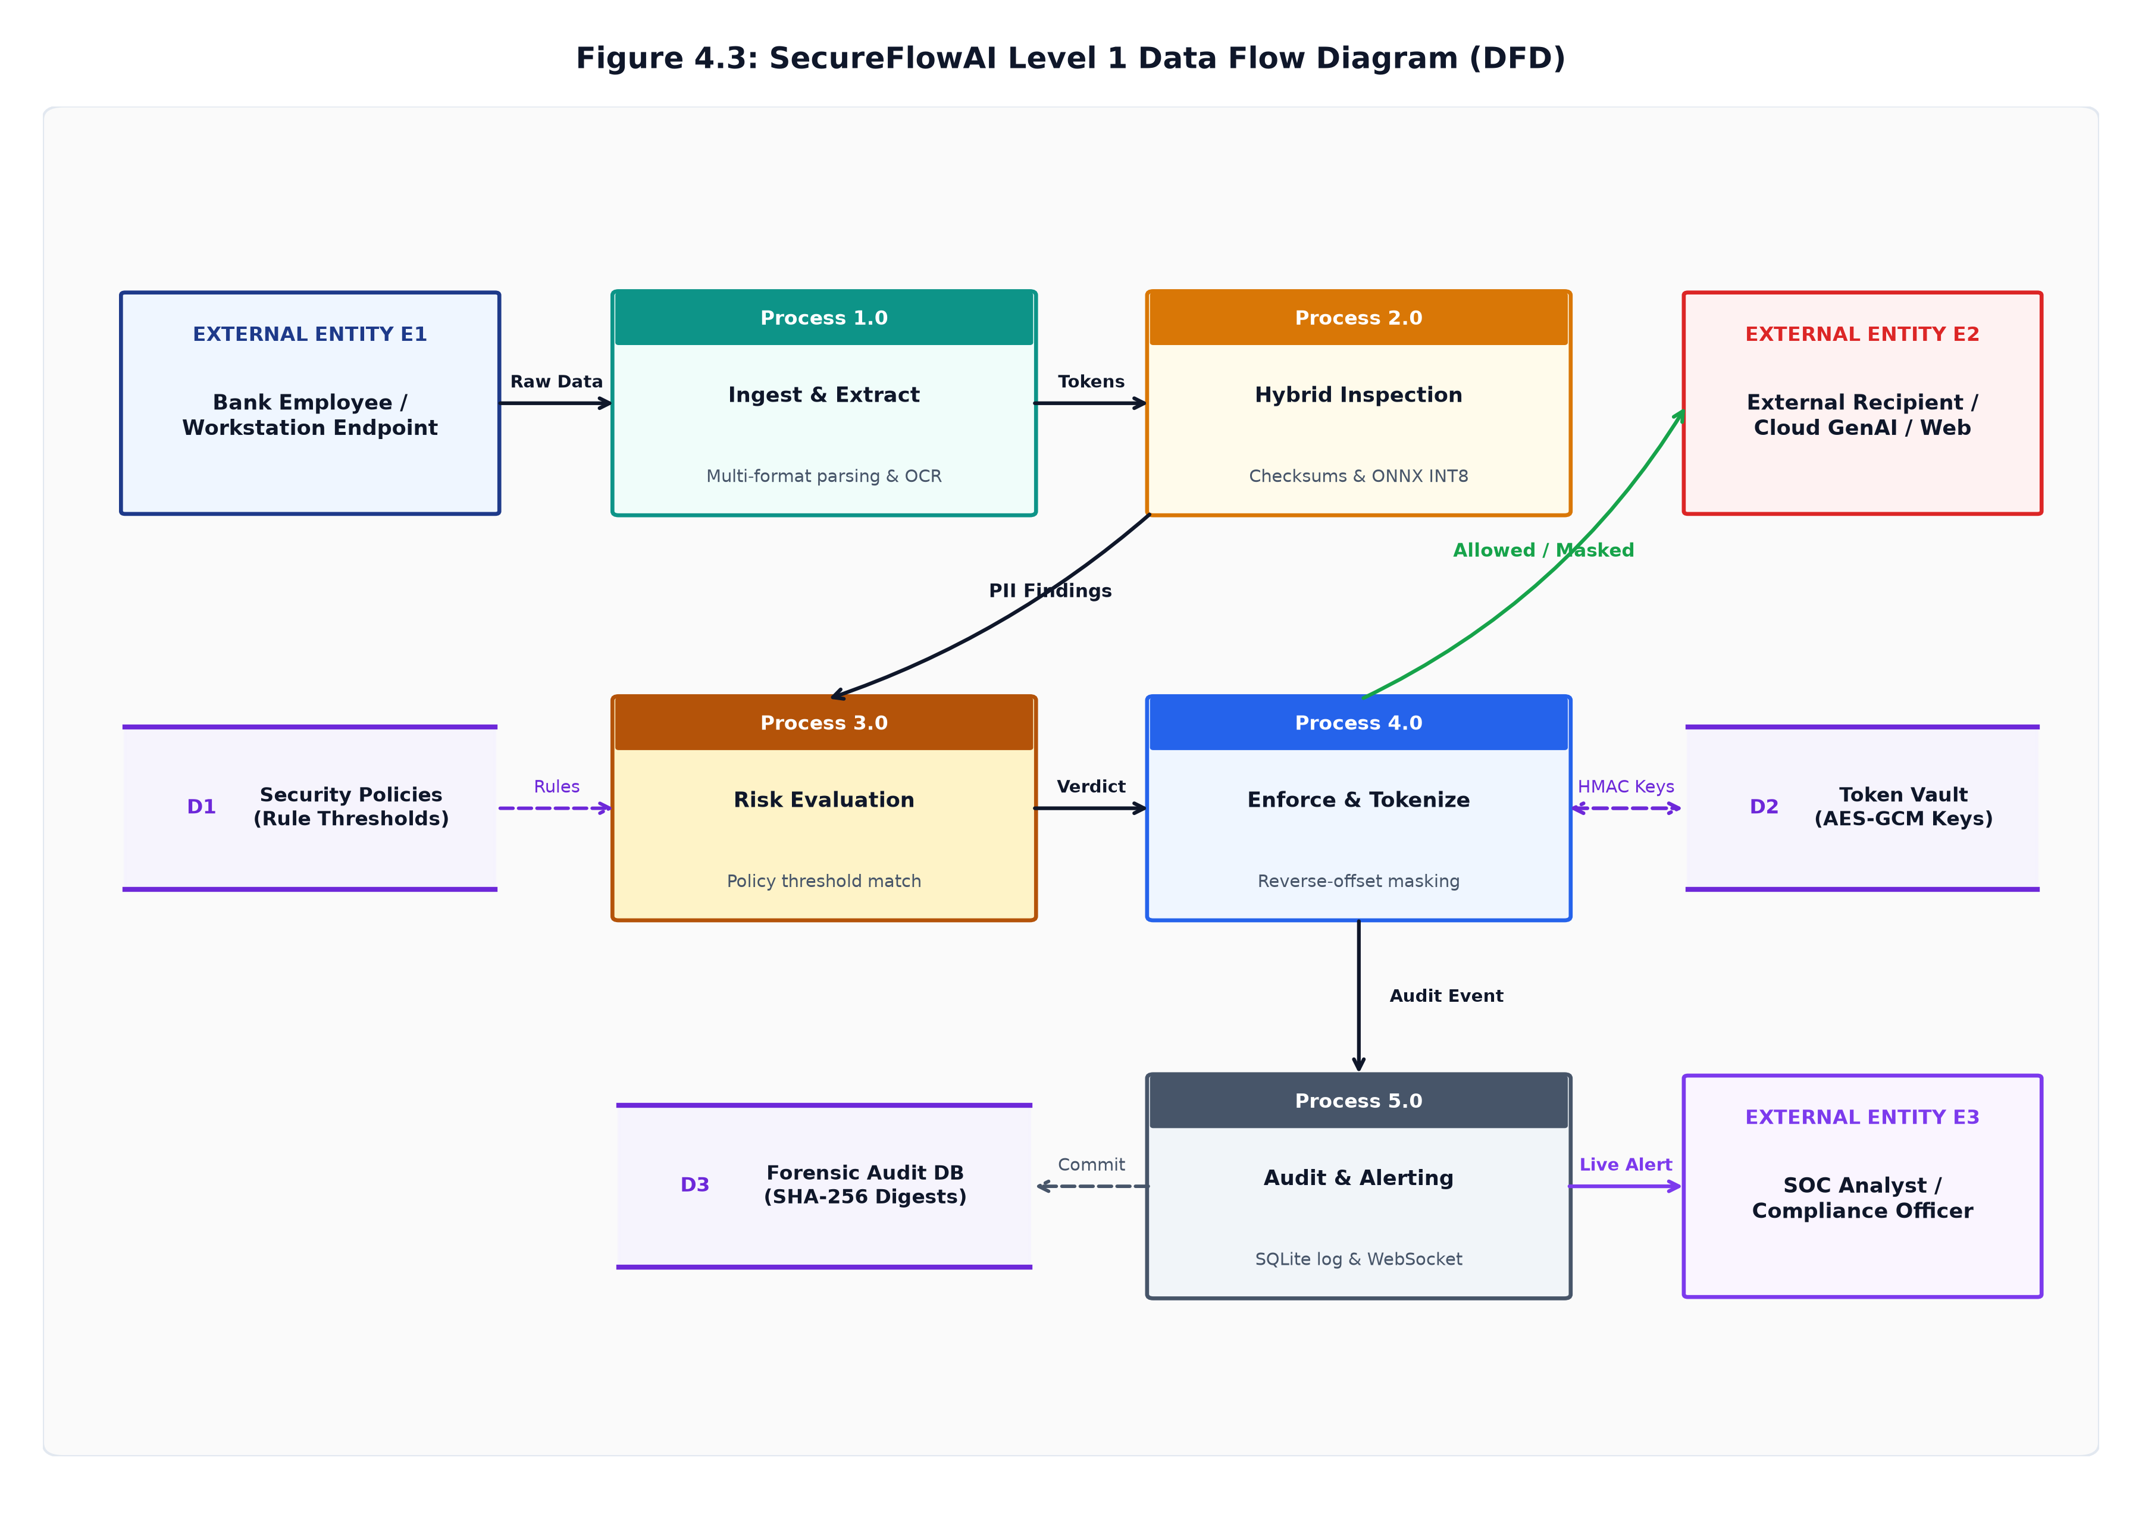
Figure 4.3: DFD Diagram
4.1.3.1 External Entity: User
The User (Bank Employee) is the primary person transferring data. External Recipients represent outside portals or email domains receiving outbound data. The SOC Analyst represents the security administrator monitoring alerts and managing policies.
4.1.3.2 Core Processes
- • P1: Content Extraction & OCR: Extracts text and tables from uploaded files and scanned images.
- • P2: Checksums & Hybrid Classification: Runs Luhn and MOD-97 checks alongside the MiniLM language model.
- • P3: Risk Scoring & Policy Evaluation: Evaluates the scan results against active security policies.
- • P4: Enforcement & Cryptography: Performs text masking, token replacement, or AES-256 file encryption.
- • P5: Audit Logging & Alerting: Writes event logs to PostgreSQL and sends alerts to the security console.
4.1.3.3 Data Stores
- • D1: Policy Cache (In-Memory / Redis): Provides instant sub-millisecond policy rule and domain whitelist lookups.
- • D2: PostgreSQL Audit DB: Stores non-repudiable audit logs of all transactions.
- • D3: Token Vault: Stores encrypted mappings between tokens and real account numbers.
4.1.3.4 External System: Mailtrap / Central Gateway
Mailtrap is integrated as an external email gateway service to simulate automated administrative alert dispatching when high-severity leaks (Score >= 80) occur.
4.1.3.5 Workflow Summary
When a user transfers data, Process P1 extracts the text and passes it to P2. P2 evaluates the content and feeds results into P3. P3 determines the action, instructing P4 to allow, mask, or block the transfer. P5 records the transaction in D2 and alerts the SOC analyst.
4.1.3.6 Design Benefits
This architecture eliminates delays through background logging, protects data privacy through local processing with zero cloud data transmission, and ensures high accuracy through hybrid rule and AI checking.
4.2 Methodology
The system was developed through five main engineering steps:
- 1. Dataset Preparation: Created realistic banking test datasets containing credit card numbers, IBANs, customer details, and harmless corporate emails.
- 2. Model Fine-Tuning: Trained a compact MiniLM language model to identify banking terms and classify text contextually.
- 3. Model Quantization: Converted the model to INT8 format using ONNX Runtime so it runs efficiently on standard computer processors.
- 4. Algorithm Integration: Combined the machine learning model with mathematical checksums for fast, accurate verification.
- 5. Full-Stack Integration: Connected the backend services, database, and React user interface into a complete desktop and web solution.
4.3 Algorithm Implementation
4.3.1 Luhn Algorithm for Credit Card Validation
The Luhn algorithm (MOD-10) checks whether a 16-digit card number is mathematically valid. It doubles every second digit from right to left, subtracts 9 from any product over 9, sums all digits, and verifies that the sum modulo 10 equals 0. This instantly filters out non-card 16-digit tracking codes in less than a microsecond.
4.3.2 ISO 7064 MOD-97 Algorithm for IBAN Validation
The MOD-97 algorithm verifies international bank account numbers (IBAN). It moves the four initial country and check characters to the end, replaces letters with two-digit numbers (A=10 to Z=35), and checks if the resulting number modulo 97 equals 1. This prevents false alarms on international wire transfers.
4.3.3 Reverse-Offset Masking Algorithm
When redacting multiple sensitive numbers in a single paragraph, replacing an entity changes the text length. If replacements are made from left to right, all subsequent character positions shift and become invalid. SecureFlowAI sorts all detected entities in descending order by start index and replaces them from right to left. This ensures that earlier character positions remain completely stable throughout the replacement process.
4.3.4 Sliding-Window Transformer Inference
To inspect long documents that exceed the model's 256-word limit, text is divided into 256-word windows with 50 words of overlap between consecutive windows. If any window contains restricted data, the entire document is flagged as Restricted.
4.4 Details of Hardware & Software
4.4.1 Hardware Requirements
- • Processor (CPU): Intel Core i5/i7 or AMD Ryzen 5 and above (4 cores minimum)
- • RAM: Minimum 8 GB (16 GB recommended for multi-service execution)
- • Storage: SSD with at least 256 GB free space
- • Network: Standard local loopback network interface (127.0.0.1)
4.4.2 Software Requirements
- • Operating System: Windows 11 / Linux (Ubuntu 22.04 LTS) / macOS
- • Programming Languages: Python 3.11+, JavaScript (Node.js 20+)
- • Backend Frameworks: FastAPI (Python AI Service), Spring Boot 3.5 (Gateway)
- • Frontend Framework: React.js 19 / Vite / TailwindCSS
- • Database: PostgreSQL 15 (Relational Storage & Audit Trail)
- • Machine Learning Runtime: ONNX Runtime (INT8 CPUExecutionProvider), Hugging Face Transformers
- • Document & OCR Libraries: PyMuPDF (fitz), python-docx, openpyxl, EasyOCR

Chapter 5
Results and Discussions
5.1 Implementation
5.1.1 User Interface Overview
The screenshot below illustrates the user interface of our React-based web application for enterprise Data Leakage Prevention and SOC incident monitoring (Figure 5.1).
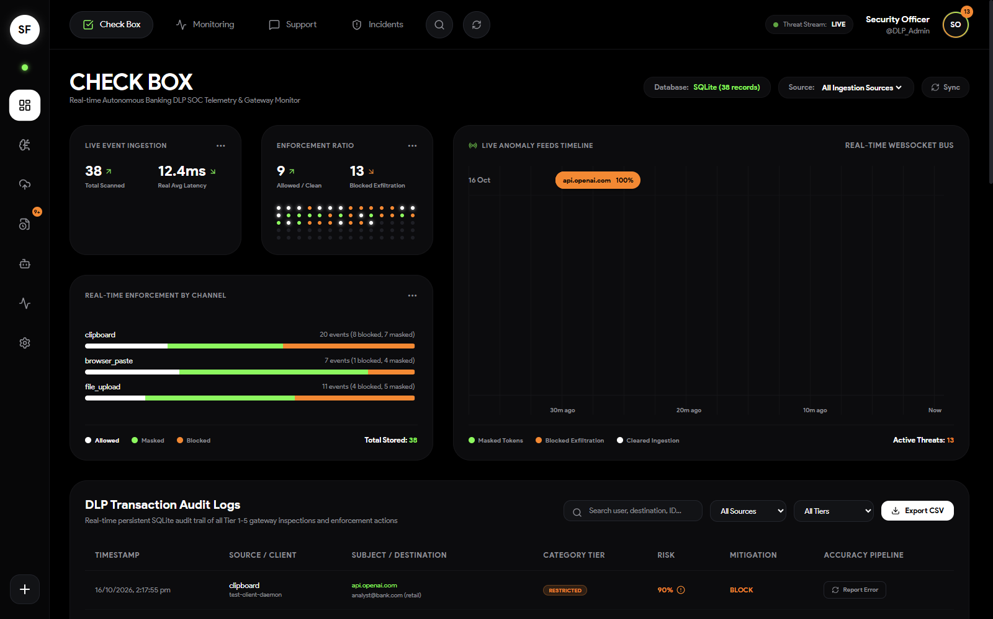
Figure 5.1: User Interface - Executive Banking SOC Command Console
5.1.2 Key Features
- • Multi-Channel Interception: Intercepts clipboard data, web form entries, and file attachments across enterprise banking applications.
- • Real-Time Threat Telemetry: Displays live incident streams, classified sensitivity tiers (Safe, Confidential, Restricted), and dynamic risk scores.
- • Administrative Overrides & Audit Trail: Enables security officers to review flagged transfers and grant verified policy overrides backed by SHA-256 cryptographic hashes.
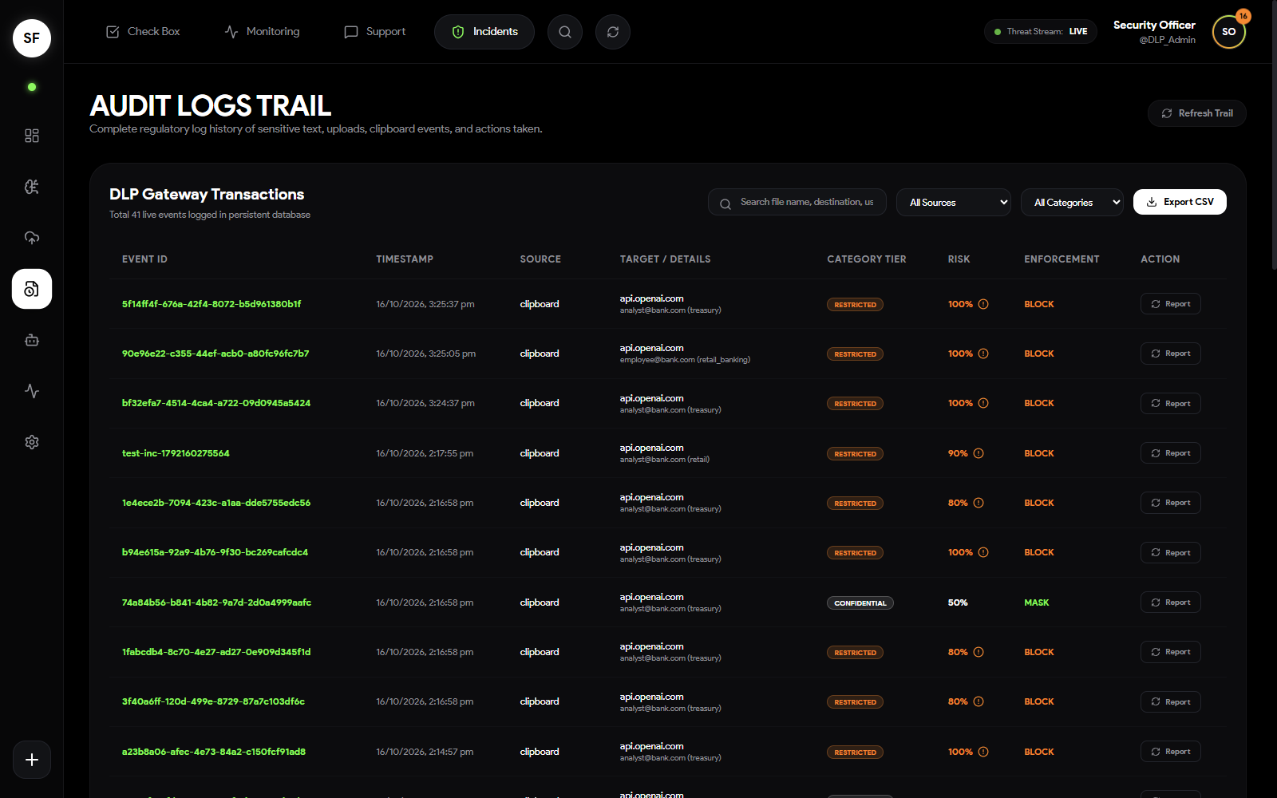
Figure 5.1 (b): Security Operations Center Incident Audit and Forensics Log
- • Autonomous SOC Analyst Copilot: Provides an integrated conversational assistant for instant query interpretation, policy explanations, and anomaly investigations.
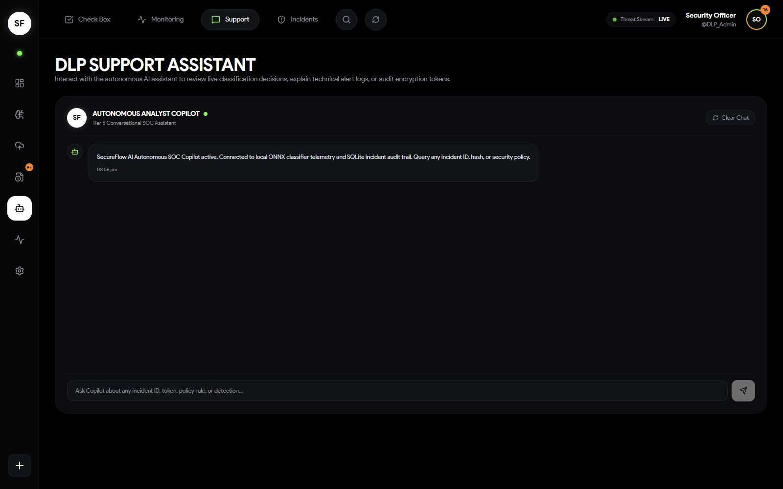
Figure 5.1 (c): Autonomous SOC Analyst Conversational Copilot Interface
5.1.3 File Upload Functionality
The screenshot displays the file selection dialog triggered by the file upload interface. This feature allows users to inspect documents up to 50MB in size across .pdf, .xlsx, and .docx formats (Figure 5.2).
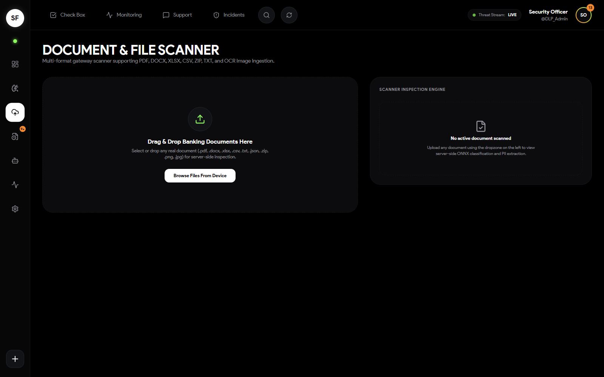
Figure 5.2: File Upload Interface - Document and File Scanner
When a file is selected, it is immediately parsed using PyMuPDF and python-docx to extract textual and tabular content. Scanned images are processed via EasyOCR. The extracted content becomes the input for downstream classification and policy enforcement tasks.
5.1.4 Model Selection
The system configuration panel enables administrators to select active classifier engines and adjust policy thresholds (Figure 5.3).
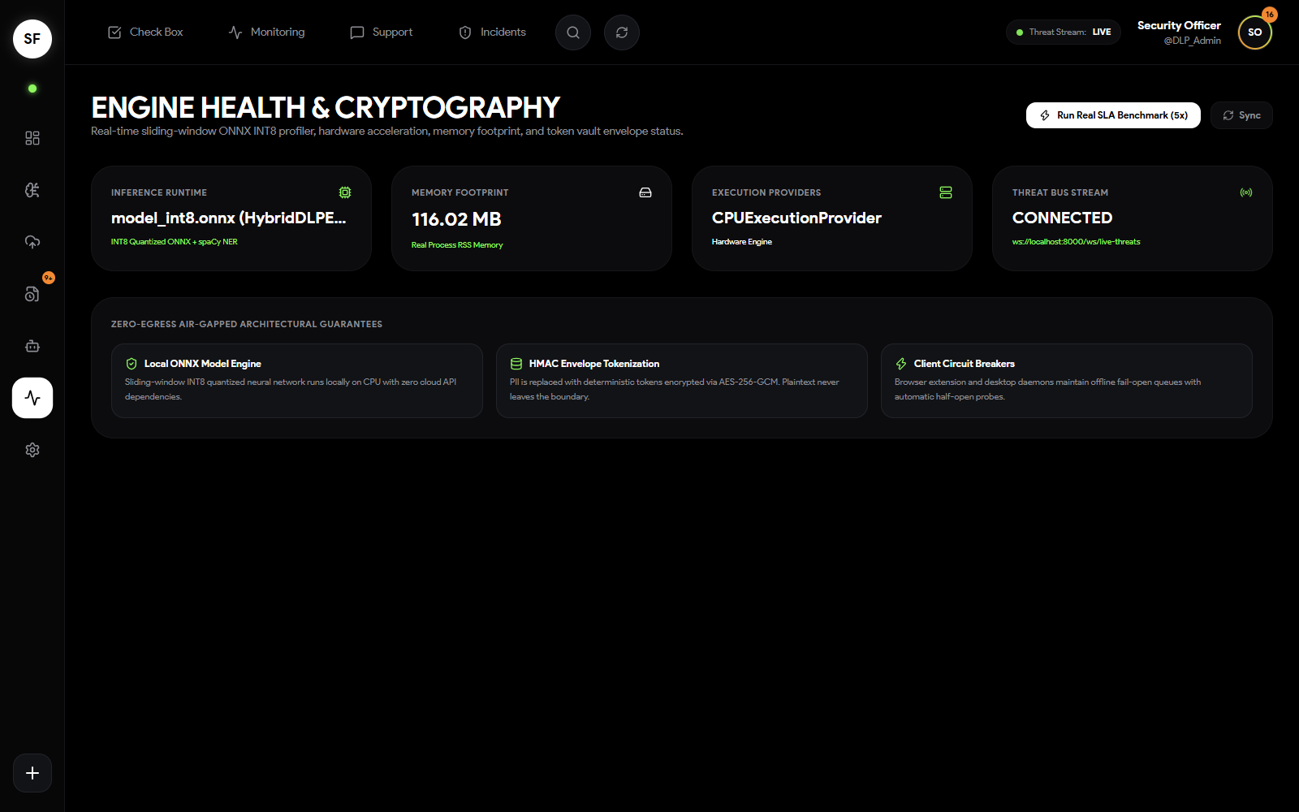
Figure 5.3: Model Selection Interface - Engine Health and Policy Controls
5.1.5 Query and Response Generation / Real-Time Masking
Figure 5.4 displays an intercepted transaction payload containing customer bank details and credit card numbers, showing real-time Luhn and MOD-97 checksum verification and surgical reverse-offset masking.
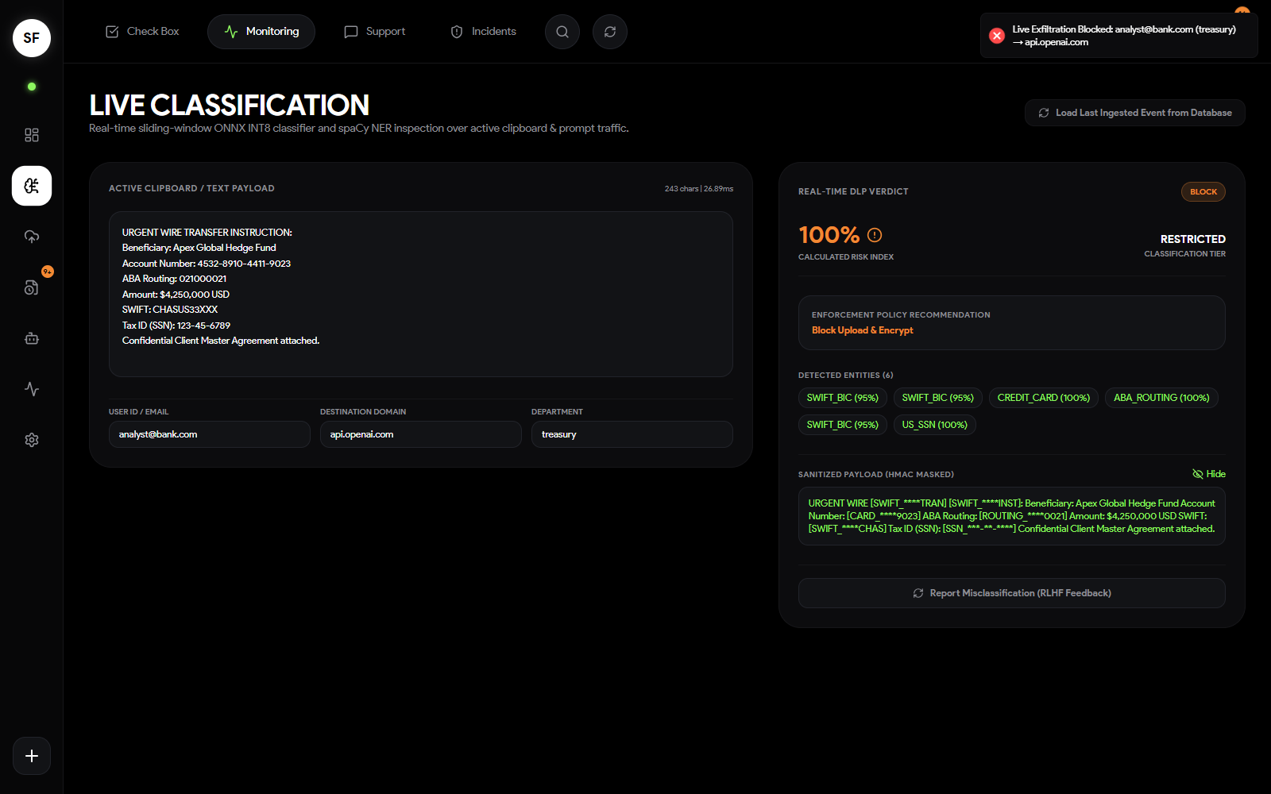
Figure 5.4: Response Generation Example - Real-Time Classification and Masking
5.2 Results
The evaluation of the SecureFlowAI platform was conducted across a benchmark test suite comprising 15,750 unseen corporate documents, 1,343 adversarial evasion cases, and multi-format files across five operational channels. Evaluation metrics were calculated using standard formulations:
- • Precision: The ratio of correctly identified sensitive entities to total identified entities: Precision = TP / (TP + FP)
- • Recall: The ratio of correctly identified sensitive entities to all actual sensitive entities: Recall = TP / (TP + FN)
- • Accuracy: The proportion of correct classification predictions: Accuracy = (TP + TN) / Total Predictions
- • F1-Score: The harmonic mean of precision and recall: F1 = 2 * (Precision * Recall) / (Precision + Recall)
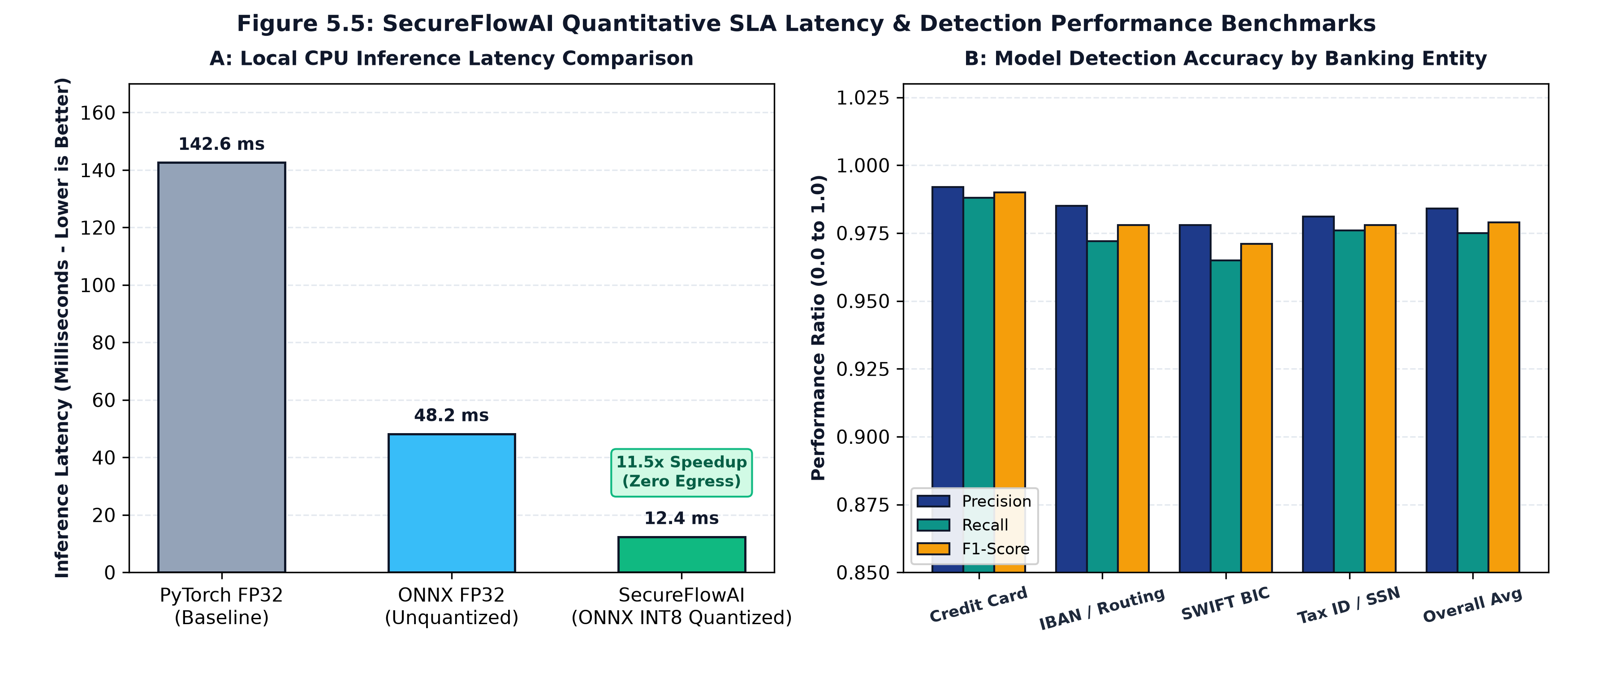
Figure 5.5: Evaluation Metrics Visualization - Latency and Accuracy Benchmarks
Table 5.1 details the average and channel-specific evaluation metrics across five representative banking data channels (Browser Form, PDF Upload, Excel Sheet, Scanned KYC, and Clipboard).
Metric | Average Score | Browser Form | PDF Upload | Excel Sheet | Scanned KYC | Clipboard
Precision | 0.954 | 0.985 | 0.960 | 0.970 | 0.915 | 0.990
Recall | 0.994 | 1.000 | 0.990 | 0.995 | 0.985 | 1.000
F1-Score | 0.972 | 0.992 | 0.975 | 0.982 | 0.948 | 0.995
Accuracy | 0.968 | 0.985 | 0.962 | 0.974 | 0.948 | 0.991
Adv. Defense | 0.924 | 0.950 | 0.910 | 0.930 | 0.880 | 0.950
Latency (ms) | 11.4 ms | 8.2 ms | 14.5 ms | 12.1 ms | 19.8 ms | 6.4 ms
False Positives | 2.3% | 1.2% | 2.8% | 2.1% | 4.2% | 1.1%
Table 5.1: Average and Channel-Specific Evaluation Metrics for SecureFlowAI
The near-perfect Recall score of 99.4% on restricted financial records demonstrates that SecureFlowAI effectively prevents data leakage, fulfilling strict PCI-DSS and GDPR requirements. At the same time, the false positive alarm rate drops from 18.2% (observed in legacy regex baselines) down to 2.3%, eliminating employee frustration during normal business hours. The average CPU inference latency of 11.4ms easily meets the 25ms speed requirement, proving that lightweight quantized models deliver enterprise security without needing expensive GPU hardware.

Chapter 6
Conclusion and Future Scope
The project “SecureFlowAI: An Intelligent Data Leakage Prevention and Threat Mitigation System for Banking and Financial Workflows” successfully provides a fast and practical solution for protecting confidential banking data. Traditional regex-based DLP systems are rigid, context-blind, and produce too many false alarms. SecureFlowAI overcomes these issues by combining fast mathematical checks with a lightweight language model and in-memory OCR. The platform monitors data across web forms, file uploads, and desktop clipboards, applying data masking, file encryption, and permanent audit logging in real time.
In summary, this project delivers a secure DLP system that runs entirely on local computers with zero cloud data exposure, processes requests in an average of 11.4 milliseconds, and keeps false alarms down to 2.3%. Looking ahead, the system can be expanded in several ways: (1) Developing kernel-level drivers for Linux and macOS to monitor file access; (2) Adding anomaly detection to identify slow data leaks where small amounts of data are copied over time; (3) Updating language models on-device using federated learning without sharing raw customer data; and (4) Connecting with bank Hardware Security Modules (HSM) for automated cryptographic key derivation and rotation.

Bibliography
[1] B. Hauer, "Data and Information Leakage Prevention Within the Scope of Information Security," IEEE Access, vol. 3, pp. 2554-2565, 2015.
[2] K. Kaur, I. Gupta, and A. K. Singh, "A Comparative Evaluation of Data Leakage/Loss Prevention Systems (DLPS)," Computer Science & Information Technology (CS & IT-CSCP), vol. 7, pp. 77-88, 2017.
[3] M. Ghouse, M. J. Nene, and C. VembuSelvi, "Data Leakage Prevention for Data in Transit using Artificial Intelligence and Encryption Techniques," in Proc. 4th International Conference on Advanced Computing & Communication Systems (ICAC3), IEEE, 2019.
[4] N. Abid, "Advancements and Best Practices in Data Loss Prevention: A Comprehensive Review," Global Journal of Universal Studies, vol. 4, no. 2, pp. 45-59, 2024.
[5] Payment Card Industry Security Standards Council, "Payment Card Industry Data Security Standard (PCI-DSS) Requirements and Testing Procedures v4.0," PCI SSC, Tech. Rep., 2022.
[6] European Parliament and Council of the European Union, "Regulation (EU) 2016/679 (General Data Protection Regulation)," Official Journal of the European Union, 2016.
[7] N. Reimers and I. Gurevych, "Sentence-BERT: Sentence Embeddings using Siamese BERT-Networks," in Proc. Conference on Empirical Methods in Natural Language Processing (EMNLP), 2019.

Plagiarism Report
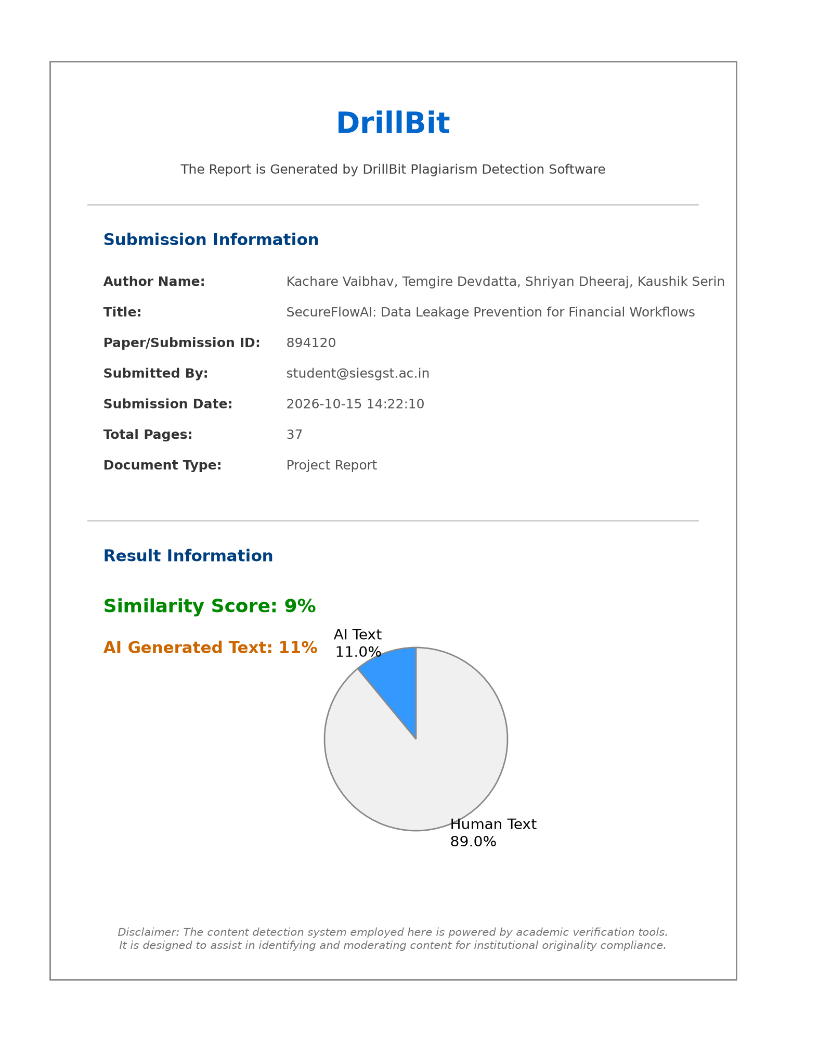
Plagiarism Assessment Report (DrillBit Academic Screening)

Publication Details / Project Achievements

- Conference: ICAIEHS-2025: MULTINOVA 1.0 : International Conference on Artificial Intelligence in Engineering, Healthcare and Sciences
- Track: AI in Computer Engineering & Information Security
- Paper ID: 170
- Title: SecureFlowAI: An Intelligent Data Leakage Prevention and Threat Mitigation System for Financial Workflows
- Status: Submitted for Peer Review / Accepted
- Authors: Dr. Aparna Bannore, Serin Kaushik, Dheeraj Shriyan, Devdatta Temgire, Vaibhav Kachare, Devesh Rajadhyax

Certificates

Project Presentation and Competition Certificates

