* Chapter 3(Hoffer, Ramesh, & Topi)
  + Problems and Exercises 1,2,12

**Solutions to Problems and Exercises**

1. An example listing follows for a GRADUATE STUDENT:

|  |  |
| --- | --- |
| Attribute Name | Data Value |
| SSN | 736-94-1802 |
| Name | Jessica James |
| Address | 25 Lake Dr. Medford OR 95106 |
| Gender | female |
| Date_of_Birth | Oct. 23, 1967 |
| Major_Dept | Computer Science |
| Test_Score | 986 |

2.

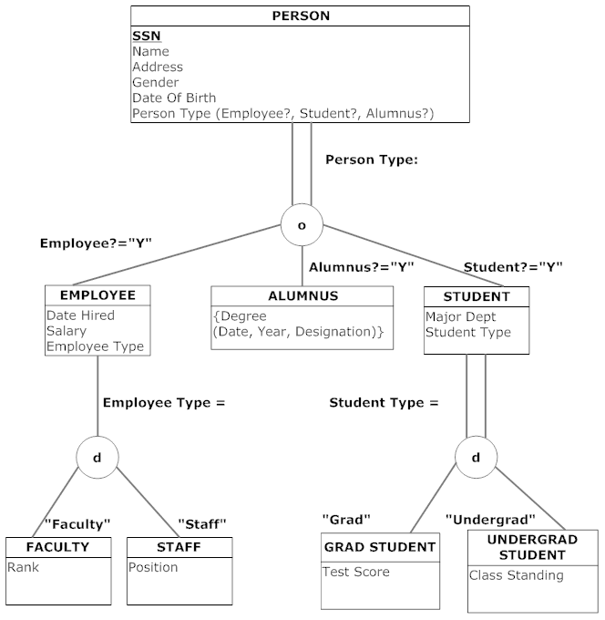

12. Please note that the problem does not explicitly state that Skill is a multivalued attribute. Given the fact that examples in the text have skill as a multivalued attribute, we have made this assumption here also.

EER Notation:

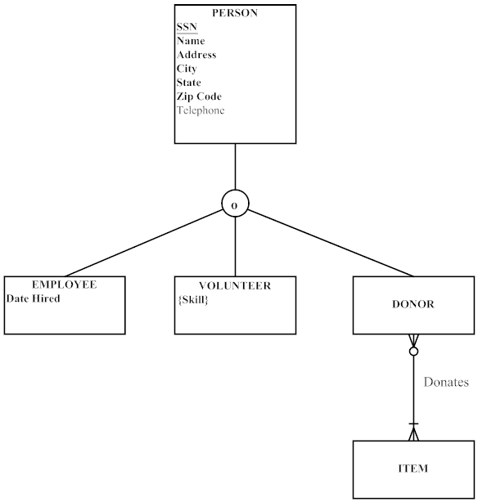

12) Visio Notation:

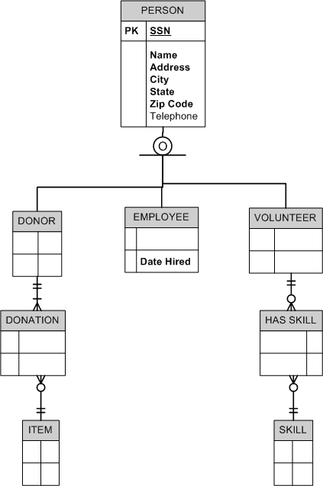

12) Subtypes inside Supertypes Notation

