* Chapter 4(Hoffer, Ramesh, & Topi)
  + Problems and Exercises 2,6,9

1. Transforming EER diagrams to relations:

a. Relations from Figure 3-6b

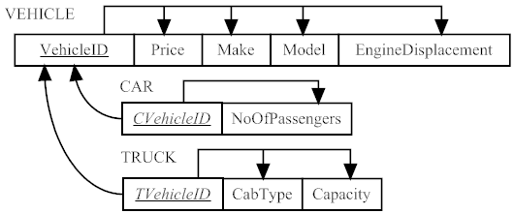

b. Relations from Figure 3-7a

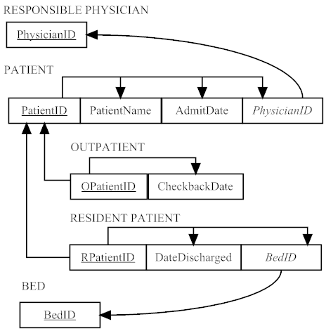

c. Relations from Figure 3-9

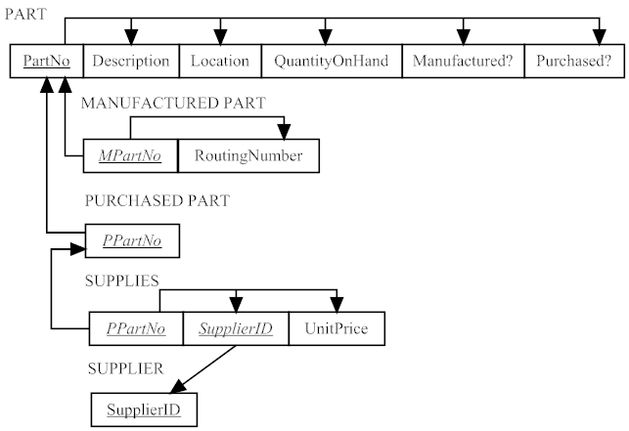

d. Relations from Figure 3-10

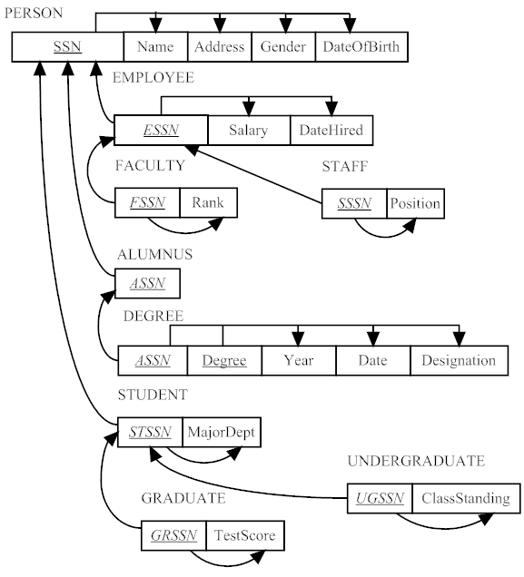

e. Relations from Figure 3-12, solution shown on next page.

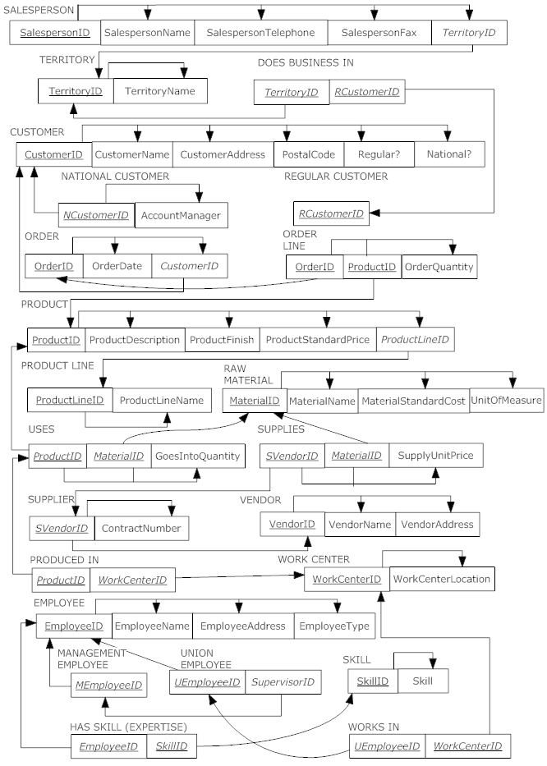6. Transforming an E-R diagram to relations (parts a and b)

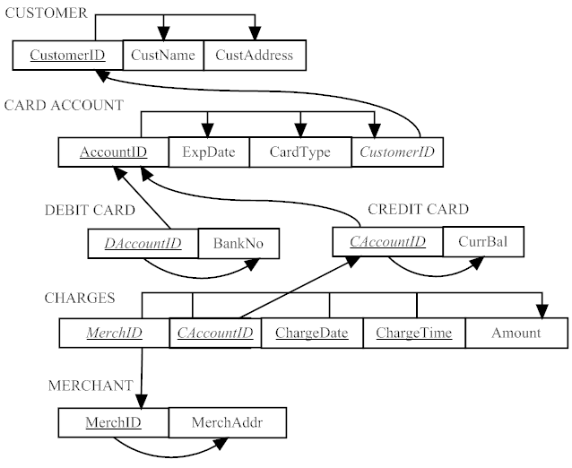

c. Using an enterprise key (*Foreign keys* shown in italics)

OBJECT (OID, ObjectType)

CUSTOMER (OID, CustomerID, CustName, CustAddress)

CARD ACCOUNT (OID, AccountID, ExpDate, CardType, *CustomerID*)

DEBIT CARD (OID, DAccountID, BankNo)

CREDIT CARD (OID, CAccountID, CurrBal)

CHARGES (OID, *MerchID*, *CAccountID*, ChargeDate, ChargeTime, Amount)

MERCHANT (OID, MerchID, MerchAddr)

9. Transforming Table 4-5 (shipping manifest) to relations:

a. Total weight is a derived attribute and can be calculated from weight and quantity. Therefore it is not shown here as part of the relational schema. Relational schema shown below:

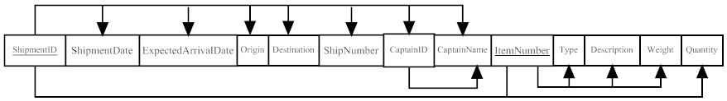

b. First normal form

c. 3NF relations

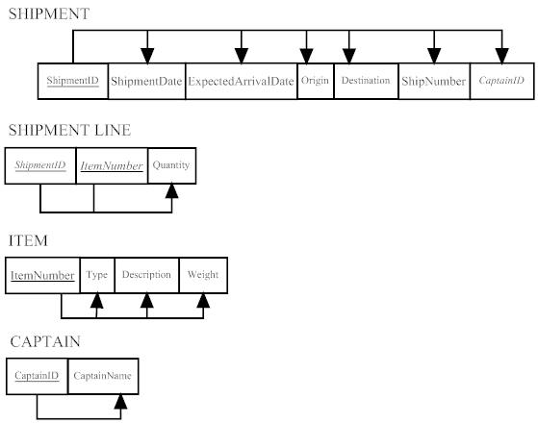

d. 3NF relations with referential integrity and functional dependencies shown

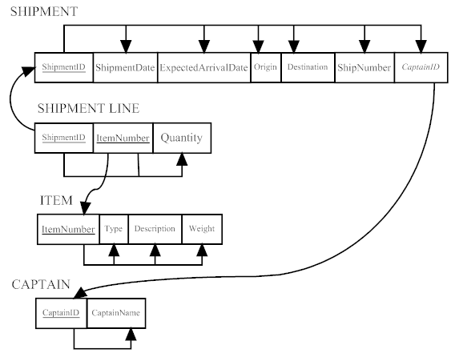

e.

