Chapter 4(Hoffer, Ramesh, & Topi)

Problems and Exercises 12,13,14

12.

Attribute version:

##### EMPLOYEE

## EmployeeID

### EmployeeName

##### SKILL

## EmployeeID

### SkillCode

### SkillTitle

### SkillType

Relationship version:

##### EMPLOYEE

## EmployeeID

### EmployeeName

##### POSSESSES

## EmployeeID

### SkillCode

##### SKILL

### SkillCode

### SkillTitle

### SkillType

The attribute version of the 3NF relations is like Figure 4-10. However, we have a much clearer definition of a primary key in this version. One main advantage of the relationship version is that we do not have to store SkillTitle and SkillType many times. If a skill title was changed or types were reclassified, this would make things much easier since update anomalies are eliminated in the relationship version of relations.

13.

a. Parking ticket table

|  |  |  |  |  |  |  |  |  |  |
| --- | --- | --- | --- | --- | --- | --- | --- | --- | --- |
| **STID** | **LName** | **FName** | **PhoneNo** | **St Lic** | **LicNo** | **Ticket#** | **Date** | **Code** | **Fine** |
| 38249 | Brown | Thomas | 111-7804 | FL | BRY 123 | 15634 | 10/17/10 | 2 | $25 |
| 38249 | Brown | Thomas | 111-7804 | FL | BRY 123 | 16017 | 11/13/10 | 1 | $15 |
| 82453 | Green | Sally | 391-1689 | AL | TRE 141 | 14987 | 10/05/10 | 3 | $100 |
| 82453 | Green | Sally | 391-1689 | AL | TRE 141 | 16293 | 11/18/10 | 1 | $15 |
| 82453 | Green | Sally | 391-1689 | AL | TRE-141 | 17892 | 12/13/10 | 2 | $25 |

###### The determinants are: STID, Ticket#, Code.

b.

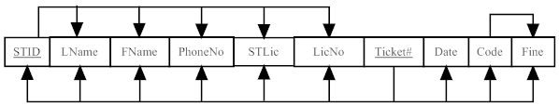

c. An insertion anomaly would occur if you tried to insert a student who has never had a parking ticket.

A deletion anomaly would occur if you were to delete a record of any student with only one parking ticket since all student information would be lost.

A modification anomaly would occur whenever the PhoneNo (or name, State License, or License Number) data of a student was updated.

d.

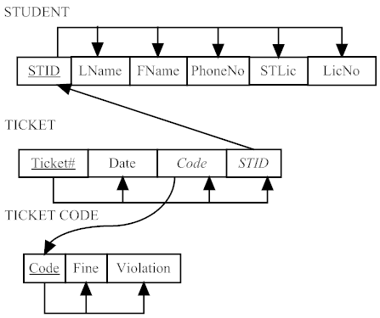

e.

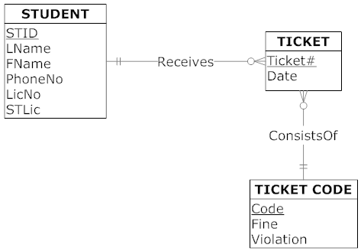

14.

a.

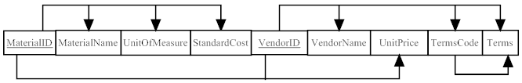

b.

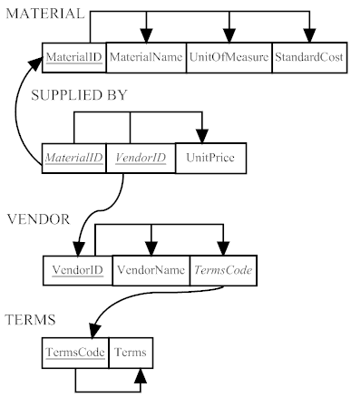

c.

