Task-1

network created dev ,prod and uat

Note:- I will update pictures in my own time with side laptop for screenshot purpose....

docker network connect nertwork_name servername
docker network create dev nginx
docker network create prod nginx
docker network create uat nginx

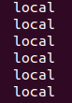
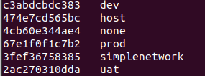

docker container is up and show all the container in it provide the ip address to ping:-
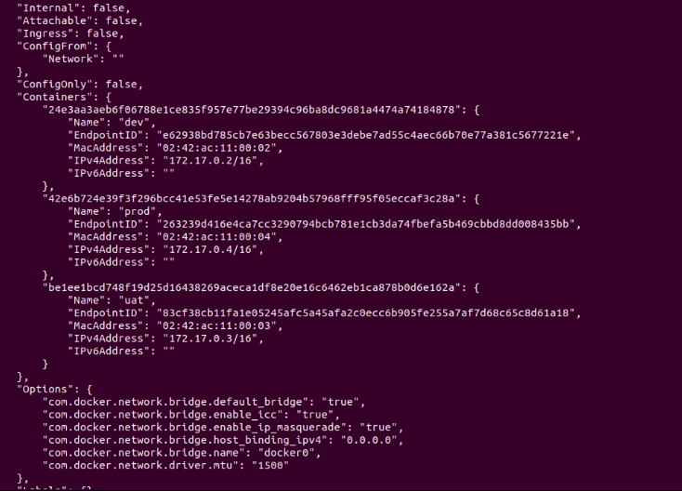

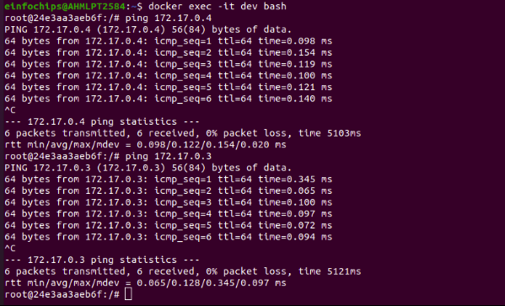

--> To go and exec the container build:- docker exec -it container_name bash to go inside it.
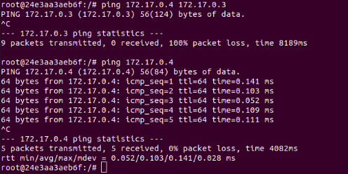

Task -2

Dockerfile:-

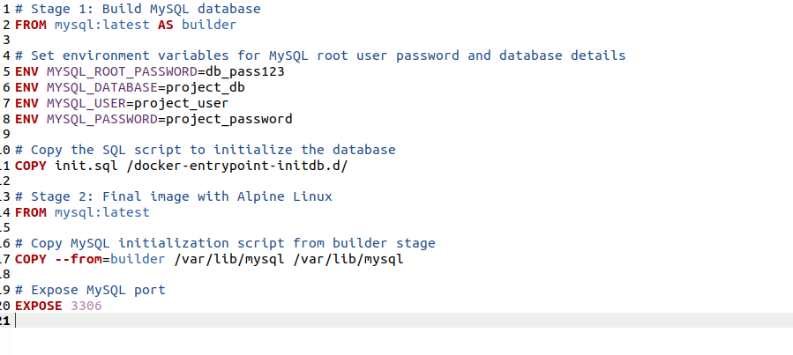
init.sql file
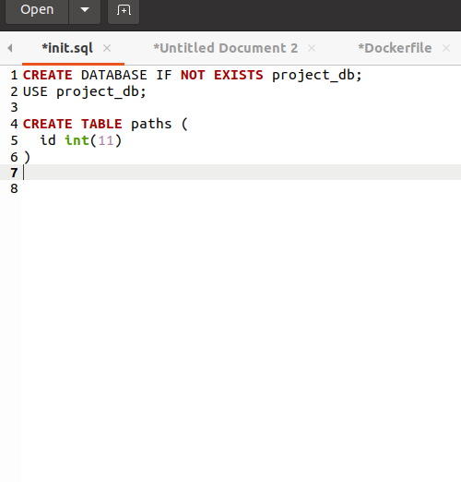

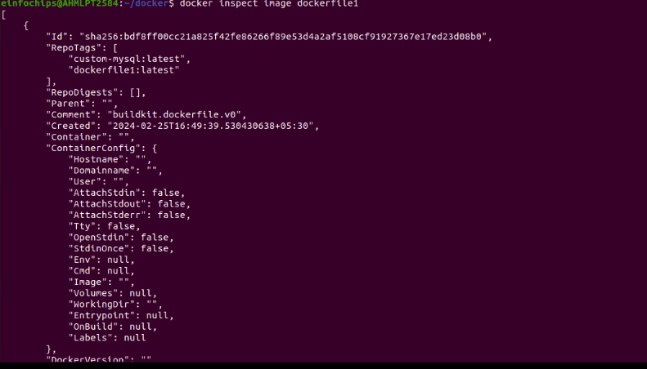

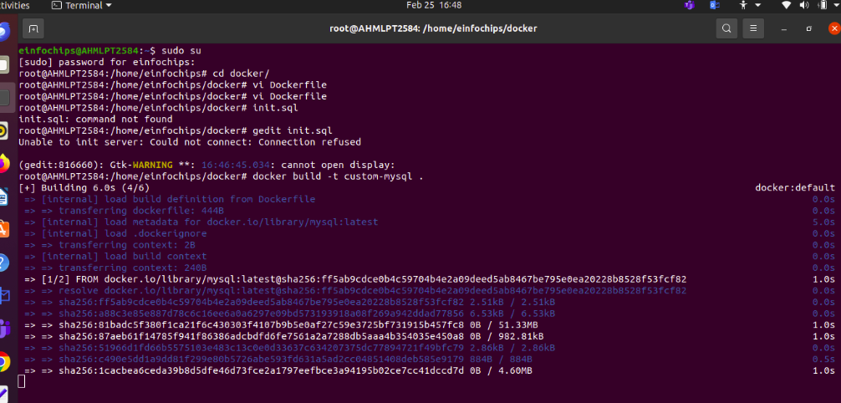

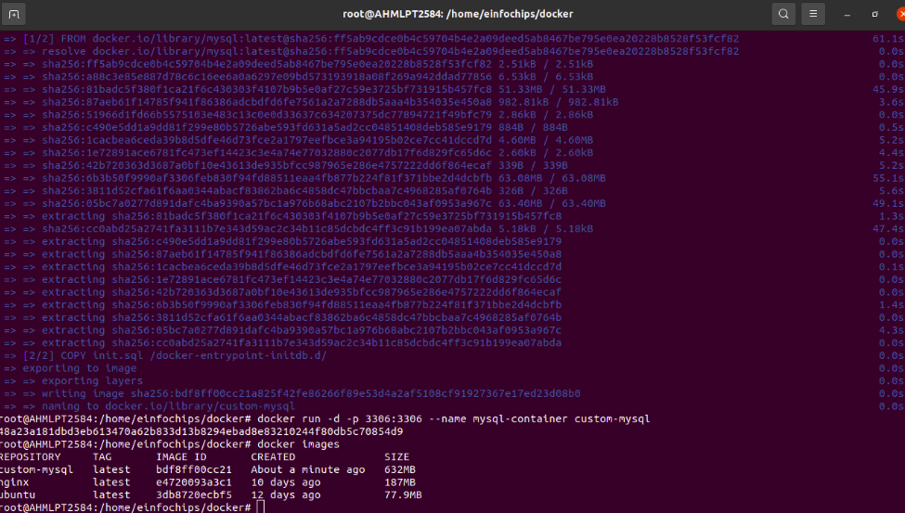

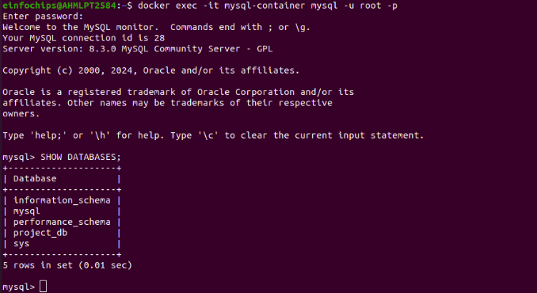
Note:- I will update pictures in my own time with side laptop for screenshot purpose....

