Java Programming – Classes, Objects, Constructors and Methods (5 Programs)

1.Create a class Student with student ID, name and age. Create three student objects and display their details.
Code:
class Student { int st_Id; String name; int age;
void displayDetails() {
System.out.println("Student ID: " + st_Id);
System.out.println("Name: " + name);
System.out.println("Age: " + age);
System.out.println("-------------------"); }
public static void main(String[] args) {
Student s1 = new Student();
s1.st_Id = 101; s1.name = "Rahul"; s1.age = 20;
Student s2 = new Student();
s2.st_Id = 102; s2.name = "Priya"; s2.age = 19;
Student s3 = new Student();
s3.st_Id = 103; s3.name = "Arjun"; s3.age = 21;
s1.displayDetails(); s2.displayDetails(); s3.displayDetails(); }}
Output:
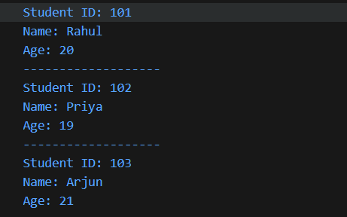
2. Create an Employee class with employee ID, name and salary. Initialize the values using a constructor and display employee details.
Code:
class Employee {
int employeeId;
String name;
double salary;
Employee(int id, String n, double s) {
employeeId = id; name = n; salary = s;
}
void displayDetails() {
System.out.println("Employee ID: " + employeeId);
System.out.println("Name: " + name);
System.out.println("Salary: " + salary);
}
public static void main(String[] args) {
Employee e1 = new Employee(101, "Rahul", 30000);
Employee e2 = new Employee(102, "Priya", 40000);
e1.displayDetails();
System.out.println("-------------------");
e2.displayDetails();
}
}
Output:
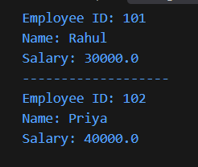
3. Create a Bank Account class with account number and balance. Implement deposit and withdrawal methods.
Code:
public class BankAccount {
int accountNumber;
String accountHolderName;
double balance;
BankAccount(int accNum, String accHolderName, double bal) {
accountNumber = accNum;
accountHolderName = accHolderName;
balance = bal; }
void displayDetails() {
System.out.println("Account Number: " + accountNumber);
System.out.println("Account Holder Name: " + accountHolderName);
System.out.println("Balance: " + balance); }
void deposit(double amount) {
balance += amount;
System.out.println("Deposited :" + balance); }
void withdrawal(double amount) {
if (amount <= balance) {
balance -= amount;
System.out.println("Withdrawal successful. New balance: " + balance);
} else {
System.out.println("Insufficient balance. Withdrawal failed."); }}
public static void main(String[] args) {
BankAccount b1 = new BankAccount(1001, "Rahul", 5000.0);
BankAccount b2 = new BankAccount(1002, "Priya", 10000.0);
b1.displayDetails();
b1.deposit(2000.0);
b1.withdrawal(12000.0);
System.out.println("-------------------");
b2.displayDetails();
b2.deposit(5000.0);
b2.withdrawal(3000.0); }}
Output:
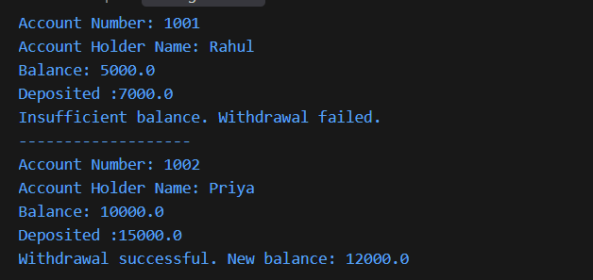

4. Create a Rectangle class with length and width. Calculate and display its area and perimeter.
Code:
class Rectangle {
double length;
double width;
Rectangle(double l, double w) {
length = l;
width = w; }
void calculateArea() {
double area = length * width;
System.out.println("Area: " + area); }
void calculatePerimeter() {
double perimeter = 2 * (length + width);
System.out.println("Perimeter: " + perimeter); }
public static void main(String[] args) {
Rectangle r1 = new Rectangle(10, 5);
r1.calculateArea();
r1.calculatePerimeter(); } }
Output:
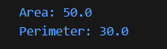
5. Create a Book class with ISBN, title and price. Initialize the values using a parameterized constructor.
Code:
class Book {
String ISBN; String title; double price;
Book(String i, String t, double p) {
ISBN = i; title = t; price = p; }
void displayDetails() {
System.out.println("ISBN: " + ISBN);
System.out.println("Title: " + title);
System.out.println("Price: " + price); }
public static void main(String[] args) {
Book b1 = new Book("9781234567890", "Java Programming", 550);
b1.displayDetails(); } }
Output:


