1. Create Database
Go to:
MongoDB Atlas → Database → Browse Collections
Click Create Database.
Database name:
bankdb
Collection name:
customers
Click Create. 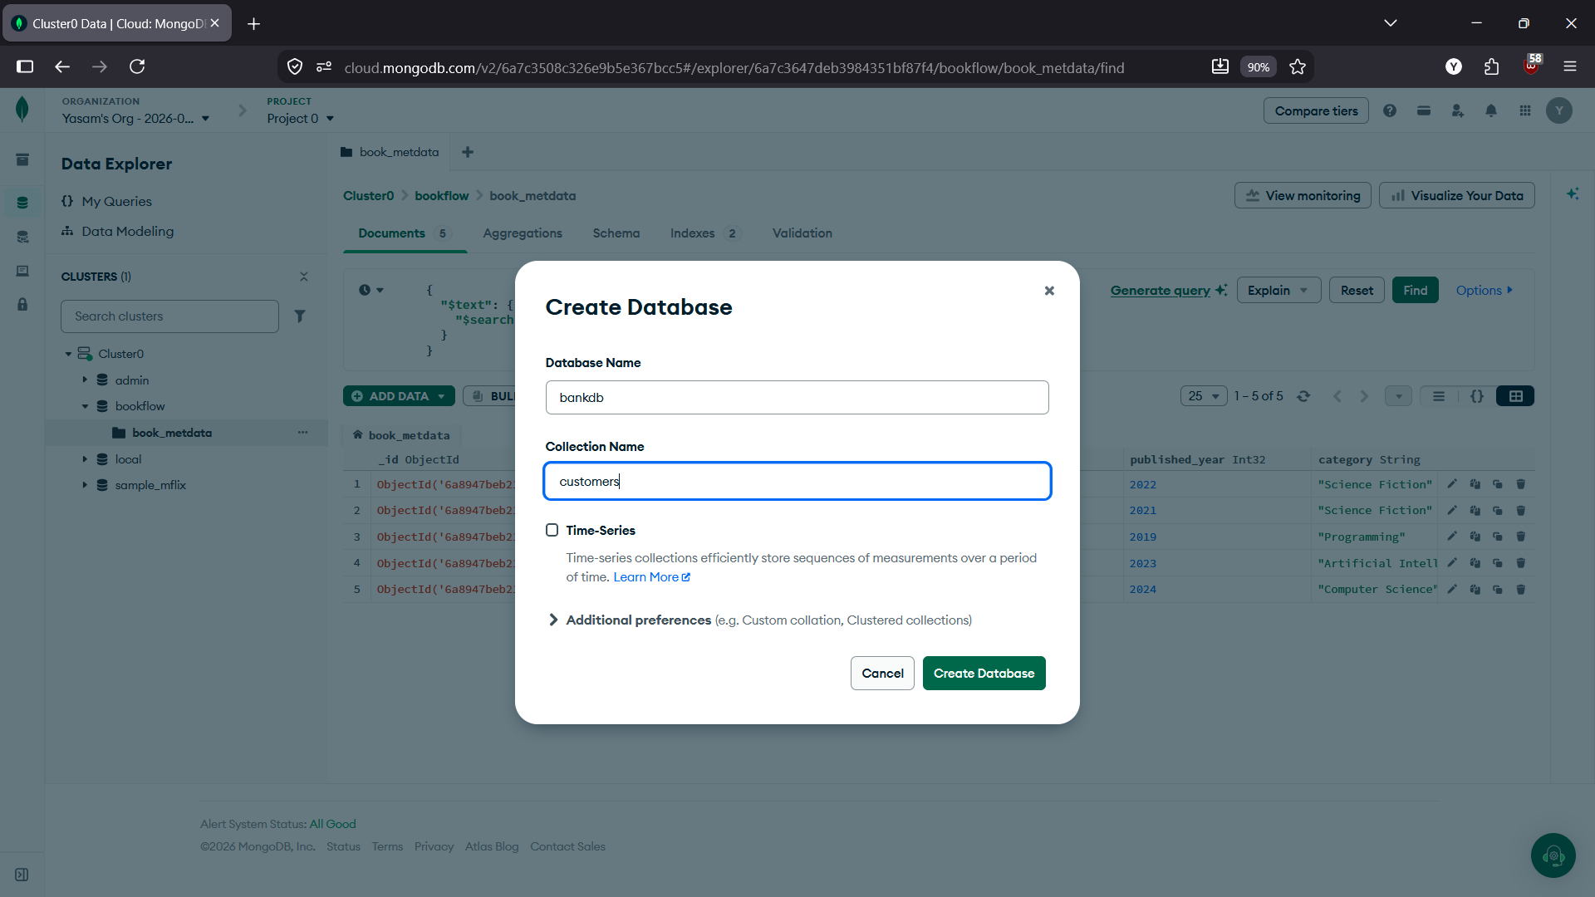

2. Create Second Collection
Open bankdb.
Click Create Collection.
Collection name:
transactions
Click Create.
You should now have:
bankdb
├── customers
└── transactions
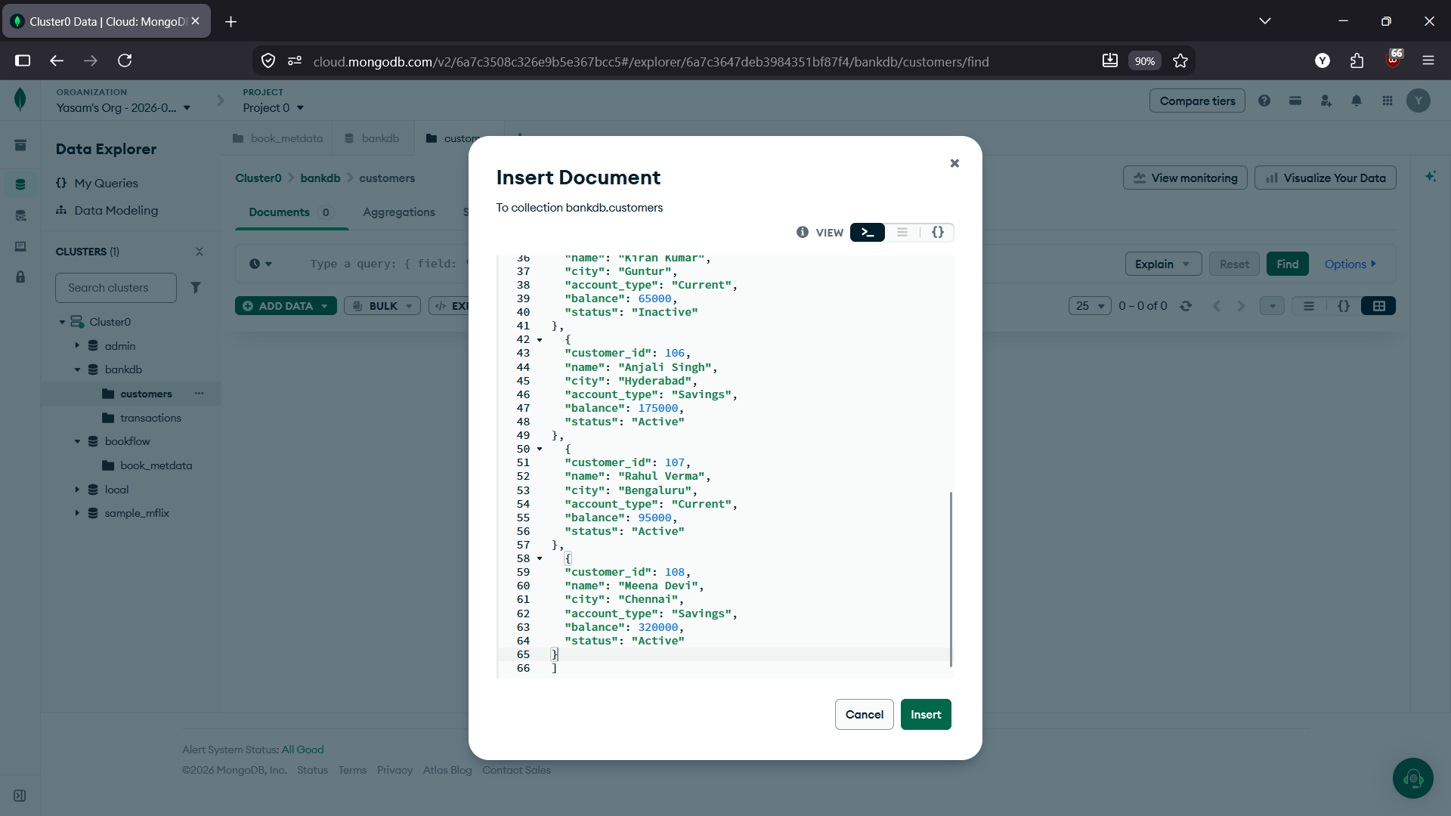

3. Insert Customer Documents
Open:
bankdb → customers → Add Data → Insert Document
Insert these one by one.
Customer 1
{
"customer_id": 101,
"name": "Ravi Kumar",
"city": "Hyderabad",
"account_type": "Savings",
"balance": 85000,
"status": "Active"
}
Customer 2
{
"customer_id": 102,
"name": "Priya Sharma",
"city": "Vijayawada",
"account_type": "Current",
"balance": 125000,
"status": "Active"
}
Customer 3
{
"customer_id": 103,
"name": "Arjun Reddy",
"city": "Hyderabad",
"account_type": "Savings",
"balance": 45000,
"status": "Active"
}
Customer 4
{
"customer_id": 104,
"name": "Sneha Rao",
"city": "Warangal",
"account_type": "Savings",
"balance": 210000,
"status": "Active"
}
Customer 5
{
"customer_id": 105,
"name": "Kiran Kumar",
"city": "Guntur",
"account_type": "Current",
"balance": 65000,
"status": "Inactive"
}
Customer 6
{
"customer_id": 106,
"name": "Anjali Singh",
"city": "Hyderabad",
"account_type": "Savings",
"balance": 175000,
"status": "Active"
}
Customer 7
{
"customer_id": 107,
"name": "Rahul Verma",
"city": "Bengaluru",
"account_type": "Current",
"balance": 95000,
"status": "Active"
}
Customer 8
{
"customer_id": 108,
"name": "Meena Devi",
"city": "Chennai",
"account_type": "Savings",
"balance": 320000,
"status": "Active"
}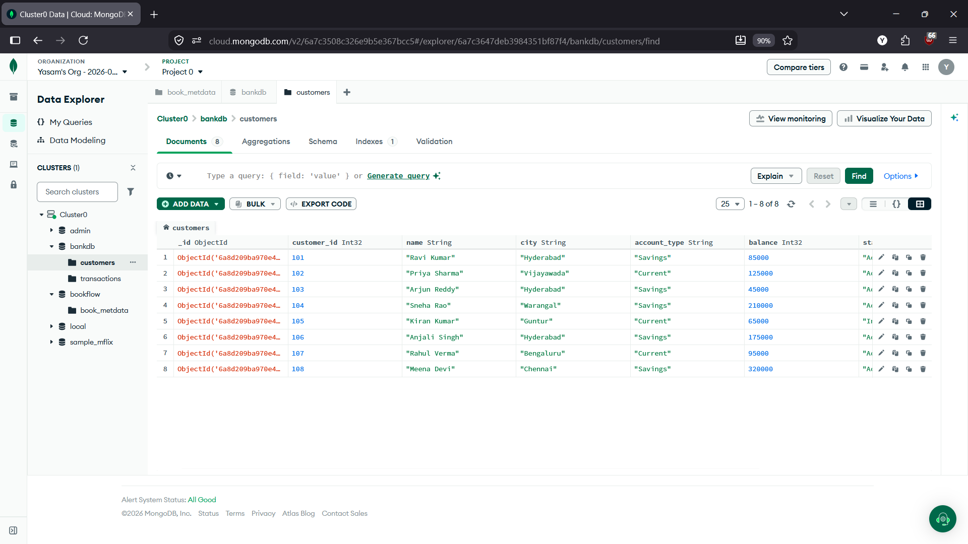

4. Insert Transaction Documents
Open:
bankdb → transactions → Add Data → Insert Document
Insert these one by one:
{
"transaction_id": 1001,
"customer_id": 101,
"type": "Deposit",
"amount": 25000,
"mode": "UPI",
"date": "2026-08-01",
"status": "Success"
}
{
"transaction_id": 1002,
"customer_id": 101,
"type": "Withdrawal",
"amount": 10000,
"mode": "ATM",
"date": "2026-08-02",
"status": "Success"
}
{
"transaction_id": 1003,
"customer_id": 102,
"type": "Deposit",
"amount": 50000,
"mode": "NEFT",
"date": "2026-08-02",
"status": "Success"
}
{
"transaction_id": 1004,
"customer_id": 102,
"type": "Withdrawal",
"amount": 15000,
"mode": "ATM",
"date": "2026-08-03",
"status": "Success"
}
{
"transaction_id": 1005,
"customer_id": 103,
"type": "Deposit",
"amount": 30000,
"mode": "UPI",
"date": "2026-08-03",
"status": "Success"
}
{
"transaction_id": 1006,
"customer_id": 103,
"type": "Withdrawal",
"amount": 5000,
"mode": "ATM",
"date": "2026-08-04",
"status": "Success"
}
{
"transaction_id": 1007,
"customer_id": 104,
"type": "Deposit",
"amount": 100000,
"mode": "NEFT",
"date": "2026-08-04",
"status": "Success"
}
{
"transaction_id": 1008,
"customer_id": 104,
"type": "Withdrawal",
"amount": 25000,
"mode": "ATM",
"date": "2026-08-05",
"status": "Success"
}
{
"transaction_id": 1009,
"customer_id": 105,
"type": "Deposit",
"amount": 15000,
"mode": "UPI",
"date": "2026-08-05",
"status": "Success"
}
{
"transaction_id": 1010,
"customer_id": 106,
"type": "Deposit",
"amount": 75000,
"mode": "NEFT",
"date": "2026-08-06",
"status": "Success"
}
{
"transaction_id": 1011,
"customer_id": 106,
"type": "Withdrawal",
"amount": 20000,
"mode": "ATM",
"date": "2026-08-06",
"status": "Success"
}
{
"transaction_id": 1012,
"customer_id": 107,
"type": "Deposit",
"amount": 40000,
"mode": "IMPS",
"date": "2026-08-07",
"status": "Success"
}
{
"transaction_id": 1013,
"customer_id": 107,
"type": "Withdrawal",
"amount": 12000,
"mode": "ATM",
"date": "2026-08-07",
"status": "Success"
}
{
"transaction_id": 1014,
"customer_id": 108,
"type": "Deposit",
"amount": 150000,
"mode": "NEFT",
"date": "2026-08-08",
"status": "Success"
}
{
"transaction_id": 1015,
"customer_id": 108,
"type": "Withdrawal",
"amount": 30000,
"mode": "ATM",
"date": "2026-08-08",
"status": "Success"
}
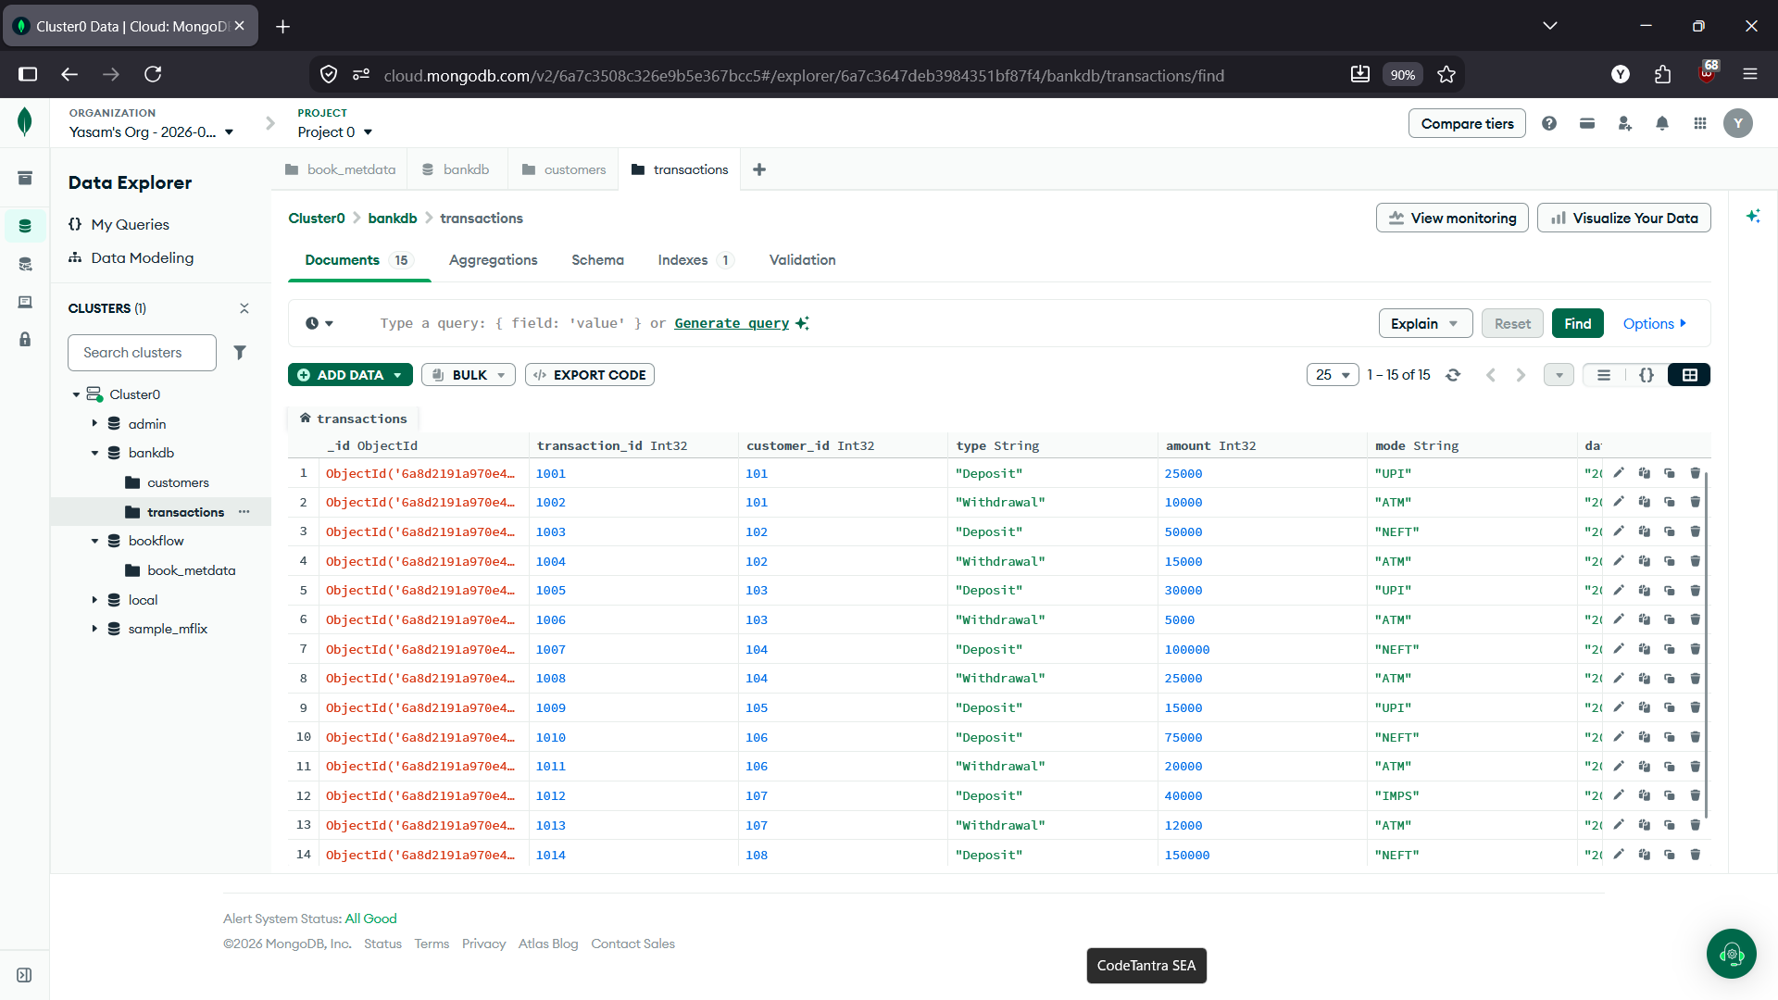

Queries 1–5: customers Collection
Query 1 — Display all customers
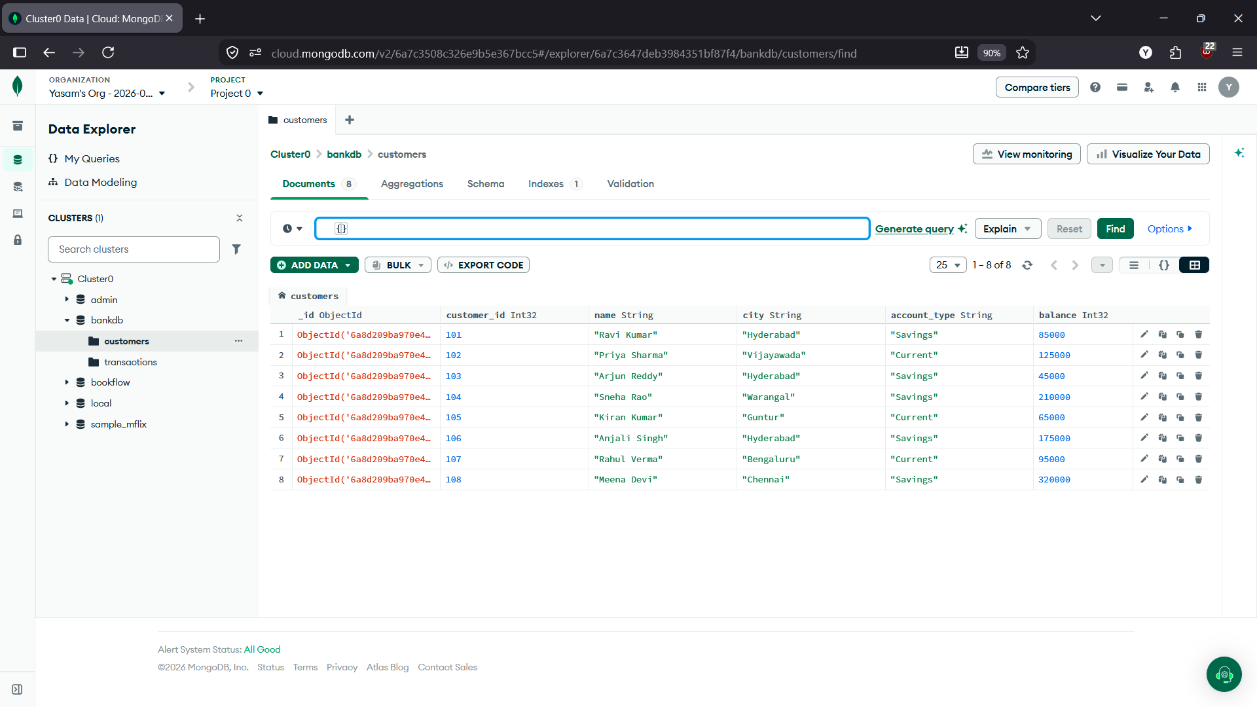
Query 2 — Active customers
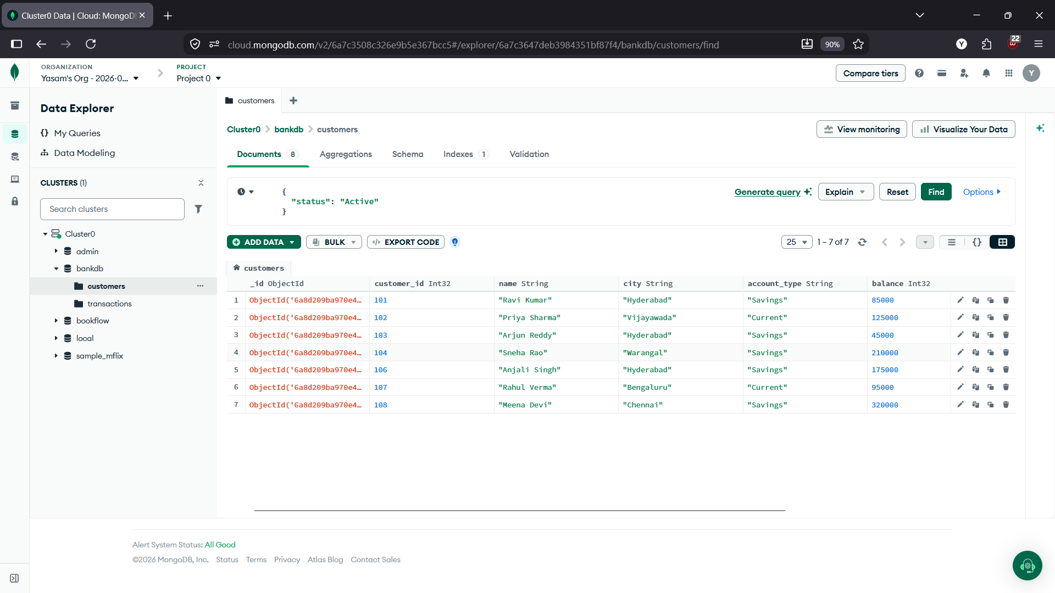
Query 3 — Balance greater than 100000
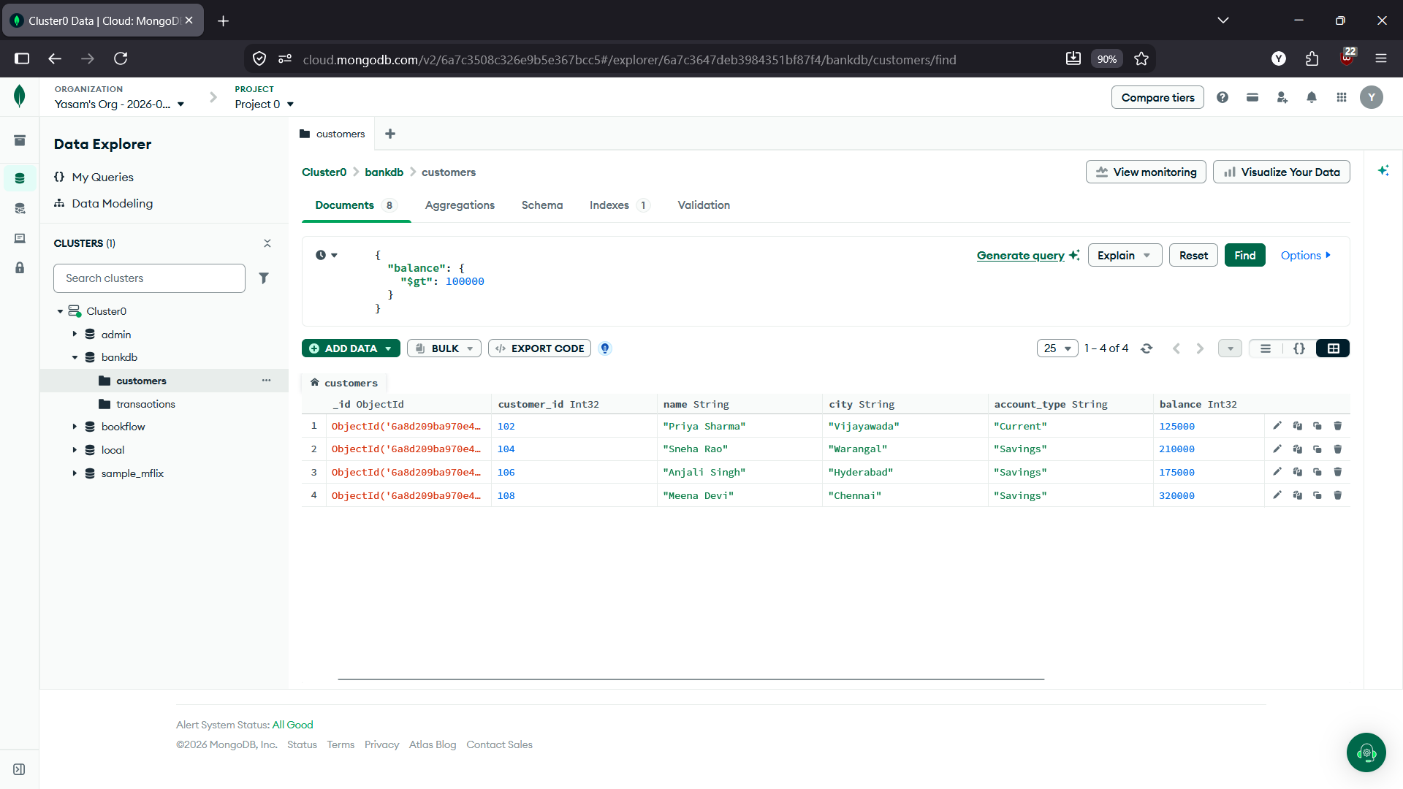

Query 4 — Hyderabad customers
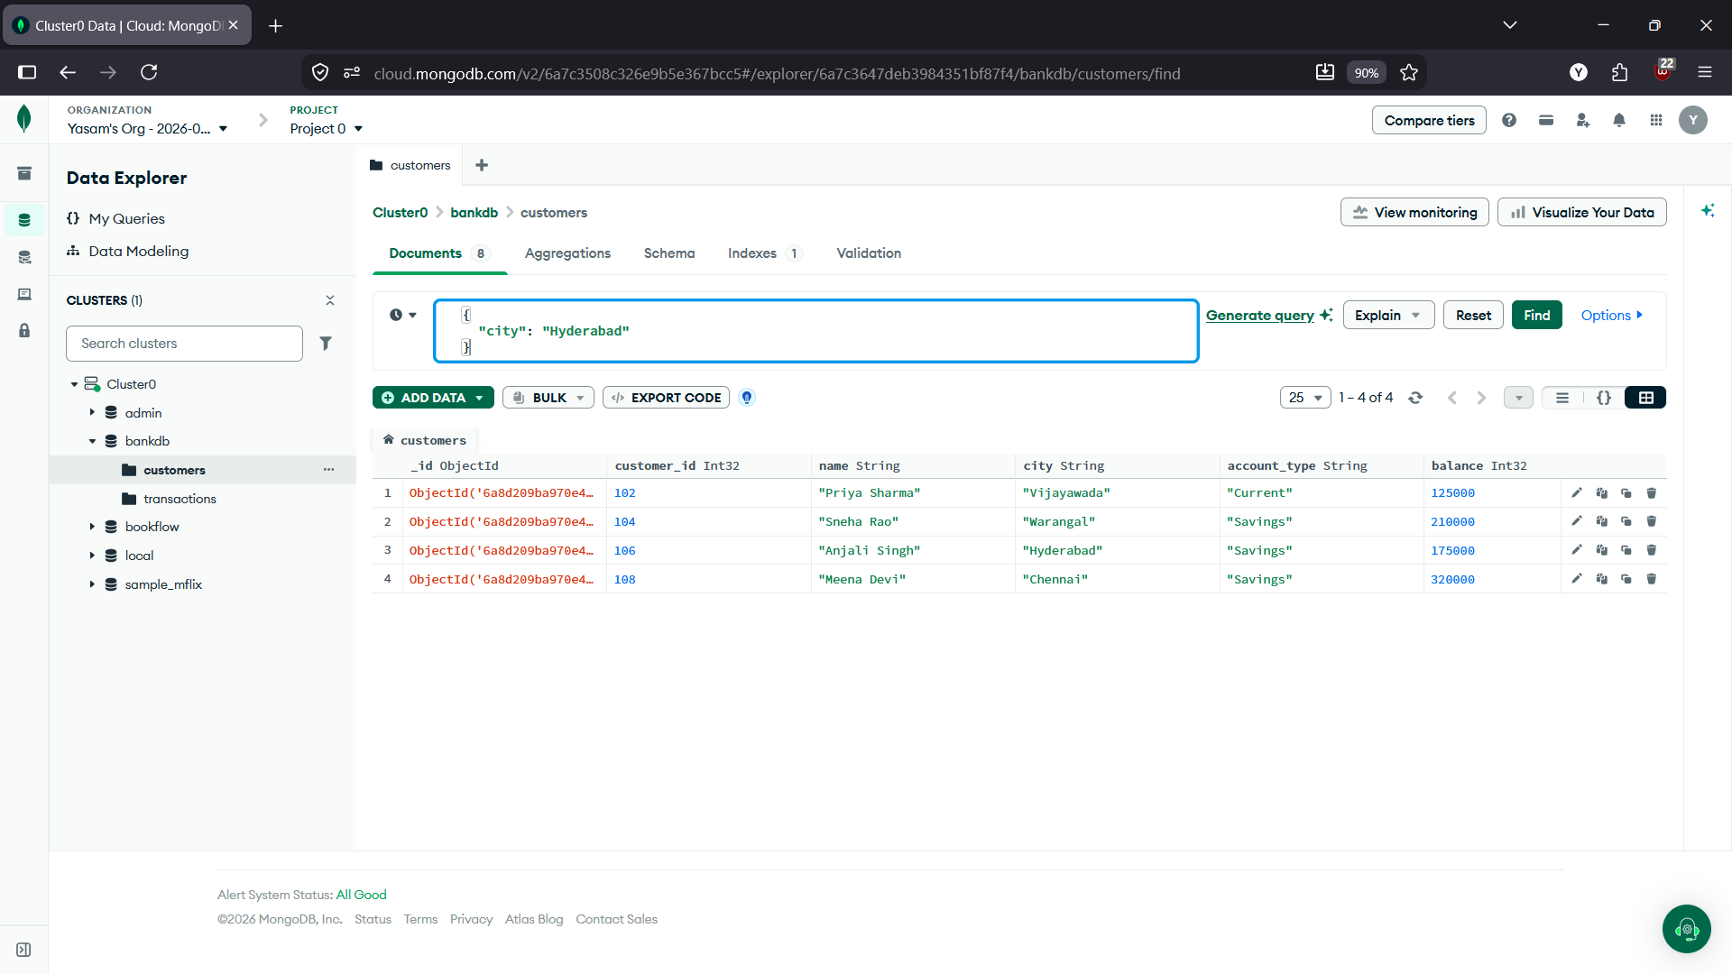
Query 5 — Savings account customers
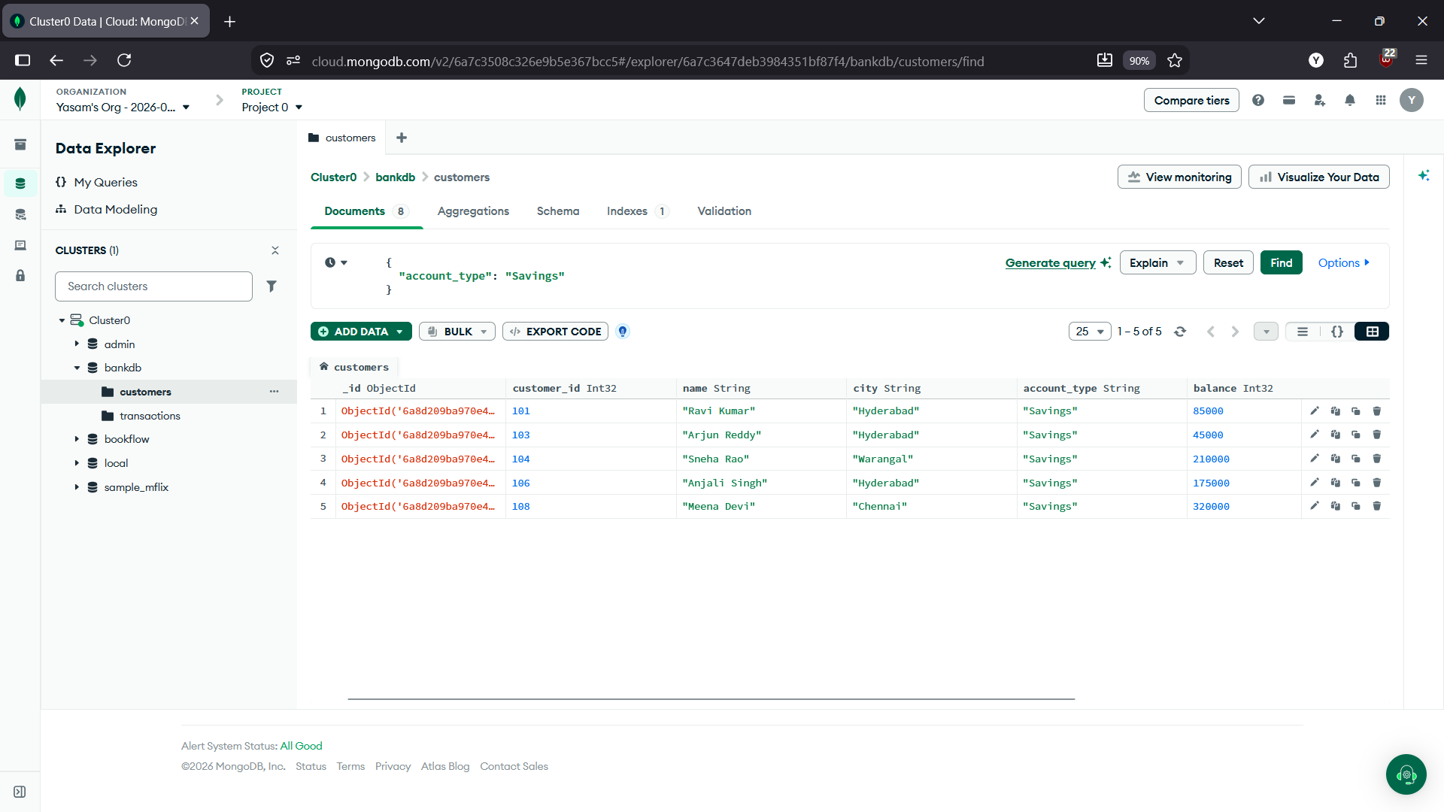
Queries 6–9: transactions Collection
Query 6 — Transactions greater than 20000
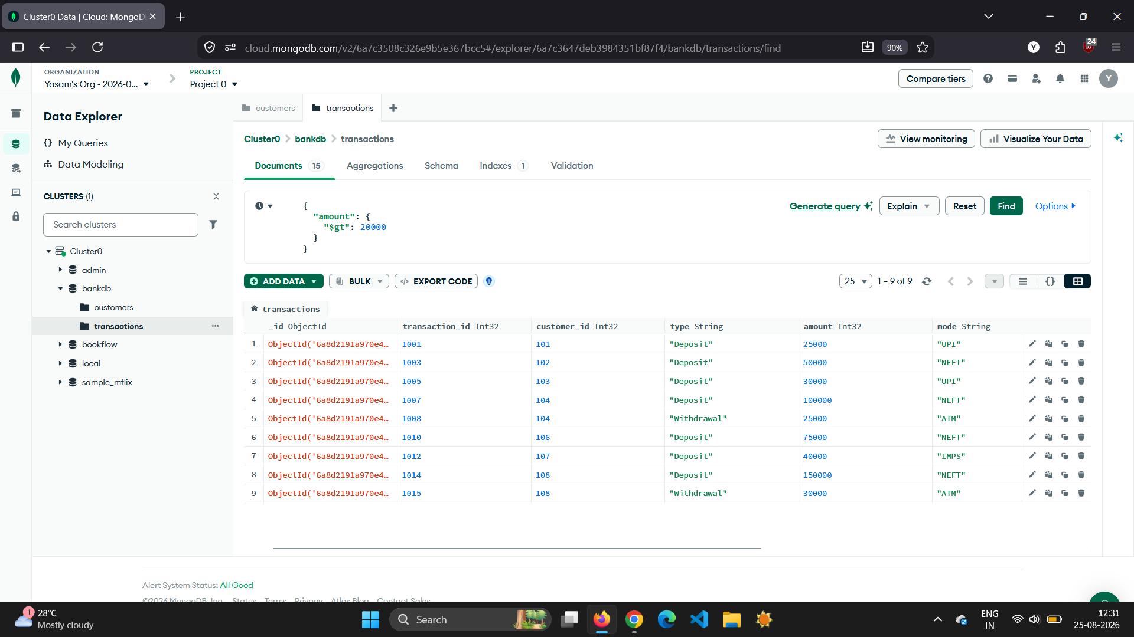

Query 7 — Deposits
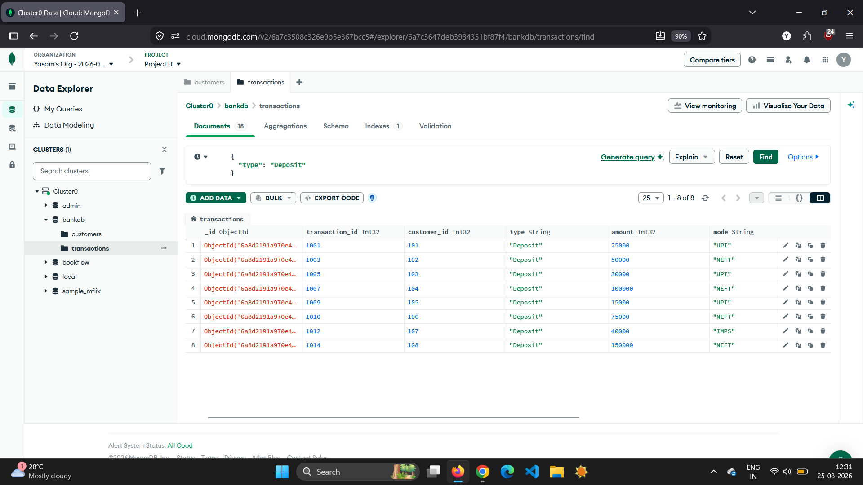
Query 8 — ATM transactions
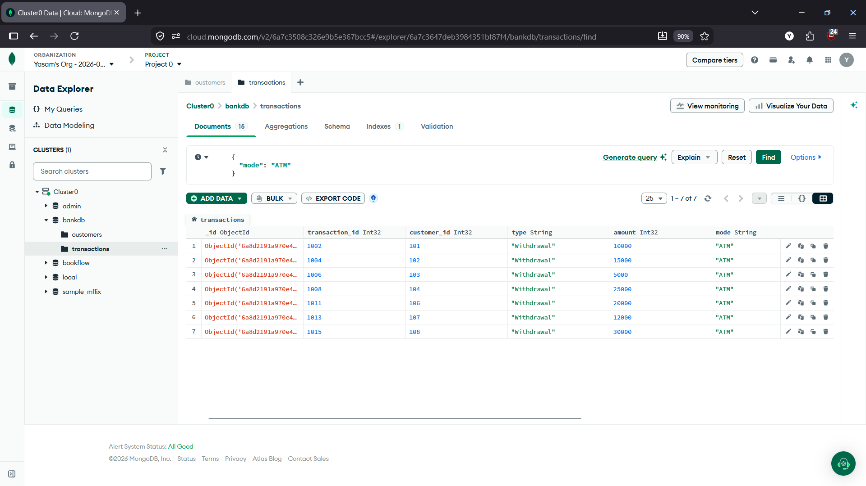

Query 9 — Deposits greater than 50000
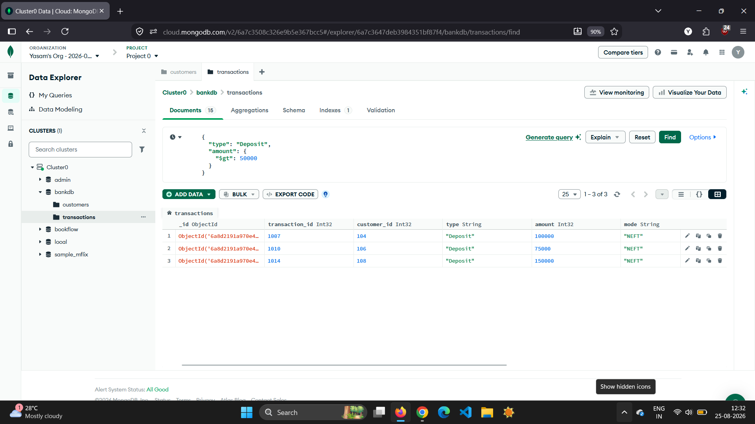
Query 10 — Hyderabad customers with balance greater than 100000
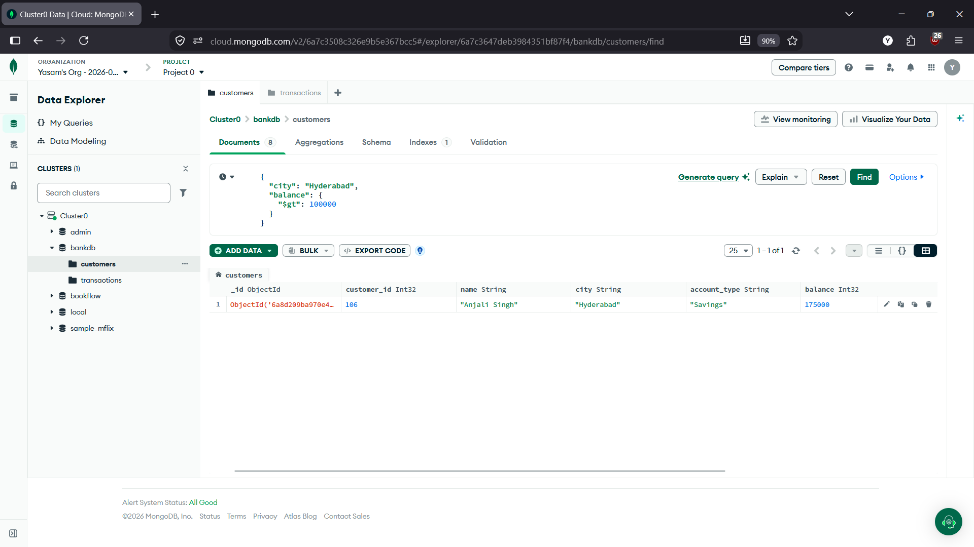

Query 11 — Customers in multiple cities
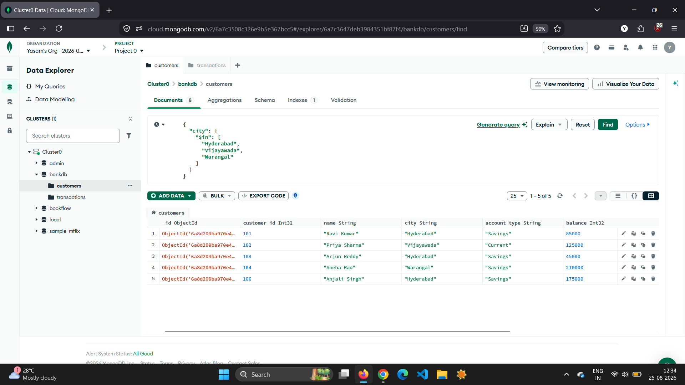
Query 12 — Sort customers by balance
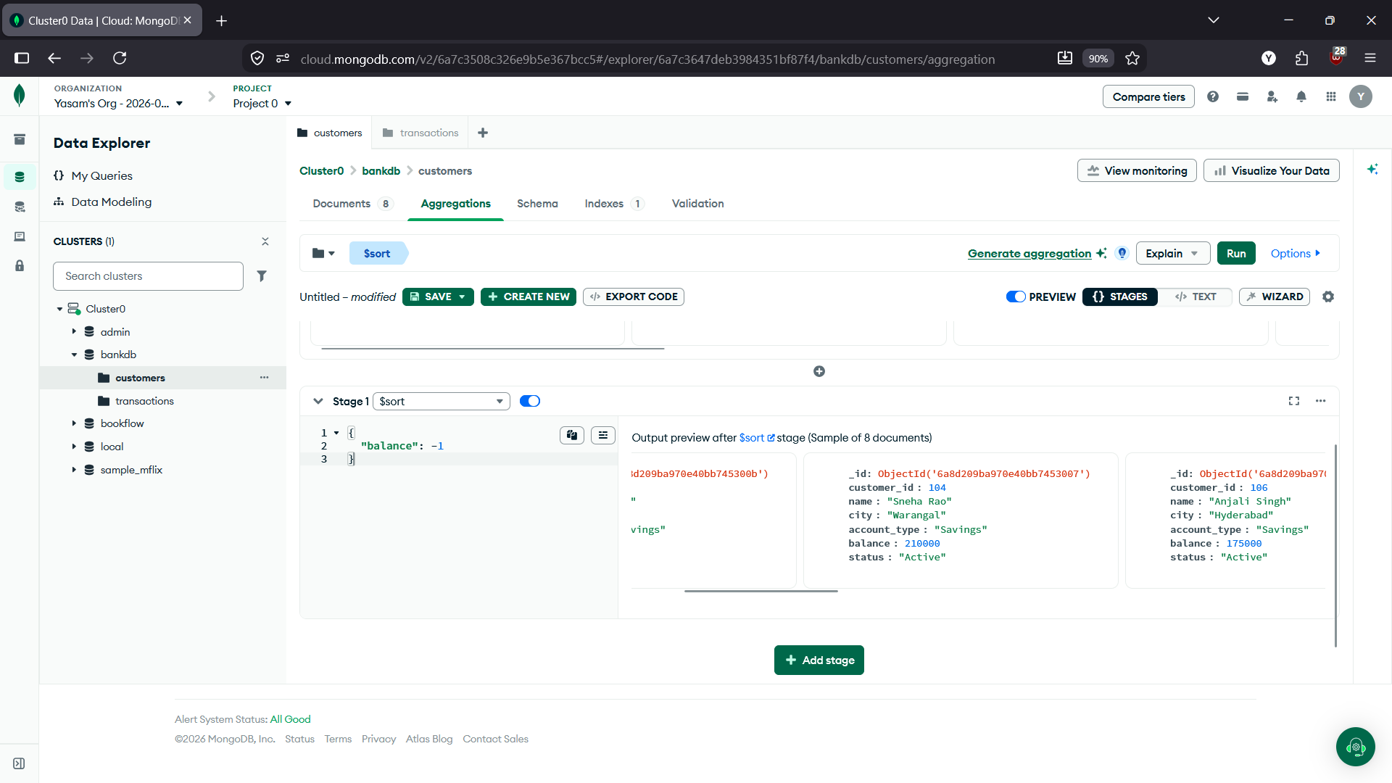

Query 13 — Total transaction amount
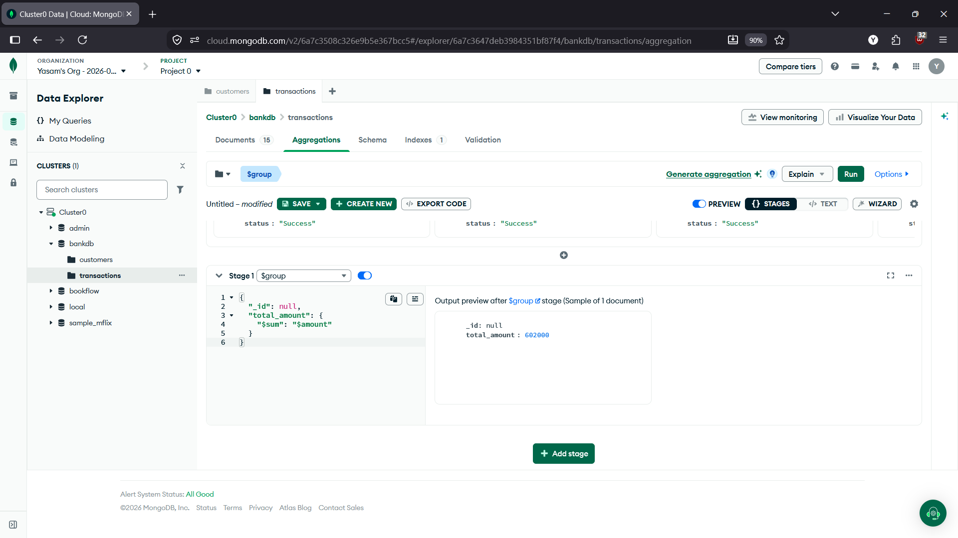
Query 14 — Average transaction amount
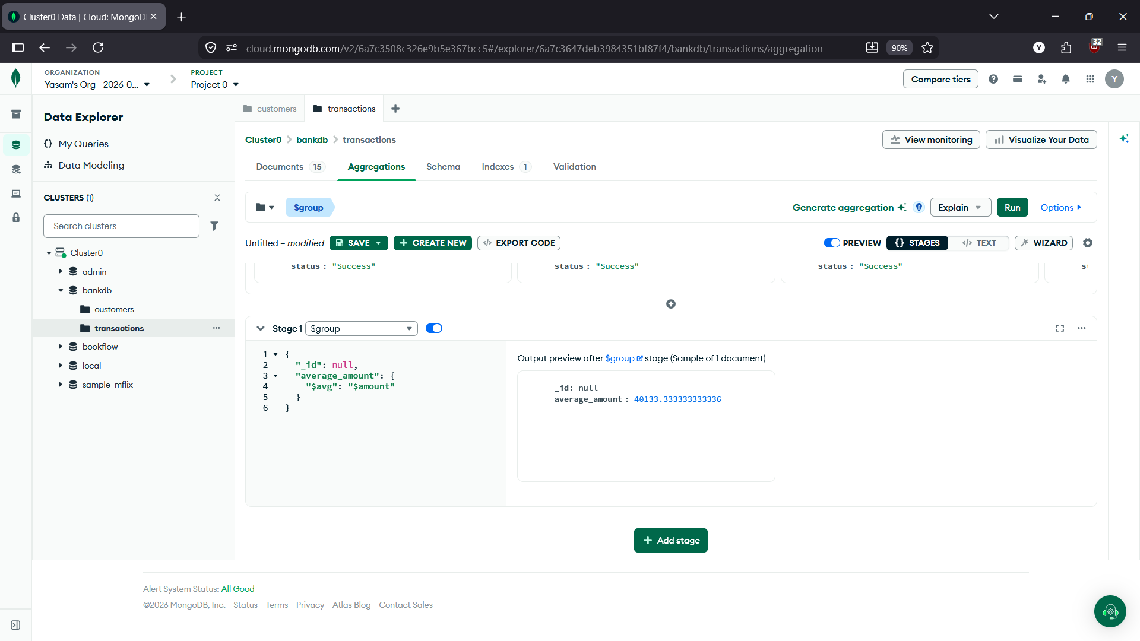

Query 15 — Total transaction amount by type
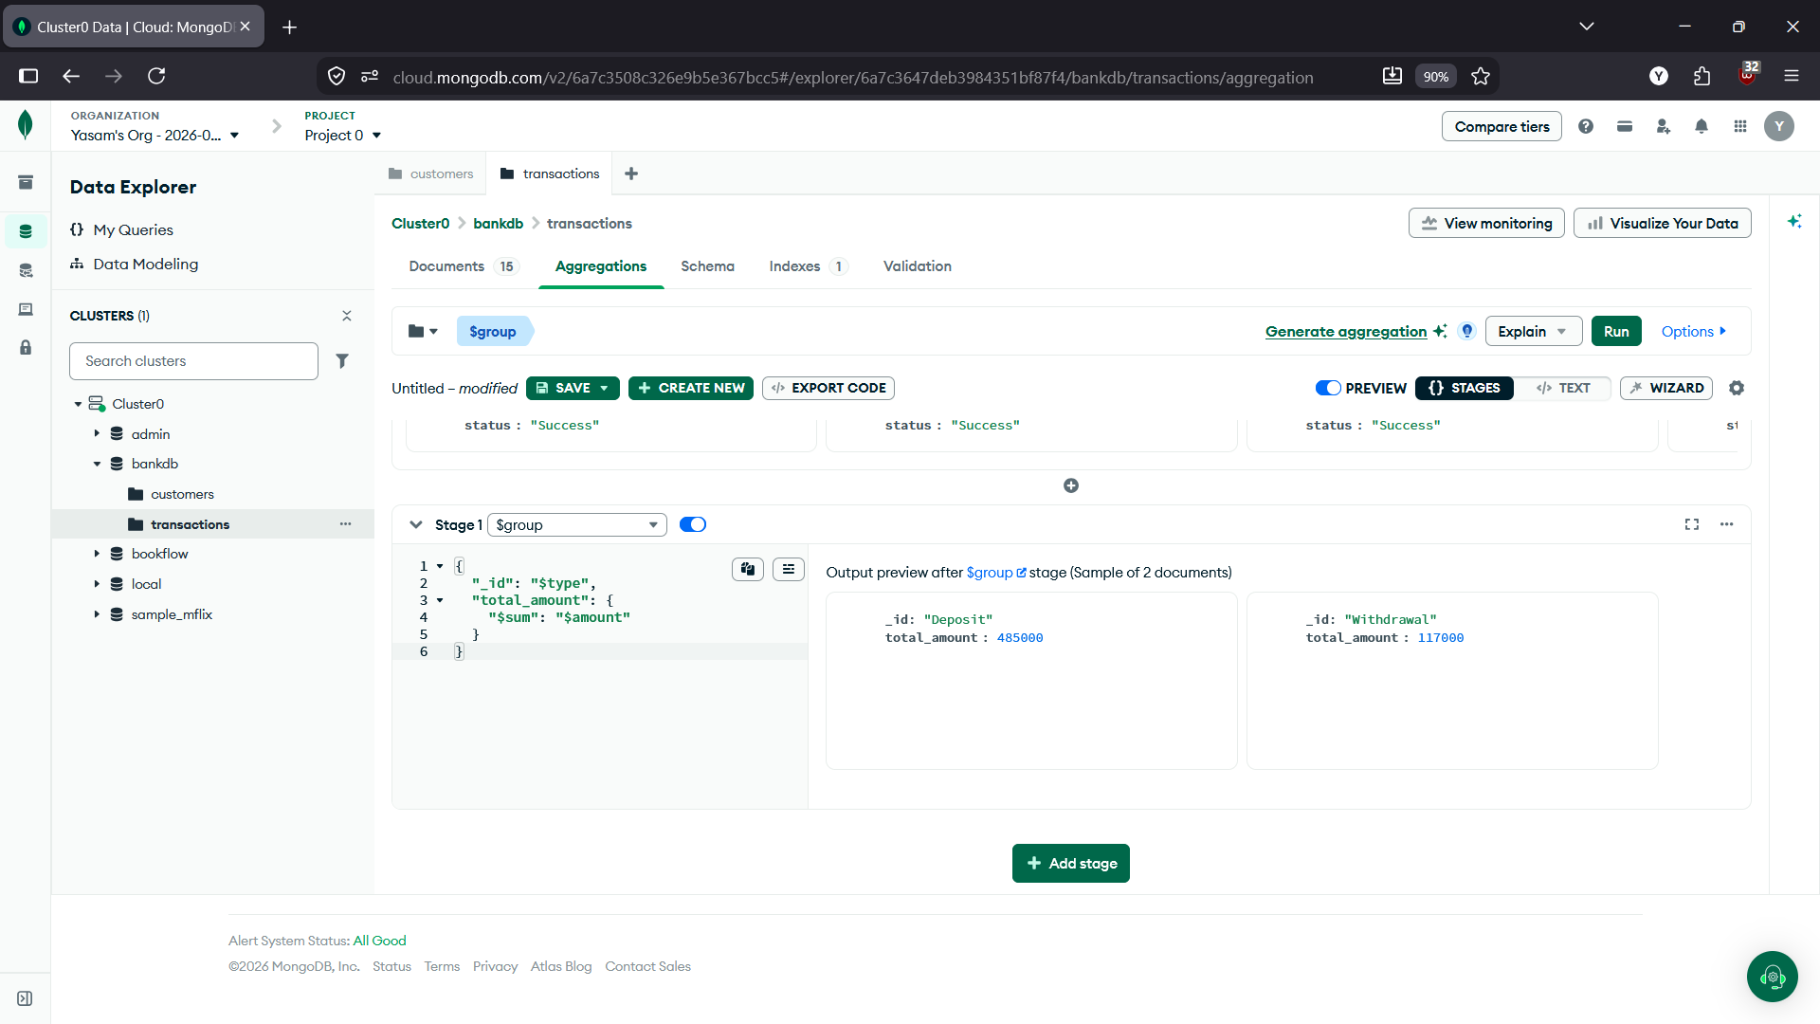
Query 16 — Number of transactions per customer
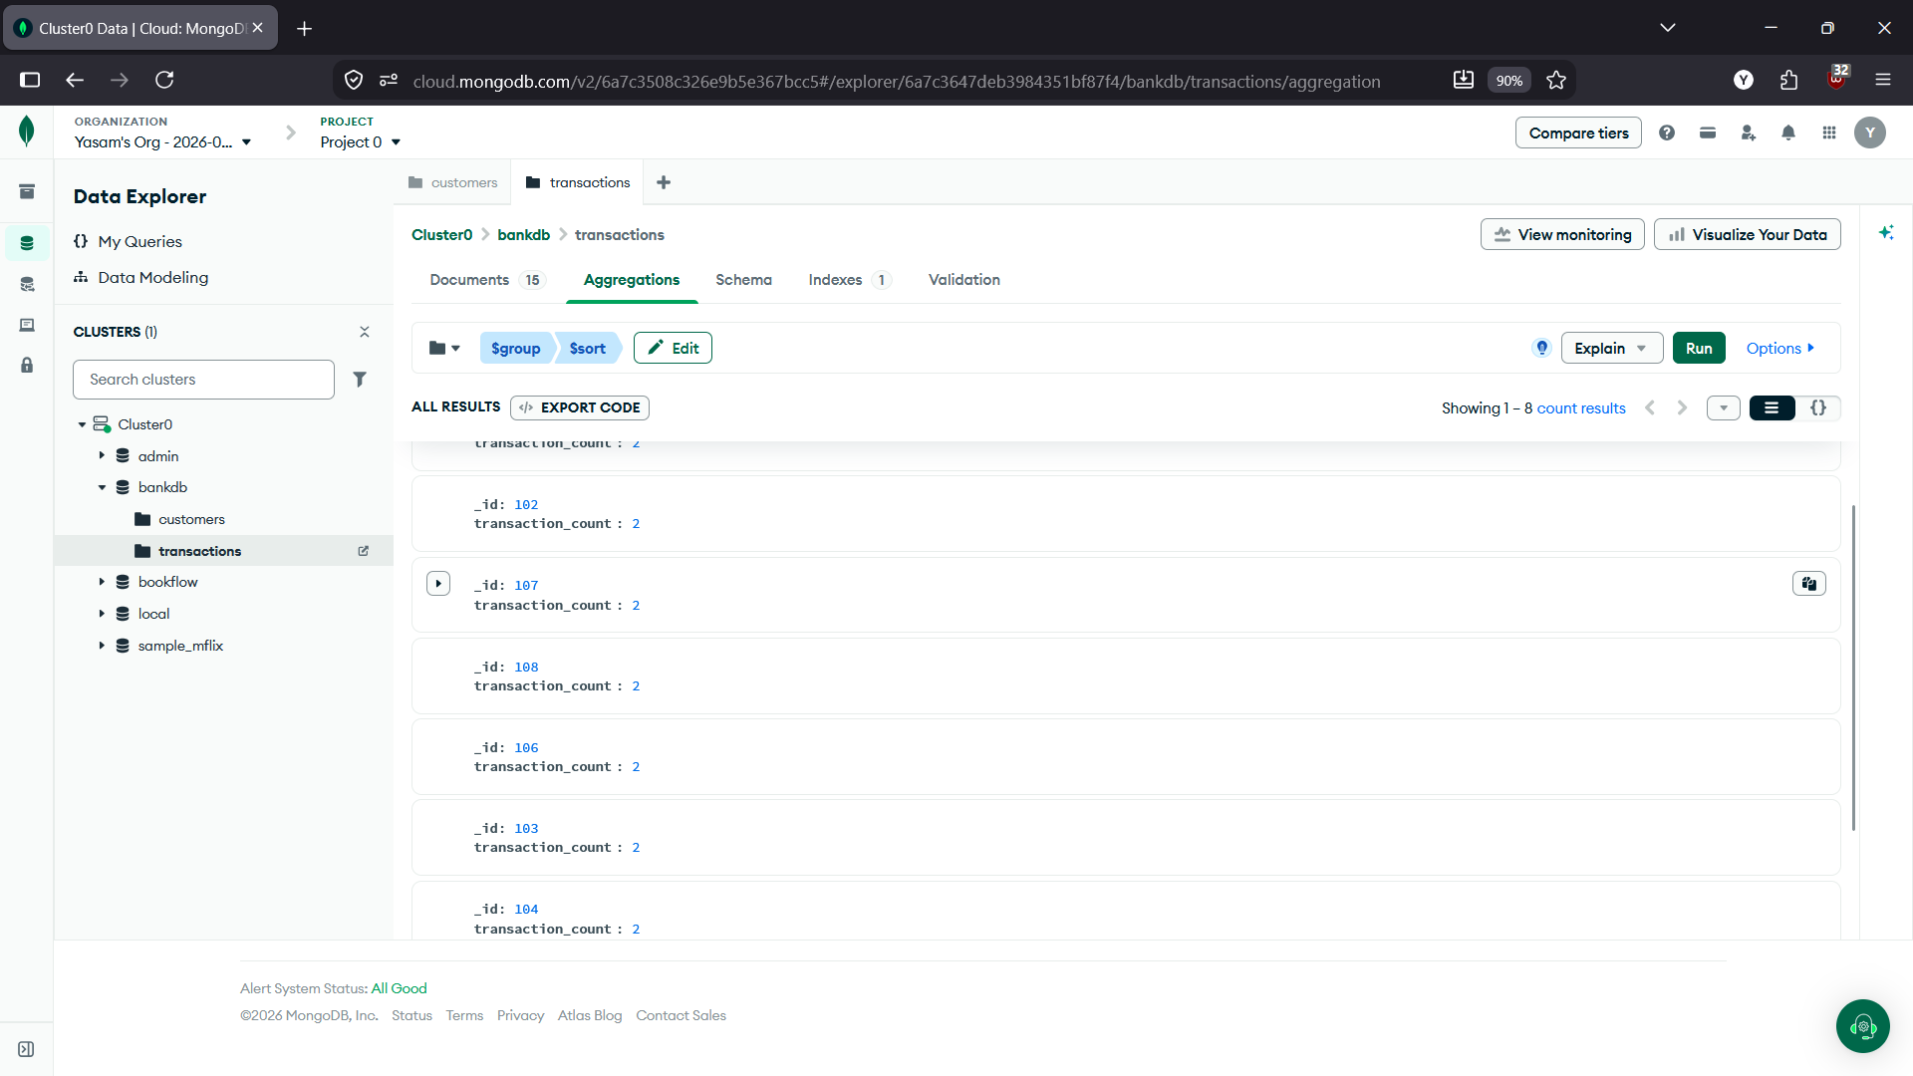

Query 17 — Customer + Transaction Join
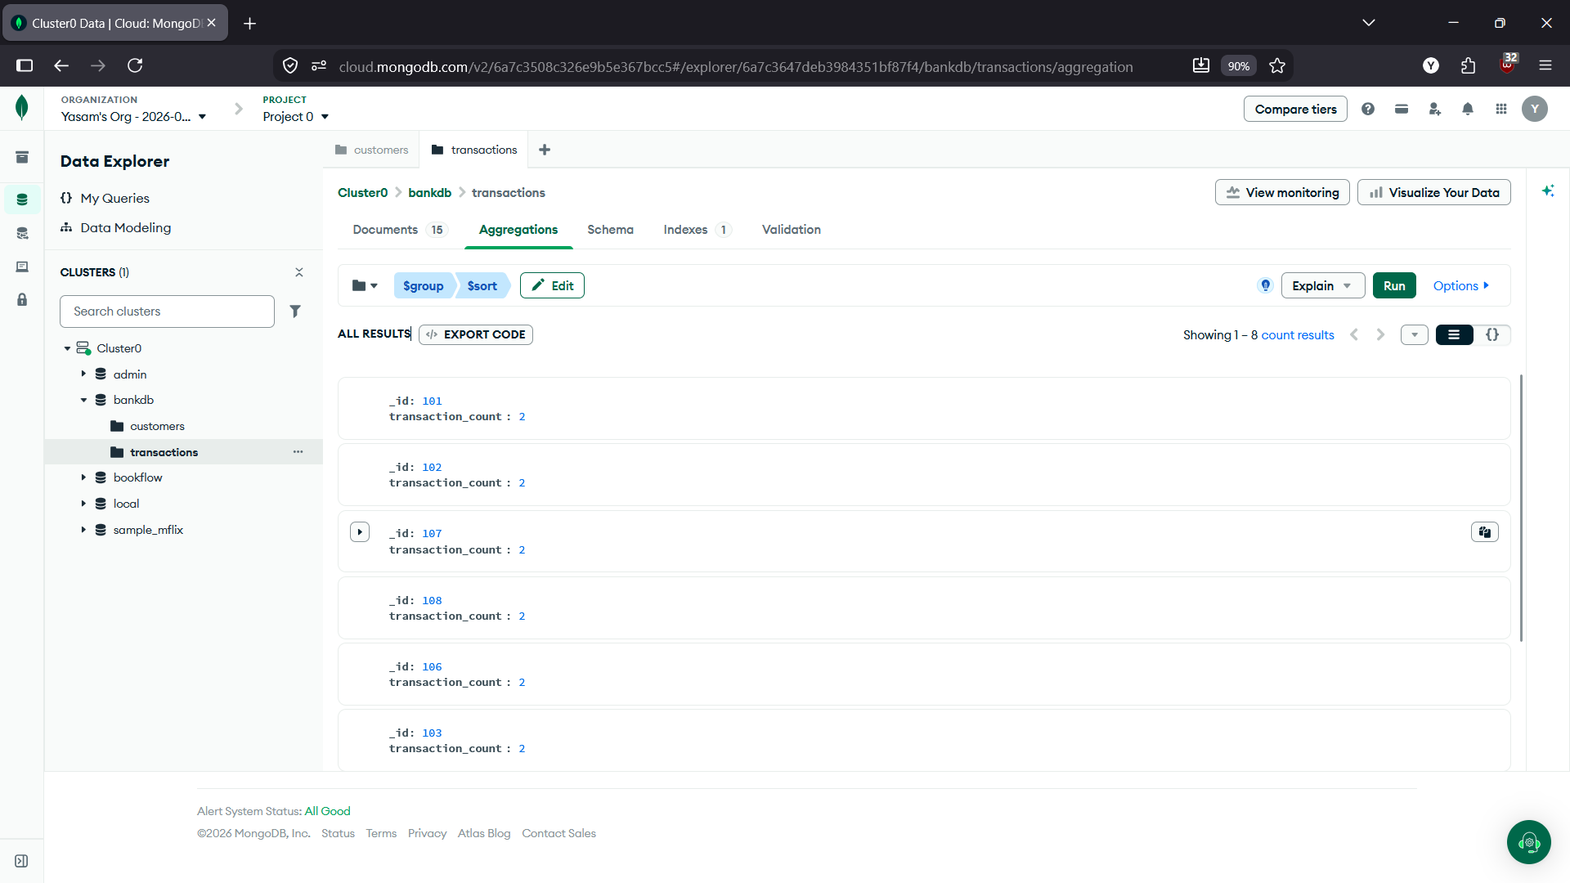
Query 18 — Customer name and transaction amount
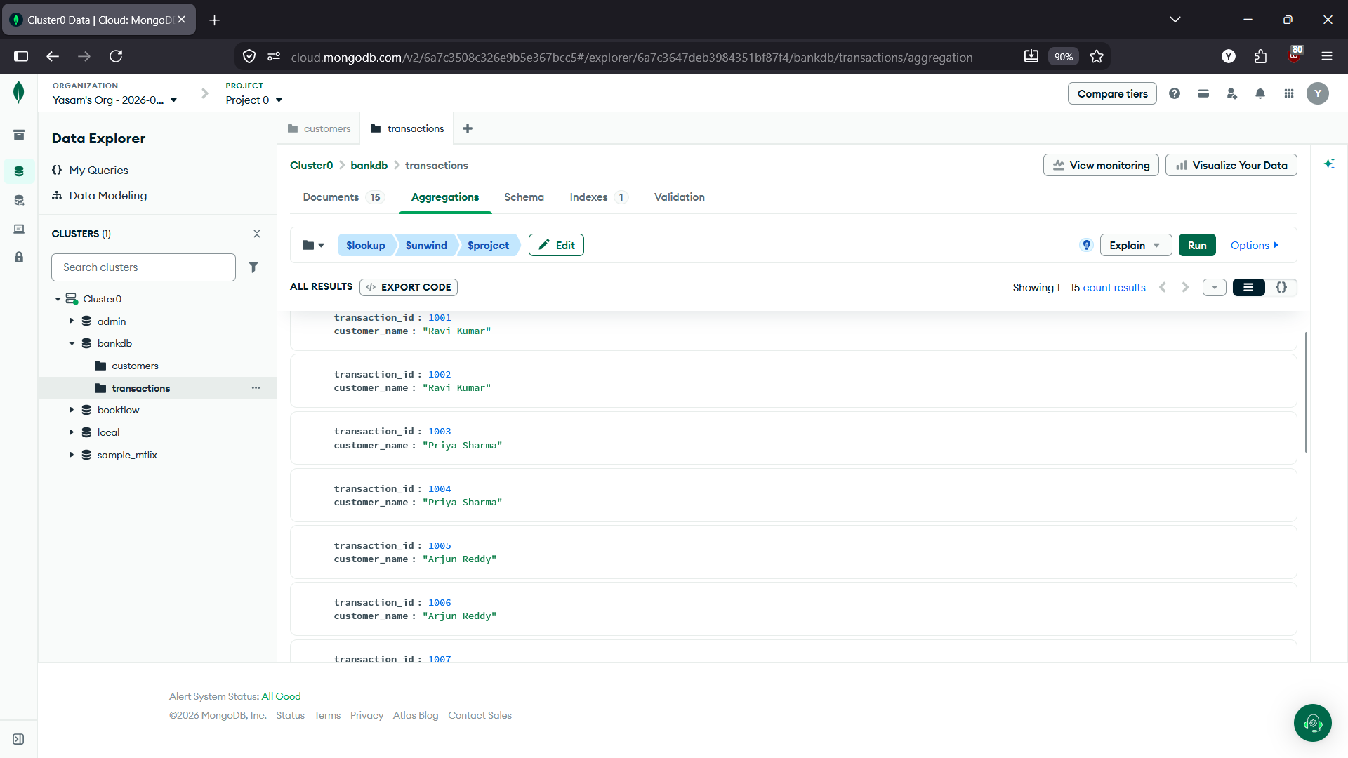

Query 19 — Total transaction amount for each customer
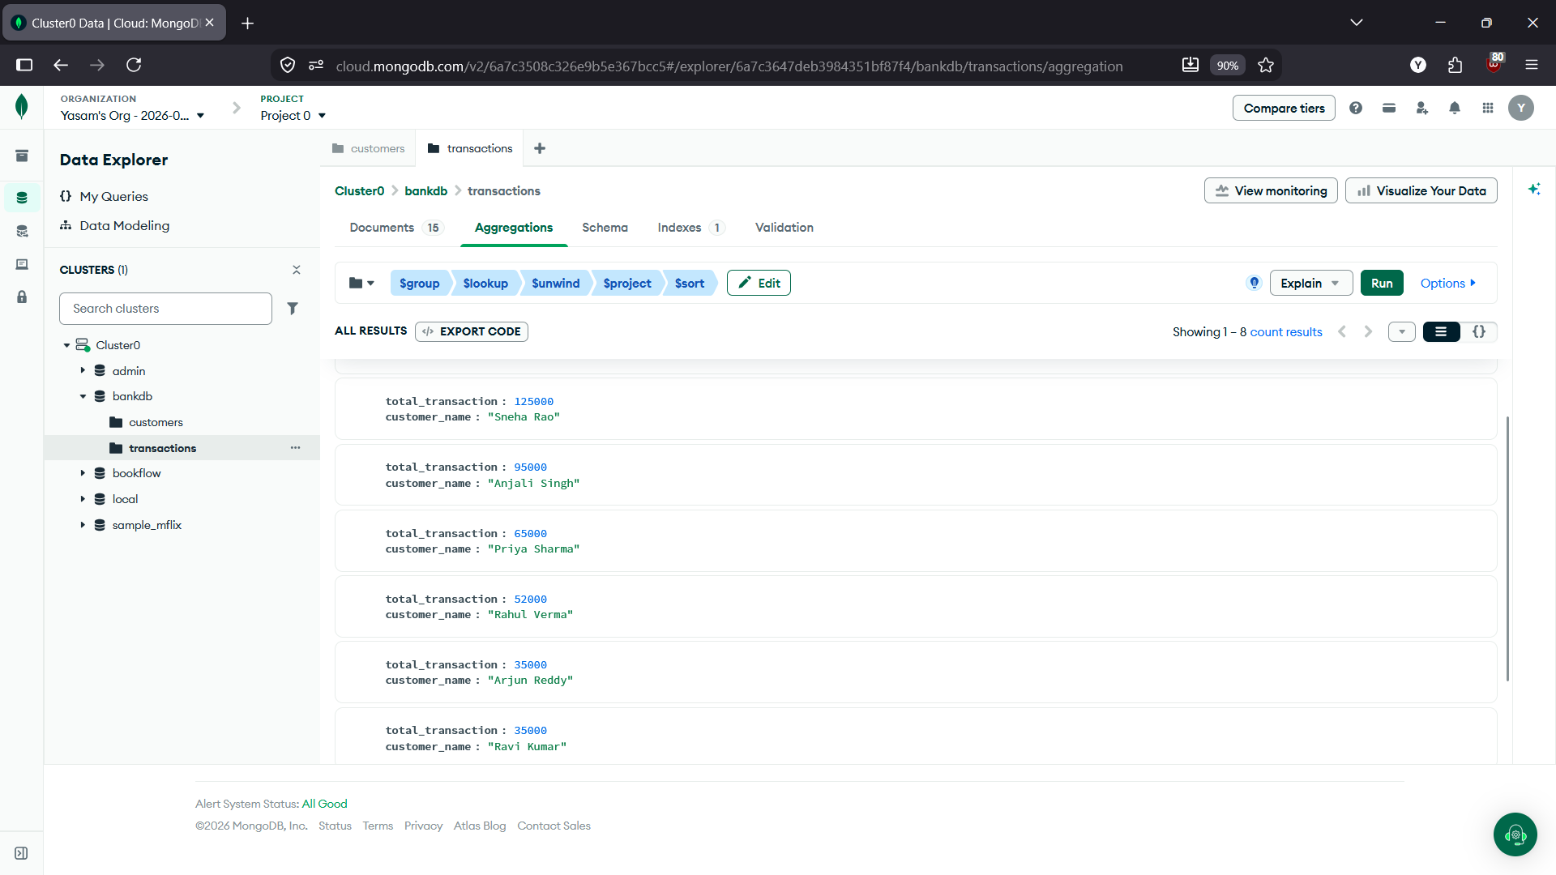
Query 20 — Complex Bank Transaction Report
