Database System Engineering and Distributed Backend Development
Course Code: 25CS1302E
Name: Yasam Bhaarathi
Roll no: 2520030211
PART 1 – CREATE DATABASE
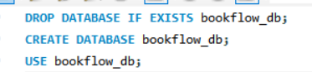
Output:
PART 2 – CREATE BOOKS TABLE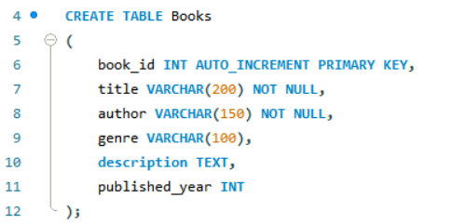
Output:
Output: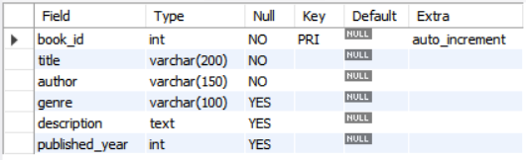
PART 3 – INSERT BOOK DATA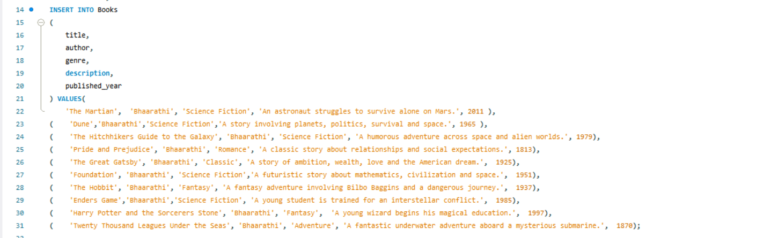
Output:
PART 4 – DISPLAY BOOKS
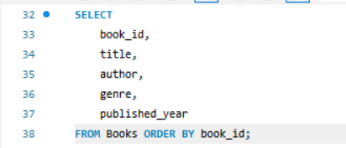
Output:
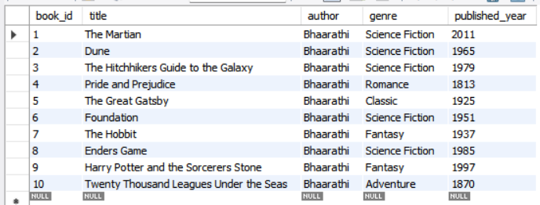
PART 5 – ADD EMBEDDING COLUMN
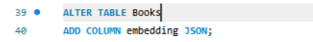
Output:

PART 6 – INSERT MOCK VECTORS
BOOK 1 – THE MARTIAN
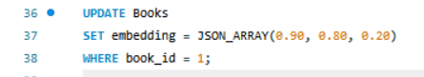
Output:
BOOK 2 – DUNE
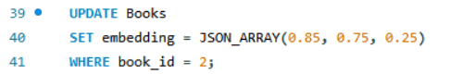
Output:
BOOK 3 – HITCHHIKERS GUIDE
Output:
BOOK 4 – PRIDE AND PREJUDICE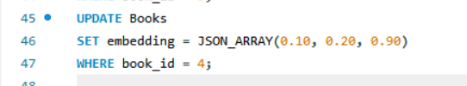
Output:
BOOK 5 – GREAT GATSBY
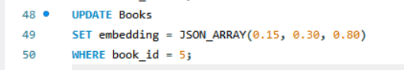
Output:
BOOK 6 – FOUNDATION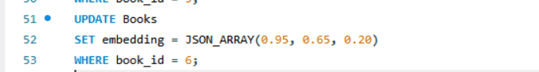
Output:
BOOK 7 – THE HOBBIT
Output:
BOOK 8 – ENDERS GAME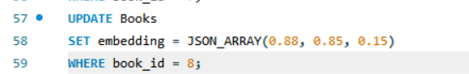
Output:
BOOK 9 – HARRY POTTER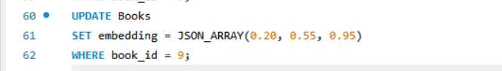
Output:
BOOK 10 – TWENTY THOUSAND LEAGUES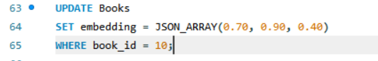
Output:

PART 7 – VERIFY ALL VECTORS
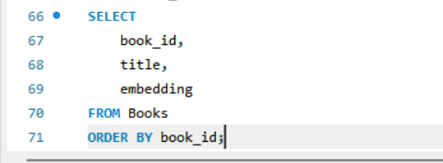
Output:
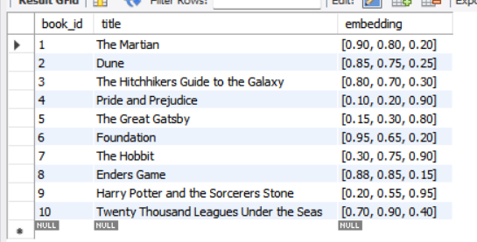
PART 8 – L2 DISTANCEPART 8 – L2 DISTANCE
Output:
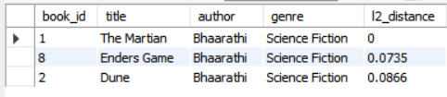

PART 9 – COSINE SIMILARITY
Output:
