Database System Engineering and Distributed Backend Development
Course Code: 25CS1302E
Joins and Set Operations
Name: Yasam Bhaarathi
Roll no: 2520030211

Query 1
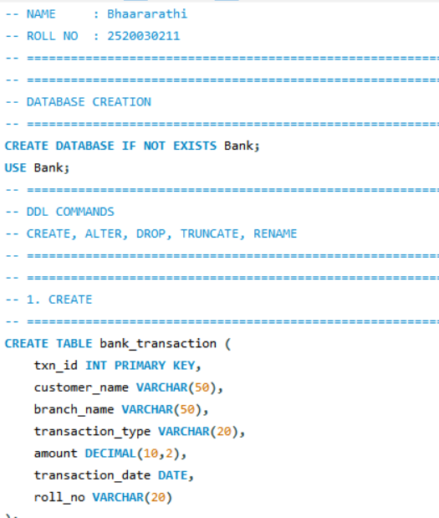
Output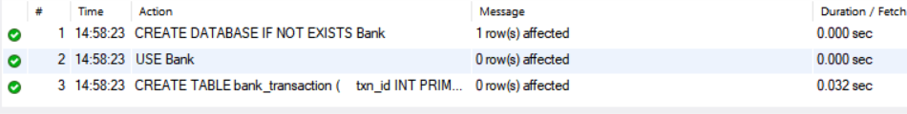

Query 2
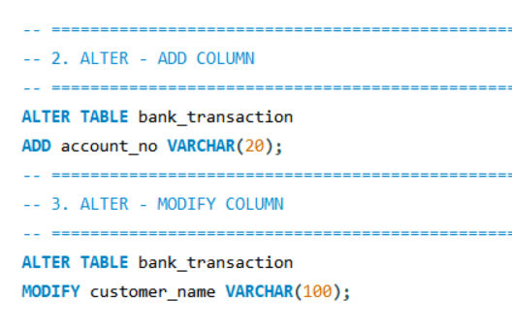
Output
Query 3
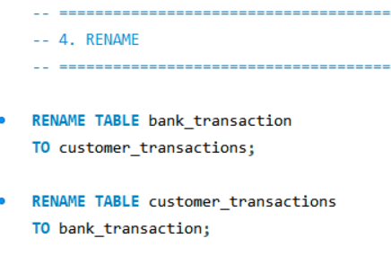
Output

Query 4
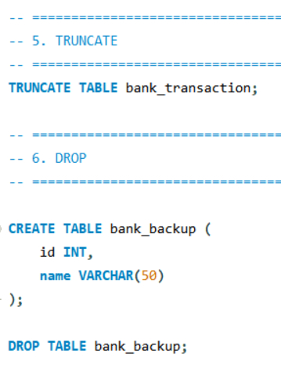
Output

DML COMMANDS
-- INSERT, UPDATE, DELETE, SELECT
Query 5
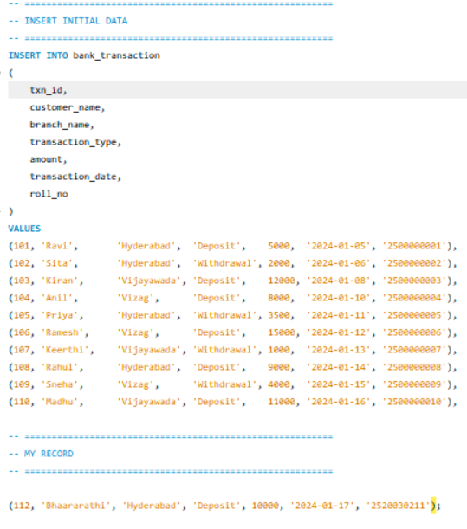
Output

Query 6
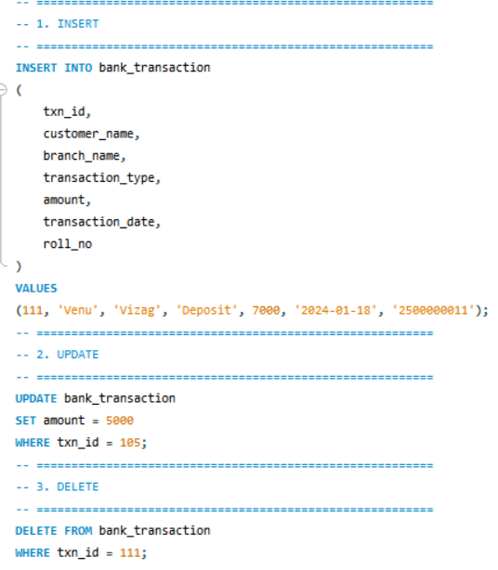
Output

Query 7
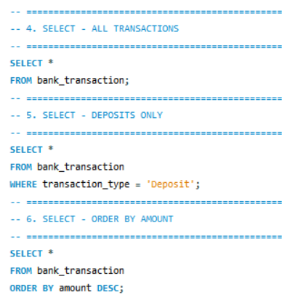
Output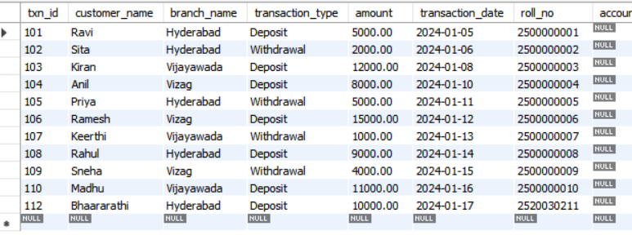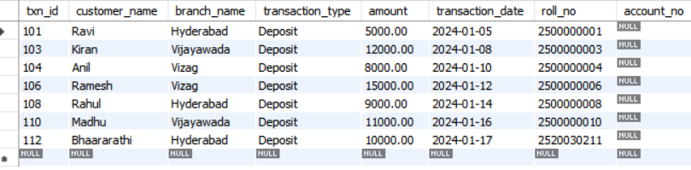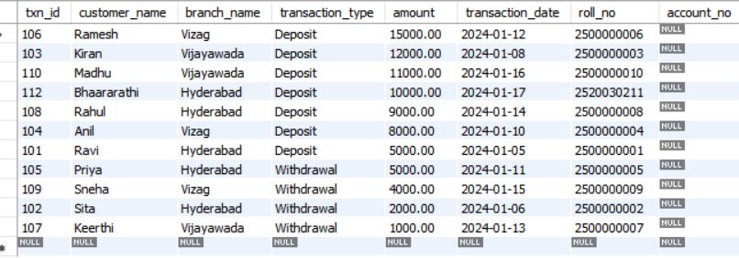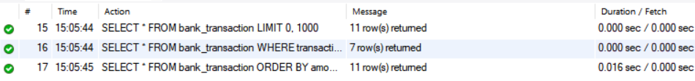

-- DCL COMMANDS
-- GRANT, REVOKE
Query 8 & 9 :
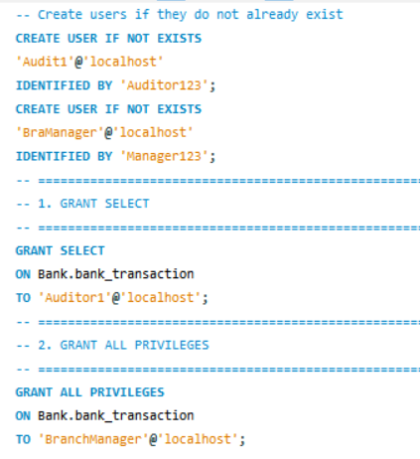
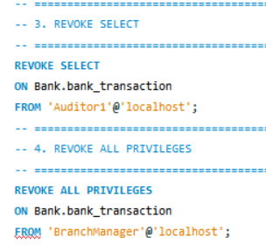
Output
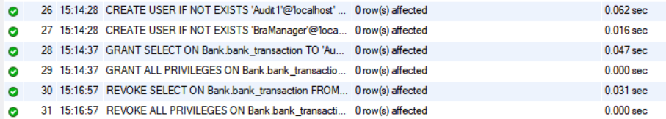

-- TCL COMMANDS
-- COMMIT, SAVEPOINT, ROLLBACK
Query 10
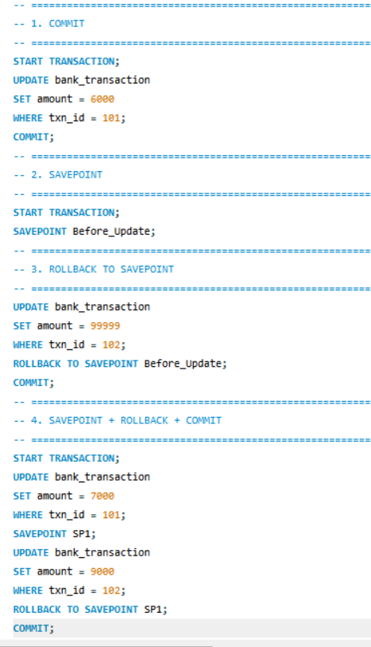
Output
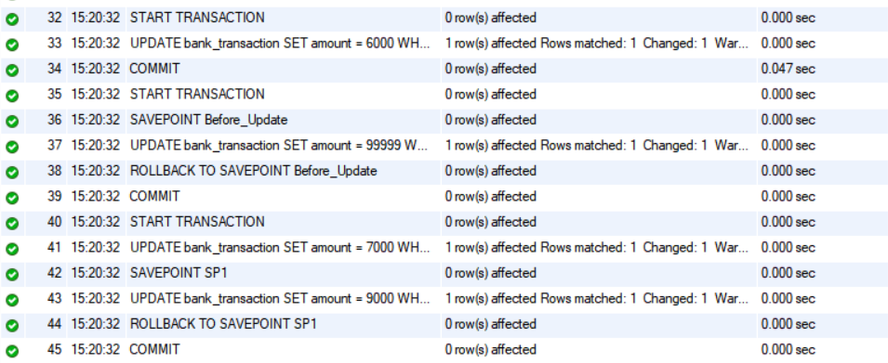
Query 11
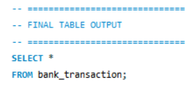
Output
