Database System Engineering and Distributed Backend
Development
Course Code: 25CS1302E
Week-2

Name: Yasam Bhaarathi Roll Name: 2520030211 Branch & Section: CSE,07 Date: 04-08-2026

Query – 1: Create a Database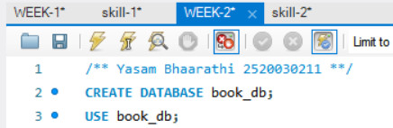
Output:
Query – 2: Create Books Table (DDL + Constraints)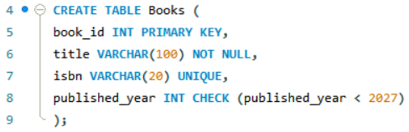
Output:

Query – 3 & 4: Insert Books and Display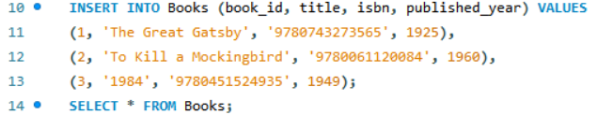Output: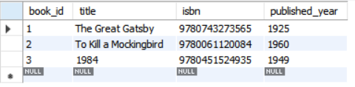
Query – 5, 6 & 7: Members Table: Create, Insert, Display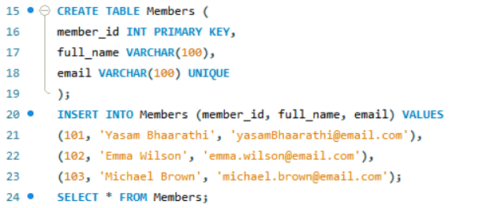Output:
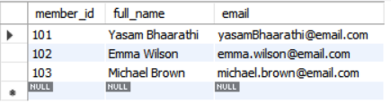

Query -8: Create Loans Table (FOREIGN KEYS)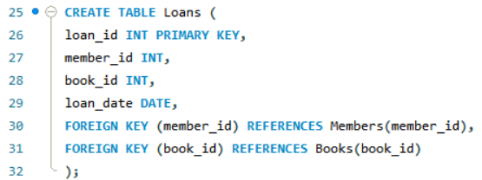
Output:
Query – 9 & 10: Insert 10 Loans and Display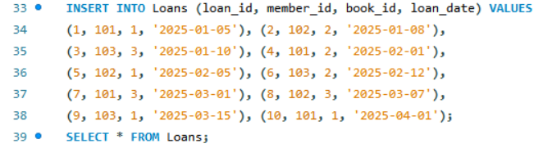Output:
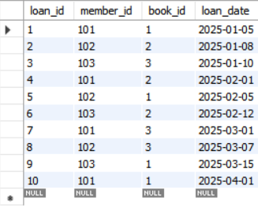

Query – 11: JOIN Query (Who Borrowed What)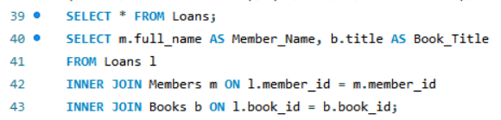Output:
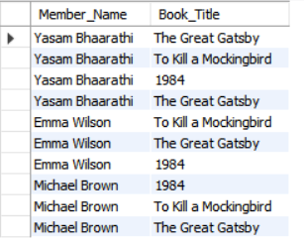Query – 12: GROUP BY Query (Books per Year) 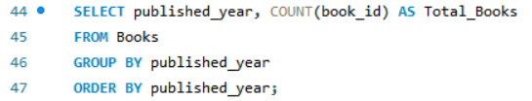Output:
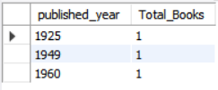
Query – 13 to 16: Donation via TRANSACTION (Atomicity) 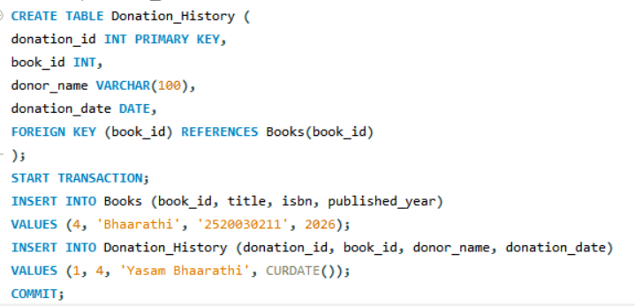Output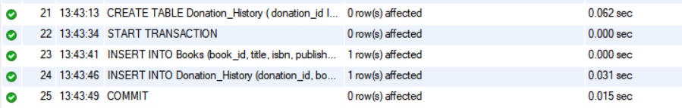
Output table after COMMIT: 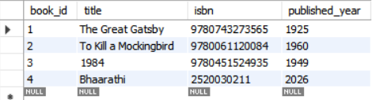 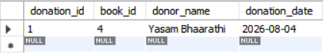

Query – 17 & 18: Index on ISBN + Fast Search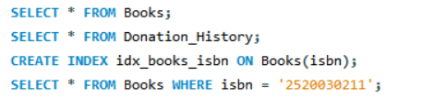
Output:
