Database System Engineering and Distributed Backend
Development
Course Code: 25CS1302E
Week-1

Name: Yasam Bhaarathi Roll Name: 2520030211 Branch & Section: CSE,07 Date: 04-08-2026

Query – 1: Create a Database 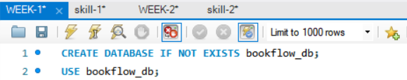
Output:
Query – 2: Create the books table 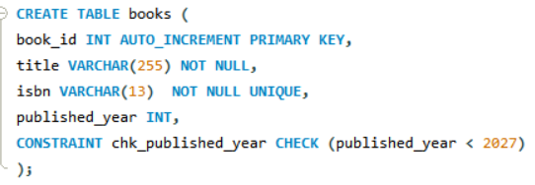
Output:

Query – 3: Create the member’s table 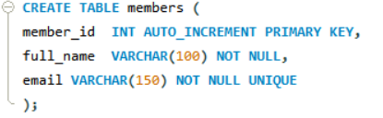
Output:
Query – 4 (verification): Inspect the table structures 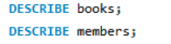
Output:
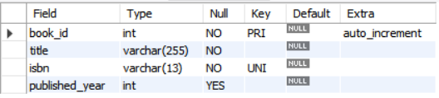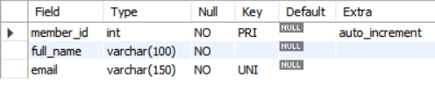
Query -5: Insert 3 books 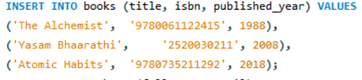
Output:

Query – 6: Insert 3 members 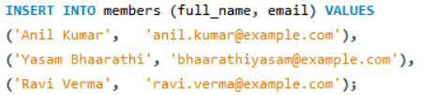
Output:
Query – 7: Select both members and books 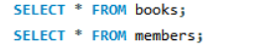
Output:
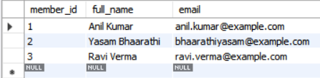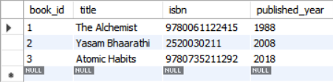

Test 1: Duplicate ISBN (UNIQUE violation) 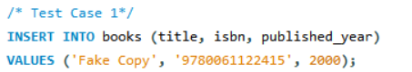
Output:
Test 2: NULL title (NOT NULL violation)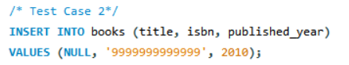
Output:

Test 3: Future publication year (CHECK violation)
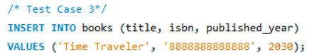
Output:
Test 4: Duplicate email (UNIQUE violation)
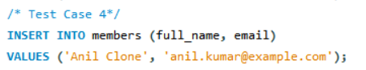
Output:

