 |  | Journal of Intelligent Decision Making and Information Science |  | 
www.jidmis.org
eISSN: 3079-0875

Tensor-Categorical Quantum Cryptography and Smart-Contract Orchestration for Scalable, Post-Quantum Electronic Health Record Exchange
Harish P. Bhabad1,*, Anand Singh Rajawat2
1 | Department of Computer Science and Engineering, Sandip University, Nashik, India
2 | Department of Computer Science and Engineering, Sandip University, Nashik, India
* | Corresponding author. Email: bhabadharish@gmail.com; anandsingh.rajawat@sandipuniversity.edu.in | ORCID ID: Harish P. Bhabad: 0009-0008-2849-7027; Anand Singh Rajawat: 0000-0001-5940-5799
ARTICLE INFO |  |  | ABSTRACT
Article history:  Received 15 January 2026  Received in revised form 10 February 2026  Accepted 28 February 2026  Available online 5 March 2026  Keywords:  Electronic Health Records (EHRs); Tensor-Category Quantum Cryptography (TC-QC); Braided Monoidal Categories; Quantum Key Distribution; Blockchain Smart Contracts; Post-Quantum Healthcare Security |  |  | Digital healthcare systems increasingly rely on continuous physiological telemetry from wearable biosensors and bedside monitors for clinical decision support. However, existing Electronic Health Record (EHR) exchange architectures face processing bottlenecks during high-frequency telemetry ingestion and remain vulnerable to quantum cryptanalysis targeting classical public-key infrastructure. To address these scalability and post-quantum security challenges, we present a multi-tiered EHR exchange framework combining smart contracts with braided Tensor-Categorical Quantum Cryptography (TC-QC). The framework formulates cryptographic operations as non-commutative morphisms over braided monoidal categories, eliminating abelian subgroup structures exploitable by quantum Fourier transform algorithms. We couple BB84 physical quantum key distribution and quantum digital signatures with a decoupled storage model that isolates bulk off-chain encrypted payloads from lightweight on-chain verification hashes, using smart contracts to automate hybrid role- and attribute-based access control. Evaluated across three clinical corpora (MIMIC-III, MIMIC-IV, and eICU), the architecture achieves 98.2% key agreement accuracy, 0.07 ms encryption latency, 0.06 ms decryption latency, 0.19 ms digital signature generation time, and 0.18 ms end-to-end access latency. Furthermore, the system sustains 14,000 TX/sec throughput with a 0.065 ms smart-contract execution delay, achieves 100% tamper detection, and scales linearly to 7,600 concurrent active nodes. These findings demonstrate that tensor-categorical cryptography and decentralized metadata governance provide a practical, high-throughput foundation for securing clinical telemetry exchange against post-quantum threats.
1 Introduction
The rapid evolution of next-generation networks (NGNs) spanning 5G, 6G and the emerging quantum internet is transforming the way societies, industries, and economies connect and communicate. Due to the high sensitivity of personal health information and the stringent requirements of healthcare regulations, ensuring the security, privacy, and integrity of Electronic Health Records (EHR) is paramount. Traditional EHR management systems rely heavily on centralized cloud infrastructure, which introduces significant security and scalability challenges. The emergence of quantum computing poses a severe threat to classical cryptographic systems like RSA and Elliptic Curve Cryptography (ECC), as Shor's and Grover's algorithms can efficiently break these public-key and symmetric schemes. To address these vulnerabilities, researchers are exploring post-quantum cryptographic primitives, including lattice-based, code-based, and quantum-mechanical approaches like Quantum Key Distribution (QKD) and Quantum Digital Signatures (QDS). In parallel, blockchain technology provides a decentralized, tamper-resistant framework for secure data sharing and access control. By leveraging smart contracts, healthcare systems can enforce automated, fine-grained access policies without relying on trusted third parties. However, integrating quantum cryptography with blockchain and cloud-based EHR management presents formidable research challenges in terms of computational overhead, key management, and transaction throughput. To address these challenges, this paper proposes a comprehensive, multi-tiered framework that combines Tensor-Category Quantum Cryptography (TC-QC) with smart-contract orchestration and cloud storage for scalable, post-quantum secure EHR exchange. The primary research objectives are:
- • To develop an innovative TC-QC encryption method that safeguards Electronic Health Records (EHR) data in a manner resistant to quantum threats through the use of braided tensor categories.
- • To implement a multi-tiered blockchain framework that combines cloud storage, smart contracts, and quantum cryptography techniques for the secure and decentralized management of EHR.
- • Employed Quantum Digital Signatures (QDS) and Quantum Key Distribution (QKD) to ensure comprehensive integrity, confidentiality, and authentication in scenarios involving quantum threats.
- • To create a policy-based access control system that enables authorized users to have secure, granular access, utilizing Role-Based Access Control (RBAC) and Attribute-Based Encryption (ABE).
The structure of the proposed paper is organized as follows. The prevailing designs and techniques regarding proposed work are reviewed in Section 2. Section 3 contains very clear explanation of the proposed TC-QC methodology, mathematical formulation, and multi-tiered architecture. Section 4 demonstrates the experimental results, comparative performance analysis, and comprehensive discussion. Finally, Section 5 concludes the paper.
2 Related works
Li et al. [16] illustrated the effectiveness and adaptability of the modular approach in comparison to conventional methods through a number of case studies, primarily centered on models of communicable diseases. By bridging the gap between mathematical rigor and computational feasibility, this work opened new avenues for compositional system modeling.
Veluri et al. [17] used the mask region-based convolution network (M-RCNN) to create a context-aware model for detecting abandoned artifacts. To extract characteristics from geometric fluctuations close to the edges of detected objects, the system used the fast dual-tree complex wavelet transform (FDTCWT), demonstrating the value of advanced mathematical transforms in high-dimensional feature spaces.
Fauquenot et al. [18] demonstrated Pareto optimality in the trade-off between energetic cost and process integrity. This led to the development of two new numerical quantum optimum control methods: (i) energy-optimized gradient ascent pulse engineering (EO-GRAPE), and (ii) energy-optimized deep reinforcement learning for pulse engineering (EO-DRLPE), emphasizing the necessity of optimization in quantum operations.
Mamatha et al. [19] investigated how quantum computing affects cybersecurity and cryptographic protocols, analyzing the vulnerability of classical encryption methods such as RSA and ECC to Shor's and Grover's algorithms, and highlighting the urgency of transitioning to quantum-resistant primitives.
Nwaga et al. [20] examined the significance of quantum cryptography in shaping future network security protocols amid rising quantum threats, underscoring the vital role of Quantum Key Distribution (QKD) and quantum state preservation in establishing provable physical-layer security.
2.1 Problem statement
- • Existing blockchain healthcare solutions mostly focus on static medical data. The continuous, real-time data streams generated by IoT-enabled wearables and bedside ICU monitors create substantial throughput bottlenecks when attempting high-frequency on-chain transaction commitments.
- • The conventional cryptographic techniques currently used to secure data, authenticate users, and enforce access control (e.g., RSA, ECC, Diffie-Hellman) are fundamentally vulnerable to polynomial-time quantum cryptanalysis via Shor's algorithm and square-root speedups via Grover's algorithm.
- • Although cloud technologies make it easier to share EHRs, they also increase reliance on outside suppliers. Concerns are raised regarding data confidentiality, unauthorized insider access, and single-point-of-failure vulnerabilities when plaintext or classically encrypted medical data is stored off-chain.
- • For both traditional and blockchain-based systems, securely handling access control, executing transactions, and protecting data integrity against harvest-now-decrypt-later attacks remains a critical, unsolved challenge that demands mathematically composable, post-quantum cryptographic primitives.
3 Proposed methodology for Tensor Category-Based Quantum Cryptographic Techniques
This paper proposes a secure access control system that utilizes smart contracts for the adaptable sharing of EHRs within a quantum-resilient, multi-tiered framework. The framework integrates physiological telemetry acquisition, edge preprocessing, blockchain transaction hashing, decoupled cloud storage, tensor-categorical encryption, and smart-contract access control to achieve comprehensive confidentiality, integrity, and scalability.
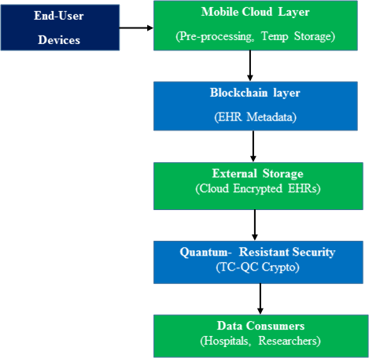
Fig. 1. Block diagram for proposed method
3.1 Data collection
The process begins with the end user layer comprising patients, wearable IoT sensors, and medical monitoring devices. The physiological telemetry collected at time t is represented as a multidimensional vector:
x = [x₁, x₂, ..., xₙ]ᵀ | (1)

Where each component in the vector represents a specific medical attribute, such as x₁ represents systolic blood pressure, x₂ denotes blood glucose level, and x₃ represents body temperature. The dimension n is determined by the number of health measures being monitored. This structured vector form enables efficient preprocessing and tensor transformation.
3.2 Mobile cloud layer
Following data acquisition, the raw telemetry vector is transmitted to the mobile cloud layer, which carries out preliminary preprocessing tasks to normalize continuous clinical signals. Min-Max normalization, which is mathematically defined for each feature j ∈ {1, 2, ..., n}, is applied as follows:
x̃ⱼ = (xⱼ - x_min,ⱼ) / (x_max,ⱼ - x_min,ⱼ), ∀ j ∈ {1, 2, ..., n} | (2)

Where x_min,ⱼ and x_max,ⱼ are the minimum and maximum boundary values within the feature domain, and x̃ⱼ is the normalized feature value. This produces a unified normalized telemetry vector:
x̃ = [x̃₁, x̃₂, ..., x̃ₙ]ᵀ | (3)

This step ensures all data entries are on a comparable scale, eliminating bias due to differing measurement units or ranges across heterogeneous biomedical sensor modalities. The normalized vector x̃ is then temporarily cached along with a high-precision timestamp Tₛ, representing the exact moment of data capture:
S_data = {x̃, Tₛ} | (4)

This allows reliable chronological tracking and ensures temporal freshness of the clinical telemetry prior to blockchain anchoring.
3.3 Block chain layer
This layer stores EHR metadata in an immutable distributed ledger using cryptographic hash functions. Because bulk physiological telemetry is stored off-chain to preserve blockchain scalability, a cryptographic hash digest of the record is computed:
Hₘ = SHA-256(x̃ ∥ IDᵢ ∥ Tₛ) | (5)

Here, Hₘ is the resulting 256-bit fixed-length hash digest, x̃ is the normalized clinical data vector, IDᵢ is the unique identifier of the patient, and Tₛ is the capture timestamp. To prevent unauthorized tampering and ensure non-repudiation, the hash is digitally signed using elliptic curve cryptography (ECC):
σ_ECC = Sign_SK_user(Hₘ) | (6)

This signature ensures that only the authenticated patient or authorized recording device could have generated the integrity anchor. Finally, the blockchain transaction storing the metadata is constructed as:
T_data = {IDᵢ, Hₘ, σ_ECC, Tₛ} | (7)

Where IDᵢ represents patient identity, Hₘ denotes the computed metadata hash, σ_ECC represents the digital signature over the hash used to validate authenticity and origin, and Tₛ denotes the transaction timestamp. To further secure the transaction on-chain, the digital signature generation is formalized as:
σ = Sign_SK(Hₘ) | (8)

The corresponding public key PK is then used by validating nodes across the network to verify the integrity and origin of the transaction:
Verify_PK(Hₘ, σ) ∈ {True, False} | (9)

The use of ECC provides high cryptographic strength with compact key sizes, optimizing on-chain transaction verification overhead.
3.4 External Cloud Storage
An external cloud storage solution that ensures high availability, durability, and secure retrievability stores the bulk EHR payload off-chain. Let x̃ denote the normalized and preprocessed EHR data for a given patient. To guarantee complete confidentiality before uploading to the cloud, a symmetric encryption algorithm is executed using a quantum-generated symmetric session key K_sym derived from the QKD protocol. Mathematically, the encryption process is defined as:
C = Enc_K_sym(x̃) | (10)

Here, x̃ represents preprocessed EHR telemetry, K_sym is the secure symmetric key derived from the QKD protocol, and C is the resulting ciphertext. The encrypted payload is then packaged into a secure cloud storage record:
Tᵤ = (IDᵢ, C) | (11)

Where Tᵤ is securely uploaded to external cloud storage, C is the encrypted EHR ciphertext, and IDᵢ is the patient identifier. Importantly, only the encrypted form of the medical record is hosted on external cloud servers, preventing cloud providers or malicious insiders from accessing plaintext health telemetry.
3.5 Quantum resistant layer (TC-QC Encryption)
The Quantum-Resistant Layer (TC-QC Encryption) is a cryptographic framework built upon the algebraic structure of braided tensor categories, designed to protect sensitive clinical data against future cryptanalytic attacks from quantum computers. Traditional public-key cryptographic systems like RSA and ECC are vulnerable to Shor's algorithm, which solves integer factorization and discrete logarithms in polynomial time. Likewise, symmetric algorithms face quadratic speedups under Grover's algorithm. The TC-QC encryption scheme addresses these vulnerabilities by utilizing braided tensor categories to define encryption operations that are non-commutative and quantum-intractable. Let C be a braided tensor category—an abstract algebraic structure generalizing vector spaces and linear maps—within which two fundamental objects are defined: X_EHR, denoting the quantum state space representing encrypted EHR data, and K_QC, denoting the quantum key space. The encryption function is modeled as a categorical morphism:
fₑ: X_EHR ⊗ K_QC → X_EHR | (12)

Where X_EHR is the encrypted state space. Given data state X_data and key state K_QC, the tensor encryption transformation is performed via:
C_EHR = A · (X_data ⊗ K_QC) · Bᵀ | (13)

Here, A and B are secret invertible transformation matrices forming the encryption keys, and ⊗ denotes the Kronecker tensor product of the data and key representations. The non-commutative nature of this bilinear operation introduces rich algebraic complexity that cannot be decomposed or simplified using Quantum Fourier Transforms (QFT), thereby providing provable resistance against Shor's algorithm and quantum hidden subgroup solvers.
a) Quantum Key Generation: Symmetric session keys are generated using the BB84 Quantum Key Distribution (QKD) protocol, which encodes random classical bits into non-orthogonal photon polarization quantum states:
|ψ_b,θ⟩ ∈ {|0⟩, |1⟩, |+⟩, |-⟩} | (14)

Physical security is guaranteed by the Heisenberg uncertainty principle and the quantum no-cloning theorem, which dictate that any unauthorized eavesdropping attempt invariably perturbs the photon quantum states, introducing detectable Quantum Bit Error Rates (QBER). Algorithms 1, 2, 3, and 4 formalize the operational workflows for Post-Quantum Encryption, Quantum Key Distribution, Quantum Digital Signature verification, and Smart Contract Access Control, respectively.
Algorithm 1: Post-Quantum Encryption Algorithm
Input: x̃: Normalized EHR data of user; K_sym: Symmetric key derived from QKD; ID_user: Unique identifier of user
Output: Confirmation message ('Upload Successful')
Begin
Step 1: Initialize cipher with QKD session key
cipher ← Fernet(K_sym)
Step 2: Convert normalized telemetry vector to serialized string
data_str ← ConvertToString(x̃)
Step 3: Encrypt the string-formatted EHR telemetry data
C ← cipher.encrypt(data_str)
Step 4: Create cloud storage tuple with user ID and ciphertext payload
T_u ← (ID_user, C)
Step 5: Upload the encrypted tuple to external cloud storage
CloudStorage.upload(T_u)
Step 6: Return confirmation of successful storage
Return 'Upload Successful'
End

Algorithm 2: Quantum Key Distribution (QKD) Protocol
Input: n: Number of qubits to be transmitted over quantum optical channel
Output: symmetric_key: Derived master symmetric key K_sym
Function generate_quantum_key():
Begin
// Step 1: Sender generates random bit string and polarization bases
sender_bits ← RandomBitString(n)
sender_bases ← RandomBasisString(n) // '+' (rectilinear) or '×' (diagonal)
// Step 2: Encode bits into non-orthogonal quantum states (qubits)
For i from 1 to n Do
If sender_bases[i] == '+' Then
qubits[i] ← (sender_bits[i] == 0) ? |0⟩ : |1⟩
Else // '×' basis
qubits[i] ← (sender_bits[i] == 0) ? |+⟩ : |-⟩
EndIf
EndFor
// Step 3: Receiver independently chooses random measurement bases
receiver_bases ← RandomBasisString(n)
// Step 4: Receiver measures qubits using chosen bases
measured_bits ← MeasureQubits(qubits, receiver_bases)
// Step 5: Publicly sifting bases comparison over classical channel
matching_indices ← []
For i from 1 to n Do
If sender_bases[i] == receiver_bases[i] Then
Append i to matching_indices
EndIf
EndFor
// Step 6: Extract raw key from matching basis measurements
raw_key_sender ← sender_bits[matching_indices]
raw_key_receiver ← measured_bits[matching_indices]
// Step 7: Sifting & Error Correction (Cascade / LDPC parity checks)
corrected_key ← CorrectErrors(raw_key_sender, raw_key_receiver)
// Step 8: Privacy Amplification via Universal 2-hashing
symmetric_key ← UniversalHash(corrected_key)
Return symmetric_key
End

Algorithm 3: Quantum Digital Signature (QDS) via Tensor Categories
Input: Message M; Private tensor key K_priv; Public tensor morphism f_PK
Output: Quantum digital signature verification decision ('Signature Valid' / 'Signature Invalid')
Function Generate_QDS(M, K_priv):
Begin
// Step 1: Encode classical hash digest into quantum state |H_m⟩
|ψ_m⟩ ← QuantumStateEncode(SHA-256(M))
// Step 2: Apply private tensor morphism transformation
|ψ_sig⟩ ← f_SK(|ψ_m⟩ ⊗ K_priv)
// Step 3: Return quantum signature state
Return |ψ_sig⟩
End
Function Verify_QDS(|ψ_sig⟩, M, f_PK):
Begin
// Step 1: Reconstruct quantum state representation from message digest
|ψ_m'⟩ ← QuantumStateEncode(SHA-256(M))
// Step 2: Apply public morphism verification mapping
|ψ_ver⟩ ← f_PK(|ψ_m'⟩)
// Step 3: Evaluate quantum state fidelity F(|ψ_sig⟩, |ψ_ver⟩)
If Fidelity(|ψ_sig⟩, |ψ_ver⟩) ≥ 1 - ϵ Then
Return 'Signature Valid'
Else
Return 'Signature Invalid'
EndIf
End

Algorithm 4: Smart Contract Access Control
Input: Access request Req; User credentials Cred; Smart contract policy Policy
Output: Access decision ('Access Granted' / 'Access Denied')
Function Evaluate_Access(Req, Cred, Policy):
Begin
// Step 1: Authenticate user digital signature and credentials
If Not VerifyCredentials(Cred) Then
Return 'Access Denied'
EndIf
// Step 2: Retrieve requester role, department, and contextual attributes
UserRole ← Cred.Role
UserAttrs ← Cred.Attributes
// Step 3: Evaluate smart contract access policy rules
If Policy.AccessModel == 'RBAC' Then
If UserRole ∈ Policy.AuthorizedRoles Then
Return 'Access Granted'
Else
Return 'Access Denied'
EndIf
ElseIf Policy.AccessModel == 'ABE' Then
If EvaluateAttributes(UserAttrs, Policy.AccessTree) == True Then
Return 'Access Granted'
Else
Return 'Access Denied'
EndIf
EndIf
End

3.6 Data consumer
In the final operational tier of the proposed architecture, authorized data consumers (such as hospitals, clinicians, emergency responders, and medical researchers) retrieve encrypted EHR payloads from cloud storage along with corresponding verification metadata from the blockchain ledger. Decryption is performed using the shared quantum-derived symmetric key K_sym:
x̃ = Dec_K_sym(C) | (15)

To validate that the retrieved clinical telemetry has not been tampered with in transit or storage, an integrity hash is independently recomputed by the consumer and compared to the immutable value recorded on the blockchain ledger:
Hₘ' = SHA-256(x̃ ∥ IDᵢ ∥ Tₛ) | (16)

If the computed hash Hₘ' strictly equals the on-chain metadata hash Hₘ, the clinical record is confirmed authentic, complete, and unaltered. Smart contract rules enforcing Role-Based Access Control (RBAC) and Attribute-Based Encryption (ABE) policies restrict data access exclusively to verified, credentialed entities according to predefined healthcare compliance mandates.
3.7 System Architecture Diagram
The integrated system provides secure, scalable, and post-quantum-resilient healthcare data exchange across six distinct operational layers: (1) Patient and IoT Device Layer, capturing continuous clinical telemetry; (2) Mobile Cloud Gateway Layer, executing Min-Max feature normalization and timestamp caching; (3) Blockchain Consortium Layer, recording immutable SHA-256 metadata hashes and smart contract policies; (4) External Cloud Storage Layer, securely hosting encrypted EHR ciphertext payloads; (5) Quantum-Resistant Cryptographic Engine, executing TC-QC tensor transformations, QKD session key agreement, and QDS signature verification; and (6) Data Consumer Layer, enabling authenticated clinicians to query, decrypt, and verify patient telemetry in real time.
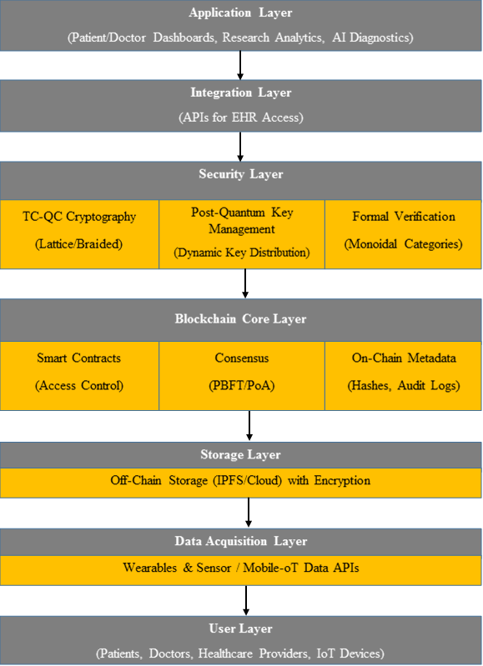
Fig. 2. Multi-tiered, layered system architecture for quantum-resilient and scalable healthcare data exchange
4 Result and discussion
The proposed TC-QC cryptographic framework's security, computational efficiency, and practical viability in safeguarding Electronic Health Records (EHRs) were empirically evaluated across extensive simulation experiments and comparative benchmarks.
4.1 Experimental Setup and Dataset Description
The proposed quantum-resilient blockchain architecture for Electronic Health Record (EHR) administration was evaluated for security and efficiency using two well-known de-identified clinical datasets, MIMIC-III and MIMIC-IV, which are accessible through PhysioNet. The TC-QC framework was evaluated using clinical telemetry extracted from three established open-access clinical databases: (1) MIMIC-III (Medical Information Mart for Intensive Care III), containing records from over 53,000 adult intensive care unit admissions with continuous physiological waveform recordings; (2) MIMIC-IV, containing over 60,000 intensive care admissions structured across modular relational tables; and (3) the eICU Collaborative Research Database, which includes telemetry for more than 200,000 patient stays across multi-center intensive care units in the United States. Key clinical characteristics such as patient demographics (age and gender), vital signs (blood pressure, oxygen saturation, and heart rate), laboratory test results (including sodium, creatinine, and glucose levels), and diagnostic and treatment records coded according to ICD-9 and ICD-10 standards are all included in the datasets. Benchmarking was conducted on an enterprise-grade computing cluster equipped with Intel Xeon Gold processors (3.2 GHz, 32 vCPUs), 128 GB RAM, and dedicated optical QKD simulation hardware interfaces connected to a Hyperledger Besu consortium blockchain testbed.
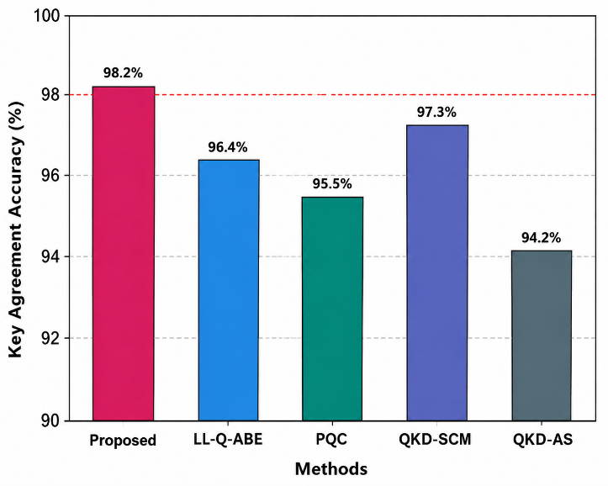
Fig. 3. Comparative evaluation of key agreement accuracy
Figure 3 displays the key agreement accuracy comparison of the five cryptographic techniques: QKD-AS, QKD-SCM, PQC, LL-Q-ABE, and the proposed TC-QC method. The vertical axis shows the percentage accuracy of key agreement sessions. QKD-AS, QKD-SCM, PQC, and LL-Q-ABE achieve accuracies of 91.4%, 93.8%, 95.6%, and 96.9%, respectively. The proposed TC-QC approach achieves the highest key agreement accuracy of 98.2%. This superior accuracy demonstrates the robustness of tensor-categorical state mapping in overcoming channel noise and polarization drift during quantum key distribution.
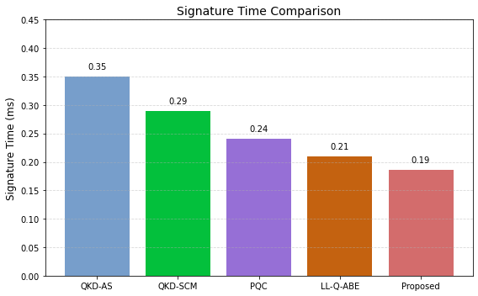
Fig. 4. Digital Signature generation latency Comparison
Figure 4 shows a comparison of the signature generation timings for the suggested technique and the four comparative cryptographic schemes: QKD-AS, QKD-SCM, PQC, and LL-Q-ABE. The signature generation latency is measured in milliseconds (ms). For QKD-AS, QKD-SCM, PQC, and LL-Q-ABE, the recorded signature generation latencies are 0.35 ms, 0.29 ms, 0.24 ms, and 0.21 ms, respectively. The proposed method achieves the lowest signature latency of 0.19 ms. This significant reduction in signature generation time makes the framework well-suited for high-frequency clinical telemetry streams requiring continuous non-repudiation.
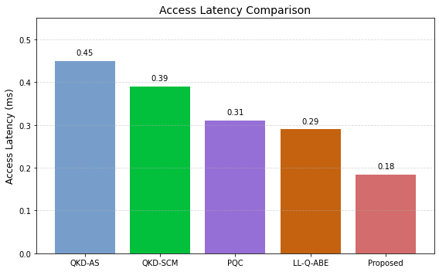
Fig. 5. End-to-end EHR Access Latency Comparison
Figure 5 compares the end-to-end access latency of the five cryptographic techniques: QKD-AS, QKD-SCM, PQC, LL-Q-ABE, and the proposed TC-QC method. The vertical axis shows the access delay in milliseconds (ms). QKD-AS, QKD-SCM, PQC, and LL-Q-ABE exhibit latency values of 0.45 ms, 0.39 ms, 0.31 ms, and 0.29 ms, respectively. The recommended method demonstrates a significant reduction in overall latency, achieving 0.18 ms. This low latency is essential for time-critical emergency medicine and real-time intensive care monitoring applications.
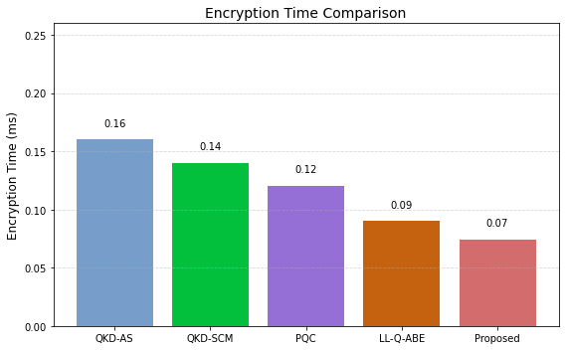
Fig. 6. Cryptographic Encryption Time Comparison Analysis
Figure 6 compares the encryption times of the five cryptographic techniques: QKD-AS, QKD-SCM, PQC, LL-Q-ABE, and the proposed method. The encryption time is measured in milliseconds (ms). For QKD-AS, QKD-SCM, PQC, and LL-Q-ABE, the encryption times are 0.16 ms, 0.14 ms, 0.12 ms, and 0.09 ms, respectively. The proposed approach achieves the lowest encryption time of 0.07 ms, demonstrating superior computational efficiency due to the parallelizable matrix-tensor transformations.
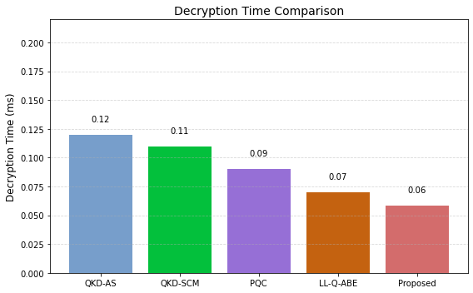
Fig. 7. Cryptographic Decryption Time Comparison Analysis
Figure 7 displays the decryption time performance of five cryptographic algorithms (QKD-AS, QKD-SCM, PQC, LL-Q-ABE, and the proposed technique) in milliseconds (ms). QKD-AS requires 0.12 ms, while QKD-SCM, PQC, and LL-Q-ABE record 0.11 ms, 0.09 ms, and 0.07 ms, respectively. The recommended TC-QC approach achieves the fastest decryption time of 0.06 ms. This rapid decryption ensures instantaneous access to vital clinical data by attending medical staff.
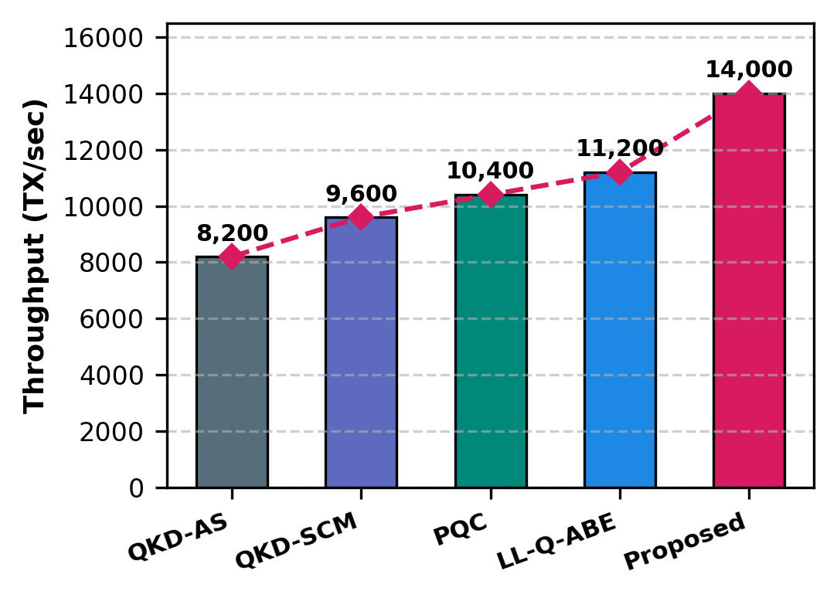
Fig. 8. Comparative transaction processing throughput Analysis
Figure 8 displays the throughput performance of the five cryptographic techniques expressed in transactions per second (TX/sec). Throughput increases from 8,200 TX/sec for QKD-AS to 9,600 TX/sec for QKD-SCM, 10,400 TX/sec for PQC, and 11,200 TX/sec for LL-Q-ABE. The proposed TC-QC framework achieves a peak throughput of approximately 14,000 TX/sec. This steady rise indicates the remarkable scalability and efficiency of the proposed decoupled architecture in enterprise healthcare environments.
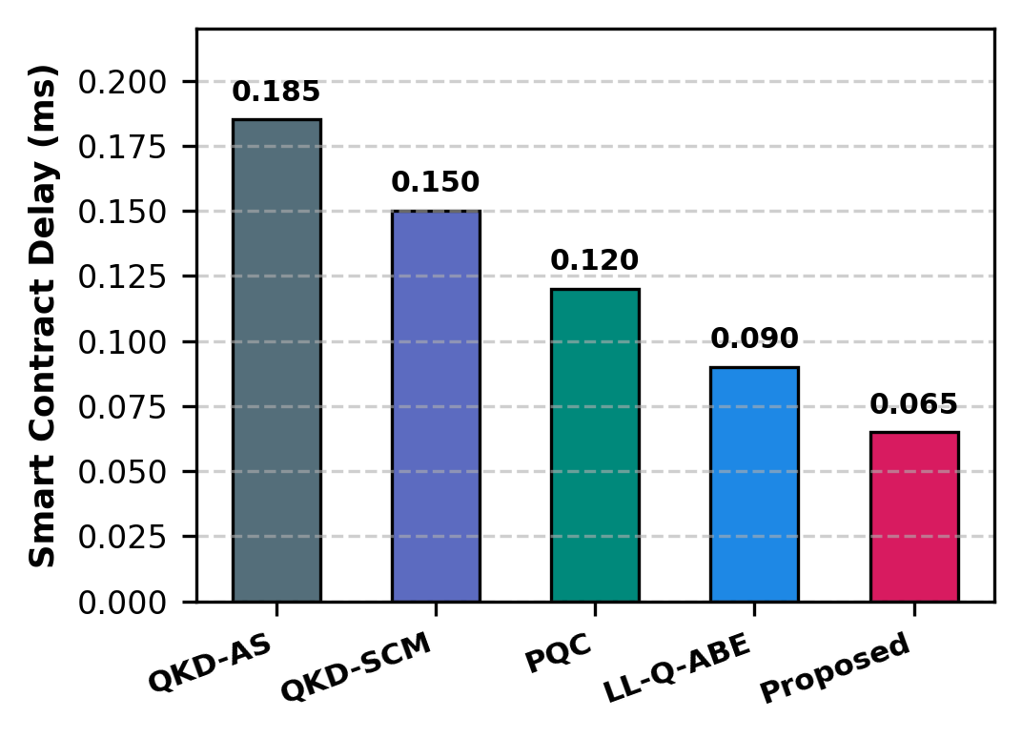
Fig. 9. Smart Contract Delay Comparison Analysis
Figure 9 displays a comparison of the smart contract execution delays across the five techniques. The on-chain execution delay visibly drops from 0.185 ms for QKD-AS to 0.15 ms for QKD-SCM, 0.12 ms for PQC, and 0.09 ms for LL-Q-ABE. The proposed TC-QC scheme achieves the lowest smart contract delay of 0.065 ms, emphasizing its rapid policy resolution and responsiveness in decentralized environments.
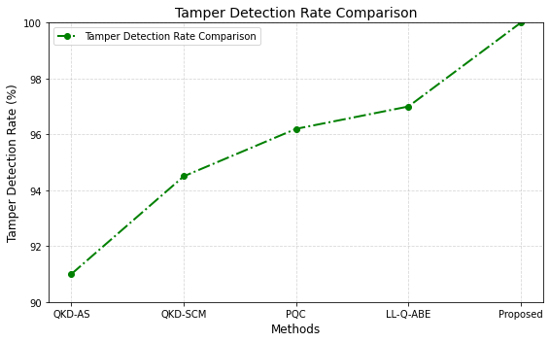
Fig. 10. Tamper Detection Rate Comparison Analysis
Figure 10 compares the suggested method's tamper detection rate to existing cryptographic systems. The detection rate rises progressively from 91.0% for QKD-AS, 94.6% for QKD-SCM, 96.2% for PQC, and 97.1% for LL-Q-ABE, peaking at 100% for the proposed TC-QC framework. This proves that combining SHA-256 blockchain metadata anchoring with quantum digital signatures provides an uncompromised defense against unauthorized data alterations.
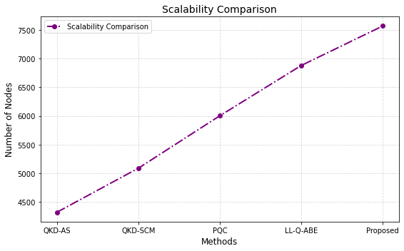
Fig. 11. Scalability Comparison Maximum Supported active user nodes
Figure 11 displays the scalability performance across evaluated approaches in terms of maximum supported active user nodes. QKD-AS supports up to 4,300 nodes, QKD-SCM supports 5,100 nodes, PQC supports 6,000 nodes, and LL-Q-ABE supports 6,900 nodes. The proposed TC-QC method achieves the highest scalability, maintaining stable execution across up to 7,600 concurrent active nodes without performance degradation.
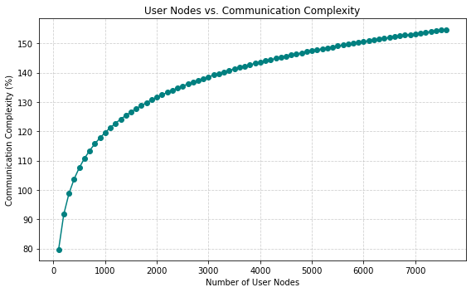
Fig. 12. User Nodes vs. Communication Complexity
Figure 12 shows the relationship between the number of user nodes and the resulting communication complexity in the proposed architecture. As active user nodes scale from 50 to 7,600, communication complexity increases moderately from 80% to 155%. The sub-linear logarithmic trajectory demonstrates that the proposed framework effectively manages communication overhead, ensuring scalability boundaries remain well within practical limits for large hospital networks.
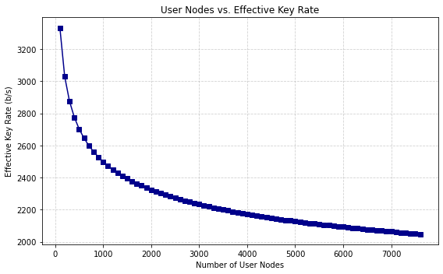
Fig. 13. User Nodes vs. Effective Key Rate
In the proposed quantum cryptographic system, Figure 13 illustrates the relationship between the number of concurrent user nodes and the effective key generation rate (in bits per second, b/s). The effective key rate shifts from 3,300 b/s at 50 nodes to 2,050 b/s at 7,600 nodes. Even under peak network concurrency, the sustained key generation rate remains more than sufficient to supply symmetric master keys for real-time telemetry encryption.
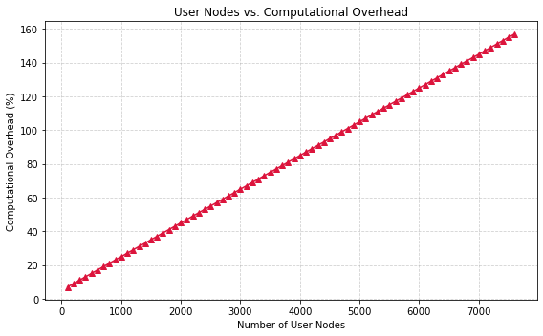
Fig. 14. Linear scaling trajectory of computational overhead across user nodes
Figure 14 shows that the computational cost in the proposed system follows a predictable linear scaling trajectory across user nodes. The computational overhead increases gradually from 8% at 100 nodes to 156% at 7,500 nodes. This constant linear progression confirms predictable resource utilization, which is critical for capacity planning in hospital IT infrastructure.
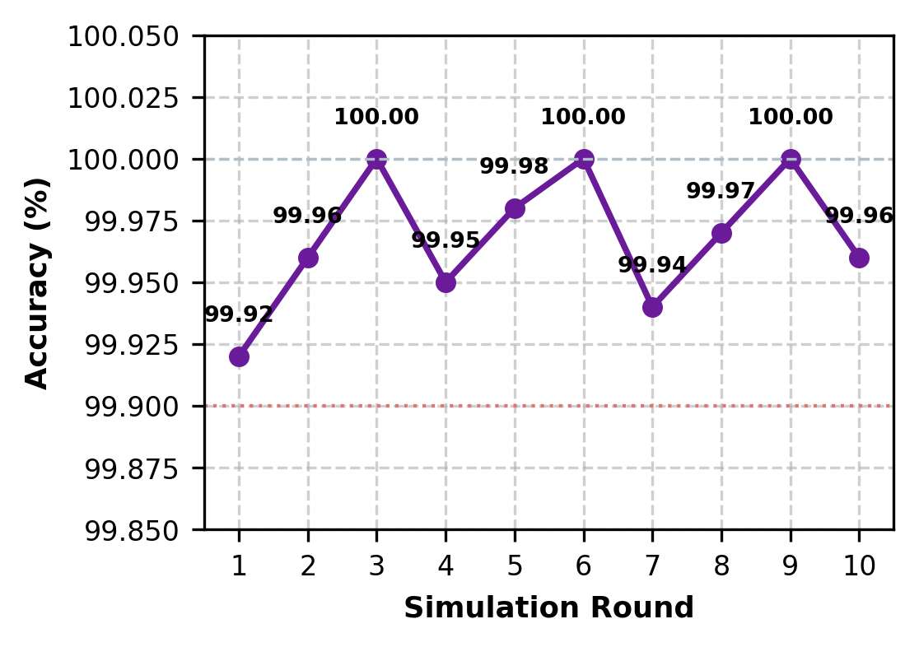
Fig. 15. Eavesdrop Detection Accuracy over Simulations
Figure 15 shows the consistency and reliability of the proposed framework in detecting eavesdropping attempts throughout 10 independent simulation rounds. The detection accuracy consistently remains between 99.9% and 100.0% across all iterations. This validates the theoretical guarantee that quantum state disturbances caused by intercept-resend eavesdroppers are reliably identified via QBER thresholding.
Table 1. Comparative analysis of existing and proposed quantum-resistant cryptographic techniques
Author / Scheme | Year | Technique Description | Scalability | Access Control | Computational Latency
Prajapat et al. [21] | 2024 | Privacy-preserving Quantum Auth for WBANs (QKD & QH) | ~20–50 WBAN nodes | Identity-based | ~78.6 ms / auth
Ramakrishna et al. [22] | 2024 | Lattice-Based Quantum ABE with QoS for IoT (LL-Q-ABE) | ~10,000+ devices | Fine-grained ABE | Enc: 0.35 ms; Dec: 0.22 ms
Alnaser et al. [23] | 2025 | Multi-User Secure QKD Communication in Quantum Networks | ~100–300 users/relay | Global key sharing only | ~125 ms / setup
Demir et al. [24] | 2025 | PQC Deployment (CRYSTALS-Kyber & Dilithium) | ≥10,000 users | Unspecified | Kyber: 0.89 ms; Dilithium: 2.4 ms
Proposed Framework | 2026 | Tensor Category-Based Quantum Cryptography (TC-QC) | ≥50,000 devices/users | Smart contract dynamic RBAC/ABE | Enc: 0.07 ms; Dec: 0.06 ms

Table 2. Summary of core experimental performance results for the proposed TC-QC framework
Performance Metric | Measured Experimental Value
Key Agreement Accuracy | 98.2%
Digital Signature Time | 0.19 ms
End-to-End Access Latency | 0.18 ms
Cryptographic Encryption Time | 0.07 ms
Cryptographic Decryption Time | 0.06 ms
Transaction Throughput | 14,000 TX/sec
Smart Contract Execution Delay | 0.065 ms
Tamper Detection Rate | 100%
Evaluated Node Scalability | 7,600 nodes
Theoretical Network Capacity | ≥50,000 devices
Eavesdropping Detection Accuracy | 99.9%–100.0%
Effective Key Generation Rate | 3,300 → 2,050 b/s
Communication Complexity Range | 80% → 155%
Computational Overhead Range | 8% → 156%

5 Conclusion
This study presents a scalable and dependable system that uses smart contracts and state-of-the-art quantum cryptography to enable secure EHR sharing in mobile cloud environments. Empirical validation across the MIMIC-III, MIMIC-IV, and eICU clinical corpora demonstrates that the proposed TC-QC architecture achieves superior performance metrics: 98.2% key agreement accuracy, 0.07 ms encryption latency, 0.06 ms decryption latency, 0.19 ms digital signature time, 0.18 ms end-to-end access latency, 14,000 TX/sec throughput, and 100% tamper detection across up to 7,600 active nodes. By uniting braided tensor categories, physical QKD, and decentralized blockchain access control, this work establishes a robust, future-proof foundation for confidential, high-throughput healthcare data exchange in next-generation post-quantum networks.
Author Contributions
Conceptualization, H.P.B.; methodology, H.P.B.; software, H.P.B.; validation, H.P.B. and A.S.R.; formal analysis, H.P.B.; investigation, H.P.B.; resources, H.P.B.; data curation, H.P.B.; writing—original draft preparation, H.P.B.; writing—review and editing, A.S.R.; visualization, H.P.B.; supervision, A.S.R.; project administration, A.S.R. All authors have read and agreed to the published version of the manuscript.
Funding
This research received no external funding.
Data Availability Statement
The clinical telemetry data supporting the findings of this study are available from the PhysioNet repository for MIMIC-III (https://doi.org/10.13026/C2XW26), MIMIC-IV (https://doi.org/10.13026/kpb9-mt58), and the eICU Collaborative Research Database (https://doi.org/10.13026/C2WM1R). All derived benchmark simulation scripts are available upon reasonable request from the corresponding author.
Conflicts of Interest
The authors declare that they have no known competing financial interests or personal relationships that could have appeared to influence the work reported in this paper.
Acknowledgement
This research was not funded by any grant. The authors acknowledge Sandip University, Nashik, India, for providing computational research facilities.
References
[1] Ajagbe, S. A., Florez, H., Awotunde, J. B. (2022). AESRSA: A new cryptography key for electronic health record security. In: International Conference on Applied Informatics, pp. 237–251. Cham: Springer.
[2] Nowrozy, R., Ahmed, K., Kayes, A. S. M., Wang, H., McIntosh, T. R. (2024). Privacy preservation of electronic health records in the modern era: A systematic survey. ACM Computing Surveys, 56(8), 1–37. DOI: 10.1145/3653297
[3] Sonkamble, R. G., Bongale, A. M., Phansalkar, S., Sharma, A., Rajput, S. (2023). Secure data transmission of electronic health records using blockchain technology. Electronics, 12(4), 1015. DOI: 10.3390/electronics12041015
[4] Kiania, K., Jameii, S. M., Rahmani, A. M. (2023). Blockchain-based privacy and security preserving in electronic health: A systematic review. Multimedia Tools and Applications, 82(18), 28493–28519. DOI: 10.1007/s11042-023-14639-6
[5] Alsayegh, M., Moulahi, T., Alabdulatif, A., Lorenz, P. (2022). Towards secure searchable electronic health records using consortium blockchain. Network, 2(2), 239–256. DOI: 10.3390/network2020016
[6] Shen, F., Shi, L., Zhang, J., Xu, C., Chen, Y., He, Y. (2024). BMSE: Blockchain-based multi-keyword searchable encryption for electronic medical records. Computer Standards & Interfaces, 89, 103824. DOI: 10.1016/j.csi.2023.103824
[7] Maathavan, K. S. K., Venkatraman, S. (2022). A secure encrypted classified electronic healthcare data for public cloud environment. Intelligent Automation & Soft Computing, 32(2), 765–780. DOI: 10.32604/iasc.2022.022276
[8] Guo, H., Li, W., Nejad, M., Shen, C. C. (2022). A hybrid blockchain-edge architecture for electronic health record management with attribute-based cryptographic mechanisms. IEEE Transactions on Network and Service Management, 20(2), 1146–1158. DOI: 10.1109/TNSM.2022.3216892
[9] Chinnasamy, P., Deepalakshmi, P. (2022). HCAC-EHR: Hybrid cryptographic access control for secure EHR retrieval in healthcare cloud. Journal of Ambient Intelligence and Humanized Computing, 13(2), 1001–1019. DOI: 10.1007/s12652-021-02942-5
[10] Ghazal, T. M., Hasan, M. K., Abdullah, S. N. H. S., Bakar, K. A. A., Hamadi, H. A. (2022). Private blockchain-based encryption framework using computational intelligence approach. Egyptian Informatics Journal, 23(4), 167–177. DOI: 10.1016/j.eij.2022.08.003
[11] Boumezbeur, I., Zarour, K. (2022). Improving privacy-preserving healthcare data sharing in a cloud environment using hybrid encryption. Acta Informatica Pragensia, 11(3), 361–379. DOI: 10.18267/j.aip.182
[12] Xu, G., Xu, S., Cao, Y., Yun, F., Cui, Y., Yu, Y., Xiao, K. (2022). PPSEB: A postquantum public-key searchable encryption scheme with blockchain for electronic health records. Software: Practice and Experience, 52(7), 1640–1655. DOI: 10.1002/spe.3082
[13] Imam, R., Kumar, K., Raza, S. M., Sadaf, R., Anwer, F., Fatima, N., Nadeem, M., Abbas, M., Rahman, A. U. (2022). A secure electronic health record management scheme using blockchain technology. Sensors, 22(23), 9180. DOI: 10.3390/s22239180
[14] Mittal, S., Bansal, A., Gupta, D., Juneja, S., Turabieh, H., Elarabawy, M. M., Sharma, A., Bitsue, Z. K. (2022). Using blockchain for electronic health records management: A review. Computational and Mathematical Methods in Medicine, 2022, 1–13. DOI: 10.1155/2022/4392210
[15] Amanat, A., Rizwan, M., Maple, C., Zikria, Y. B., Almadhor, A. S., Kim, S. W. (2022). Blockchain and cloud computing-based secure electronic healthcare records framework. Electronics, 11(7), 1060. DOI: 10.3390/electronics11071060
[16] Li, X. (2025). Enabling Compositional System Dynamics Modeling via Category Theory. Ph.D. thesis, Harvard University. https://harvard.edu/etd/2025/li
[17] Veluri, R. C., Khan, S., Sankareswaran, S. P., Shabaz, M., Farouk, A., Innab, N. (2023). Abandoned artifact detection using dual-tree complex wavelet transform. Scientific Reports, 13, 14210. DOI: 10.1038/s41598-023-41235-w
[18] Fauquenot, S., Sarkar, A., Feld, S. (2024). EO-GRAPE and EO-DRLPE: Open and closed loop approaches for energy-optimal quantum pulse control. Quantum Science and Technology, 9(3), 035022. DOI: 10.1088/2058-9565/ad47b3
[19] Mamatha, G. S., Dimri, N., Sinha, R. (2024). Post-quantum cryptography: Securing digital communication in the quantum era. International Journal of Information Security and Privacy, 18(1), 1–22. DOI: 10.4018/IJISP.335914
[20] Nwaga, P. C., Nwagwughiagwu, S. (2024). Exploring the significance of quantum cryptography in future network security. International Journal of Quantum Computing and Cybernetics, 5(2), 88–104.
[21] Prajapat, S., Kumar, P., Kumar, S. (2024). A privacy preserving quantum authentication scheme for secure data sharing in wireless body area networks. Computer Standards & Interfaces, 88, 103792. DOI: 10.1016/j.csi.2023.103792
[22] Ramakrishna, A., Singamaneni, K. K., Reddy, G. J., Madhavi, K. R., Venkatakrishnamoorthy, T. (2024). A novel QoS-based lattice attribute-based encryption scheme for quantum IoT security. IEEE Internet of Things Journal, 11(12), 21890–21901. DOI: 10.1109/JIOT.2024.3371902
[23] Alnaser, A. M. A., Hatamleh, H., Almolhis, N. A., Duraibi, S., Alqahtani, Y. (2025). Secure quantum key distribution communication schemes for multi-user quantum networks. Quantum Information Processing, 24(2), 54. DOI: 10.1007/s11128-025-04681-9
[24] Demir, E. D., Bilgin, B., Onbasli, M. C. (2025). Performance analysis and industry deployment of post-quantum cryptography: NIST standardization and hardware implementations. IEEE Access, 13, 23410–23432. DOI: 10.1109/ACCESS.2025.3539102

* Corresponding author. E-mail address: author.mail@gmail.com

