**Topics: Normal distribution, Functions of Random Variables**

1. The time required for servicing transmissions is normally distributed with *μ* = 45 minutes and *σ* = 8 minutes. The service manager plans to have work begin on the transmission of a customer’s car 10 minutes after the car is dropped off and the customer is told that the car will be ready within 1 hour from drop-off. What is the probability that the service manager cannot meet his commitment?
2. 0.3875
3. 0.2676
4. 0.5
5. 0.6987

ANS:- **B**  
Here *μ* = 45   
 *σ* = 8  
 The service manager plans to have work begin on the transmission of a customer’s car 10 minutes after the car is dropped off and the customer is told that the car will be ready within 1 hour from drop-off. Remaining time = 60-10=50 min  
What is the probability that the service manager cannot meet his commitment=  
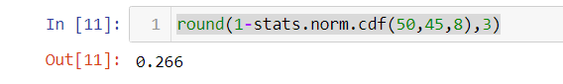

26 % or 0.2676

1. The current age (in years) of 400 clerical employees at an insurance claims processing center is normally distributed with mean *μ* = 38 and Standard deviation *σ* =6. For each statement below, please specify True/False. If false, briefly explain why.
2. More employees at the processing center are older than 44 than between 38 and 44.  
   **ANS:-** false  
   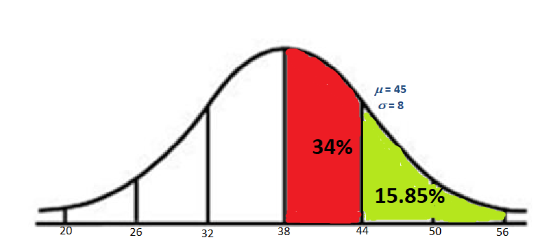

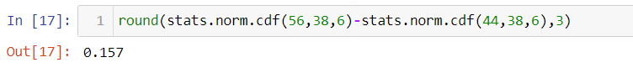As we show in the figure 34% of the employees age is between 38 and 44 , and 15.85% employees are more than 44 years old . so the age group of 38-44 years are more than above 44 year.  
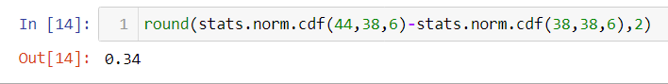

1. A training program for employees under the age of 30 at the center would be expected to attract about 36 employees.  
   **ANS:-**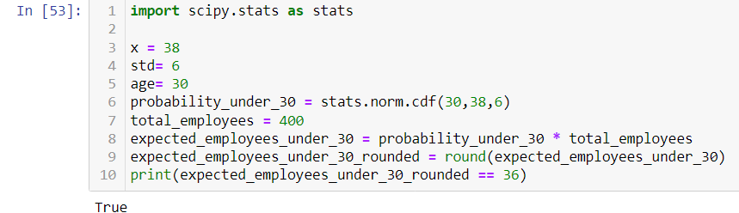

1. If *X1* ~ *N*(μ, σ2) and *X*2 ~ *N*(μ, σ2) are *iid* normal random variables, then what is the difference between 2 *X*1 and *X*1 + *X*2? Discuss both their distributions and parameters.   
   **ANS:-**The Normal Distribution has its link with the Central Limit Theorem, which states that ‘Any large sum of independent identically distribution random variables are approximately Normal then (X1 + X2) and (2X1) tends to have Normal distribution only If X1 and X2 are i.i.d and n is Large.The Normal distribution has two parameters, the mean, µ, and the variance, σ2. µ and σ2satisfy −∞ < µ < ∞, σ2> 0. We write X ∼ Normal (µ, σ2) or X ∼ N(µ, σ2 ).
2. Let X ~ N(100, 202). Find two values, *a* and *b*, symmetric about the mean, such that the probability of the random variable taking a value between them is 0.99.
3. 90.5, 105.9
4. 80.2, 119.8
5. 22, 78
6. 48.5, 151.5
7. 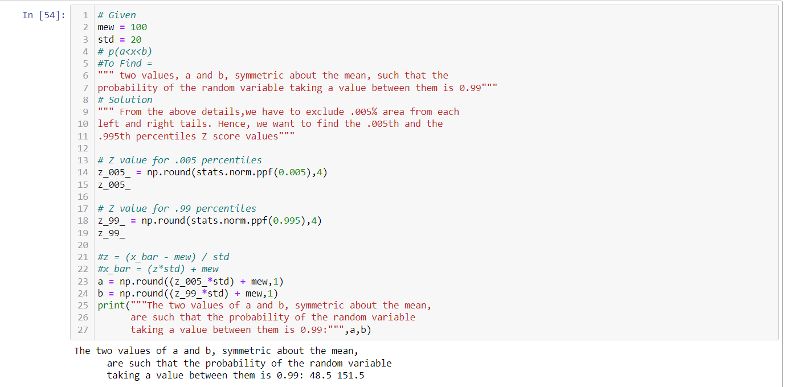90.1, 109.9  
   ANS:-  
   D-48.5, 151.5

1. Consider a company that has two different divisions. The annual profits from the two divisions are independent and have distributions Profit1 ~ N(5, 32) and Profit2 ~ N(7, 42) respectively. Both the profits are in $ Million. Answer the following questions about the total profit of the company in Rupees. Assume that $1 = Rs. 45
2. Specify a Rupee range (centered on the mean) such that it contains 95% probability for the annual profit of the company.

ANS:- 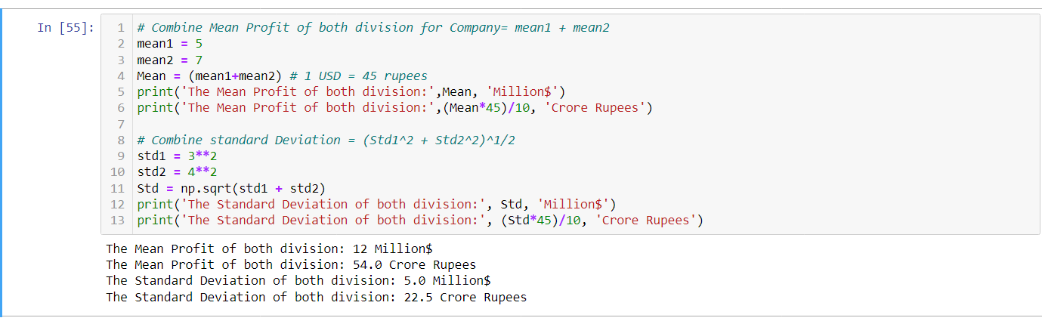 Rupee ranges in between [9.9 to 98.1] Crore Rupees, 95% of the time for the Annual Profit of the Company.

B. Specify the 5th percentile of profit (in Rupees) for the company  
ANS:- The 5TH Percentile of profit for the company is 17 Crore Rupees

C. Which of the two divisions has a larger probability of making a loss in a given year?  
**ANS:-** The Division #2 (Profit2 ~ N(7, 42) ) has a larger probability of making a loss in a given year