EXPERIMENT NO. 4

DATA FLOW DIAGRAMS (DFD)

BLOOD BRIDGE — BLOOD DONATION AND EMERGENCY RESPONSE SYSTEM

TEAM MEMBERS
2. Aditi Ahuja
8. Komal
14. Piyusha Bhadane

1. AIM
To design and study the Data Flow Diagram (DFD) of the Blood Bridge system and represent the flow of information between external entities, processes, and data stores at different levels of abstraction.

2. INTRODUCTION
A Data Flow Diagram (DFD) is a graphical representation used in software engineering to show how data moves through a system. It represents the sources of data, the processes that transform the data, the locations where data is stored, and the destinations of the processed data.
For the Blood Bridge system, the DFD represents the flow of information between Blood Donors, Patients or Families, Hospital Staff, and Platform Administrators, along with the major processes and data stores of the system.
Blood Bridge is a blood donation and emergency response platform that supports donor registration, AI-based donor matching, emergency SOS requests, donation tracking, shortage prediction, and administration.
DFDs focus on the logical movement of data within the system rather than programming implementation details.

3. WHAT IS A DATA FLOW DIAGRAM?
A Data Flow Diagram (DFD) is a graphical model that represents how data enters a system, how it is processed, where it is stored, and how the resulting information is delivered.
A DFD mainly represents four components:
- External Entities
- Processes
- Data Stores
- Data Flows
DFDs can be developed at different levels. A Level 0 DFD gives a high-level view of the complete system, a Level 1 DFD divides the system into major processes, and a Level 2 DFD provides a detailed decomposition of a selected Level 1 process.

4. OBJECTIVES OF DFD
The main objectives of a Data Flow Diagram are:
- To represent the flow of information through the system.
- To identify the sources and destinations of data.
- To identify the major processes performed by the system.
- To identify the data stores used by the system.
- To understand the interaction between users and system processes.
- To simplify the understanding of a complex system.
- To support system analysis and design.
- To improve communication between developers and stakeholders.
- To provide a logical representation of the system before implementation.
For Blood Bridge, the DFD helps represent the flow of donor, patient, hospital, emergency, donation, and administrative information.

5. STANDARD DFD NOTATIONS
DFDs use standard graphical symbols to represent different components of a system.

5.1 External Entity
An external entity represents a person, organization, or external system that interacts with the system.
It is generally represented using a rectangle.
Examples in Blood Bridge are:
- Blood Donor
- Patient / Family
- Hospital Staff
- Platform Admin

5.2 Process
A process represents an operation that receives input data, transforms it, and produces output data.
In the Blood Bridge DFD, processes include:
- 1.0 Registration
- 2.0 AI Matching
- 3.0 Emergency SOS
- 4.0 Tracking
- 5.0 Prediction
- 6.0 Admin
Processes are represented using circles in the diagrams prepared for this experiment.

5.3 Data Store
A data store represents a location where information is stored for later use.
The Blood Bridge system contains:
- D1 Donors — Profiles, QR
- D2 Requests — SOS Log
- D3 Donations — History, Demand
- D4 Accounts — Users, Rewards

5.4 Data Flow
A data flow represents the movement of information between an external entity, process, or data store.
It is represented using a directed arrow.
Examples include:
- Registration Details
- Donor Profile Data
- Blood Request Details
- Matched Donor Data
- SOS Request Details
- Donation History Data
- Historical Donation Data
- User and Rewards Data

6. IMPORTANT DFD RULES
The following rules are followed while designing a DFD:
- Every data flow should have a meaningful label.
- Processes should transform input data into output data.
- Data stores should represent persistent information.
- External entities should interact with the system through processes.
- Each process should have appropriate inputs and outputs.
- Data flows should represent meaningful information.
- DFDs should represent logical data movement rather than program execution.
- Different levels of DFD should remain consistent with each other.
- A lower-level DFD should provide more detail about the corresponding higher-level process.

7. LEVELS OF DATA FLOW DIAGRAM
DFDs are generally represented using multiple levels of detail.

7.1 LEVEL 0 DFD — CONTEXT DIAGRAM
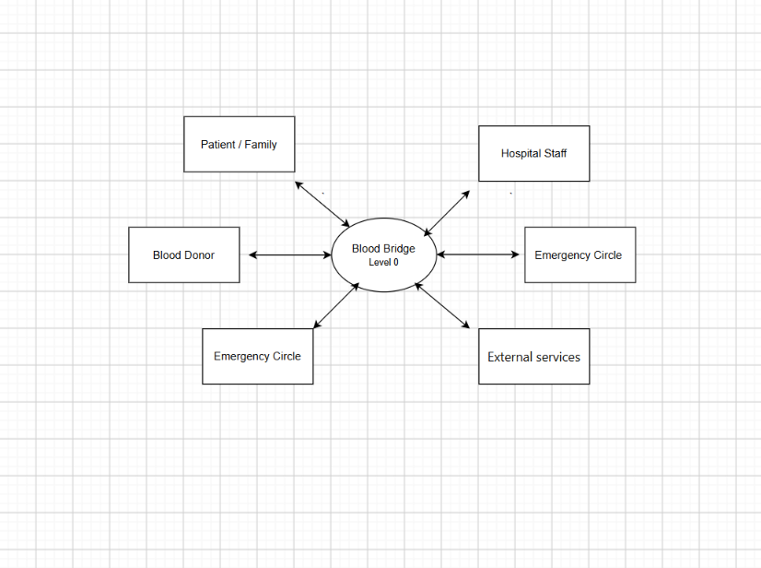
The Level 0 DFD, also known as the Context Diagram, represents the entire system as a single high-level process.
It shows the interaction between the complete system and its external entities.
For the Blood Bridge system, the major external entities are:
- Blood Donor
- Patient / Family
- Hospital Staff
- Platform Admin
The Level 0 DFD does not show the internal processes and data stores in detail.
It provides an overall understanding of how external users interact with the Blood Bridge system.

7.2 LEVEL 1 DFD
The Level 1 DFD decomposes the complete Blood Bridge system into its major functional processes.
The six major processes are:

1.0 Registration — Eligibility Check
Handles donor registration and eligibility verification.

2.0 AI Matching — Rank Donors
Matches and ranks eligible donors according to blood request requirements.

3.0 Emergency SOS — Alerts, SMS Fallback
Handles emergency blood requests, donor alerts, and SMS fallback.

4.0 Tracking — QR Verify, Confirm
Handles donation tracking, QR verification, and confirmation.

5.0 Prediction — Shortage Forecast
Uses historical information to generate blood shortage forecasts.

6.0 Admin — Moderation, Rewards
Handles administrative functions, moderation, users, and rewards.
The major data stores are:
- D1 Donors — Profiles, QR
- D2 Requests — SOS Log
- D3 Donations — History, Demand
- D4 Accounts — Users, Rewards

7.3 LEVEL 1 DFD OF BLOOD BRIDGE

Piyusha
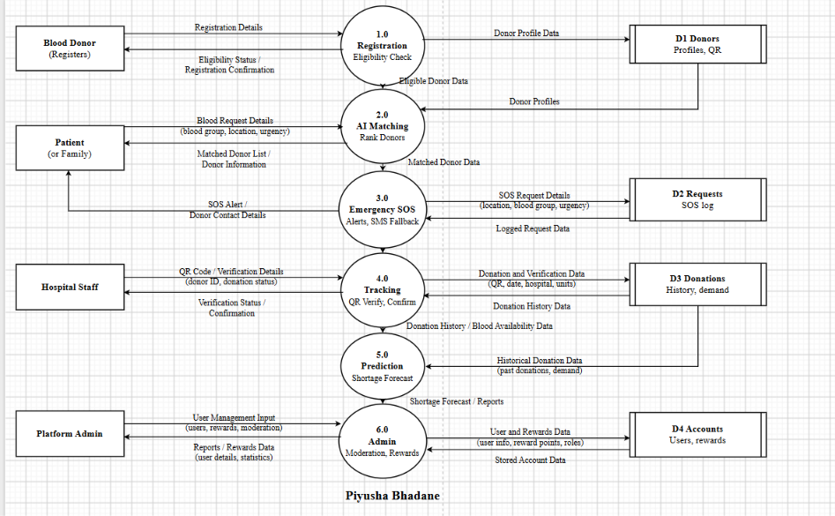
Aditi
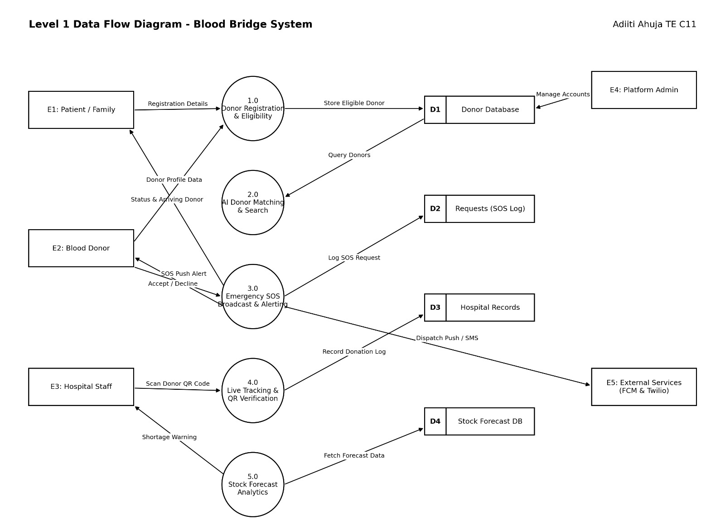

Figure 1: Level 1 Data Flow Diagram of Blood Bridge System
The Level 1 DFD provides an overview of how the major Blood Bridge processes interact with external entities and data stores.

7.4 LEVEL 2 DFD
A Level 2 Data Flow Diagram provides a more detailed representation of a selected process from the Level 1 DFD.
Instead of representing the complete system, Level 2 focuses on one major Level 1 process and decomposes it into smaller sub-processes.
For example, the Level 1 process:
3.0 Emergency SOS
can be decomposed into:
- 3.1 Capture SOS
- 3.2 Match Donors
- 3.3 Push Alerts
- 3.4 SMS Fallback
- 3.5 Donor Response
This decomposition explains how an emergency blood request is processed in greater detail.
Similarly, the Level 1 process:
4.0 Tracking
can be decomposed into:
- 4.1 Live Tracking
- 4.2 Generate QR
- 4.3 Verify QR
- 4.4 Confirm
- 4.5 Close and Update
These smaller processes provide a detailed view of the internal data movement within the selected Level 1 process.

7.5 LEVEL 2 DFD — EMERGENCY SOS
The 3.0 Emergency SOS process is responsible for handling emergency blood requests and communicating with eligible donors.
Its Level 2 decomposition consists of:

3.1 Capture SOS
Captures the emergency blood request from the Patient or Family, including information such as blood group, location, and urgency.

3.2 Match Donors
Uses the eligible donor pool to identify suitable nearby donors based on the emergency request.

3.3 Push Alerts
Sends notifications to relevant donors and other emergency participants using a push notification service.

3.4 SMS Fallback
Provides an alternative communication mechanism when push notification delivery fails or times out.

3.5 Donor Response
Receives the donor's response, such as acceptance or rejection of the emergency request.
The Level 2 Emergency SOS DFD therefore provides a detailed representation of the data movement within 3.0 Emergency SOS.
Piyusha
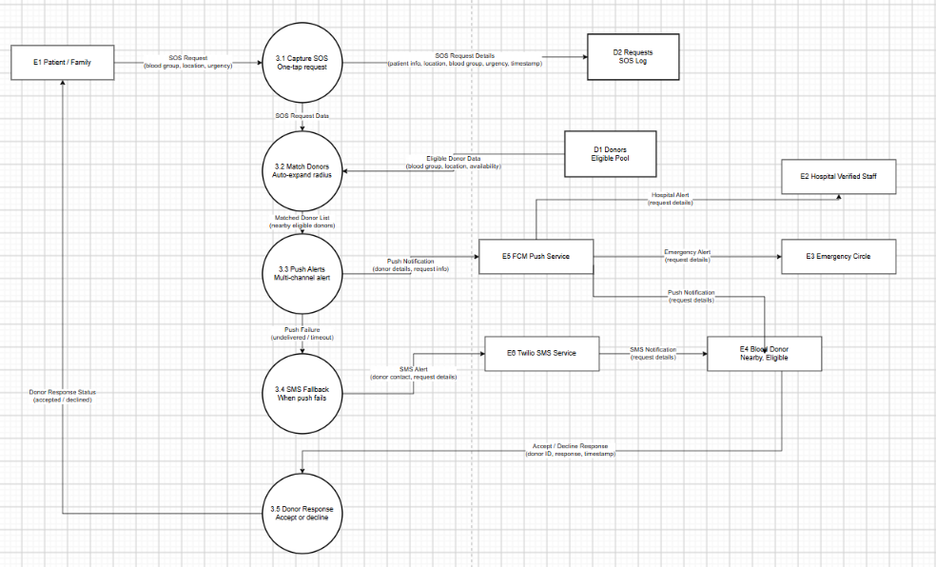
Aditi
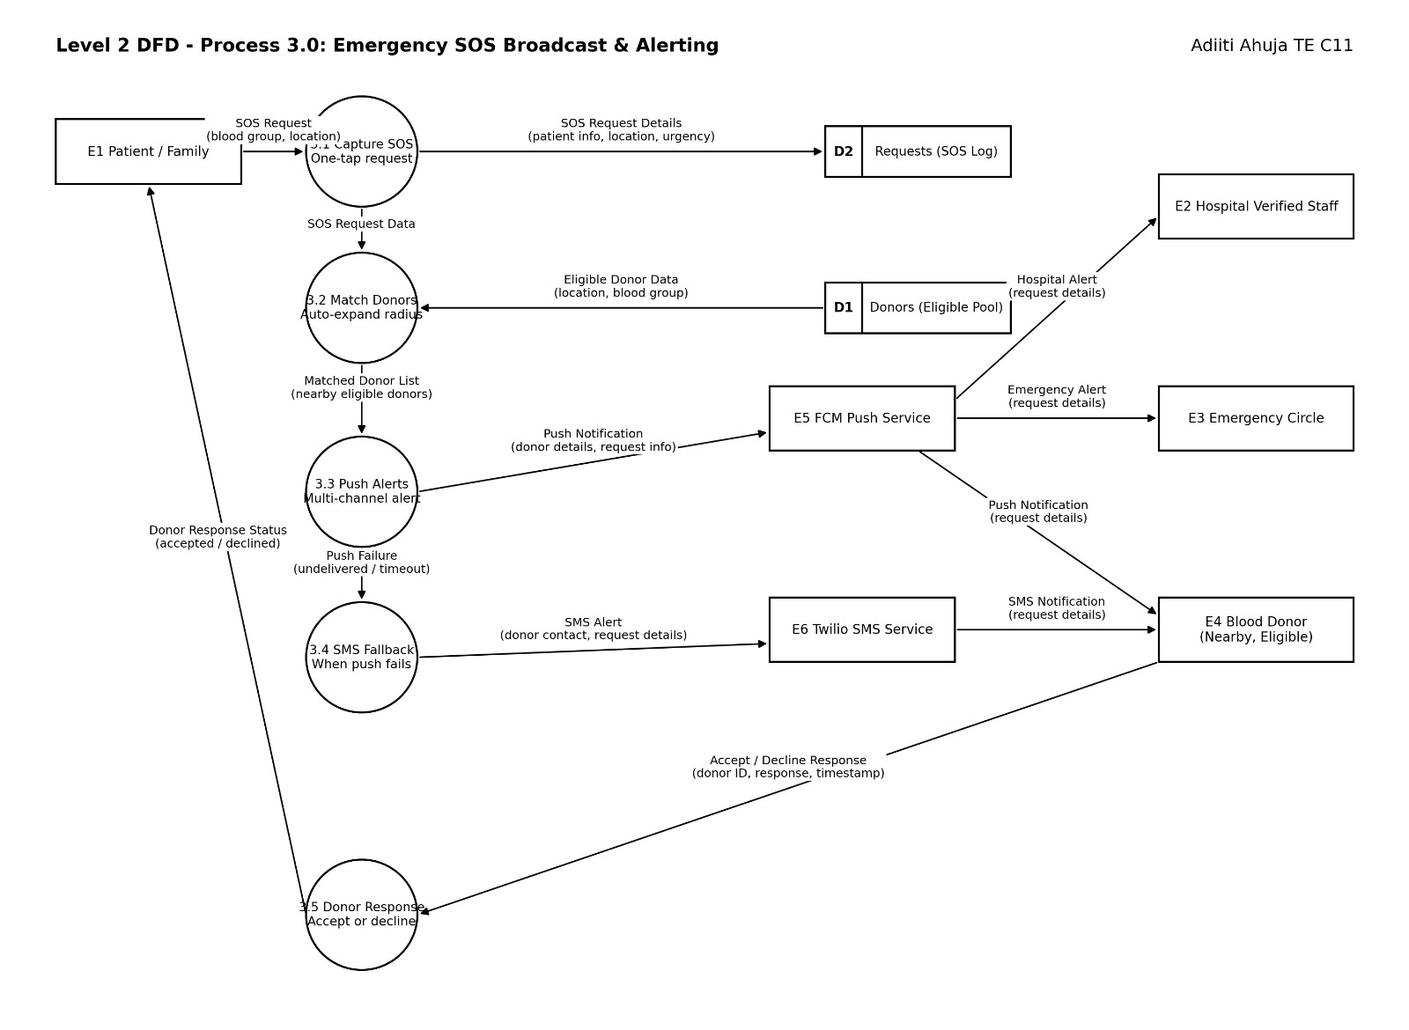

Komal
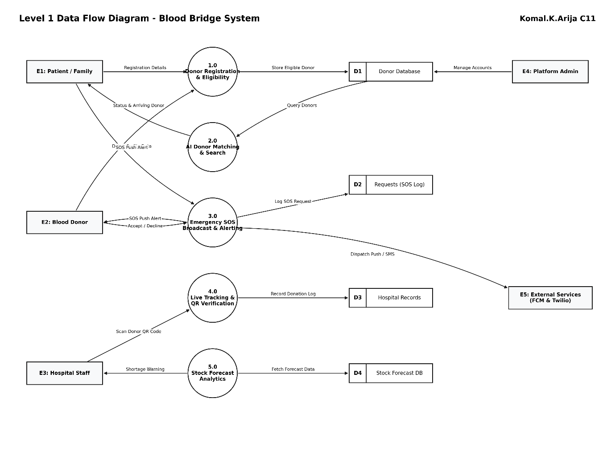
Figure 2: Level 2 DFD of Process 3.0 — Emergency SOS

7.6 LEVEL 2 DFD — TRACKING
The 4.0 Tracking process handles the tracking and verification of blood donations.
Its Level 2 decomposition consists of:

4.1 Live Tracking
Provides location and route information during the tracking process.

4.2 Generate QR
Generates a unique and time-bound QR code associated with the donation.

4.3 Verify QR
Verifies the QR code and donor information. Manual identification can be used as a fallback when required.

4.4 Confirm
Allows Hospital Staff to confirm the verified donation.

4.5 Close and Update
Closes the tracking process and updates the relevant donation information.
Piyusha
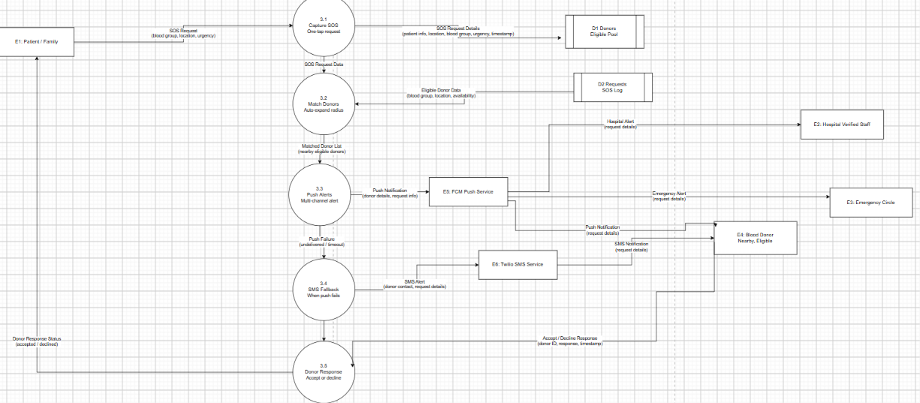
Aditi

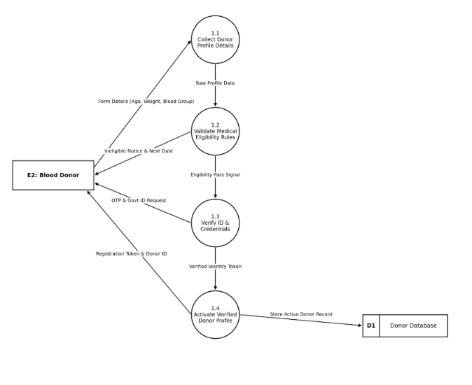

Komal: DFD Level 1

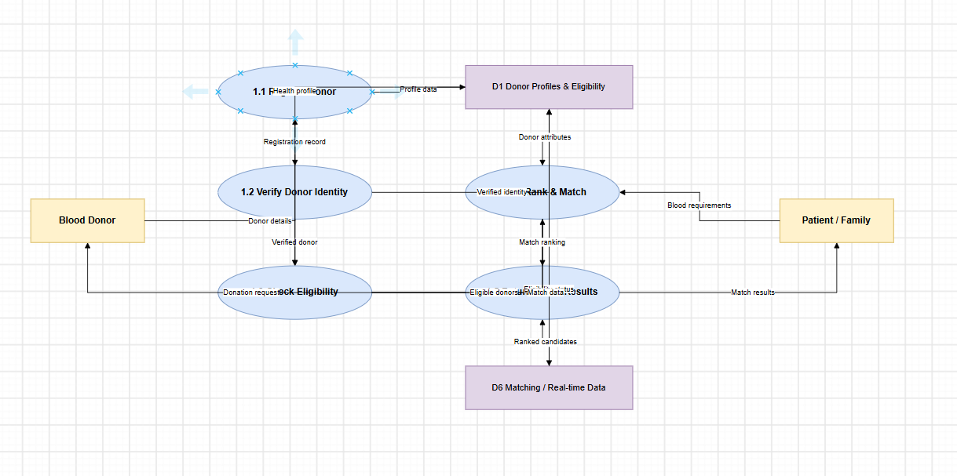

Komal: DFD Level 2
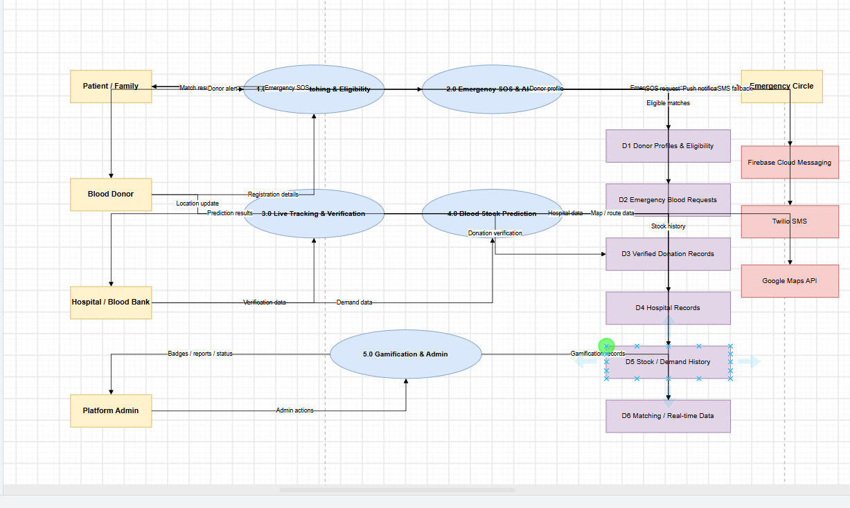

8. DESCRIPTION OF MAJOR LEVEL 1 PROCESSES

8.1 1.0 REGISTRATION — ELIGIBILITY CHECK
The Registration process allows a Blood Donor to register with the Blood Bridge system.
The donor provides Registration Details to the system.
The system performs an eligibility check and provides:
Eligibility Status / Registration Confirmation
The donor profile information is stored in:
D1 Donors — Profiles, QR
The eligible donor information can then be used by the AI Matching process.

8.2 2.0 AI MATCHING — RANK DONORS
The AI Matching process identifies suitable donors for a blood request.
The process receives:
- Blood group
- Location
- Urgency
- Donor profile information
- Eligible donor data
The system ranks suitable donors and provides:
Matched Donor List / Donor Information
to the Patient or Family.
Matched donor information is also passed to the Emergency SOS process when required.

8.3 3.0 EMERGENCY SOS — ALERTS, SMS FALLBACK
The Emergency SOS process handles urgent blood requirements.
It receives matched donor information and manages emergency blood requests.
The request details are stored in:
D2 Requests — SOS Log
The process can generate:
SOS Alert / Donor Contact Details
for the Patient or Family.
The detailed Level 2 decomposition of this process consists of Capture SOS, Match Donors, Push Alerts, SMS Fallback, and Donor Response.

8.4 4.0 TRACKING — QR VERIFY, CONFIRM
The Tracking process manages blood donation tracking and verification.
Hospital Staff provide:
QR Code / Verification Details
The system verifies the donation and provides:
Verification Status / Confirmation
The verified donation information is stored in:
D3 Donations — History, Demand
Tracking information is also used by the Prediction process.

8.5 5.0 PREDICTION — SHORTAGE FORECAST
The Prediction process uses historical donation and blood availability information.
It receives:
Donation History / Blood Availability Data
and:
Historical Donation Data
from the donation data store.
The process generates:
Shortage Forecast / Reports
which can be used by the Admin process.

8.6 6.0 ADMIN — MODERATION, REWARDS
The Admin process manages platform administration.
The Platform Admin provides:
User Management Input
which includes users, rewards, and moderation.
The process generates:
Reports / Rewards Data
and maintains information in:
D4 Accounts — Users, Rewards

9. MAJOR DATA FLOWS
The major data flows in the Blood Bridge system are:

9.1 Registration
Blood Donor → Registration:
Registration Details
Registration → Blood Donor:
Eligibility Status / Registration Confirmation
Registration → D1 Donors:
Donor Profile Data

9.2 AI Matching
Patient / Family → AI Matching:
Blood Request Details
D1 Donors → AI Matching:
Donor Profiles
Registration → AI Matching:
Eligible Donor Data
AI Matching → Patient / Family:
Matched Donor List / Donor Information
AI Matching → Emergency SOS:
Matched Donor Data

9.3 Emergency SOS
Emergency SOS → Patient / Family:
SOS Alert / Donor Contact Details
Emergency SOS → D2 Requests:
SOS Request Details
D2 Requests → Emergency SOS:
Logged Request Data

9.4 Tracking
Hospital Staff → Tracking:
QR Code / Verification Details
Tracking → Hospital Staff:
Verification Status / Confirmation
Tracking → D3 Donations:
Donation and Verification Data
D3 Donations → Tracking:
Donation History Data

9.5 Prediction
Tracking → Prediction:
Donation History / Blood Availability Data
D3 Donations → Prediction:
Historical Donation Data
Prediction → Admin:
Shortage Forecast / Reports

9.6 Administration
Platform Admin → Admin:
User Management Input
Admin → Platform Admin:
Reports / Rewards Data
Admin → D4 Accounts:
User and Rewards Data
D4 Accounts → Admin:
Stored Account Data

10. ADVANTAGES OF DFD
The advantages of using a DFD for the Blood Bridge system are:
- Provides a simple graphical representation of data flow.
- Makes complex system processes easier to understand.
- Clearly identifies external entities and data stores.
- Helps understand the movement of donor and patient information.
- Supports requirement analysis.
- Helps in software system design.
- Improves communication between developers and stakeholders.
- Helps identify relationships between processes and data stores.
- Provides a structured representation of the system.
- Helps identify important inputs and outputs.

11. LIMITATIONS OF DFD
The limitations of DFD are:
- It does not describe the internal algorithms of a process.
- It does not represent programming logic in detail.
- It does not show user-interface design.
- Timing and processing delays are not explicitly represented.
- Concurrency is not clearly represented.
- Error-handling mechanisms may not be completely represented.
- Large systems may require multiple DFD levels and can become complex.
- DFDs need to be combined with other modelling techniques for complete system representation.

12. CONCLUSION
The Data Flow Diagram of the Blood Bridge system provides a clear and structured representation of how information moves through the blood donation and emergency response platform.
The Level 0 DFD provides a high-level view of the complete system and its interaction with external entities.
The Level 1 DFD divides the Blood Bridge system into six major processes: Registration, AI Matching, Emergency SOS, Tracking, Prediction, and Admin, along with four major data stores.
The Level 2 DFD provides a detailed decomposition of selected Level 1 processes. For example, 3.0 Emergency SOS is decomposed into 3.1 Capture SOS, 3.2 Match Donors, 3.3 Push Alerts, 3.4 SMS Fallback, and 3.5 Donor Response. Similarly, 4.0 Tracking is decomposed into smaller processes for live tracking, QR generation, verification, confirmation, and updating.
Thus, DFDs provide a useful foundation for understanding the data movement, functional processes, external interactions, and storage requirements of the Blood Bridge system and support its further software design and development.

