1. Application Developed in React -> .Net Core -> EF Core (local db)
2. Create User by filling register Page

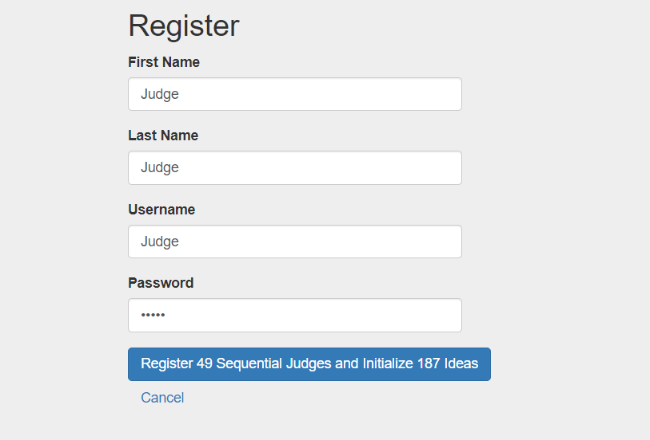

It will initialize the application and create 187 ideas and 49 Judges by following serial Credential (Password above is also Judge, you can provide as per your choice):

Judge_1, Judge_1

.

.

.

.

Judge_49, Judge_49

1. Login using Above credentials to see the Ideas assigned to you for evaluation

