--a. Write a function to return the number of leaves to be added if an employee joins anytime during the year, considering 1 day leave per month.
-- =============================================
-- Author: Tirth
-- Create date: 2026-01-29
-- =============================================
create function dbo.fn_leaves_add_on_employee_join
(
@joindate date
)
returns int
as
begin
declare @leaves int;

if @joindate IS NULL
return 0;

set @leaves = (12 - MONTH(@joindate) + 1);

return @leaves;
end;

select dbo.fn_leaves_add_on_employee_join('2026-01-10') as emp;
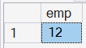

--b. Write a stored procedure such that as soon as a new Employee is added, his leave balance is added in Leave Balance table. Use the function created in previous step.

create procedure dbo.sp_c_employee_with_leave_balance
@employee_name varchar(50),
@fk_department_id int,
@join_date date
as
begin
set nocount on;
declare @pk_employee_id int;
declare @init_leaves_balanve int;

insert into employees (employee_name, fk_department_id,join_date,is_active)
values (@employee_name, @fk_department_id,@join_date,1);

set @pk_employee_id = scope_identity();

set @init_leaves_balanve = dbo.fn_leaves_add_on_employee_join(@join_date);

insert into leaves_balance(fk_employee_id, fk_leave_type_id,total_balance,remaining_balance)
select @pk_employee_id, t.pk_leave_type_id, @init_leaves_balanve, @init_leaves_balanve
from leave_types t;

end;

exec dbo.sp_c_employee_with_leave_balance @employee_name='naman',
@fk_department_id=1,@join_date='2026-07-12';

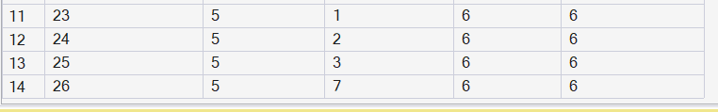

--c. Create a stored procedure to cancel a Leave Request, update the leave balance of cancelled leave. and Rollback if any step fails.

create procedure dbo.sp_du_leave_request_and_restore_balance
@pk_leave_request_id int
as
begin
set nocount on;
begin try
begin transaction;
declare @fk_employee_id int;
declare @days_taken int;
declare @fk_leave_type_id int;

select
@fk_employee_id = fk_employee_id,
@days_taken = days_taken,
@fk_leave_type_id = fk_leave_type_id
from leave_requests
where pk_leave_requests_id = @pk_leave_request_id;

update leave_requests
set application_status = 'cancelled',
leave_log = 'by employee'
where pk_leave_requests_id = @pk_leave_request_id;

update leaves_balance
set remaining_balance = remaining_balance + @days_taken
where fk_employee_id = @fk_employee_id
and fk_leave_type_id = @fk_leave_type_id;
commit transaction;
end try
begin catch
if @@TRANCOUNT>0
begin
rollback transaction;
end
print 'Error: cancel a Leave Request fail.';
throw;
end catch
end;

exec dbo.sp_du_leave_request_and_restore_balance @pk_leave_request_id=4;
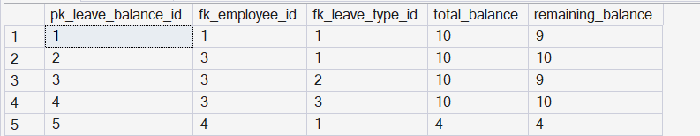

--d. Create a view to see the approved leave details for next 1 month for all employees.

create view for_all_employee_approve_leave_detail_for_next_month as
select e.employee_name, l.start_date, l.days_taken
from employees e
left join leave_requests l on l.fk_employee_id = e.pk_employee_id
where application_status = 'approved'
and l.start_date between dateadd(day,-1,getdate()) and dateadd(month, 1, getdate());

select * from for_all_employee_approve_leave_detail_for_next_month;
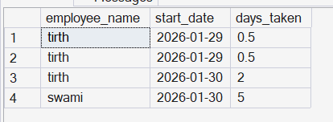
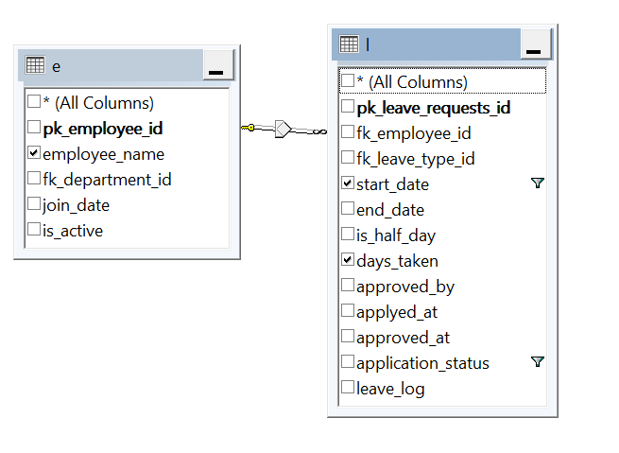

--e. Create a view to have Department-wise, employee-wise total number of all leaves.

create view bepartment_vise_employee_vise_total_leaves as
select d.department_name, e.employee_name, sum(l.days_taken) as total_leaves
from departments d
join employees e on e.fk_department_id = d.pk_department_id
join leave_requests l on l.fk_employee_id = e.pk_employee_id
where l.application_status = 'approved'
group by d.department_name,e.employee_name;

select * from bepartment_vise_employee_vise_total_leaves;
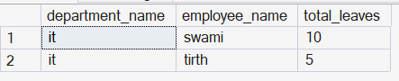
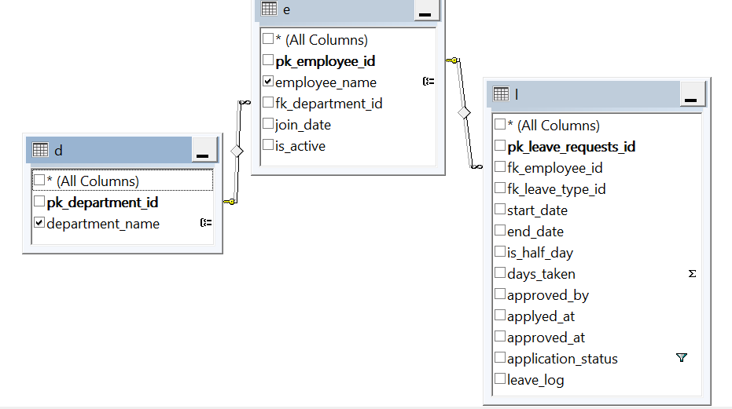

--f. Write a trigger such that when a new Leave Type is added, its related Leave details and balance are added as well.

create trigger dbo.tr_u_leave_balance_for_new_type
on leave_types
after insert
as
begin
set nocount on;
declare @pk_leave_type_id int;
declare @fk_employee_id int;
declare @default_leave_balance int;

select @default_leave_balance = default_leave_balance,
@pk_leave_type_id = pk_leave_type_id
from inserted;

insert into leaves_balance
(fk_employee_id, fk_leave_type_id, total_balance, remaining_balance)
select e.pk_employee_id, @pk_leave_type_id, @default_leave_balance, @default_leave_balance
from employees e where e.is_active = 1;
end;

insert into leave_types (leave_type_name,default_leave_balance) values ('gov leave',6);

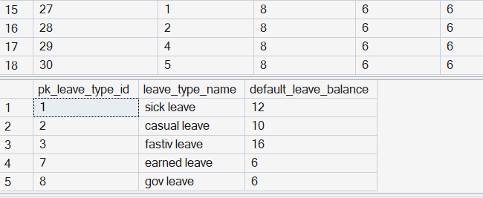

--g. Write a trigger such that as soon as a Leave Request is approved, the remaining balance should get updated.

create trigger dbo.tr_u_leave_balance
on leave_requests
after update
as
begin
set nocount on;

update leaves_balance
set remaining_balance = remaining_balance - i.days_taken
from leaves_balance lb
inner join inserted i on i.fk_employee_id=lb.fk_employee_id
and i.fk_leave_type_id=lb.fk_leave_type_id
inner join deleted d on d.pk_leave_requests_id = i.pk_leave_requests_id
where i.application_status = 'approved' and d.application_status not in('approved','cancelled','rejected');

end;

update leave_requests
set application_status = 'approved',approved_by = 'hari',
approved_at='2026-01-29',leave_log='by hari'
where pk_leave_requests_id=6;

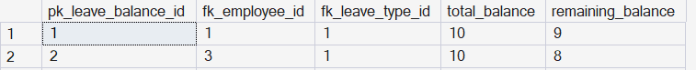

--a. Create a stored procedure which runs at the start of every year. For all active employees, For all leave types, Add yearly quota from Leave Type table into Leave Balance(If balance record exists → update, If not → insert)
Example: Leave Type can be: Earned Leave: 12, Casual Leave: 6, 10 Public Holidays

create procedure dbo.sp_u_yearly_leave_balance
as
begin
set nocount on;

update lb
set lb.remaining_balance = lb.remaining_balance + lt.default_leave_balance,
lb.total_balance = lb.total_balance + lt.default_leave_balance
from leaves_balance lb
join leave_types lt on lb.fk_leave_type_id = lt.pk_leave_type_id
join employees e on lb.fk_employee_id = e.pk_employee_id
where e.is_active = 1;

insert into leaves_balance (fk_employee_id, fk_leave_type_id, total_balance, remaining_balance)
select e.pk_employee_id,
lt.pk_leave_type_id,
lt.default_leave_balance,
lt.default_leave_balance
from employees e
cross join leave_types lt
where e.is_active = 1
and not exists (
select 1
from leaves_balance lb
where lb.fk_employee_id = e.pk_employee_id
and lb.fk_leave_type_id = lt.pk_leave_type_id
);

end;

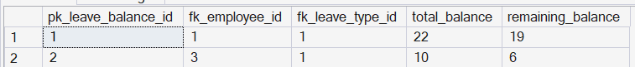
exec dbo.sp_u_yearly_leave_balance;
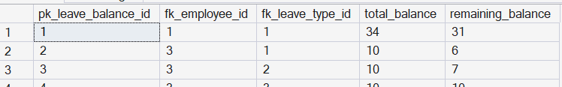

--b. Create a stored procedure which accepts LeaveId, ApprovedBy, ApprovalStatus and Updates Leave Request status of employee based on approval status

create procedure dbo.sp_u_leave_request_status
@pk_leave_request_id int,
@approved_by varchar(10),
@application_status varchar(10)
as
begin
set nocount on;

update leave_requests
set application_status = @application_status,
leave_log = @approved_by,
approved_by = @approved_by,
approved_at = getdate()
where pk_leave_requests_id = @pk_leave_request_id;

end;

exec dbo.sp_u_leave_request_status
@pk_leave_request_id = 11,
@approved_by = 'hari',
@application_status ='approved';

--c. Create a trigger that ensures before adding a new leave if Remaining balance > Requested leave days else Raise a proper error message.

create trigger dbo.tr_test_leave_balance
on leave_requests
instead of insert
as
begin
set nocount on;
declare @remaining_balance int;
declare @days_taken int;
declare @fk_employee_id int;
declare @fk_leave_type_id int;
declare @start_date date;
declare @end_date date;
declare @is_half_day bit;
declare @applyed_at date;
declare @application_status varchar(10);

select @remaining_balance = lb.remaining_balance,
@days_taken = i.days_taken,
@fk_employee_id = i.fk_employee_id,
@fk_leave_type_id = i.fk_leave_type_id,
@start_date = i.start_date,
@end_date = i.end_date,
@is_half_day = i.is_half_day,
@applyed_at = i.applyed_at,
@application_status = i.application_status
from leaves_balance lb
inner join inserted i on i.fk_employee_id=lb.fk_employee_id
and i.fk_leave_type_id=lb.fk_leave_type_id
where i.application_status = 'pendding';

if @remaining_balance < @days_taken
print 'Error: employee does not have sufficient leave balance.';
else
insert into leave_requests (fk_employee_id, fk_leave_type_id, start_date, end_date, is_half_day, days_taken, applyed_at, application_status)
values (@fk_employee_id, @fk_leave_type_id, @start_date, @end_date, @is_half_day, @days_taken,@applyed_at,@application_status);

end;

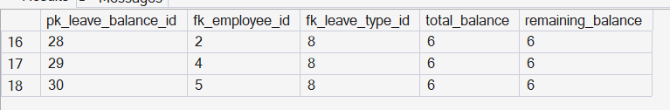

insert into leave_requests (fk_employee_id, fk_leave_type_id, start_date, end_date, is_half_day, days_taken, applyed_at, application_status)
values (5, 8, '2026-01-10', '2026-02-17', 0, 8 ,'2026-01-30','pendding');
insert into leave_requests (fk_employee_id, fk_leave_type_id, start_date, end_date, is_half_day, days_taken, applyed_at, application_status)
values (5, 8, '2026-01-10', '2026-02-17', 0, 4 ,'2026-01-30','pendding');

