SonarQube : It is automatically analyse code quality and security by detecting bugs and security issue.
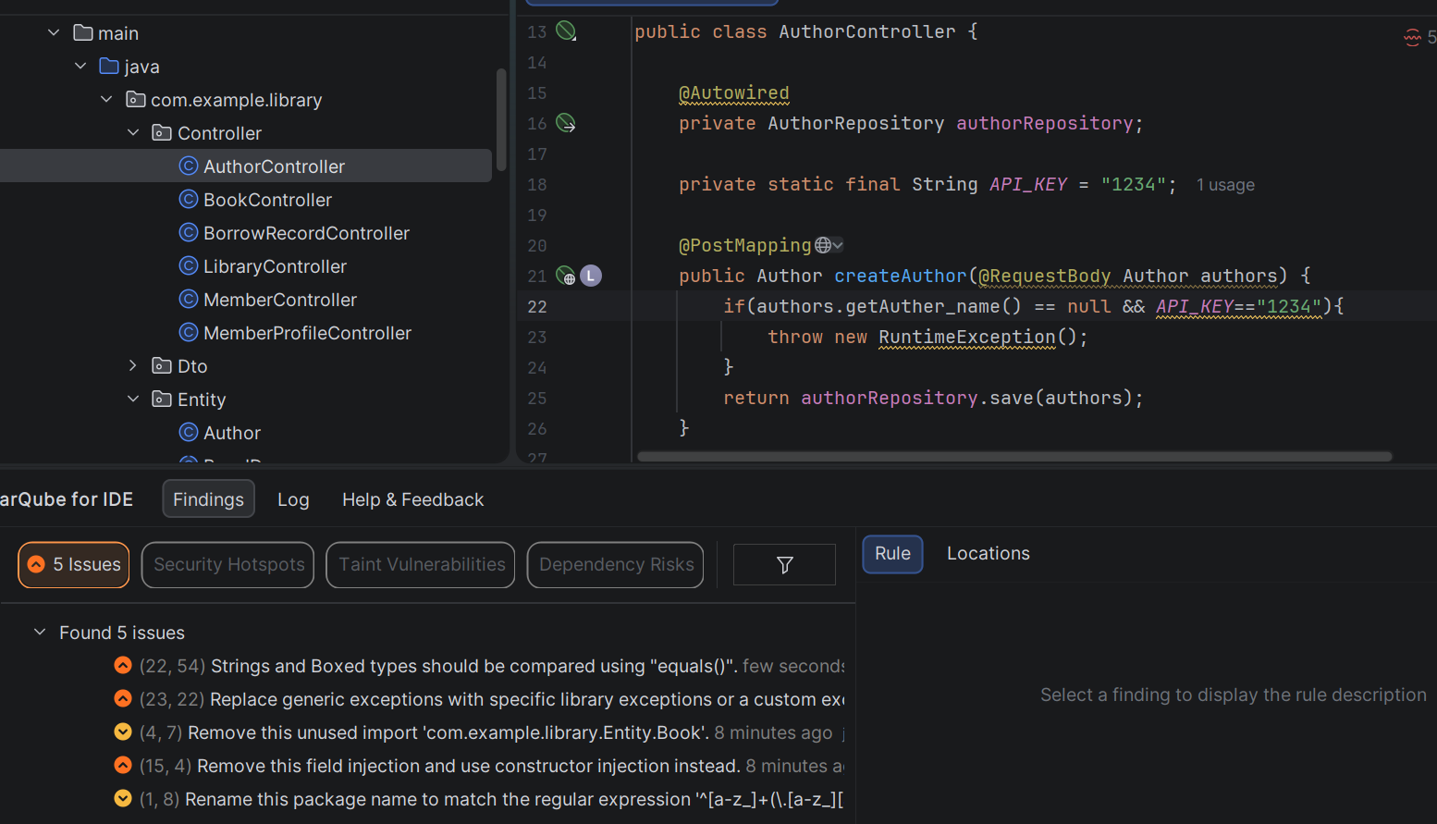
- In this image you can see 5 issues are there so for solve them all first I solve Dependency injection issues so I remove field injection because it break immutability and make code harder to test so I use constructor injection to solve this issue.
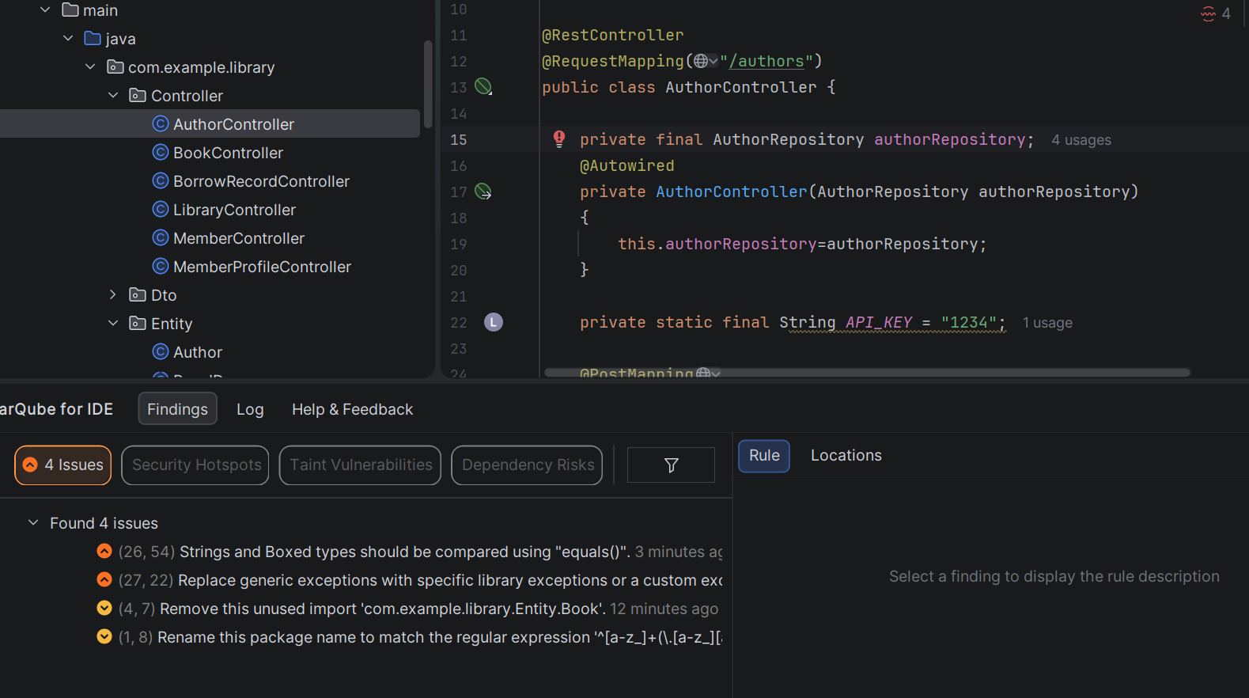
- Then I solve string and box type comparison issue so using equals() I solve that and then I remove unused import and then replace generic exception run time exception to response status exception to make meaningful and improve API quality and solve issue.
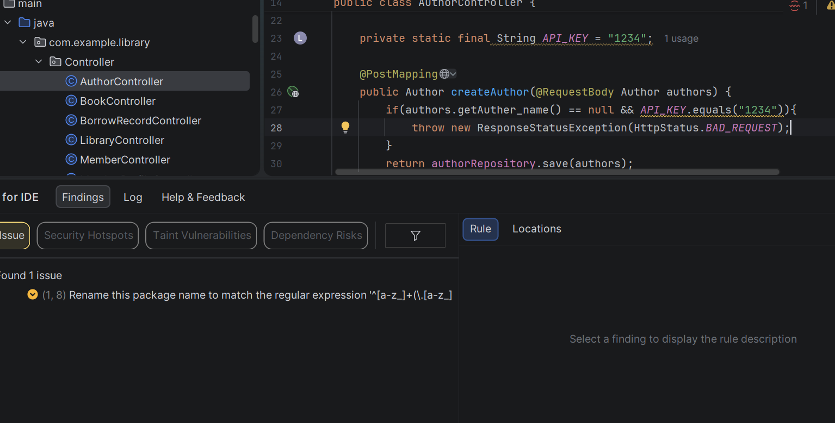
- Then at last I rename package to controller to solve last regular expression issue.
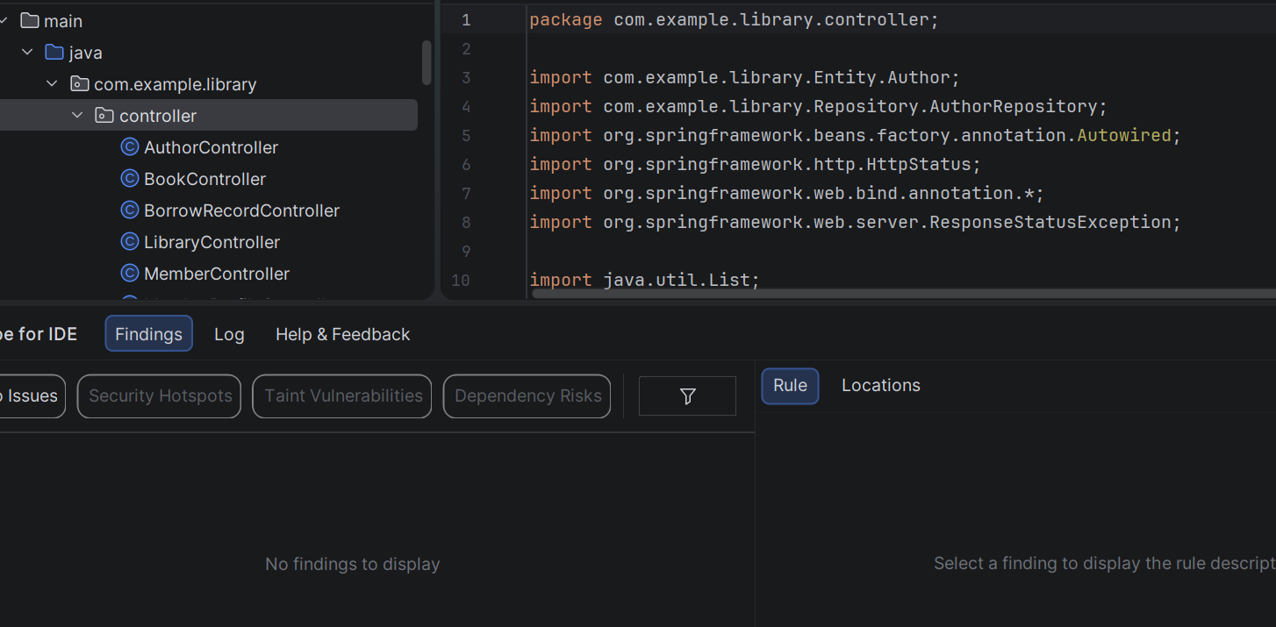

Snyk : To find and solve vulnerable issues.
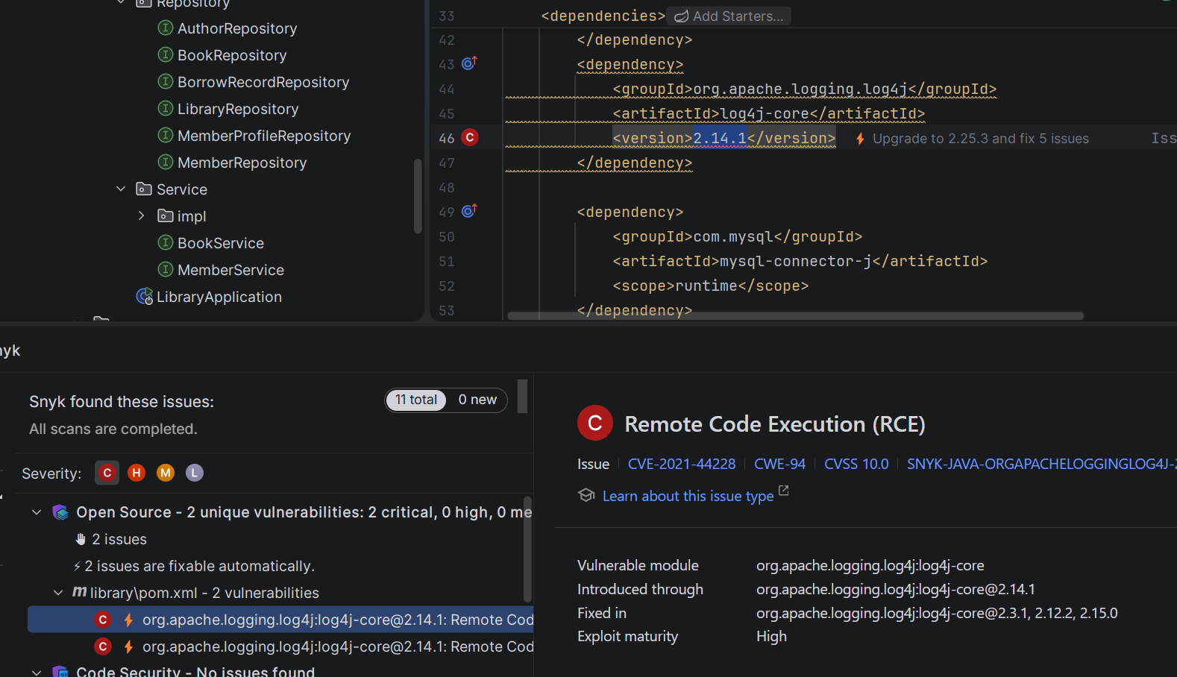
- In this image you can see like one vulnerable issue is come because I use very older versions so it not safe because from this dependency any other outsider hacker hack our project so I update that version to solve this problem.
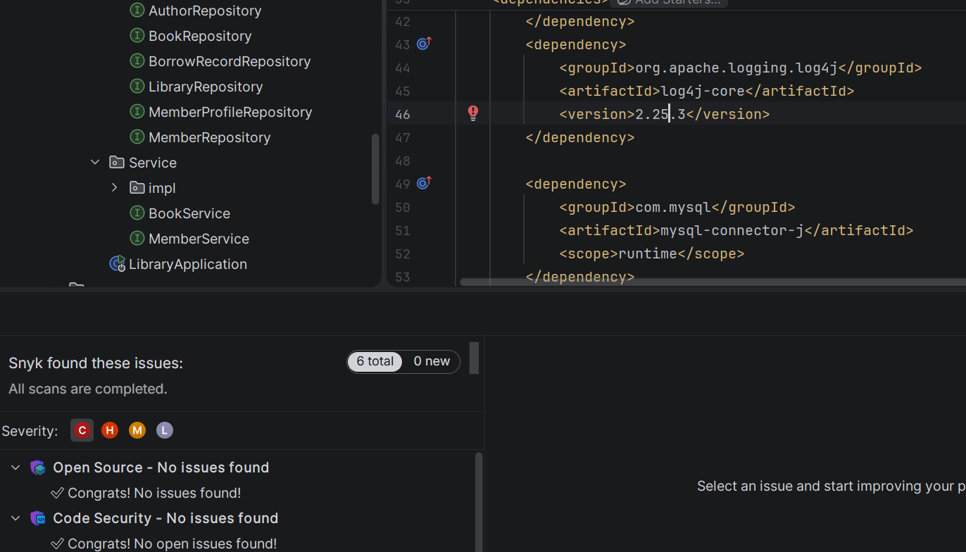

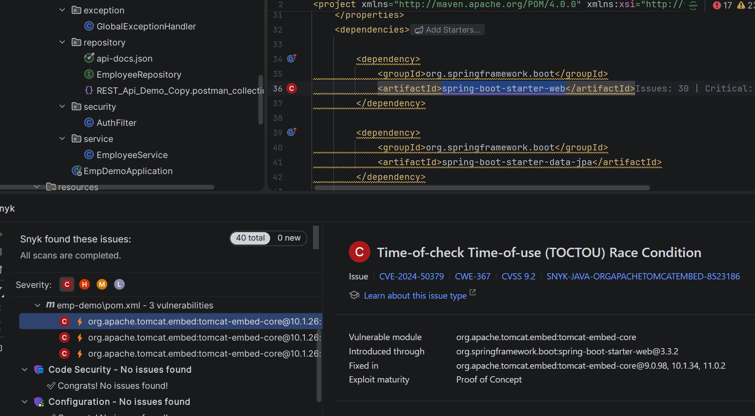
- In this the version issue I solve by giving proper version to dependency.
