-- Calculate a running total of sales amount per region ordered by date.​
select region, sale_date, amount, sum(amount) over (partition by region order by sale_date)as total_sales
from sales;
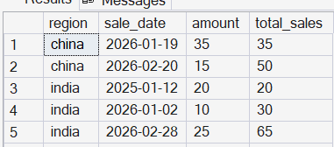

-- Running total of quantity per product: Return all rows with the running total
select fk_product_id, sale_date, amount, count(fk_product_id) over (partition by fk_product_id order by pk_sale_id)as total_quantity
from sales;
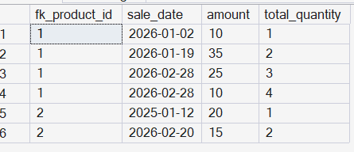

-- If I require quantity separate column then
select *, sum(quantity) over (partition by fk_product_id order by pk_sale_id)as total_quantity
from sales_data;
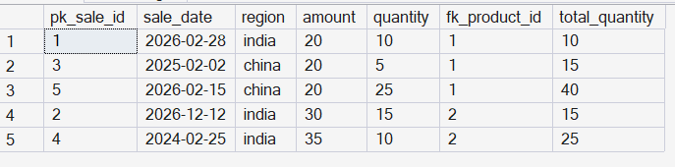

-- Show each employee’s salary along with the average salary of their department
select department, employee_name, salary, avg(salary) over (partition by department) as avg_salary
from employees;
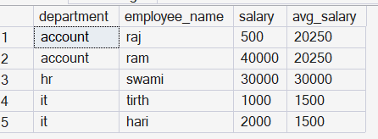

-- Rank students within each class based on score, with the highest score ranked first.
select class, student_name, score, rank() over (partition by class ORDER BY score desc) as rank
from students;


Write a MERGE statement that:​
Updates ProductName and Price if ProductID already exists in Products​
Inserts the record if ProductID does not exist in Products​

MERGE products AS p
USING products_staging AS ps
ON ps.pk_product_id = p.pk_product_id
WHEN MATCHED THEN
UPDATE SET
p.product_name = ps.product_name,
p.price = ps.price

WHEN NOT MATCHED BY TARGET THEN
INSERT (pk_product_id, product_name, price)
VALUES (ps.pk_product_id, ps.product_name, ps.price)

WHEN NOT MATCHED BY SOURCE THEN
delete;
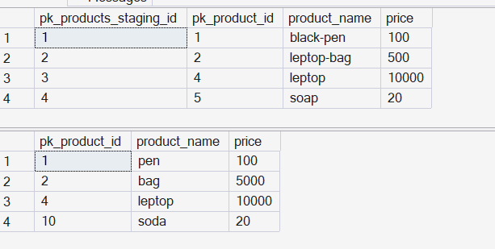
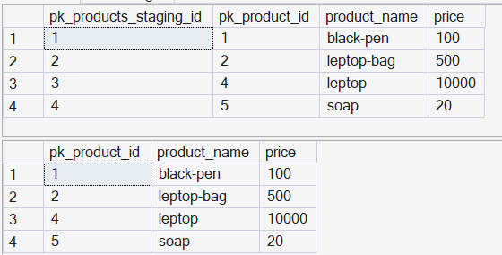

Write a MERGE statement that:​
Updates CustomerName for existing customers​
Inserts new customers​
Marks customers as inactive (IsActive = 0) if they no longer exist in the staging table​

MERGE customers AS c
USING customers_staging AS cs
ON c.pk_customer_id = cs.pk_customer_id
WHEN MATCHED THEN
UPDATE SET
c.customer_name = cs.customer_name

WHEN NOT MATCHED BY TARGET THEN
INSERT (pk_customer_id, customer_name,is_active)
VALUES (cs.pk_customer_id, cs.customer_name,1)

WHEN NOT MATCHED BY SOURCE THEN
UPDATE SET c.is_active = 0
;
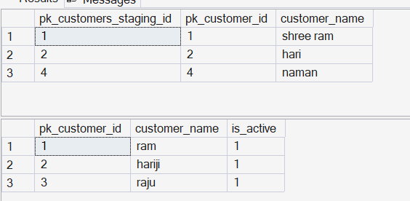
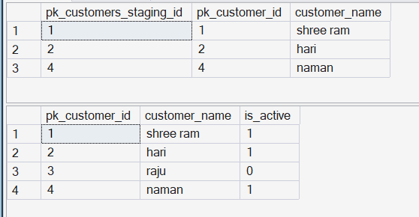

Write a MERGE statement that:​
Updates salary only if the new salary is higher​
Inserts new employees if they do not exist​ ​

MERGE employee_salary AS ess
USING employee_salary_staging AS es
ON ess.pk_employee_id = es.pk_employee_id
WHEN MATCHED AND ess.salary < es.salary THEN
UPDATE SET ess.salary = es.salary

WHEN NOT MATCHED BY TARGET THEN
INSERT (pk_employee_id, salary)
VALUES (es.pk_employee_id, es.salary)

WHEN NOT MATCHED BY SOURCE THEN
delete;
