Module 5: Program Listing

5.1 Cost Estimation

User Inputs:
- User Registration & Profile Setup
- Login (Google OAuth / Email)
- Text Input for Handwriting Synthesis (up to 1600 characters)
- Style Selection (0-12 handwriting styles)
- Bias/Neatness Adjustment (0.0-1.5 range)
- Stroke Color Selection (color picker)
- Stroke Width Adjustment (1-5 pixels)
- Paper Type Selection (white, cream, aged, lined, grid, recycled)
- Ink Type Selection (ballpoint, gel, fountain, marker, pencil)
- Wear Level Adjustment (0.0-1.0)
- Batch Generation Configuration (multiple styles)
- Gallery Filtering & Search
- Favorite/Tag Management

User Outputs:
- Generated Handwriting SVG Display
- Realistic PNG Rendering Preview
- Gallery Grid View with Thumbnails
- Download Options (SVG/PNG/PDF)
- Credit Balance Display
- Generation Status Indicators
- Batch Job Progress Tracking
- Error Messages & Validation Feedback

User Enquiries:
- Search Gallery (by text, tags, date)
- Filter by Style/Status
- View Generation Details
- Check Credit Balance

Number of Files (Internal Logical Files):
- Users
- SavedGenerations
- BatchJobs
- SynthesisUsage
- Accounts (OAuth)
- Sessions

Number of External Interfaces:
- Authentication Provider (Google OAuth 2.0)
- Handwriting Synthesis API (Python FastAPI)
- File Storage Provider (UploadThing)
- Background Job Processor (Inngest)

Domain Characteristic Table
MEASUREMENT PARAMETER | COUNT (value >= 0) | WEIGHTING FACTOR
 |  | Simple
Number of User Inputs | 13
Number of User Outputs | 8
Number of User Inquiries | 4
Number of Files | 6
Number of External Interfaces | 4

Complexity Adjustment Table
ITEM | COMPLEXITY ADJUSTMENT QUESTIONS | SCALE (0-5)
1 | Does the system require reliable backup and recovery? | 4
2 | Are data communications required? | 5
3 | Are there distributed processing functions? | 5
4 | Is performance critical? | 4
5 | Will the system run in an existing, heavily utilized operational environment? | 3
6 | Does the system require on-line data entry? | 5
7 | Does the on-line data entry require the input transaction to be built over multiple screens or operations? | 4
8 | Are the master files updated on-line? | 5
9 | Are the inputs, outputs, files or inquiries complex? | 4
10 | Is the internal processing complex? | 5
11 | Is the code to be designed reusable? | 5
12 | Are conversion and installation included in the design? | 4
13 | Is the system designed for multiple installations in different organizations? | 3
14 | Is the application designed to facilitate change and ease of use by the user? | 5
Total Complexity Adjustment Factor (CAF): 61

Function Point Calculation
Unadjusted Function Points (UFP):
Parameter | Count | Simple | Average | Complex | Total
User Inputs | 13 | - | - | 13 x 6 | 78
User Outputs | 8 | - | 8 x 5 | - | 40
User Inquiries | 4 | - | - | 4 x 6 | 24
Files | 6 | - | 6 x 10 | - | 60
External Interfaces | 4 | - | - | 4 x 10 | 40
UFP Total |  |  |  |  | 242
Value Adjustment Factor (VAF): VAF = 0.65 + (0.01 x CAF) = 0.65 + (0.01 x 61) = 1.26
Adjusted Function Points (AFP): AFP = UFP x VAF = 242 x 1.26 = 305.0

RESULT
PROJECT FUNCTION POINTS | 305.0

5.2 Schema Design

Database Tables Overview
The application uses PostgreSQL with Prisma ORM. The schema consists of the following main tables:
- _prisma_migrations
- accounts
- users
- saved_generations
- batch_jobs
- synthesis_usage
- sessions
- verification_tokens

Users Table
Column | Type | Constraints | Description
id | VARCHAR(25) | PRIMARY KEY | CUID identifier
name | VARCHAR(255) | NULLABLE | Display name
email | VARCHAR(255) | UNIQUE, NULLABLE | Email address
emailVerified | TIMESTAMP | NULLABLE | Verification date
image | VARCHAR(500) | NULLABLE | Profile image URL
password | VARCHAR(255) | NULLABLE | Bcrypt hashed password
credits | INTEGER | DEFAULT 10 | Available synthesis credits
createdAt | TIMESTAMP | DEFAULT NOW() | Account creation
updatedAt | TIMESTAMP | ON UPDATE | Last modification

SavedGenerations Table
Column | Type | Constraints | Description
id | VARCHAR(25) | PRIMARY KEY | CUID identifier
userId | VARCHAR(25) | FOREIGN KEY -> Users | Owner reference
status | ENUM | DEFAULT ‘COMPLETED’ | PENDING, GENERATING, COMPLETED, FAILED
text | TEXT | NOT NULL | Input text content
style | INTEGER | NOT NULL | Style index (0-12)
bias | FLOAT | NOT NULL | Neatness value (0.0-1.5)
strokeColor | VARCHAR(50) | DEFAULT ‘black’ | CSS color value
strokeWidth | INTEGER | DEFAULT 2 | Stroke width (1-5)
fileUrl | VARCHAR(500) | NULLABLE | UploadThing URL
fileKey | VARCHAR(100) | UNIQUE, NULLABLE | UploadThing file key
svgContent | TEXT | NULLABLE | Raw SVG markup
realisticPng | TEXT | NULLABLE | Base64 encoded PNG
paperType | VARCHAR(20) | NULLABLE | Paper type identifier
inkType | VARCHAR(20) | NULLABLE | Ink type identifier
wearLevel | FLOAT | NULLABLE | Degradation (0.0-1.0)
isFavorite | BOOLEAN | DEFAULT FALSE | Favorite flag
tags | TEXT[] | DEFAULT [] | Array of tag strings
batchJobId | VARCHAR(25) | FOREIGN KEY -> BatchJobs | Batch reference
createdAt | TIMESTAMP | DEFAULT NOW() | Creation timestamp
Indexes: userId, status, batchJobId

BatchJobs Table
Column | Type | Constraints | Description
id | VARCHAR(25) | PRIMARY KEY | CUID identifier
userId | VARCHAR(25) | FOREIGN KEY -> Users | Owner reference
name | VARCHAR(255) | NULLABLE | Job display name
text | TEXT | NOT NULL | Source text
totalVariants | INTEGER | NOT NULL | Number of variants
creditsUsed | INTEGER | DEFAULT 0 | Credits consumed
status | ENUM | DEFAULT ‘PENDING’ | PENDING, PROCESSING, COMPLETED, FAILED
completedCount | INTEGER | DEFAULT 0 | Completed count
createdAt | TIMESTAMP | DEFAULT NOW() | Creation timestamp
Indexes: userId, status

SynthesisUsage Table
Column | Type | Constraints | Description
id | VARCHAR(25) | PRIMARY KEY | CUID identifier
userId | VARCHAR(25) | FOREIGN KEY -> Users | User reference
creditsUsed | INTEGER | NOT NULL | Credits consumed
linesCount | INTEGER | NOT NULL | Lines generated
charactersCount | INTEGER | NOT NULL | Characters processed
style | INTEGER | NOT NULL | Style used
bias | FLOAT | NOT NULL | Bias value
success | BOOLEAN | DEFAULT TRUE | Success status
createdAt | TIMESTAMP | DEFAULT NOW() | Usage timestamp
Indexes: userId, createdAt

Accounts Table (OAuth)
Column | Type | Constraints | Description
id | VARCHAR(25) | PRIMARY KEY | CUID identifier
userId | VARCHAR(25) | FOREIGN KEY -> Users | User reference
type | VARCHAR(50) | NOT NULL | Account type
provider | VARCHAR(50) | NOT NULL | OAuth provider
providerAccountId | VARCHAR(255) | NOT NULL | Provider’s user ID
access_token | TEXT | NULLABLE | OAuth access token
refresh_token | TEXT | NULLABLE | OAuth refresh token
expires_at | INTEGER | NULLABLE | Token expiration
token_type | VARCHAR(50) | NULLABLE | Token type
scope | VARCHAR(255) | NULLABLE | OAuth scopes
id_token | TEXT | NULLABLE | ID token
Unique Constraint: (provider, providerAccountId)

Sessions Table
Column | Type | Constraints | Description
id | VARCHAR(25) | PRIMARY KEY | CUID identifier
sessionToken | VARCHAR(255) | UNIQUE | Session token
userId | VARCHAR(25) | FOREIGN KEY -> Users | User reference
expires | TIMESTAMP | NOT NULL | Expiration time

Entity Relationship Diagram
┌─────────────────┐ ┌──────────────────────┐
│ Users │ │ Accounts │
├─────────────────┤ ├──────────────────────┤
│ id (PK) │──┐ │ id (PK) │
│ name │ │ │ userId (FK) ─────────┼──┐
│ email │ │ │ provider │ │
│ password │ │ │ providerAccountId │ │
│ credits │ │ │ access_token │ │
│ createdAt │ │ │ refresh_token │ │
│ updatedAt │ │ └──────────────────────┘ │
└─────────────────┘ │ │
│ │ ┌──────────────────────┐ │
│ └────┤ Sessions │ │
│ ├──────────────────────┤ │
│ │ id (PK) │ │
│ │ userId (FK) ─────────┼──┤
│ │ sessionToken │ │
│ │ expires │ │
│ └──────────────────────┘ │
│ │
▼ │
┌─────────────────┐ ┌──────────────────────┐ │
│ BatchJobs │ │ SavedGenerations │ │
├─────────────────┤ ├──────────────────────┤ │
│ id (PK) │──┐ │ id (PK) │ │
│ userId (FK) ────┼──┼────│ userId (FK) ─────────┼──┤
│ name │ │ │ batchJobId (FK) ─────┼──┘
│ text │ │ │ status │
│ totalVariants │ │ │ text │
│ creditsUsed │ │ │ style │
│ status │ │ │ bias │
│ completedCount │ │ │ strokeColor │
│ createdAt │ │ │ svgContent │
└─────────────────┘ │ │ realisticPng │
│ │ isFavorite │
│ │ tags │
│ │ createdAt │
│ └──────────────────────┘
│
│ ┌──────────────────────┐
│ │ SynthesisUsage │
│ ├──────────────────────┤
│ │ id (PK) │
└────│ userId (FK) │
│ creditsUsed │
│ linesCount │
│ charactersCount │
│ style │
│ bias │
│ success │
│ createdAt │
└──────────────────────┘

5.3 User Manual With Screenshots

5.3.1 Getting Started
Registration: 1. Navigate to the application URL 2. Click “Sign Up” button 3. Enter your full name, email, and password 4. Alternatively, click “Continue with Google” for OAuth login 5. Upon successful registration, you receive 10 free credits
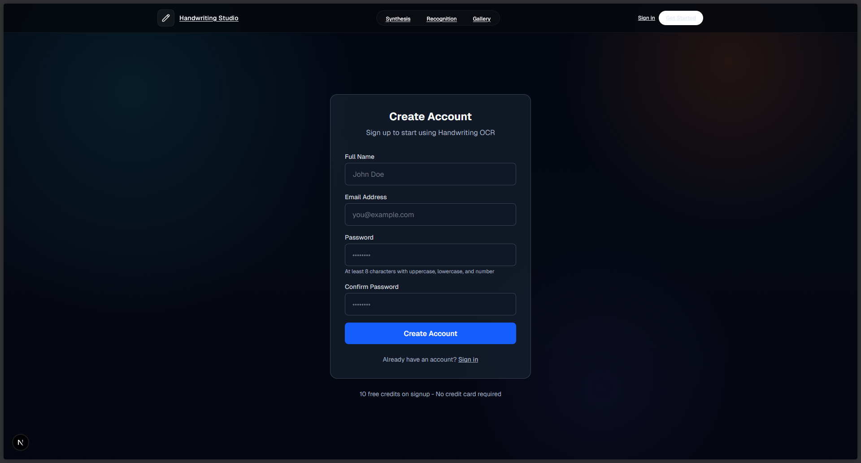

Login: 1. Navigate to the login page 2. Enter your email and password 3. Click “Sign In” or use Google OAuth 4. You will be redirected to the dashboard
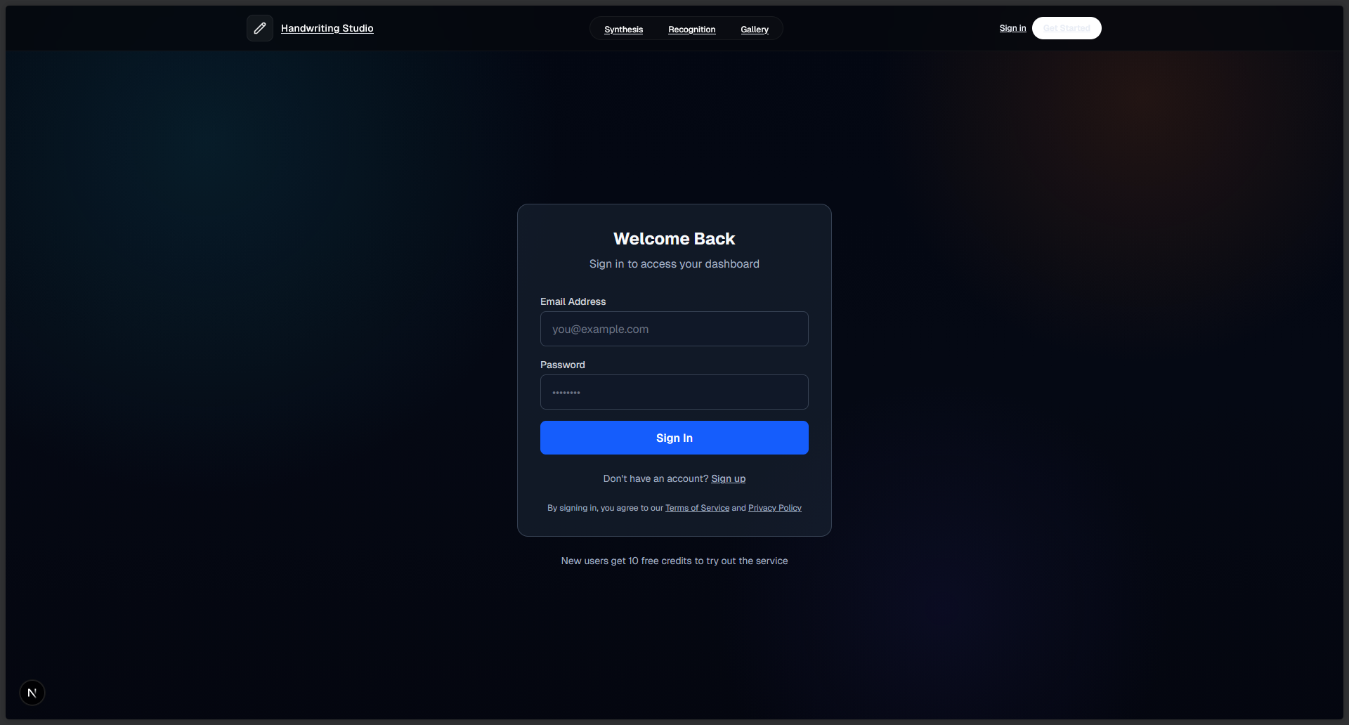

5.3.2 Generating Handwriting
Step 1: Enter Text - Navigate to the “Synthesis” tab on the dashboard - Enter your text in the text area (maximum 1600 characters) - Text supports multiple lines (up to 20 lines, 75 characters per line) - Supported characters: a-z, A-Z (except Q, X, Z), 0-9, common punctuation
Step 2: Configure Style Options - Style Selection: Choose from 13 unique handwriting styles (0-12) - Bias/Neatness: Adjust the slider (0.0 = messy, 1.5 = very neat) - Stroke Color: Click the color picker to select ink color - Stroke Width: Adjust stroke thickness (1-5 pixels)
Step 3: Generate - Click the “Generate Handwriting” button - Wait for the synthesis to complete (typically 2-5 seconds) - The generated handwriting SVG will appear in the preview area - 1 credit is deducted per generation
Step 4: Save or Download - Click “Save to Gallery” to store the generation - Click “Download SVG” to download the vector file - Click “Download PNG” to download as an image
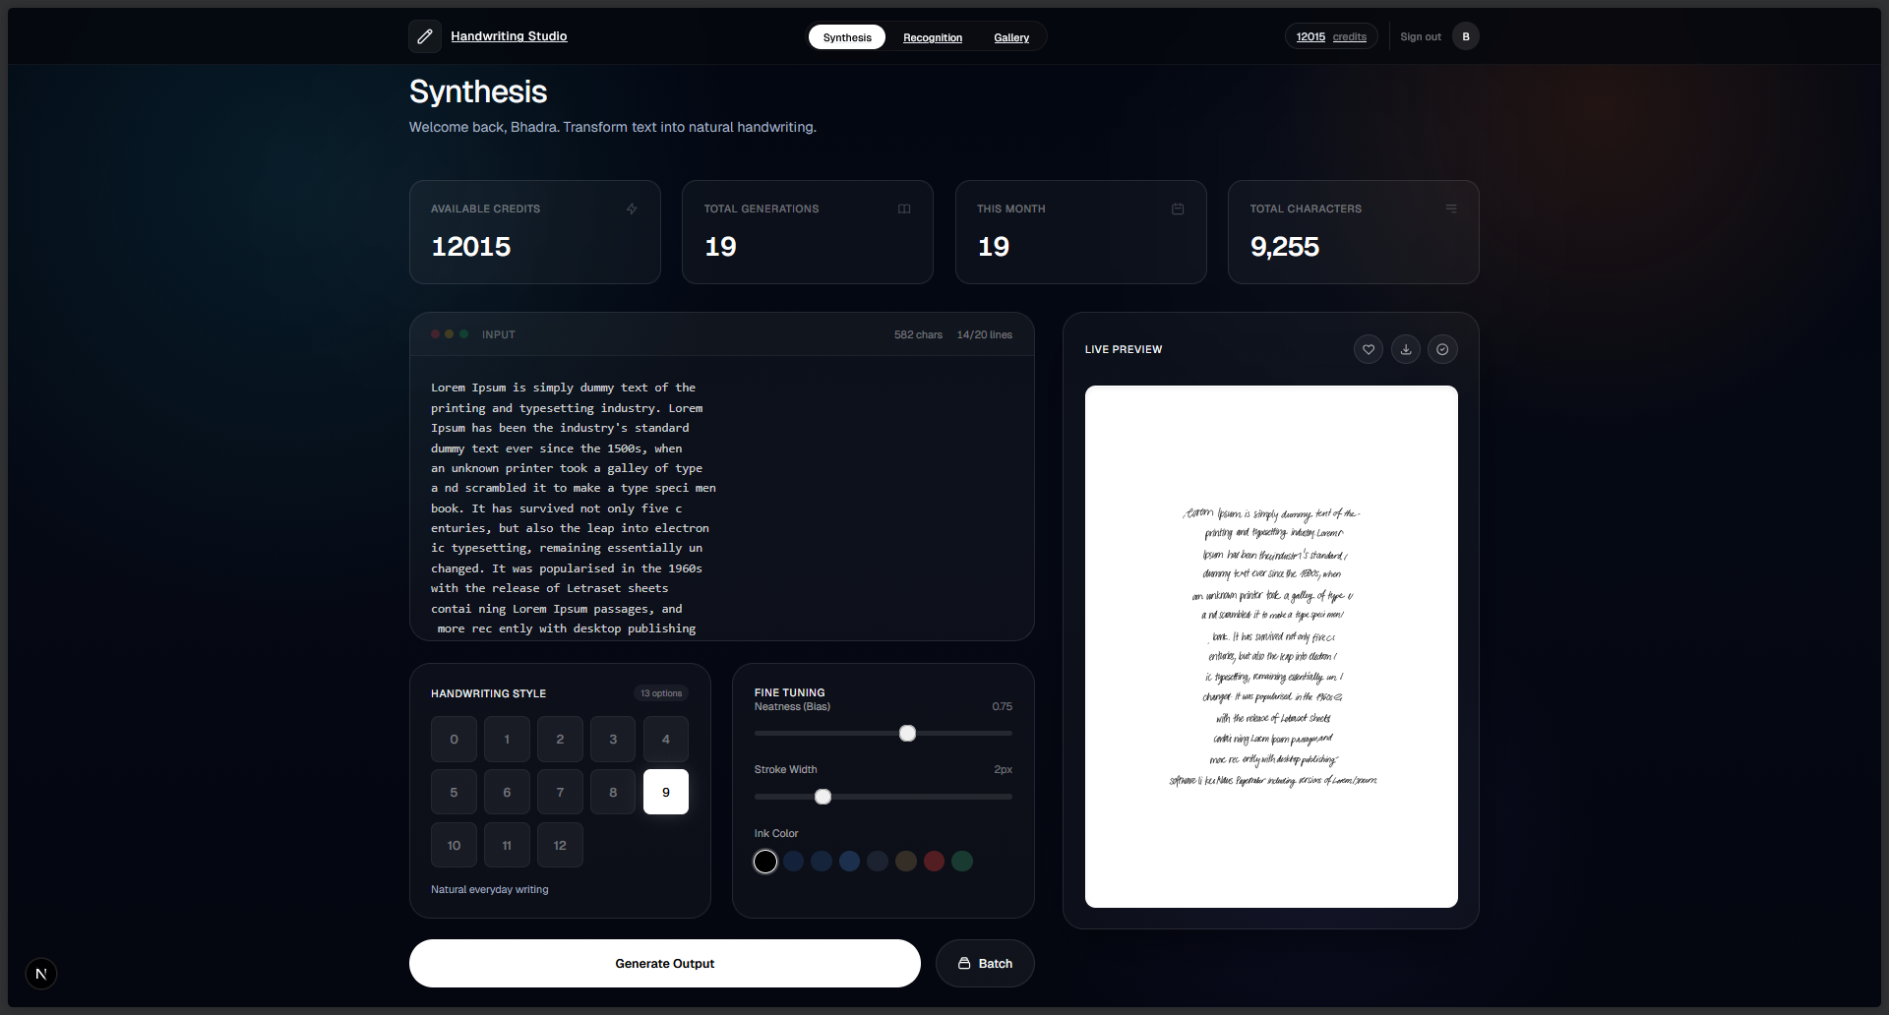

5.3.3 Realistic Rendering
Make it Look Handwritten: 1. From the gallery, select a saved generation 2. Click “Make Realistic” button 3. Configure realistic rendering options: - Paper Type: white, cream, aged, lined, grid, recycled - Ink Type: ballpoint, gel, fountain, marker, pencil - Wear Level: 0.0 (pristine) to 1.0 (heavily worn) 4. Click “Apply” to generate the realistic PNG 5. Download the realistic version
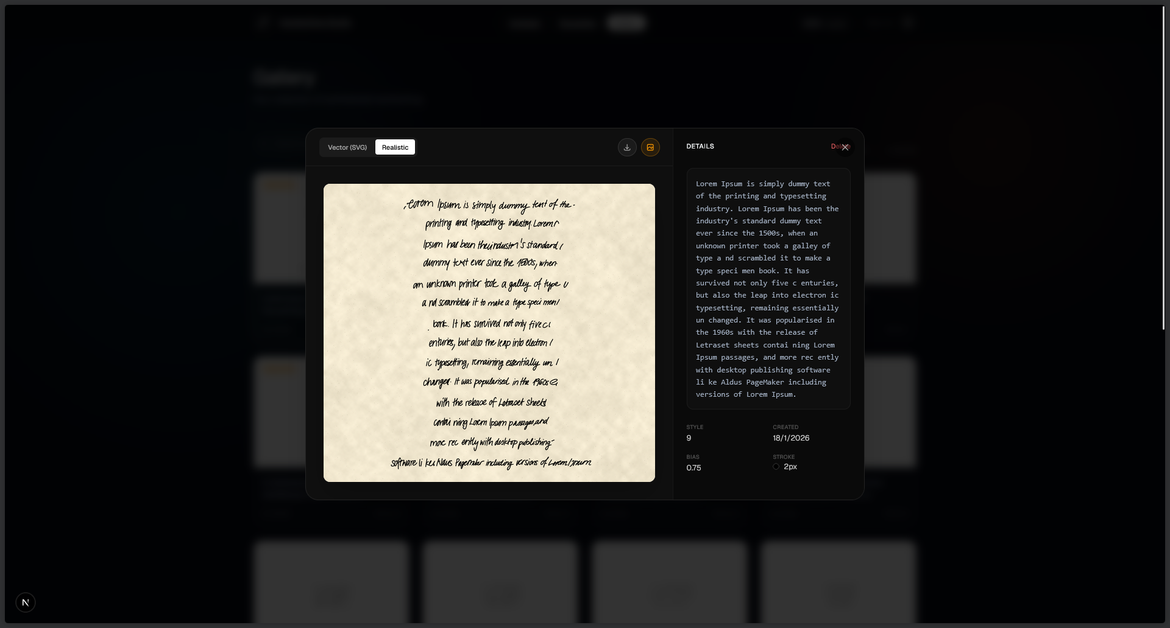

5.3.4 Batch Generation
Generate Multiple Variants: 1. Navigate to “Batch” tab 2. Enter your text content 3. Select multiple styles you want to generate 4. Configure other parameters (bias, colors) 5. Click “Generate Batch” 6. Monitor progress in the batch jobs panel 7. View all variants in the gallery when complete
Note: Batch generation requires sufficient credits for all selected variants.
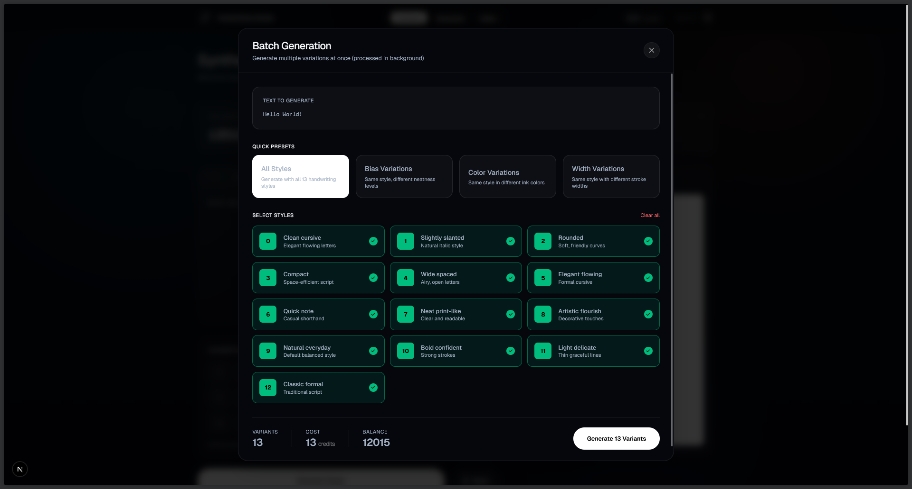
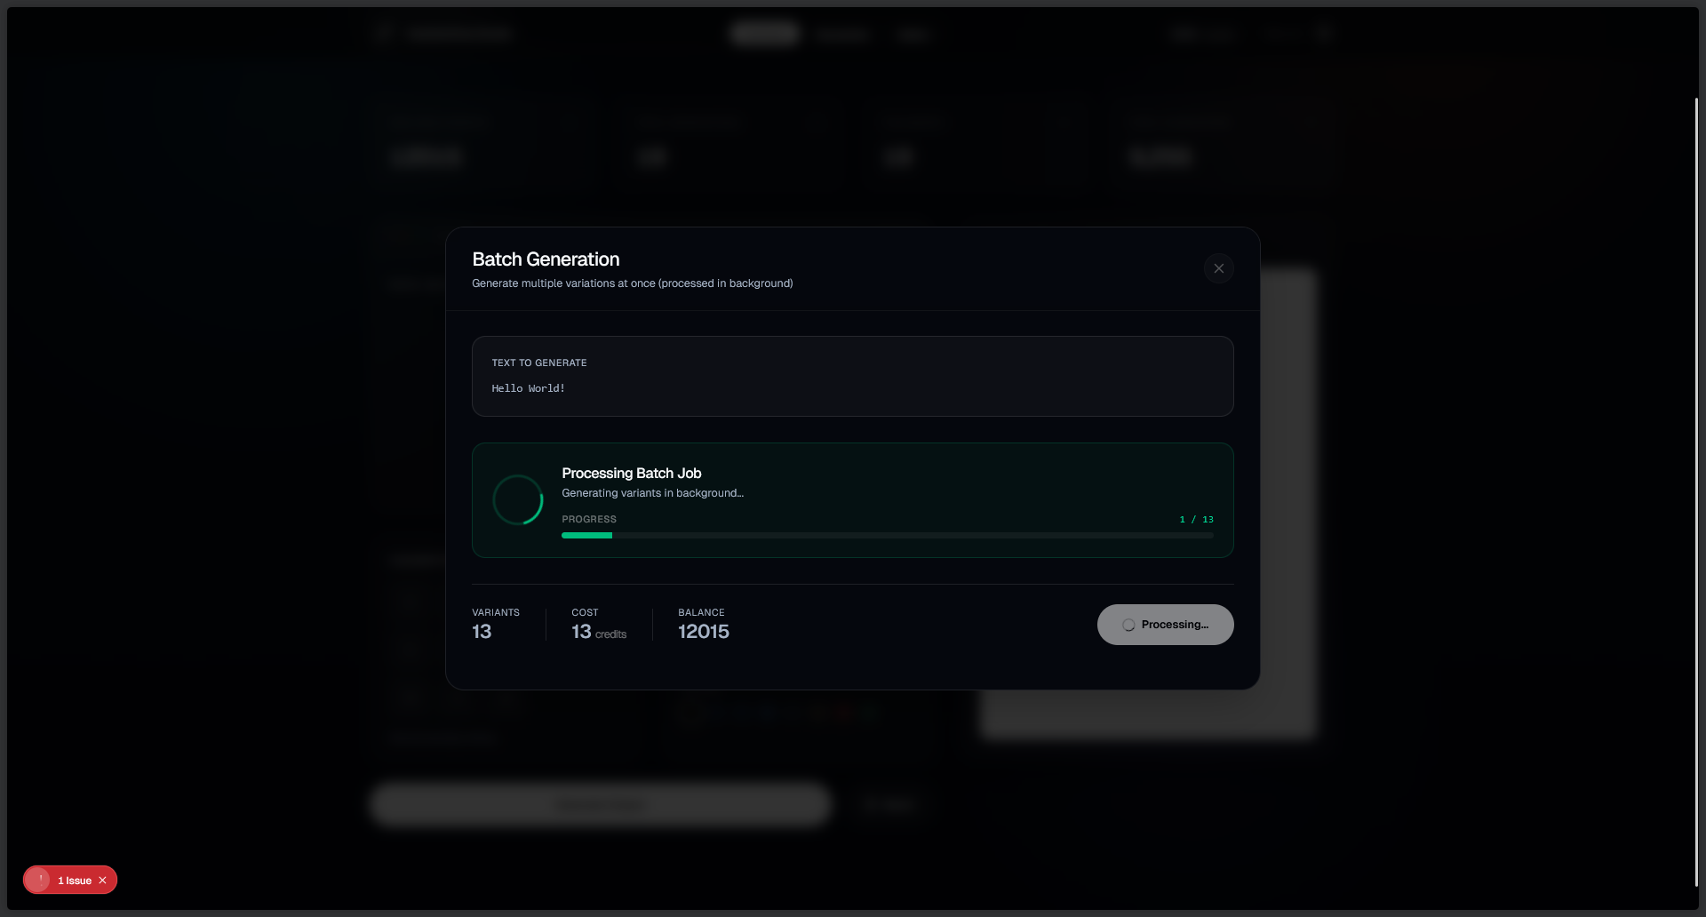
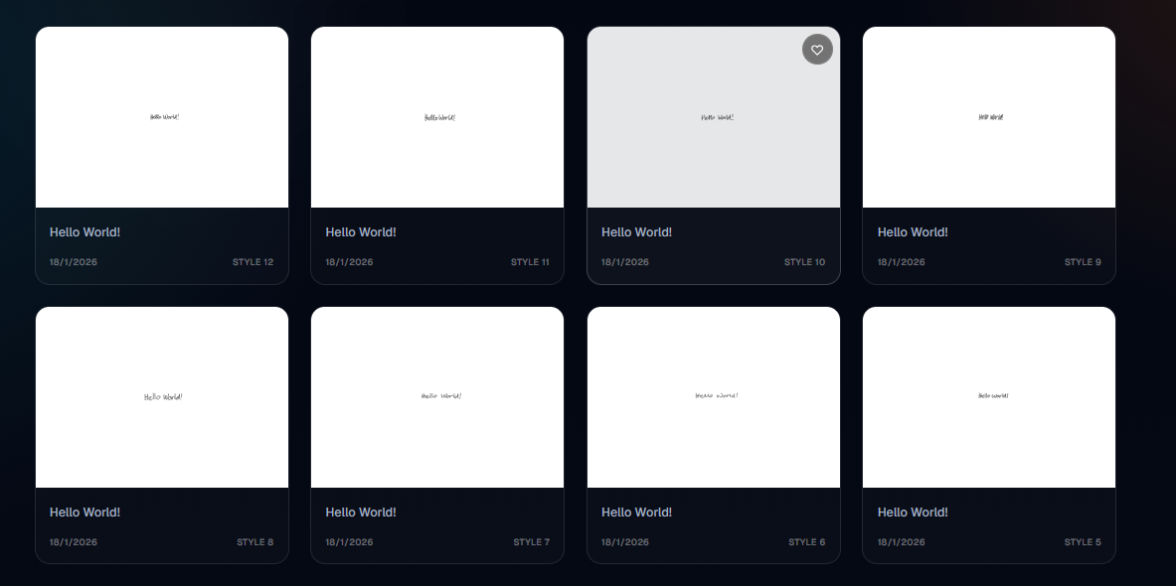

5.3.5 Gallery Management
Viewing Generations: - Access the “Gallery” tab to see all saved generations - Use grid or list view toggle - Filter by: All, Favorites, By Style, By Date
Managing Generations: - Click the heart icon to mark as favorite - Click the tag icon to add tags - Click the trash icon to delete - Click on a generation to view details
Search: - Use the search bar to find generations by text content - Filter by tags using the tag dropdown - Sort by date (newest/oldest)
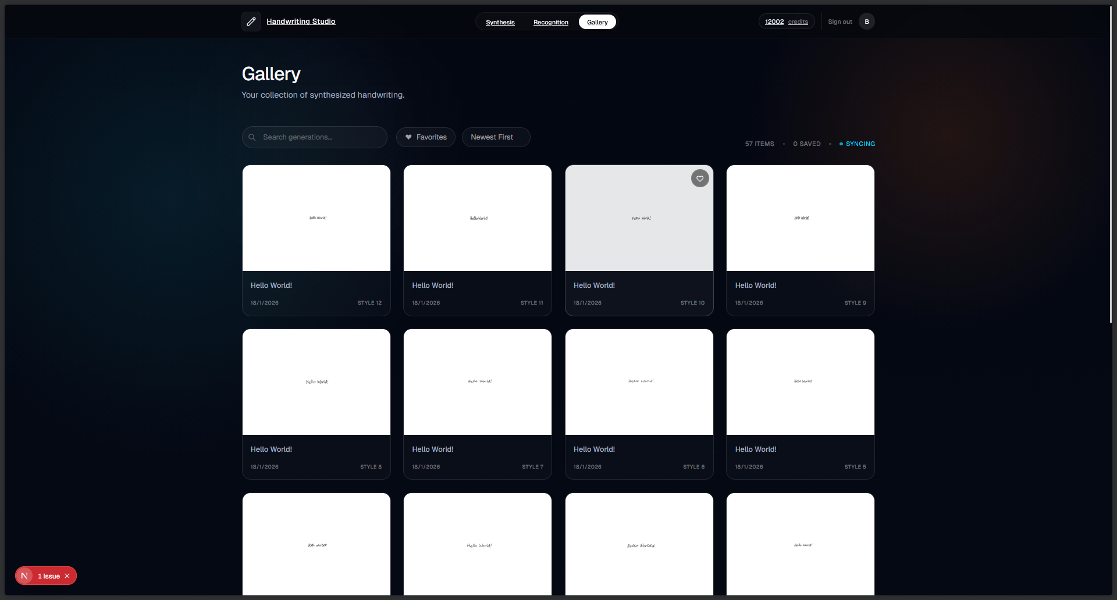
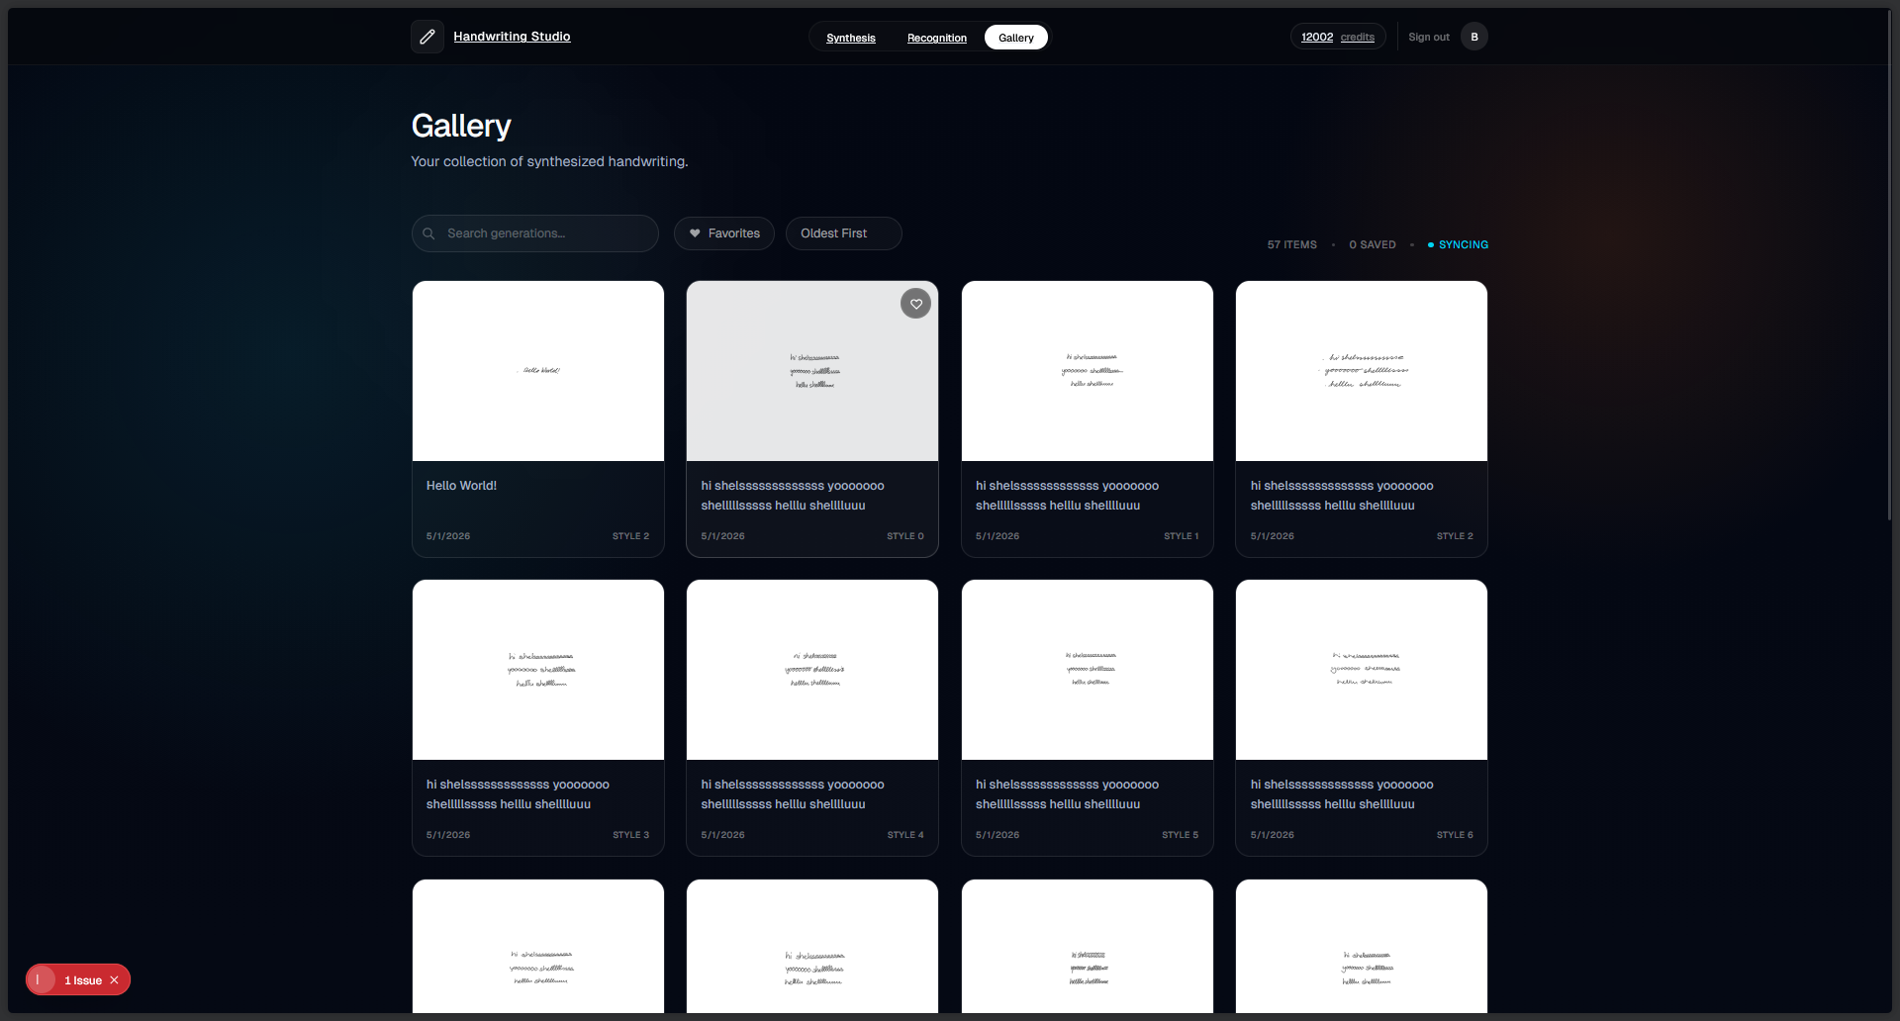

5.3.6 Credits System
Checking Balance: - Your credit balance is displayed in the navigation bar - Each synthesis generation costs 1 credit - New users receive 10 free credits
Managing Credits: - Navigate to “Credits” or “Settings” page - View usage history - Purchase additional credits if needed
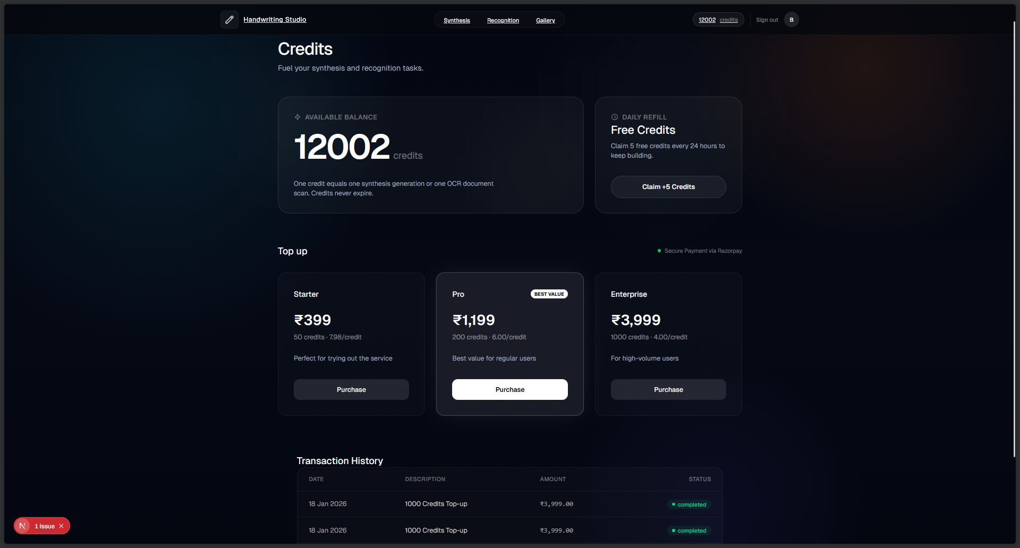
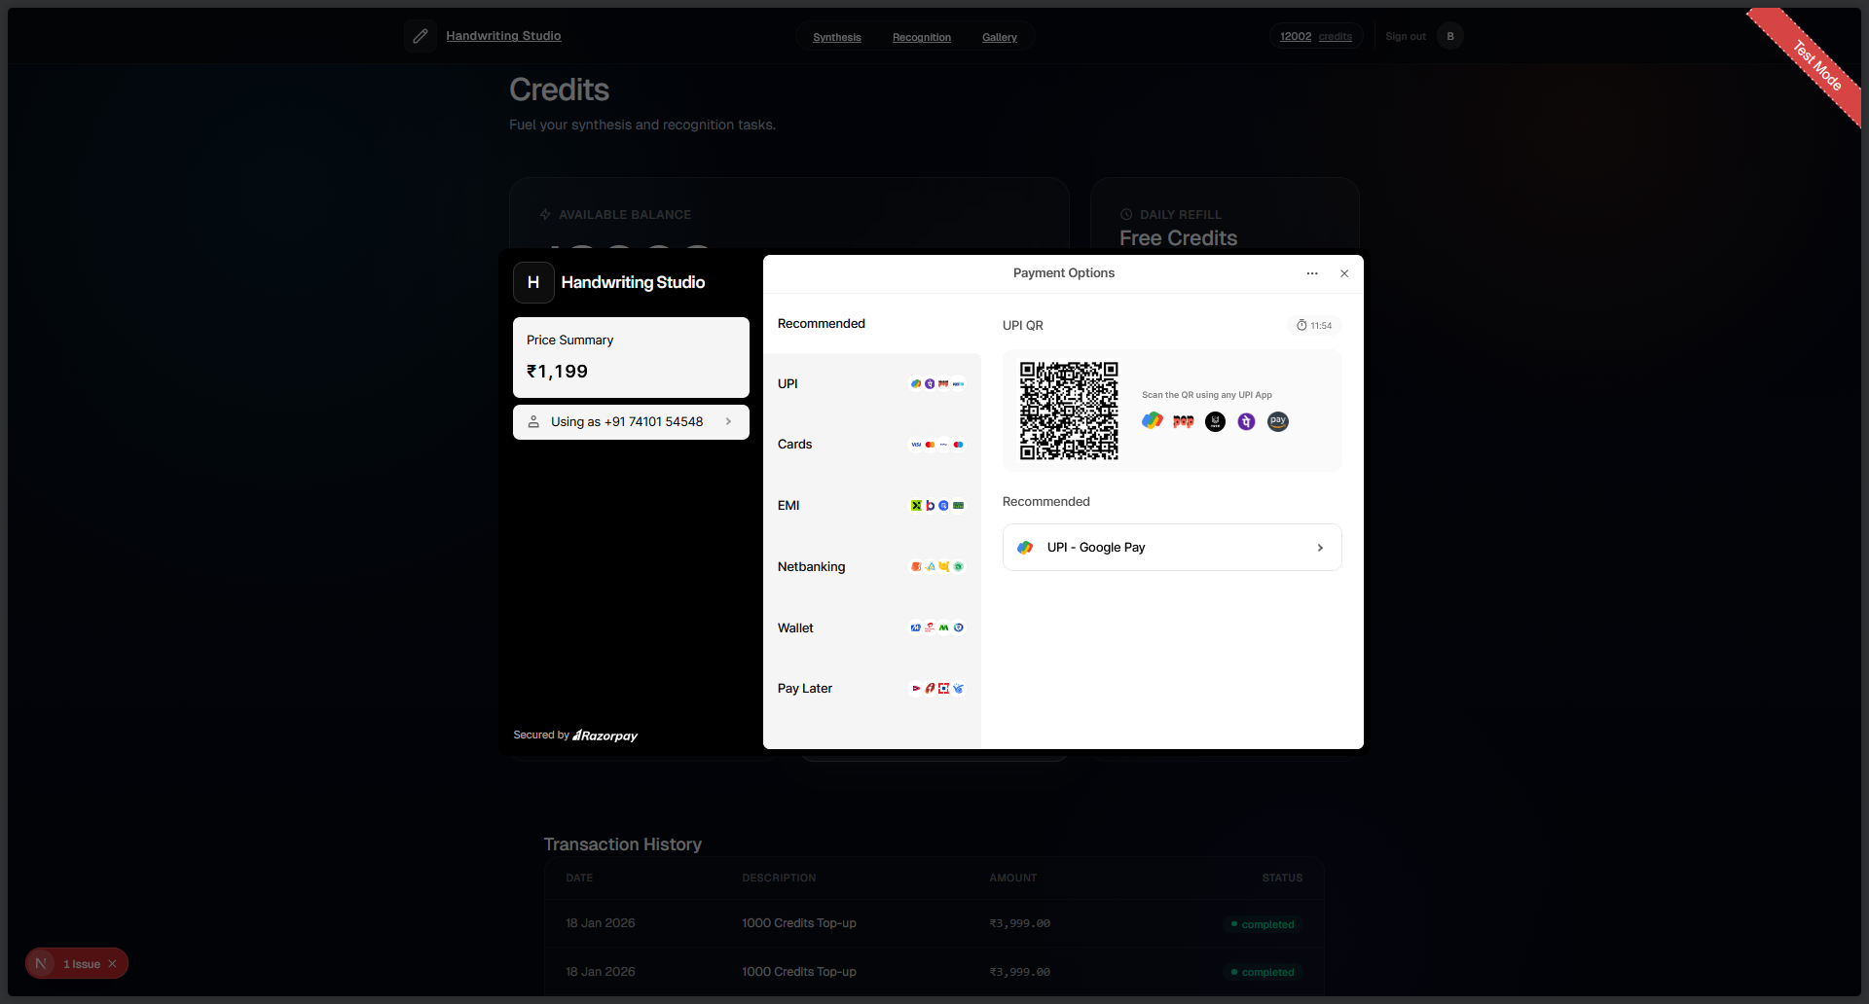

5.4 Test Cases Design

5.4.1 Authentication Test Cases
Test Case ID | Test Case Description | Pre-Conditions | Test Steps | Expected Result | Actual Result | Status
TC_001 | Verify user registration with valid details | User does not exist | 1) Open registration page. 2) Enter valid full name, email, password. 3) Submit form. | New user is created with unique userId; createdAt set to current time; credits = 10 | As expected | Pass
TC_002 | Verify registration fails for duplicate email | A user with same email exists | 1) Open registration page. 2) Enter existing email + valid details. 3) Submit. | Registration rejected; “email already in use” error shown. | As expected | Pass
TC_003 | Verify login with valid credentials | User account exists and verified | 1) Open login. 2) Enter valid email & password (or Google OAuth). 3) Submit. | User session created; redirected to Dashboard. | As expected | Pass
TC_004 | Verify login fails with wrong password | User exists | 1) Open login. 2) Enter valid email + wrong password. 3) Submit. | Error shown; no session created. | As expected | Pass
TC_005 | Verify Google OAuth login | User has Google account | 1) Click “Continue with Google”. 2) Complete OAuth flow. | User authenticated; account linked if new. | As expected | Pass

5.4.2 Synthesis Generation Test Cases
Test Case ID | Test Case Description | Pre-Conditions | Test Steps | Expected Result | Actual Result | Status
TC_006 | Generate handwriting with valid text | User logged in; credits > 0 | 1) Enter “Hello World”. 2) Select style 9. 3) Click Generate. | SVG generated; displayed in preview; 1 credit deducted. | As expected | Pass
TC_007 | Verify empty text rejection | User logged in | 1) Leave text field empty. 2) Click Generate. | Validation error: “Text cannot be empty” | As expected | Pass
TC_008 | Verify invalid character rejection | User logged in | 1) Enter “Hello @World”. 2) Click Generate. | Validation error listing invalid characters. | As expected | Pass
TC_009 | Verify line limit enforcement | User logged in | 1) Enter text with 25 lines. 2) Click Generate. | Validation error: “Maximum 20 lines allowed” | As expected | Pass
TC_010 | Verify character limit per line | User logged in | 1) Enter line with 80 characters. 2) Click Generate. | Validation error: “Line exceeds 75 characters” | As expected | Pass
TC_011 | Verify insufficient credits error | User logged in; credits = 0 | 1) Enter valid text. 2) Click Generate. | Error: “Insufficient credits”; generation blocked. | As expected | Pass
TC_012 | Verify style range (0-12) | User logged in | 1) Attempt style = 15 via API. | Validation error: style must be 0-12 | As expected | Pass
TC_013 | Verify bias range (0.0-1.5) | User logged in | 1) Set bias = 2.0. 2) Click Generate. | Validation error: bias must be 0.0-1.5 | As expected | Pass

5.4.3 Gallery Test Cases
Test Case ID | Test Case Description | Pre-Conditions | Test Steps | Expected Result | Actual Result | Status
TC_014 | Save generation to gallery | User logged in; generation exists | 1) Generate handwriting. 2) Click “Save to Gallery”. | Generation saved with unique id; appears in gallery. | As expected | Pass
TC_015 | View gallery items | User logged in; has saved items | 1) Navigate to Gallery tab. | All user’s generations displayed in grid view. | As expected | Pass
TC_016 | Mark generation as favorite | User logged in; item exists | 1) Click heart icon on item. | isFavorite set to true; icon filled. | As expected | Pass
TC_017 | Add tags to generation | User logged in; item exists | 1) Click tag icon. 2) Enter “important”. 3) Save. | Tag added to generation’s tags array. | As expected | Pass
TC_018 | Delete generation | User logged in; item exists | 1) Click trash icon. 2) Confirm deletion. | Generation removed from database; removed from view. | As expected | Pass
TC_019 | Filter by favorites | User has favorites | 1) Click “Favorites” filter. | Only items with isFavorite=true shown. | As expected | Pass
TC_020 | Search generations by text | User has generations | 1) Enter search term. 2) Press Enter. | Only matching generations displayed. | As expected | Pass

5.4.4 Realistic Rendering Test Cases
Test Case ID | Test Case Description | Pre-Conditions | Test Steps | Expected Result | Actual Result | Status
TC_021 | Apply realistic rendering | User logged in; generation saved | 1) Select generation. 2) Click “Make Realistic”. 3) Select paper=cream, ink=ballpoint. 4) Apply. | Realistic PNG generated; realisticPng field populated. | As expected | Pass
TC_022 | Verify paper type options | User on realistic modal | 1) Open paper type dropdown. | Options: white, cream, aged, lined, grid, recycled. | As expected | Pass
TC_023 | Verify ink type options | User on realistic modal | 1) Open ink type dropdown. | Options: ballpoint, gel, fountain, marker, pencil. | As expected | Pass
TC_024 | Verify wear level bounds | User on realistic modal | 1) Adjust wear level slider. | Slider constrained to 0.0-1.0 range. | As expected | Pass
TC_025 | Download realistic PNG | Realistic rendering complete | 1) Click “Download PNG”. | PNG file downloaded with paper texture and ink effects. | As expected | Pass

5.4.5 Batch Processing Test Cases
Test Case ID | Test Case Description | Pre-Conditions | Test Steps | Expected Result | Actual Result | Status
TC_026 | Create batch job | User logged in; credits >= variants | 1) Enter text. 2) Select 3 styles. 3) Click “Generate Batch”. | BatchJob created with status=PENDING; 3 generations queued. | As expected | Pass
TC_027 | Verify batch progress tracking | Batch job processing | 1) View batch jobs panel. | Progress bar updates; completedCount increments. | As expected | Pass
TC_028 | Verify batch completion | All variants generated | 1) Wait for batch to complete. | Status=COMPLETED; all generations in gallery. | As expected | Pass
TC_029 | Verify insufficient credits for batch | User credits < variants | 1) Select 5 styles. 2) Have only 3 credits. | Error: “Insufficient credits for batch”; job not created. | As expected | Pass
TC_030 | Verify variant limit (1-13) | User logged in | 1) Try to select 15 styles via API. | Validation error: max 13 variants allowed. | As expected | Pass

5.4.6 API Integration Test Cases
Test Case ID | Test Case Description | Pre-Conditions | Test Steps | Expected Result | Actual Result | Status
TC_031 | Verify API health check | API server running | 1) GET /health endpoint. | Response: status=healthy, model info returned. | As expected | Pass
TC_032 | Verify unauthorized API access | No session token | 1) Call protected endpoint without auth. | 401 Unauthorized error returned. | As expected | Pass
TC_033 | Verify API rate limiting | Multiple rapid requests | 1) Send 100 requests in 10 seconds. | Rate limiting applied; 429 Too Many Requests after threshold. | As expected | Pass
TC_034 | Verify CORS configuration | Request from allowed origin | 1) Make request from frontend domain. | Request allowed; proper CORS headers returned. | As expected | Pass
TC_035 | Verify file upload limits | User uploading file | 1) Try to upload 10MB SVG file. | Error: file exceeds 4MB limit. | As expected | Pass

5.4.7 Security Test Cases
Test Case ID | Test Case Description | Pre-Conditions | Test Steps | Expected Result | Actual Result | Status
TC_036 | Verify ownership check on gallery | User A and User B exist | 1) User A tries to access User B’s generation by ID. | NOT_FOUND error returned (not FORBIDDEN). | As expected | Pass
TC_037 | Verify password hashing | User registered | 1) Check database for password field. | Password stored as bcrypt hash, not plaintext. | As expected | Pass
TC_038 | Verify session expiration | Session exists | 1) Wait for session to expire. 2) Try to access protected route. | Redirect to login; session invalidated. | As expected | Pass
TC_039 | Verify XSS prevention | User logged in | 1) Enter <script>alert('xss')</script> as text. | Text escaped/sanitized; no script execution. | As expected | Pass
TC_040 | Verify SQL injection prevention | User logged in | 1) Enter '; DROP TABLE users; -- as text. | Query parameterized; no SQL injection. | As expected | Pass

