Amazia

Pages to design

1. Home
2. About Us
3. Services
4. Service Detail
5. Portfolio
6. Project Detail
7. Blog
8. Blog Detail
9. Contact

Home page

Main header section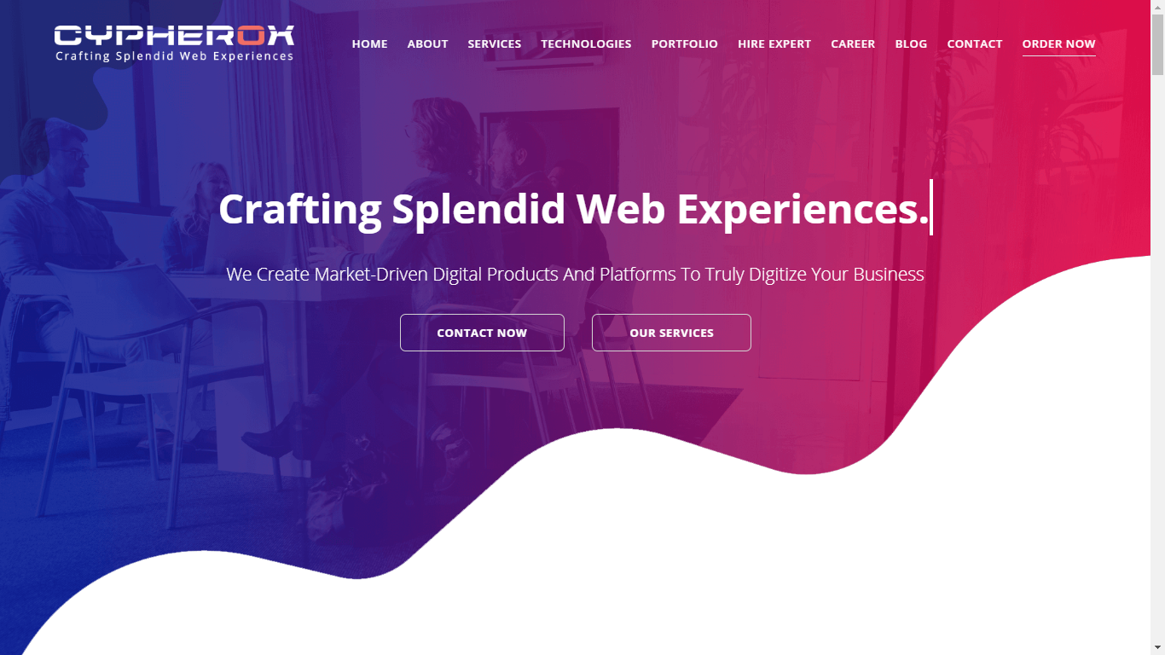

Services section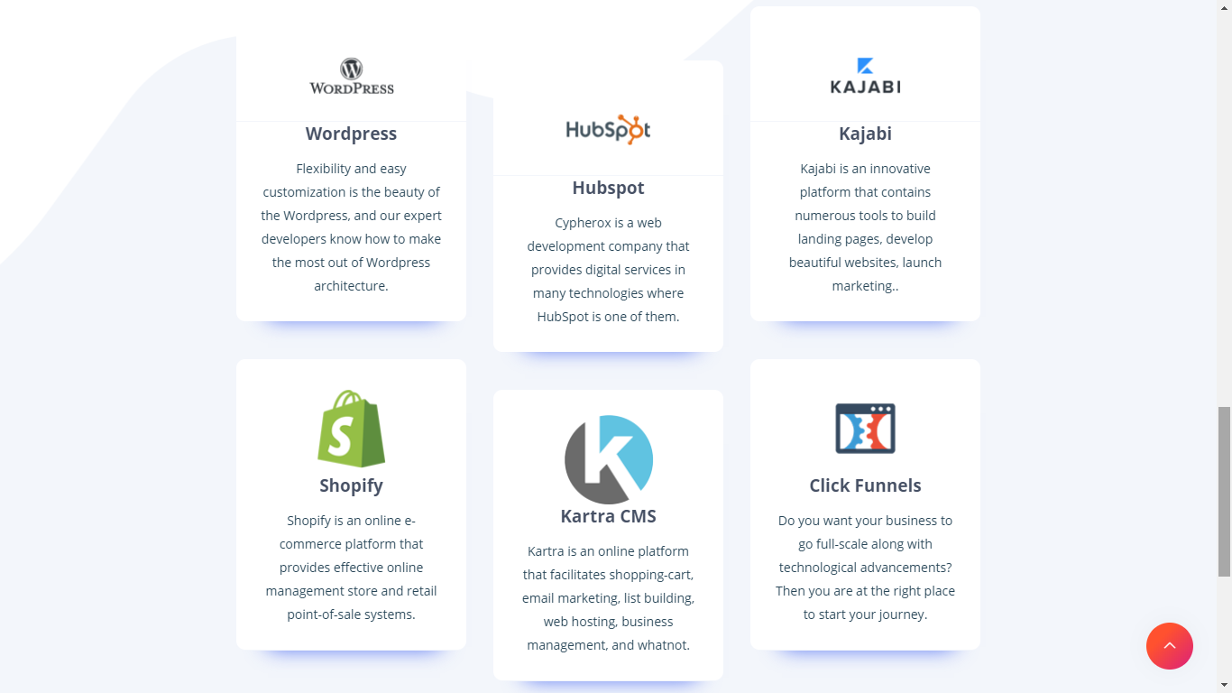

Portfolio section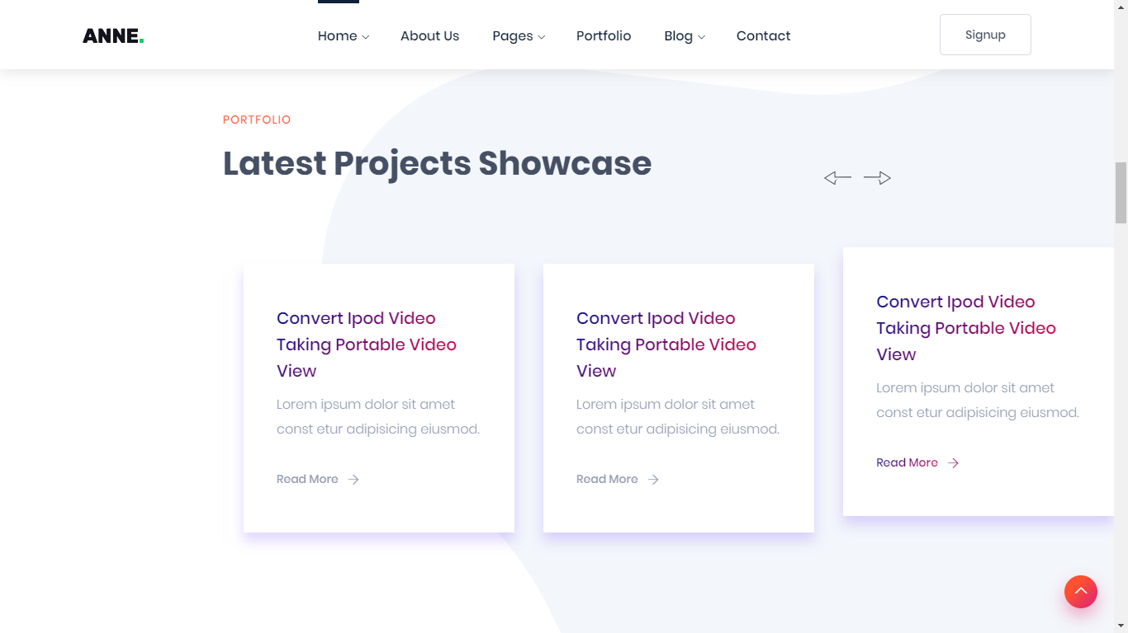Note: Project definition and detail will be shown on hover of images with flip card effect.

Client section 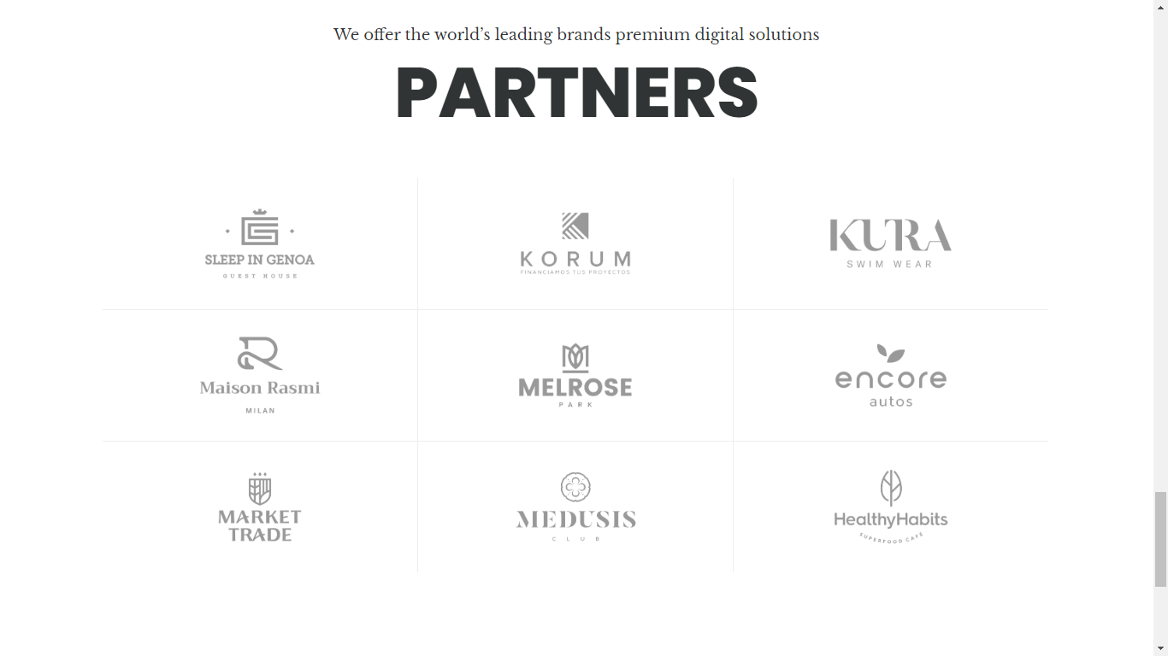

About section 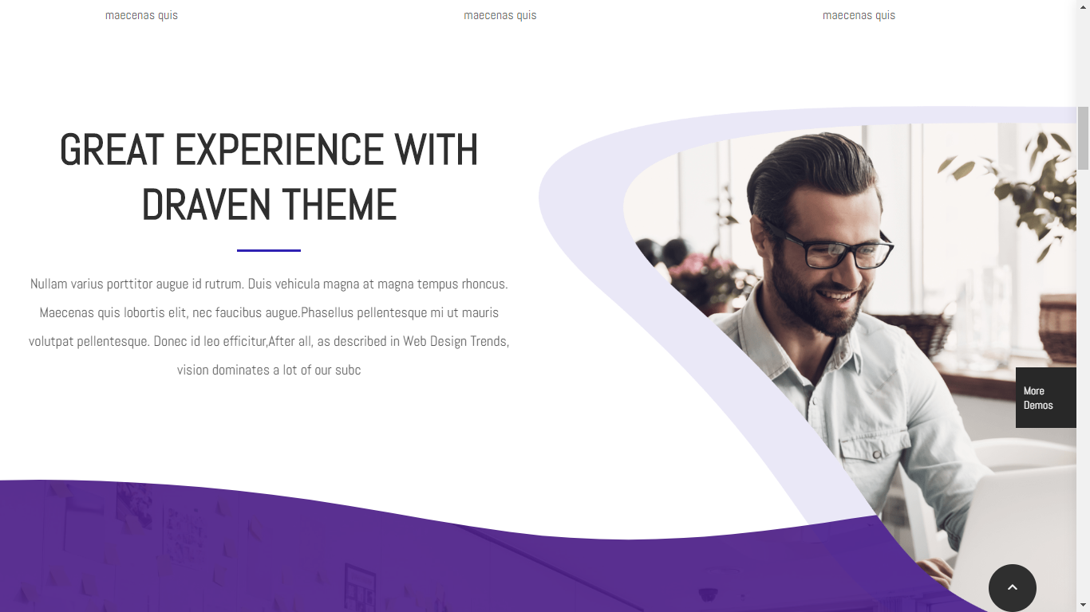

Video section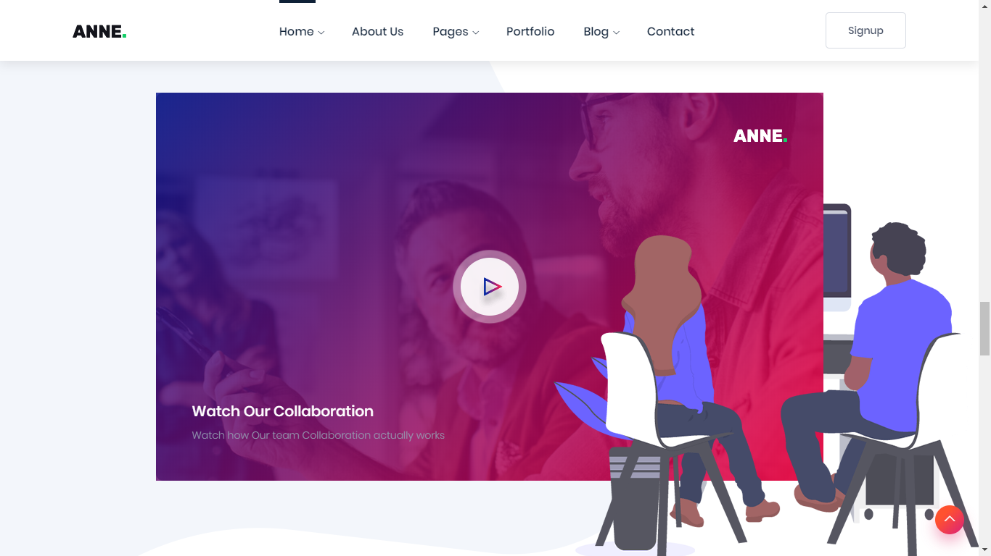Video section with people watching movie in theatre instead of these both are watching TV.

Testimonial section 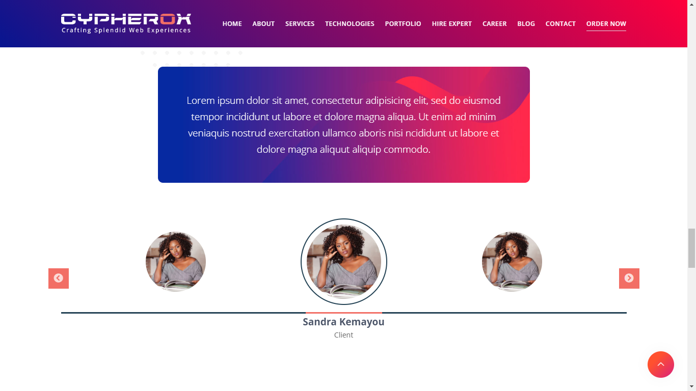

Blog section 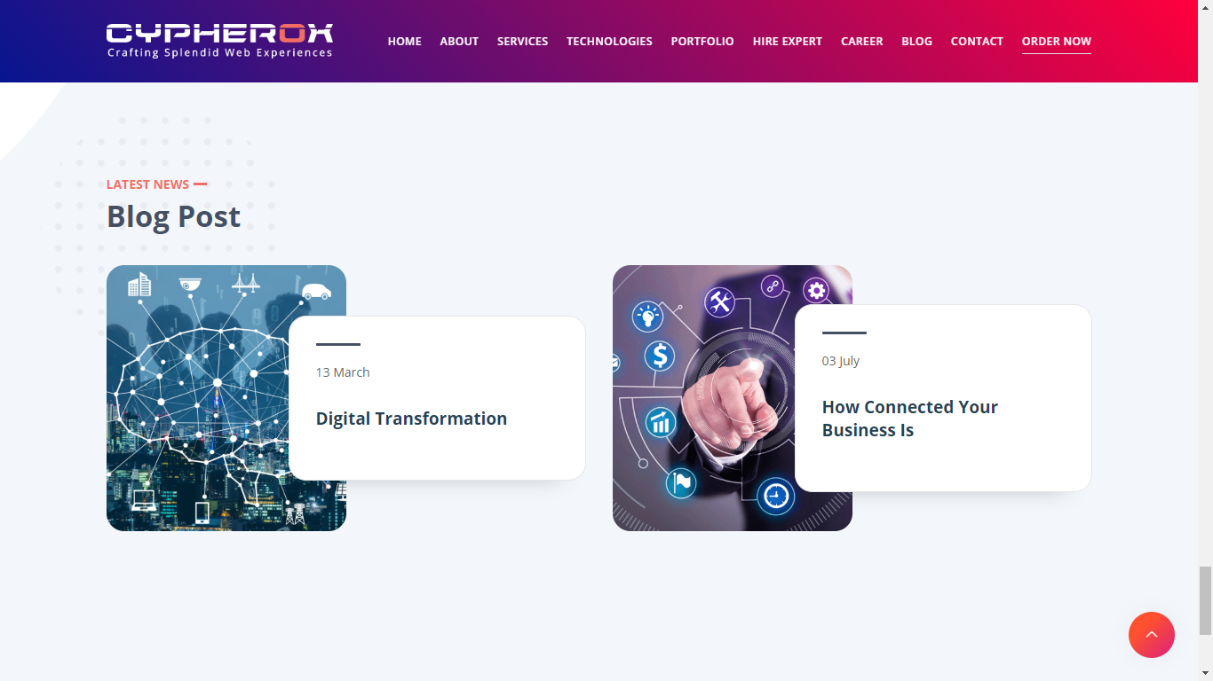

Subscribe to Newsletter section 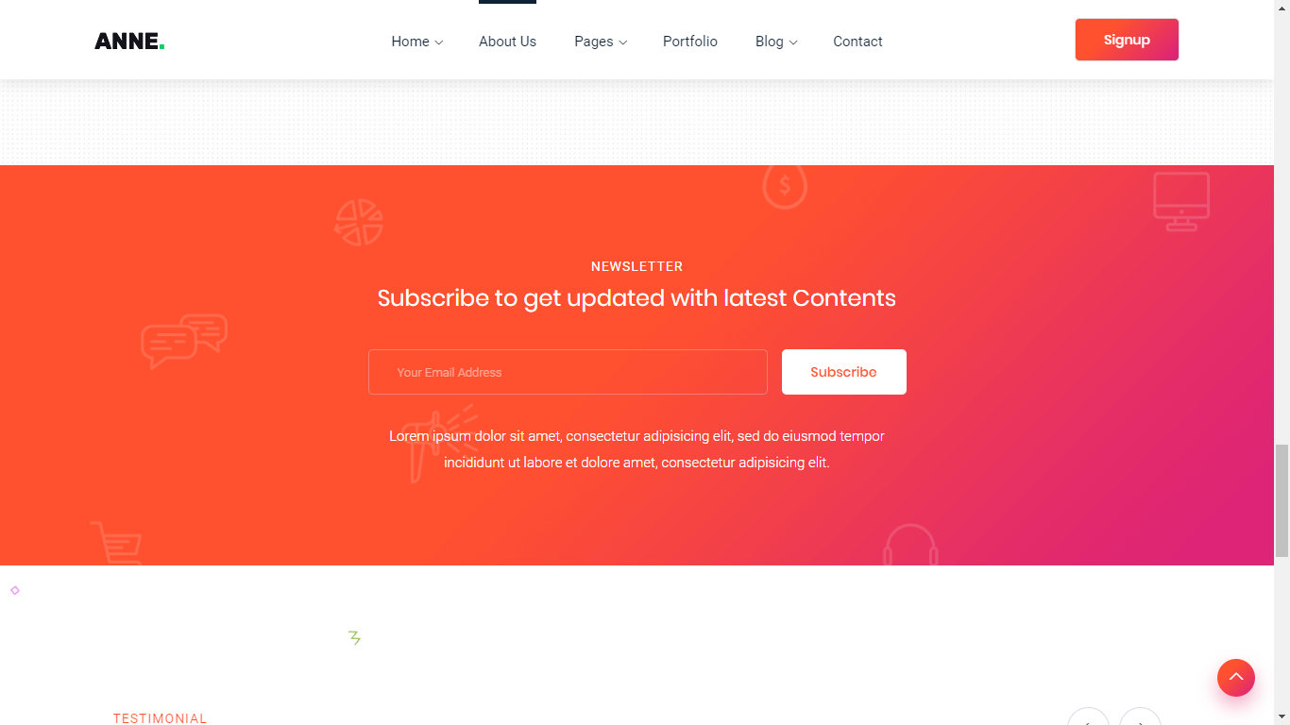with primary gradient used in website and animated transparent subscription related icons.

Footer section 