CHAPTER 1
INTRODUCTION

The Health Center Management System is a web-based solution designed to modernize and automate healthcare services in Primary Health Centers (PHCs). This project addresses the inefficiencies of traditional manual healthcare management, where long queues, paperwork delays, and disconnected systems often lead to poor patient experiences and operational challenges. With the increasing need for efficient, digital healthcare solutions, this system provides an integrated platform that streamlines patient management, doctor consultations, pharmacy and lab operations, and community healthcare services.

Patients can book OP tickets online, reducing wait times and ensuring smooth hospital visits. Doctors can access digital patient history, directly forward prescriptions to pharmacies and lab test requests to laboratories, improving efficiency and accuracy. Pharmacists and lab technicians can process prescriptions and test results digitally, allowing patients to view their reports online.

The system also offers dedicated support for JHI (Junior Health Inspector) workers, enabling them to collect and manage health data, assist bedridden patients, send broadcast health alerts during disease outbreaks, and organize community health events. Additionally, the system features remote consultation services, where patients can consult doctors via a chatbot-based system and schedule Google Meet appointments if needed. A centralized admin dashboard allows PHC administrators to manage users, medical staff, pharmacy inventory, and lab activities, ensuring smooth and organized healthcare service delivery.

This unified platform eliminates the fragmentation of healthcare services in PHCs, creating a seamless, digital healthcare ecosystem that enhances efficiency, accessibility, and quality of care for all users.
The Health Center Management System is a comprehensive, web-based application developed to modernize and streamline the healthcare services provided by Primary Health Centers (PHCs). In many rural and semi-urban regions, PHCs still rely heavily on manual processes that often result in long patient queues, inefficient record-keeping, delayed medical services, and a lack of coordination among departments. This traditional model poses significant challenges not only for patients but also for healthcare providers and administrative staff. Recognizing the urgent need for a digitized, centralized solution, this project proposes an integrated platform that addresses these challenges and elevates the overall standard of primary healthcare.
This system serves as a centralized digital hub that brings together all key aspects of healthcare management under one roof. It allows patients to book Outpatient (OP) tickets online, significantly reducing crowding and waiting time at the hospital. Once registered, patients can access their medical history digitally, which doctors can also view during consultations. This ensures better diagnosis and treatment, as the doctor is equipped with complete and accurate patient records.
The doctor’s portal enables physicians to prescribe medicines and recommend lab tests with a few clicks. These prescriptions are sent instantly to the pharmacy and laboratory modules, where pharmacists and lab technicians can view and process the requests digitally. Once the tests are completed, patients can access their lab results online, further improving convenience and reducing unnecessary visits to the health center.
An important feature of the system is its dedicated support for Junior Health Inspector (JHI) workers. These healthcare workers play a crucial role in community-level health monitoring. The platform allows them to collect field health data, track house visits, send broadcast alerts during disease outbreaks or pandemics, and organize community health awareness events. This makes the system highly responsive during public health emergencies and preventive care campaigns.
Additionally, the system provides remote consultation capabilities for patients who are bedridden, elderly, or unable to visit the PHC physically. Through a chatbot interface, patients can interact with the system, describe their symptoms, and get directed to a doctor if needed. Google Meet integration enables virtual appointments, ensuring that timely medical advice is always accessible, even from remote locations.
The entire system is managed via a centralized admin dashboard, through which administrators can monitor and control various activities—such as user registration, appointment scheduling, doctor assignments, inventory tracking in pharmacies, and lab operations. This results in improved transparency, accountability, and efficiency in PHC operations.
In summary, the Health Center Management System is a unified digital solution that eliminates the fragmentation of traditional healthcare delivery at the primary level. By leveraging technology to integrate various departments and stakeholders, it enhances efficiency, reduces operational delays, and most importantly, improves the quality and accessibility of healthcare services for every individual relying on their local PHC.

1.1 ORGANIZATIONAL PROFILE
The Primary Health Center (PHC) is a cornerstone of the healthcare system, providing essential medical services to communities, especially in rural and semi-urban areas. PHCs operate under the Ministry of Health and Family Welfare, focusing on preventive, curative, and promotive healthcare. These centers are responsible for outpatient services, maternal and child healthcare, immunization programs, and disease control initiatives. However, many PHCs still rely on manual record-keeping and fragmented processes, leading to inefficiencies in patient management, pharmacy stock handling, and lab result processing.

This project aims to develop a fully automated and integrated system that streamlines healthcare operations within a PHC. The system caters to patients, doctors, pharmacists, lab technicians, and JHI workers, ensuring seamless communication and efficient management of healthcare services. Patients can book OP tickets online, access their medical history, and receive test results digitally. Doctors will have a centralized dashboard to review patient records and prescribe medications electronically. The system also assists JHI workers in organizing health awareness programs and broadcasting important health updates.

To bridge this gap, the Health Center Management System is designed to digitize and streamline PHC operations. The system integrates patient registration, doctor consultations, pharmacy, lab management, and JHI support services into a single platform, reducing paperwork and enhancing accessibility. By leveraging modern technology, this solution aims to improve service efficiency, data accuracy, and communication between healthcare providers and patients, ensuring a more effective and responsive healthcare environment.

1.2 SCOPE OF THE WORK

The Health Center Management System is designed to provide a fully automated and integrated solution for Primary Health Centers (PHCs) by addressing inefficiencies in patient management, doctor consultations, pharmacy operations, laboratory processes, and JHI worker coordination. The system aims to reduce the dependency on manual processes and fragmented digital solutions by offering a centralized web-based platform where patients, doctors, pharmacists, lab technicians, and JHI workers can seamlessly interact.

One of the primary objectives of the system is to facilitate online OP ticket booking, allowing patients to schedule appointments in advance and reducing long queues at the PHC. Doctors will have instant access to patient medical history, enabling them to make well-informed treatment decisions without relying on paper-based records. The system will also automate the prescription and pharmacy management process, ensuring that medicines are dispensed efficiently while maintaining accurate stock records. Similarly, the laboratory module will streamline test requests and result processing, allowing patients to view their reports online without needing multiple visits to the PHC.
A key feature of the system is the JHI worker module, which plays a crucial role in public health management. JHI workers will be able to send broadcast messages during the outbreak of diseases, organize health awareness programs, and efficiently manage patient records. This ensures better communication between healthcare workers and the community, leading to improved public health services. Additionally, the system will provide a remote consultation service through an AI-powered chatbot integrated with Google Meet scheduling, allowing bedridden patients or those in remote areas to consult doctors online.

The project is being developed using Python Flask as the backend framework, with a secure authentication system to protect patient data. The platform will support real-time notifications for appointment reminders, test results, and medicine availability. The user-friendly web interface will be designed to ensure accessibility for all stakeholders, making healthcare services more efficient, transparent, and accessible. By integrating all these functionalities, the Health Center Management System aims to enhance patient care, reduce administrative workload, improve coordination between healthcare professionals, and ultimately create a more efficient healthcare ecosystem for PHCs.

CHAPTER 2
PROOF OF CONCEPT

2.1 Review of Literatures (Methods, Results, Accuracy, and Comparison)

J. Smith et al., in their paper “Automated Health Care Management System Using Big Data Technology” [1], explore the application of big data technologies in health care automation. The study emphasizes efficient handling of large-scale patient records, real-time monitoring, and predictive analytics for better decision-making in clinical environments.
This project incorporates a big data-inspired approach by digitally storing and retrieving structured patient information like OP booking, lab reports, prescriptions, and history. The system also enables real-time data updates across different user modules (patients, doctors, pharmacy), ensuring improved clinical efficiency and operational automation.

A. Brown and M. Green, in their study “A Systematic Literature Review of Health Information Systems for Healthcare” [2], provide an overview of health information systems (HIS), their architecture, challenges in rural adoption, and the importance of integrated platforms. The proposed Health Center Management System aims to overcome the fragmented nature of current systems by offering a unified platform for PHCs. It integrates patient registration, diagnosis, medicine distribution, lab results, and remote consultations within a centralized digital framework accessible to all stakeholders.

L. Wang, in the article “The Use of Automated Health Information Systems in the Health Services” [3], discusses the benefits of automation in healthcare operations, including enhanced accuracy, faster processing, and better record management.
The automation principles outlined in the study are directly applied in this project’s modules. OP ticket generation, medicine inventory management, and lab report uploads are fully automated, reducing manual workload and enabling staff to focus more on patient care rather than paperwork.

R. Patel et al., in their paper “A Literature Review of Current Technologies on Health Data Integration” [4], examine technologies used to merge diverse health data into coherent systems. They stress the need for interoperability and real-time communication across health departments.
This project supports seamless health data flow by synchronizing patient interactions with doctors, lab technicians, and pharmacists. Real-time integration ensures that updates made in one module (e.g., doctor’s prescription) are instantly reflected in others (e.g., pharmacy/lab), maintaining data consistency and transparency.

D. Johnson and K. Lee, in their study “Patient Health Record Systems Scope and Functionalities: Literature Review and Future Directions” [5], analyze the structure and evolution of patient health record systems. They emphasize features like secure access, patient history tracking, and user-friendly interfaces for both patients and professionals.
These insights guide the user interface design of this project’s patient and staff dashboards. Patients can view history, receive lab results, and access prescriptions online, while medical staff can review records instantly during consultations. This promotes a more connected and informed healthcare ecosystem at the PHC level.

S. Kumar and V. Sharma, in their paper “Smart Healthcare Monitoring and Management Systems: A Review” [6], review the development of intelligent healthcare systems that leverage IoT, cloud computing, and AI for remote patient monitoring and efficient resource utilization. The study highlights the role of smart technologies in improving healthcare delivery. Inspired by this work, the Health Center Management System incorporates remote consultation features using chatbot-based doctor interaction and Google Meet integration. This enables PHCs to offer care to bedridden or remote patients, aligning with the vision of accessible, tech-driven primary healthcare. Additionally, automated updates and notifications enhance patient engagement and resource coordination.

2.2 Existing System
The current healthcare management system in Primary Health Centers (PHCs) is highly manual and fragmented, leading to inefficiencies in patient care, data management, and service delivery. Patients are required to visit the PHC in person to obtain an OP ticket, resulting in long queues, extended waiting times, and overcrowding, as there is no online appointment booking system. Additionally, there is no centralized digital system to store patient medical records, making it difficult for doctors to access previous health histories, leading to delayed diagnoses and ineffective treatments. The reliance on handwritten prescriptions increases the risk of errors in medication dispensing, and pharmacies lack automated inventory management, which results in frequent medicine shortages or overstocking.
Similarly, laboratory tests are managed manually, requiring patients to return to the PHC to collect their results, causing delays and inconvenience due to the absence of online test report access or notifications. Furthermore, JHI workers, who play a crucial role in public health awareness and disease prevention, struggle to send health alerts, organize health programs, or manage pandemic responses due to the lack of an automated system for broadcasting messages or scheduling health events. Another major limitation of the existing system is the absence of remote consultation services, making it difficult for bedridden or remote patients to access healthcare, forcing them to either delay treatment or travel long distances to the PHC.
Additionally, different healthcare departments, such as doctors, pharmacists, lab technicians, and JHI workers, operate independently without a shared platform, leading to poor coordination, slow information flow, and delays in patient care. Since PHCs rely on paper-based records, there is also a risk of lost or damaged patient files, making it challenging to track medical history, analyze health trends, or ensure data security. Due to these significant limitations, the need for a fully automated, integrated, and digital Health Center Management System is essential to streamline patient management, enhance coordination between departments, improve data accuracy, and provide better accessibility to healthcare services in PHCs. Furthermore, patient data is maintained on paper, making it prone to loss, damage, and security risks, while also limiting the ability to track health trends, analyze medical data, or ensure long-term patient monitoring. These limitations highlight the urgent need for a fully automated, integrated, and digital Health Center Management System to streamline PHC operations, improve healthcare accessibility, and enhance service efficiency.

2.3 Limitations of Existing Models/Systems
The existing healthcare management systems used in Primary Health Centers (PHCs) have several limitations that affect efficiency, patient care, and service delivery. One of the major drawbacks is the lack of a centralized and automated system, leading to manual record-keeping and poor data management. Patients must physically visit the PHC for OP ticket booking, resulting in long queues and extended waiting times. Additionally, patient medical records are not digitally stored, making it difficult for doctors to access previous health histories, which can lead to delayed or less-informed diagnoses.
Another significant limitation is the absence of an automated pharmacy and laboratory management system. Handwritten prescriptions increase the chances of medication errors, and lab test results are not available online, forcing patients to return to the PHC for report collection. This manual process is time-consuming and inefficient. Moreover, JHI workers face challenges in sending health alerts and organizing health programs, as they lack a dedicated digital platform for communication and event coordination.
Furthermore, the existing systems do not support remote consultations, making it difficult for bedridden and remote patients to receive medical advice without visiting the PHC. The lack of real-time notifications and appointment reminders also contributes to missed consultations and delays in patient care. Overall, the limitations of existing systems highlight the need for a fully automated, integrated, and user-friendly Health Center Management System to enhance efficiency, accuracy, and accessibility in Primary Health Centers.
2.4 Objectives
The primary objective of this project is to develop a fully automated Health Center Management System that enhances the efficiency and accessibility of healthcare services in Primary Health Centers (PHCs). The system aims to digitize patient management by enabling online OP ticket booking, reducing waiting times and eliminating the need for patients to visit the PHC early in the morning for manual ticket collection. It also seeks to provide doctors with instant access to patient medical history, ensuring better diagnosis and treatment decisions. Another key goal is to automate pharmacy and laboratory management, allowing doctors to electronically prescribe medications and enabling patients to view their test results online, eliminating paperwork and reducing human errors.
Additionally, the system aims to enhance JHI worker functionalities by offering tools for health event management and disease outbreak notifications, ensuring better communication with the community. The project also focuses on integrating remote consultation services using a chatbot-based doctor consultation system with Google Meet scheduling, allowing bedridden or remote patients to receive medical advice without traveling to the PHC. Furthermore, the system will include secure authentication, real-time notifications, and a user-friendly web interface to improve usability and accessibility for all stakeholders. By integrating these features, the project aims to streamline healthcare services, reduce manual workload, enhance coordination among healthcare professionals, and ultimately improve patient care in PHCs.
Furthermore, the system is designed to improve coordination between doctors, pharmacists, lab technicians, and JHI workers by integrating all healthcare functions into a single platform, ensuring real-time information flow and better decision-making. Security and privacy are also key objectives, as the system will incorporate secure authentication and data encryption to protect patient records and sensitive medical information. Ultimately, this Health Center Management System aims to streamline healthcare services, enhance operational efficiency, reduce workload for medical staff, and improve patient satisfaction, making healthcare more accessible, accurate, and efficient in Primary Health Centers.

2.5 Proposed System
The proposed Health Center Management System is a fully automated and integrated web-based platform designed to overcome the inefficiencies of the existing manual and fragmented healthcare management system in Primary Health Centers (PHCs). This system introduces online OP ticket booking, allowing patients to schedule their visits in advance, reducing long queues and waiting times. It also provides doctors with instant access to digital patient medical records, ensuring better diagnosis and treatment without relying on paper-based records. The system further integrates automated pharmacy and laboratory management, enabling doctors to electronically prescribe medications, pharmacists to manage medicine dispensing efficiently, and patients to view their lab test results online, eliminating the need for unnecessary visits.
Additionally, the system includes a dedicated module for JHI workers, allowing them to send health alerts, organize health programs, and manage disease outbreak notifications efficiently. A key innovation in the proposed system is the chatbot-based remote consultation feature, which is integrated with Google Meet scheduling, providing telemedicine services for bedridden and remote patients who cannot visit the PHC. The system is developed using Python Flask as the backend framework, ensuring secure authentication, real-time notifications, and seamless interaction between patients, doctors, pharmacists, lab technicians, and JHI workers. By offering a centralized, digital, and user-friendly platform, the proposed system aims to enhance the accessibility, accuracy, and efficiency of healthcare services in PHCs, ultimately improving patient care and healthcare delivery.

CHAPTER 3
SYSTEM ANALYSIS AND DESIGN

3.1 SYSTEM ANALYSIS
3.1.1 INTRODUCTION
System analysis is a crucial phase in the development of the Health Center Management System, as it involves examining the current healthcare processes, identifying inefficiencies, and defining the functional and technical requirements for the new system. The primary goal of this analysis is to understand the existing manual operations in Primary Health Centers (PHCs) and determine how automation can enhance efficiency, accuracy, and accessibility. The analysis evaluates patient registration, medical record management, prescription handling, laboratory test processing, JHI worker coordination, and remote consultation services, highlighting the key challenges in these areas. By conducting a detailed study of user requirements, workflow processes, and data handling techniques, system analysis ensures that the proposed solution aligns with the needs of patients, doctors, pharmacists, lab technicians, and JHI workers. This phase also includes a comparison of existing healthcare systems, identifying gaps and areas for improvement, and defining hardware, software, and security requirements for the new system. Through this structured approach, system analysis lays the foundation for designing a fully automated, integrated, and user-friendly Health Center Management System, ensuring seamless coordination, reduced manual workload, and enhanced healthcare service delivery in PHCs.

System analysis is a fundamental phase in the development of the Health Center Management System, as it involves a thorough examination of the existing healthcare workflows in Primary Health Centers (PHCs) to identify inefficiencies, redundancies, and areas that require improvement. This phase aims to understand the limitations of manual processes currently used for patient registration, appointment booking, medical record management, prescription handling, laboratory operations, JHI coordination, and remote consultations. It highlights how the lack of integration between departments, paper-based records, and manual data handling contributes to delays, errors, and poor patient experiences. By conducting a detailed study of user needs, daily operational challenges, and data flow patterns, the analysis defines the functional and technical requirements for a digital solution that can enhance efficiency, accuracy, and accessibility. This includes the need for online OP booking systems, centralized electronic health records, digital prescriptions, lab integration, and tools for JHI workers to manage field data, send alerts, and organize health events. Additionally, the analysis evaluates the feasibility of incorporating remote consultation features using chatbot assistance and Google Meet scheduling. Technical aspects such as software architecture, database design, security protocols, and hardware requirements are also addressed to ensure robust system performance. A comparative study with existing healthcare systems further helps identify gaps specific to PHCs, enabling the development of a solution tailored to grassroots healthcare needs. Through this structured and comprehensive approach, the system analysis phase lays a strong foundation for designing an automated, user-friendly, and fully integrated Health Center Management System that improves coordination, reduces manual workload, and delivers efficient healthcare services across all user roles.

3.1.2 METHODOLOGY
The development of the Health Center Management System follows a systematic and structured methodology to ensure the creation of a fully automated, efficient, and user-friendly healthcare platform for Primary Health Centers (PHCs). The methodology begins with a requirement analysis, where the existing manual inefficiencies in patient registration, appointment booking, prescription handling, pharmacy and lab management, JHI functionalities, and remote consultation are identified. Based on this analysis, the system is designed using a modular architecture, integrating different components such as patient management, doctor consultation, pharmacy, laboratory, and JHI support into a single platform.
System Analysis and Design Methodology is a crucial phase in the development of the Health Center Management System, as it provides a structured framework for understanding the existing challenges in Primary Health Centers (PHCs) and designing a suitable digital solution. The system analysis involves a detailed examination of the current manual workflows such as patient registration, medical record handling, doctor consultations, pharmacy and laboratory operations, JHI activities, and remote healthcare services. This analysis helps identify inefficiencies like long waiting times, data redundancy, lack of coordination, and limited accessibility, which affect the overall quality of healthcare delivery. Based on this study, the system's functional and non-functional requirements are clearly defined. The design methodology follows a modular and layered approach to ensure scalability, maintainability, and user-friendliness. Each module—patient portal, doctor dashboard, lab and pharmacy management, JHI interface, and admin panel—is designed to work independently yet integrate smoothly within the system. The user interface is designed to be simple and intuitive, while the backend ensures data integrity, security, and performance. Emphasis is placed on designing a responsive and role-based system that addresses the specific needs of patients, doctors, pharmacists, lab technicians, and health inspectors. By combining systematic analysis with thoughtful design strategies, this phase lays a solid foundation for building an efficient, reliable, and comprehensive web-based Health Center Management System.
The system is developed using the Python Flask framework for backend development, ensuring a scalable and secure server-side infrastructure, while the frontend is designed using web technologies to provide an interactive and intuitive user experience. A relational database is used to store patient records, medical history, prescriptions, and lab reports securely, ensuring fast retrieval and efficient data management. The system incorporates digital OP ticket booking, enabling patients to schedule appointments online, reducing waiting times and overcrowding. Automated prescription handling eliminates handwritten errors, and lab test results are made available online, allowing patients to access them remotely.
For public health management, the system integrates JHI support features, including a broadcast messaging system for health alerts and an event scheduling module for vaccination and awareness programs. Additionally, a chatbot-based doctor consultation system with Google Meet integration is implemented to provide remote healthcare services for bedridden and remote patients. The testing and evaluation phase ensures the system meets performance, security, and usability standards, with continuous improvements based on user feedback. By adopting this methodological approach, the project ensures the development of a robust, reliable, and efficient Health Center Management System, enhancing healthcare accessibility and service delivery in PHCs.
3.1.3 HARDWARE AND SOFTWARE REQUIREMENTS
To ensure the smooth operation of the Health Center Management System, various hardware and software components are required. The hardware setup includes cloud or on-premise servers to host the application, client devices such as desktops, laptops, tablets, or smartphones for patients, doctors, pharmacists, lab technicians, and JHI workers, and a stable internet connection for real-time data synchronization, remote consultations, and notification delivery. Additional peripherals like barcode scanners for pharmacy inventory management and printers for medical reports and prescriptions can enhance system efficiency.
On the software side, the system utilizes JavaScript, HTML, CSS, and Bootstrap for the frontend, ensuring a responsive and user-friendly interface for different user roles. The backend is developed using Python Flask, handling server-side logic, API communication, and data processing. The system relies on SQL-based databases like MySQL or PostgreSQL to efficiently store and manage patient records, prescriptions, test reports, pharmacy inventory, and JHI communications. The notification system uses email allowing automated alerts for appointment confirmations, test results, and health event broadcasts. Additionally, the system supports secure authentication and role-based access control (RBAC) to ensure data security and privacy. The application is compatible with both Linux and Windows operating systems, ensuring flexible deployment and scalability across different healthcare setups.

3.2 SYSTEM DESIGN
3.2.1 INTRODUCTION
The system design of the Health Center Management System is structured to provide an automated, efficient, and user-friendly solution for managing healthcare services in Primary Health Centers (PHCs). The design follows a modular approach, ensuring seamless integration of key functionalities such as patient management, doctor consultations, pharmacy operations, laboratory testing, and JHI worker services. The backend of the system is developed using Python Flask, handling server-side logic, API communication, and data processing. The frontend is built using JavaScript, HTML, CSS, and Bootstrap, offering a responsive and intuitive user interface for doctors, patients, pharmacists, lab technicians, and JHI workers. The system relies on SQLyog as the database management tool, utilizing MySQL to store and manage patient records, prescriptions, laboratory test results, appointment details, and pharmacy inventory securely and efficiently. The database design ensures data integrity, quick retrieval, and secure access through role-based authentication (RBAC). Additionally, the system incorporates secure login mechanisms, encrypted communication, and automated notifications via email and SMS APIs to enhance user experience. With this well-structured system design, the Health Center Management System aims to reduce manual workload, improve service accuracy, minimize patient waiting times, and ensure better coordination among healthcare professionals.

3.2.2 MODULE DESCRIPTION
1. Registration Module
The Registration Module is responsible for managing user authentication and access control for different system users, including patients, doctors, pharmacists, lab technicians, and JHI workers. It ensures that each user has a secure login and can access only the functionalities relevant to their role. This module helps maintain data security and privacy, preventing unauthorized access to patient records and other sensitive information.
2. Booking Management Module
The Booking Management Module allows patients to book OP tickets online, reducing long queues and waiting times at PHCs. Appointments are scheduled based on the availability of doctors, ensuring an organized and systematic consultation process. The system also provides real-time appointment confirmations and notifications, helping patients plan their visits more efficiently.
3. Medical Staff Management Module
The Medical Staff Management Module enables doctors to efficiently manage patient details, medical history, and ongoing treatments. It allows doctors to provide consultations, update prescriptions digitally, and forward them directly to the pharmacy and lab departments. Additionally, the system supports remote consultations via Google Meet, helping bedridden or remote patients access healthcare services without physically visiting the PHC.
4. JHI Support Management Module
The JHI Support Management Module is designed to assist JHI workers in organizing and tracking health programs, vaccination drives, and awareness campaigns. It also includes a broadcast messaging system for sending emergency alerts during disease outbreaks, ensuring quick and effective communication within the community. By automating these processes, this module helps JHI workers improve public health initiatives and provide better healthcare support.
5. Pharmacy Management Module
The Pharmacy Management Module automates prescription processing, ensuring accurate medicine dispensing based on digital prescriptions received from doctors. This eliminates errors associated with handwritten prescriptions and improves the efficiency of pharmacy operations. Additionally, this module includes inventory management features, allowing pharmacists to track stock levels and avoid shortages of essential medicines.
6. Lab Test Management Module
The Lab Test Management Module handles digital lab test requests and results processing, streamlining the diagnostic workflow. Doctors can submit test requests electronically, and lab technicians can process and upload test results online, reducing paperwork and processing delays. Patients can also view their lab reports remotely, eliminating the need for physical visits to the PHC and ensuring quicker access to test results.
Each of these modules is interconnected, ensuring a seamless healthcare management experience. By automating critical tasks, the Health Center Management System enhances efficiency, accuracy, and accessibility, offering a comprehensive and fully integrated solution for Primary Health Centers (PHCs)

3.2.3 SYSTEM ARCHITECTURE /UML DIAGRAM
The Health Center Management System (HCMS) follows a layered system architecture, integrating multiple components to enhance healthcare services in Primary Health Centers (PHCs). It consists of a frontend interface, developed using JavaScript, HTML, and CSS, that allows patients, doctors, pharmacists, lab technicians, and JHI workers to interact with the system. The backend, built using Python Flask, handles core functionalities such as appointment scheduling, prescription management, and lab test processing. The system stores healthcare data securely in SQLyog (MySQL Database), ensuring efficient patient record management and real-time access to medical information. Additionally, third-party API integrations, such as Google Meet for remote consultations and email/SMS notifications for updates, enhance accessibility and communication. Security is ensured through role-based access control (RBAC) and data encryption, protecting sensitive medical records.
To visualize the system, UML diagrams are used to represent different aspects of its functionality. The Use Case Diagram defines interactions between users and the system, while the Class Diagram outlines the relationships between entities such as patients, doctors, prescriptions, and lab reports. The Sequence Diagram illustrates workflows, such as how a patient books an OP ticket or how prescriptions are processed. The Activity Diagram provides a structured flow of key operations, such as handling patient check-ins or processing lab test requests. Together, these architectural components and UML diagrams ensure that the HCMS is a fully automated, efficient, and patient-friendly healthcare management solution for PHCs.

The system architecture of the Health Center Management System follows a three-tier model comprising the presentation layer, application layer, and data layer, ensuring modularity, scalability, and ease of maintenance. The presentation layer provides user-friendly interfaces for different user roles such as patients, doctors, pharmacists, lab technicians, JHI workers, and administrators through a responsive web-based front end. The application layer contains the core business logic developed using Python Flask, handling functionalities like appointment booking, medical history access, prescription forwarding, lab test processing, health alert broadcasting, and remote consultations. The data layer consists of a centralized relational database (such as MySQL), which securely stores patient records, appointment details, prescriptions, test results, user data, and event logs. To visualize and understand the system flow, several UML diagrams are used. The Use Case Diagram represents the interactions between the system and various users, highlighting key operations like booking appointments, prescribing medication, and viewing lab results. The Class Diagram outlines the main system classes such as Patient, Doctor, Appointment, Prescription, and LabReport, along with their attributes and relationships. The Sequence Diagram illustrates the step-by-step interaction flow for important scenarios like patient registration or remote consultation. The Activity Diagram demonstrates the workflow of processes such as OP ticket booking or lab result uploading. Finally, the Deployment Diagram shows the physical setup of the system, including client devices, web server, and database server, and how they communicate.

UML DIAGRAM
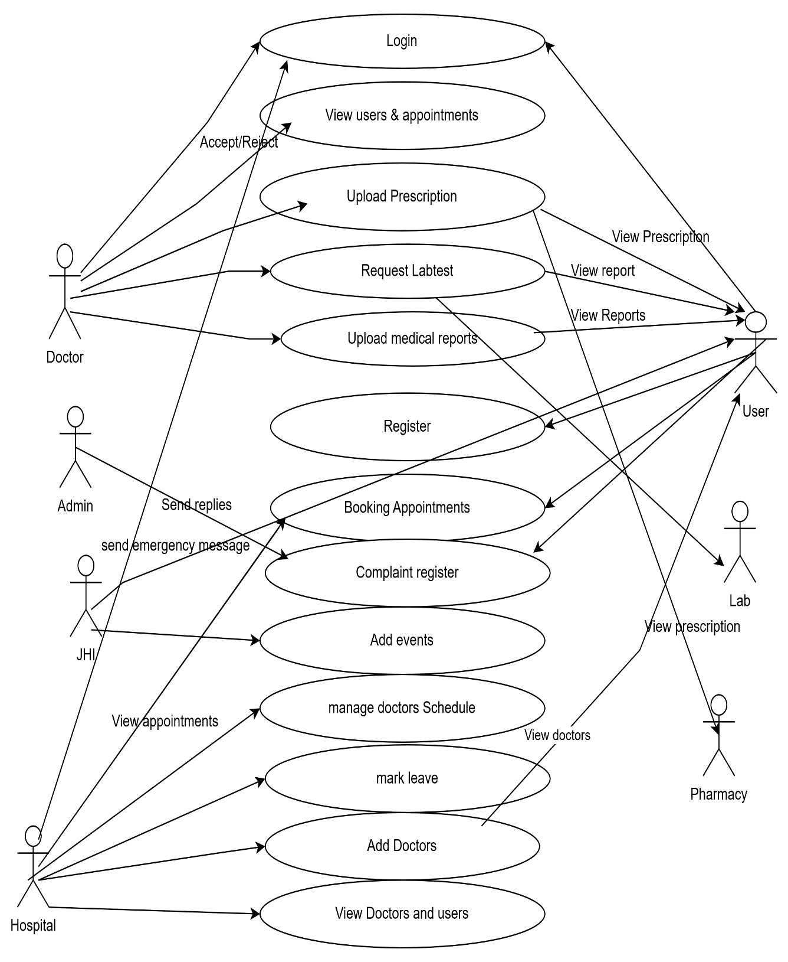

3.2.4 DATABASE
USER SCHEMA
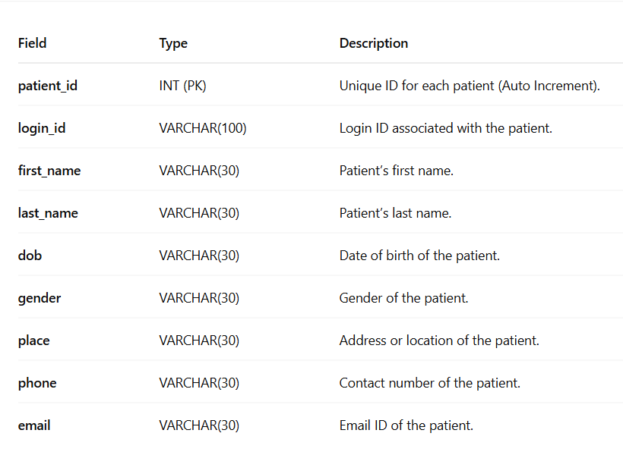

DOCTOR SCHEMA
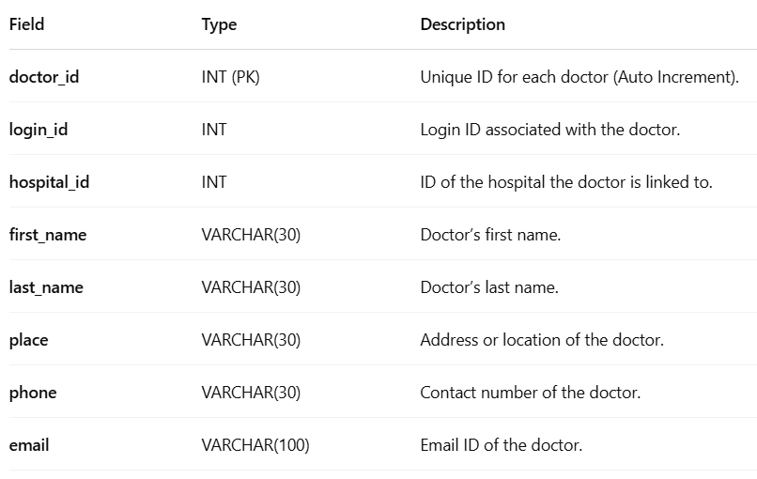

BOOKING SCHEMA
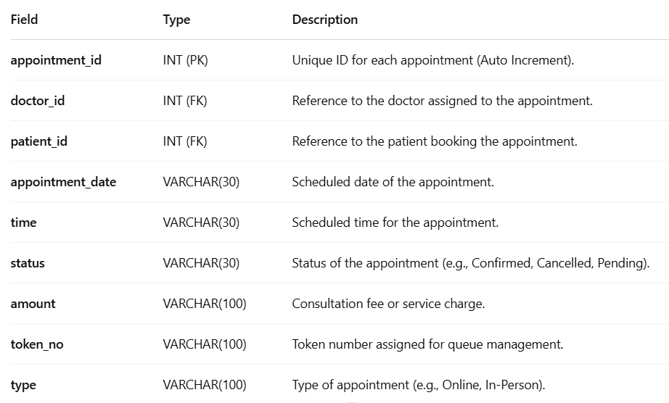

EVENT SCHEMA

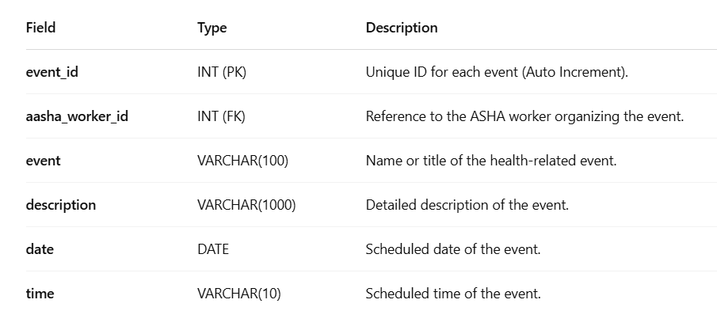

COMPLAINT SCHEMA
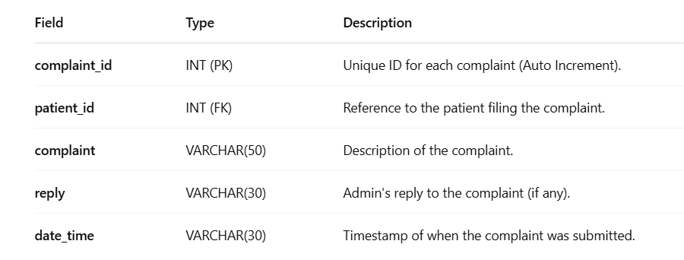

3.3 ISSUES FACED AND REMEDIES TAKEN
3.3.1 ISSUES
During the development of the Health Center Management System (HCMS), several challenges were encountered, requiring careful problem-solving and optimizations. One of the primary issues was ensuring seamless integration between different modules, such as patient management, doctor consultations, pharmacy services, lab tests, and JHI functionalities. Since each module had unique workflows, designing a well-structured database with optimized queries was crucial to maintaining system performance and avoiding data inconsistencies.

Another significant challenge was implementing role-based access control (RBAC) to ensure that patients, doctors, pharmacists, lab technicians, JHI workers, and administrators could access only the relevant sections of the system. Proper authentication and authorization mechanisms were required to maintain data privacy and security, especially for sensitive medical records.

Ensuring real-time updates and notifications was also a challenge, particularly for online OP ticket booking, prescription forwarding, and lab test results. Implementing automated notifications through email and SMS required third-party integrations, which needed extensive testing to ensure reliability.

Additionally, the remote consultation feature using Google Meet integration posed difficulties in scheduling, generating meeting links dynamically, and providing a smooth user experience. Compatibility with different devices and browsers also needed to be addressed for a seamless experience.

Lastly, during deployment, optimizing database queries and ensuring efficient server performance to handle multiple concurrent users was a challenge. The backend, developed in Python Flask, required careful query optimization and structured data handling to ensure fast response times. Despite these challenges, careful planning, debugging, and iterative testing helped overcome these issues, leading to a fully functional and efficient Health Center Management System for Primary Health Centers (PHCs).

3.3.2 REMEDIES
To overcome the challenges encountered during the development of the Health Center Management System (HCMS), several remedies were implemented to enhance system efficiency, security, and overall performance. To ensure seamless integration between different modules, a well-structured relational database was designed using SQLyog (MySQL) with proper normalization techniques to eliminate redundancy and improve query execution speed. This allowed efficient management of patient data, doctor consultations, pharmacy operations, lab tests, and JHI functionalities.

For role-based access control (RBAC), secure authentication and authorization mechanisms were introduced, ensuring that patients, doctors, pharmacists, lab technicians, JHI workers, and administrators could access only the relevant sections of the system. Secure password hashing and encryption techniques were also applied to protect sensitive user information. To improve real-time communication, automated email and SMS notifications were integrated to alert patients about appointment confirmations, lab results, and prescription statuses. Additionally, a scheduler-based notification system was implemented to ensure timely updates regarding OP bookings and JHI-organized health campaigns.

To address the challenges of remote consultation, the Google Meet API was utilized for automated meeting scheduling, providing patients with an easy way to access virtual consultations. A user-friendly interface was developed to simplify navigation and improve accessibility. Lastly, to optimize database performance and system responsiveness, SQL queries were refined using indexes and stored procedures, reducing response time and improving efficiency. Stress testing was conducted to ensure the system could handle multiple concurrent users without lag or data inconsistencies. Through these remedies, the Health Center Management System was successfully optimized to provide a secure, efficient, and seamless healthcare management experience for Primary Health Centers (PHCs).

CHAPTER 4
CONCLUSION AND FUTURE SCOPE
4.1 CONCLUSION
The Health Center Management System (HCMS) is a comprehensive and fully automated solution designed to improve the efficiency, accessibility, and coordination of healthcare services in Primary Health Centers (PHCs). The system addresses the limitations of manual healthcare management by integrating patient registration, online OP ticket booking, doctor consultations, prescription handling, pharmacy management, lab test processing, and JHI functionalities into a single, centralized platform. By streamlining these operations, the system reduces waiting times, enhances medical record accessibility, minimizes human errors, and ensures better coordination among medical staff, pharmacists, and lab technicians.
One of the key advancements introduced by this system is the online appointment booking module, which eliminates the need for patients to wait in long queues by allowing them to schedule OP tickets remotely. Doctors can access patient history instantly, ensuring informed and accurate diagnoses, while prescriptions are directly forwarded to pharmacies and lab test requests are processed efficiently. Additionally, JHI workers can organize health events, send emergency broadcast messages, and ensure timely dissemination of critical healthcare information, making community health management more effective.
The system was developed using Python Flask for backend processing, SQLyog (MySQL) for structured and secure data storage, and JavaScript-based technologies for a dynamic and user-friendly frontend. The incorporation of role-based access control (RBAC), real-time email/SMS notifications, and remote consultation through Google Meet integration further enhances the system's functionality, ensuring seamless communication and accessibility for all stakeholders. The adoption of digital lab reports also minimizes errors in result processing, allowing patients to access their medical information without unnecessary visits to the PHC.
Despite challenges such as module integration, security management, database optimization, and remote consultation handling, strategic problem-solving and rigorous testing enabled the successful deployment of a scalable and high-performance system. The project not only ensures better patient care but also facilitates the digital transformation of PHCs, making healthcare services more efficient, transparent, and accessible to all, including bedridden and remote patients.
In conclusion, the Health Center Management System is a significant technological advancement in the healthcare sector, revolutionizing Primary Health Centers (PHCs) by automating processes, reducing inefficiencies, and ensuring better healthcare service delivery. With its robust architecture and well-integrated features, the system serves as a model for future healthcare automation efforts, contributing to the overall improvement of medical infrastructure and ultimately benefiting both healthcare providers and patients alike.

4.2 FUTURE ENHANCEMENT
The Health Center Management System (HCMS) has been designed to streamline and automate healthcare services in Primary Health Centers (PHCs), but there is significant scope for future enhancements to improve its efficiency, scalability, and user experience. One key enhancement would be the integration of Artificial Intelligence (AI) and Machine Learning (ML) for predictive healthcare analytics, which can help identify disease patterns, suggest personalized treatment plans, and provide early diagnosis recommendations based on patient history. Additionally, electronic health record (EHR) interoperability can be introduced to enable data exchange between different healthcare facilities, allowing doctors to access patient medical history even if the patient visits another hospital or clinic.
To improve patient engagement, a mobile application can be developed to provide seamless access to appointments, prescriptions, lab results, and remote consultations. This will enhance accessibility for patients, especially those in rural and remote areas. Another major enhancement would be the implementation of an AI-powered chatbot for 24/7 virtual healthcare assistance, allowing patients to ask medical-related queries, schedule appointments, and receive preliminary health advice before consulting a doctor.
For pharmacy and lab management, an automated stock monitoring system could be introduced to track medicine availability in real-time and alert the administration about low stock levels. Furthermore, integration with telemedicine platforms beyond Google Meet, such as dedicated video consultation portals, could enhance remote healthcare services by offering a more specialized virtual consultation experience.
Future enhancements for the Health Center Management System aim to expand its usability, intelligence, and inclusivity. One of the key improvements would be integrating the system with AADHAAR/UIDAI for secure and seamless retrieval of patient history across PHCs. A mobile application can be developed for both patients and healthcare workers to ensure on-the-go access to OP bookings, prescriptions, and notifications. Incorporating AI-based disease prediction models can assist doctors in diagnosing illnesses early based on patient symptoms and medical history. To cater to a broader audience, multilingual support (including Malayalam, Hindi, and Tamil) can be added for better accessibility. For patients without internet access, SMS and IVR-based services could provide essential features like appointment booking and health alerts. A dedicated module for vaccination scheduling and health campaigns conducted by JHI workers can also be included. Furthermore, pharmacy inventory management can be upgraded with real-time stock tracking and automated restocking. A data-driven analytics dashboard can be integrated to help administrators monitor patient trends and resource usage. Additionally, linking the system with national health portals like ABHA and eSanjeevani would enable greater interoperability. Lastly, an emergency alert feature can help staff escalate urgent issues such as outbreaks or shortages to authorities in real-time. These enhancements would significantly improve the system’s efficiency, reach, and impact on rural healthcare delivery.
Security enhancements such as blockchain-based patient data management could also be implemented to ensure tamper-proof medical records, enhancing data privacy and security. Additionally, multilingual support can be incorporated to make the system accessible to patients from diverse linguistic backgrounds, ensuring inclusivity.
Overall, these future enhancements will further optimize the Health Center Management System, making healthcare services more intelligent, accessible, and patient-centric, ultimately improving the efficiency of Primary Health Centers (PHCs) and enhancing overall healthcare outcomes.

CHAPTER 5
APPENDIX
5.1 SOURCE CODE
5.1.1 FRONT-END CODE
Login.html
<!DOCTYPE html>
<html lang="en">

<head>
<meta charset="utf-8">
<meta content="width=device-width, initial-scale=1.0" name="viewport">

<title>health care</title>
<meta content="" name="description">
<meta content="" name="keywords">

</head>

<body>

<i class="bi bi-list mobile-nav-toggle d-xl-none"></i>
<header id="header" class="d-flex flex-column justify-content-center" >

<nav id="navbar" class="navbar nav-menu">
<ul>
<li><a href="/" class="nav-link scrollto active"><i class="bx bx-home"></i> <span>Home</span></a></li>
<li><a href="login" class="nav-link scrollto"><i class="bx bx-user"></i> <span>Login</span></a></li>
<li><a href="patient_registration" class="nav-link scrollto"><i class="bx bx-file-blank"></i> <span>Patient Registration</span></a></li>
<li><a href="aasha_worker_registration" class="nav-link scrollto"><i class="bx bx-file-blank"></i> <span>Aasa Worker Registration</span></a></li>
<li><a href="publick_view_event" class="nav-link scrollto"><i class="bx bx-file-blank"></i> <span>Awareness Event</span></a></li>

</ul>

</header>
<section id="hero" class="d-flex flex-column justify-content-center" >
<div class="container" data-aos="zoom-in" data-aos-delay="100">
<form method="post">
<center>

<table class="table" style="width: 600px; background-color: rgba(0, 0, 0, 0.7);color:white" >
<h2 style="color:white;font-weight:bold">Login</h2>
<tr>
<th>Username</th>
<td><input type="text" class="form-control" required style="background-color: #00000080 ; color: #fff" name="uname"></td>
</tr>
<tr>
<th>Password</th>
<td><input type="password" class="form-control" required style="background-color: #00000080 ; color: #fff" name="pwd"></td>
</tr>
<tr>
<td colspan="2" align="center"><input type="submit" value="LOGIN" class="btn btn-primary" name="submit"></td>
</tr>
<tr>
<td colspan="2" align="center"><a href="/forget_password">Forget Password</a></td>
</tr>
</table>
</center>

</form>
<!-- <div class="social-links">
<a href="#" class="twitter"><i class="bx bxl-twitter"></i></a>
<a href="#" class="facebook"><i class="bx bxl-facebook"></i></a>
<a href="#" class="instagram"><i class="bx bxl-instagram"></i></a>
<a href="#" class="google-plus"><i class="bx bxl-skype"></i></a>
<a href="#" class="linkedin"><i class="bx bxl-linkedin"></i></a>
</div> -->
</div>
</section>

<main id="main" style="background-color: rgb(204, 210, 216);">

<style type="text/css"></style>

{% include 'footer.html' %}

Registration.html
<!DOCTYPE html>
<html lang="en">

<head>
<meta charset="utf-8">
<meta content="width=device-width, initial-scale=1.0" name="viewport">

<title>health care</title>
<meta content="" name="description">
<meta content="" name="keywords">

</head>

<body>
<header id="header" class="d-flex flex-column justify-content-center" >

<nav id="navbar" class="navbar nav-menu">
<ul>
<li><a href="/" class="nav-link scrollto active"><i class="bx bx-home"></i> <span>Home</span></a></li>
<li><a href="login" class="nav-link scrollto"><i class="bx bx-user"></i> <span>Login</span></a></li>
<li><a href="patient_registration" class="nav-link scrollto"><i class="bx bx-file-blank"></i> <span>Patient Registration</span></a></li>
<li><a href="aasha_worker_registration" class="nav-link scrollto"><i class="bx bx-file-blank"></i> <span>JHI Registration</span></a></li>
<li><a href="publick_view_event" class="nav-link scrollto"><i class="bx bx-file-blank"></i> <span>Awareness Event</span></a></li>

</ul>
</nav>

</header>

<section id="hero" class="d-flex flex-column justify-content-center" >
<div class="container" data-aos="zoom-in" data-aos-delay="100">
<form method="post">
<center>

<table class="table" style="width: 600px; background-color: rgba(0, 0, 0, 0.7);color:white" >
<h2 style="color:white;font-weight:bold">Patient Registration</h2>
<tr>
<th>First Name</th>
<td><input type="text" class="form-control" required name="fn"></td>
</tr>
<tr>
<th>Last Name</th>
<td><input type="text" class="form-control" required name="ln"></td>
</tr>
<tr>
<th>DOB</th>
<td><input type="date" class="form-control" required name="dob"></td>
</tr>
<tr>
<th>Gender</th>
<td>

<select name="gen" class="form-control">
<option value="male">Male</option>
<option value="female">Female</option>
</select>
</td>
</tr>
<tr>
<th>Place</th>
<td><input type="text" class="form-control" required name="Place"></td>
</tr>
<tr>
<th>Phone</th>
<td><input type="text" class="form-control" required name="phone"></td>
</tr>
<tr>
<th>Email</th>
<td><input type="text" class="form-control" required name="email"></td>
</tr>
<tr>
<th>Username</th>
<td><input type="text" class="form-control" required name="un"></td>
</tr>
<tr>
<th>Password</th>
<td><input type="password" class="form-control" required name="pw">

</td>
</tr>
<tr>
<td colspan="2" align="center"><input type="submit" value="Register" class="btn btn-primary" name="submit"></td>
</tr>
</table>
</center>

</form>
</div>
</section>

<main id="main" style="background-color: rgb(204, 210, 216);">

<style type="text/css"></style>

{% include 'footer.html' %}

User book appointment.html

{% include 'user_header.html' %}
<style type="text/css">
th, tr {
padding: 20px;
}

</style>

<center>
<section id="hero" class="d-flex flex-column justify-content-center">
<div class="container" data-aos="zoom-in" data-aos-delay="100">
<p>
<span data-typed-items="Laboratory"
style="font-family:bold;color:white;font-size:50px">
Appointment
</span>
</p>

<form method="post">
<table class="table" style="width: 700px; background-color: rgba(0, 0, 0, 0.7); color:white">
<tr>
<td colspan="5" align="center">
<select name="type" class="form-control">
<option value="Face To Face">Face To Face</option>
<option value="Remote Consultation">Remote Consultation</option>
</select>
</td>
</tr>
<!-- <tr>
<th>Date</th>
<td>
<input type="date" name="date" required=""
class="form-control" value="{{ date }}"
style="background-color: #00000080; color: #fff">
</td>
</tr>

<tr>
<th>Time</th>
<td>
<input type="time" required="" name="time"
class="form-control"
style="background-color: #00000080; color: #fff">
</td>
</tr> -->

<tr>
<td colspan="2" align="center">
<input type="submit" name="submit"
class="btn btn-primary" value="ADD">
</td>
</tr>
</table>
</form>
</div>
</section>

<main id="main">

<h1>Appointments</h1>

<table class="table" style="width: 500px;" id="customers">
<tr>
<th>Slno</th>
<th>Date</th>
<th>Time</th>
<th>Token Number</th>
</tr>

{% for row in data['view'] %}
<tr>
<td>{{ loop.index }}</td>
<td>{{ row['appointment_date'] }}</td>
<td>{{ row['time'] }}</td>
<td>{{ row['token_no'] }}</td>
</tr>
{% endfor %}
</table>

</center>

{% include 'footer.html' %}

Userview doctors.html

{% include 'user_header.html' %}
<style>
.checked {
color: orange;
}

body {
font-family: 'Segoe UI', Tahoma, Geneva, Verdana, sans-serif;
background-color: #f5f5f5;
margin: 0;
padding: 0;
}

.container {
max-width: 2200px;
margin: 20px auto;
}

table {
width: 100%;
border-collapse: collapse;
box-shadow: 0 4px 8px rgba(0, 0, 0, 0.1);
overflow: hidden;
border-radius: 8px;
}

th, td {
padding: 15px;
text-align: left;
border-bottom: 1px solid #ddd;
}

th {
background-color: #3498db;
color: #fff;
}

.btn {
text-decoration: none;
padding: 10px 20px;
border-radius: 5px;
display: inline-block;
}

.btn-primary {
background-color: #2ecc71;
color: #fff;
}

.btn-danger {
background-color: #e74c3c;
color: #fff;
}
</style>
<!-- ======= Hero Section ======= -->
<section id="hero" class="d-flex flex-column justify-content-center">
<div class="container" data-aos="zoom-in" data-aos-delay="100">
<!-- <h1></h1> -->
<p><span data-typed-items="View Doctor" style="font-family:bold;color:white;font-size:50px">DOCTOR</span></p>

<form method="post">

<table class="table" style="width: 900px; background-color: rgba(0, 0, 0, 0.7);color:white">
<tr style="background-color:#3498DB">
<th>Sno</th>

<th>image</th>
<th>Name</th>
<th>Place</th>
<th>Phone</th>
<th>Email</th>
<th>Qualification</th>
<th>Schedule</th>
<th>Chat</th>
</tr>
{% for row in data['doctor'] %}
<tr>
<td>{{ loop.index}}</td>
<td><img src="/{{row['image']}}" width="130px"
height="100px"></td>
<td>{{ row['first_name'] }}</td>

<td>{{ row['place'] }}</td>
<td>{{ row['phone'] }}</td>
<td>{{ row['email'] }}</td>
<td>{{ row['qualification'] }}</td>
<td><a href="user_view_schedule?did={{row['doctor_id']}}" class="btn btn-primary">VIEW SCHEDULE</a></td>
<td><a href="user_chat_with_doctor?did={{row['doctor_id']}}&name={{row['first_name']}} {{row['last_name']}}" class="btn btn-primary">CHAT</a></td>
</tr>
{% endfor %}
</td>
</tr>
</table>

</div>
</section><!-- End Hero -->

<main id="main">

{% include 'footer.html' %}

Pharmacy viewprescription.html

{% include 'pharmacy_header.html' %}

<style>
body {
font-family: 'Segoe UI', Tahoma, Geneva, Verdana, sans-serif;
background-color: #f8f9fa;
margin: 0;
padding: 0;
}

#hero {
background-color: #3498db;
color: #fff;
text-align: center;
padding: 80px 0;
}

#hero h1 {
font-size: 48px;
margin-bottom: 20px;
}

#hero p {
font-size: 18px;
margin-bottom: 40px;
}

.container {
max-width: 1200px;
margin: 0 auto;
}

.card-container {
display: grid;
grid-template-columns: repeat(auto-fit, minmax(300px, 1fr));
gap: 20px;
margin-top: 20px;
}

.card {
background-color: #ffffff;
border: 2px solid #3498db;
border-radius: 10px;
box-shadow: 0 4px 10px rgba(0, 0, 0, 0.2);
padding: 20px;
text-align: left;
}

.card h3 {
margin: 0 0 10px;
font-size: 15px;
color: #3498db;
}

.card p {
margin: 5px 0;
color: #333;
}

.btn-primary {
background-color: #2ecc71;
color: #fff;
text-decoration: none;
padding: 8px 20px;
border-radius: 5px;
display: inline-block;
margin-top: 10px;
}

.empty-message {
text-align: center;
font-size: 20px;
color: #999;
margin-top: 20px;
}
</style>

<!-- ======= Hero Section ======= -->
<section id="hero" class="d-flex flex-column justify-content-center">
<div class="container" data-aos="zoom-in" data-aos-delay="100">
<p>
<span data-typed-items="PRESCRIPTION"
style="font-family:bold; color:white; font-size:50px">
PRESCRIPTION
</span>
</p>

<div class="card-container">
{% if data['view'] %}
{% for row in data['view'] %}
<div class="card">
<h3>Prescription #{{ loop.index }}</h3>
<p><strong>Patient's Name:</strong> {{ row['patients_name'] }}</p>
<p><strong>Doctor's Name:</strong> {{ row['doctor_name'] }}</p>
<p><strong>Prescription:</strong> {{ row['prescription'] }}</p>
<p><strong>Date & Time:</strong> {{ row['date'] }}</p>
</div>
{% endfor %}
{% else %}
<p class="empty-message">No prescriptions found.</p>
{% endif %}
</div>
</div>
</section>

<main id="main">
{% include 'footer.html' %}

Labview request.html

{% include 'lab_header.html' %}
<style>
.checked {
color: orange;
}

body {
font-family: 'Segoe UI', Tahoma, Geneva, Verdana, sans-serif;
background-color: #f5f5f5;
margin: 0;
padding: 0;
}

.container {
max-width: 2200px;
margin: 20px auto;
}

table {
width: 100%;
border-collapse: collapse;
box-shadow: 0 4px 8px rgba(230, 233, 220, 0.1);
overflow: hidden;
border-radius: 8px;
}

th, td {
padding: 15px;
text-align: left;
border-bottom: 1px solid #ddd;
}

th {
background-color:rgb(192, 205, 51);
color: #fff;
}

.btn {
text-decoration: none;
padding: 10px 20px;
border-radius: 5px;
display: inline-block;
}

.btn-primary {
background-color: #2ecc71;
color: #fff;
}

.btn-danger {
background-color: #e74c3c;
color: #fff;
}
</style>
<!-- ======= Hero Section ======= -->
<section id="hero" class="d-flex flex-column justify-content-center">
<div class="container" data-aos="zoom-in" data-aos-delay="100">
<!-- <h1></h1> -->
<p><span data-typed-items="View Doctor" style="font-family:bold;color:white;font-size:50px">TEST RESULT</span></p>

<form method="post">

<table class="table" style="width: 900px; background-color: rgba(0, 0, 0, 0.7);color:white">
<tr style="background-color:pink">
<th>Slno</th>
<th>Doctor Name</th>
<th>Patient Name</th>
<th>Amount</th>
<th>Medical Report</th>
<th>Add Test Result</th>
<th></th>
</tr>
{% for row in data['view'] %}
<tr>
<td>{{ loop.index}}</td>

<td>{{ row['doctor_name'] }} </td>
<td>{{ row['patient_name'] }} </td>
{% if row['xxx']=="pending" %}
<td>
<input type="text" class="form-control" style="background-color: #00000080 ; color: #fff" name="reply{{ loop.index }}"></td>
<td><input type="submit" name="replys{{ loop.index }}" value="Send" class="btn btn-warning" >
</td>

{% else %}
<td>{{ row['xxx'] }}</td>

{% endif %}
<td><a class="btn btn-success" href="/lab/lab_view_medical_report?patient_id={{ row['patient_id'] }}">VIEW</a></td>
<td><a class="btn btn-success" href="/lab/lab_add_test_result?appointment_id={{ row['appointment_id'] }}">ADD</a></td>

</tr>
{% endfor %}
</td>
</tr>
</table>

</form>

</div>
</section><!-- End Hero -->

<main id="main">

{% include 'footer.html' %}

5.1.2 BACK-END CODE

Main.py
from flask import *
from public import public
from werkzeug.security import generate_password_hash
from admin import admin
from hospital import hospital
from doctor import doctor
from pharmacy import pharmacy
from aasha_worker import aasha_worker
from user import user
from lab import lab
from flask_mail import Mail, Message
import random
from database import *
app=Flask(__name__)
app.secret_key='alex'

@app.errorhandler(404)
def not_found(e):
return render_template("404.html")

app.register_blueprint(public)
app.register_blueprint(admin,url_prefix='/admin')
app.register_blueprint(hospital,url_prefix='/hospital')
app.register_blueprint(doctor,url_prefix='/doctor')
app.register_blueprint(pharmacy,url_prefix='/pharmacy')
app.register_blueprint(aasha_worker,url_prefix='/aasha_worker')
app.register_blueprint(user,url_prefix='/user')
app.register_blueprint(lab,url_prefix='/lab')
app.config['MAIL_SERVER'] = 'smtp.gmail.com'
app.config['MAIL_PORT'] = 587
app.config['MAIL_USE_TLS'] = True
app.config['MAIL_USERNAME'] = 'annaeldho4@gmail.com'
app.config['MAIL_PASSWORD'] = 'fvhj ykzo epra turg'
mail = Mail(app)
@app.route('/forget_password', methods=['GET', 'POST'])
def forget_password():
if request.method == 'POST' and 'submitbutton' in request.form:
uname = request.form.get('uname')
email = request.form.get('email') # Use request.form instead of request.json

vv = "SELECT * FROM patients INNER JOIN login USING(login_id) WHERE username='%s' AND email='%s'" % (uname, email)
cc = select(vv)
if cc:
otp = random.randint(100000, 999999)
session['otp'] = otp # Store OTP in session
session['uname'] = uname # Store OTP in session

msg = Message('Your OTP Code', sender='bhagyaajayan@gmail.com', recipients=[email])
msg.body = f'Your OTP code is {otp}. Do not share it with anyone.'
mail.send(msg)

flash("OTP sent successfully!") # You can redirect to OTP verification page
return redirect(url_for('verify_otp_and_chage_password'))
else:
flash("Invalid username or email..........!") # You can redirect to OTP verification page
return redirect(url_for('forget_password'))
return render_template('forget_password.html')

@app.route('/verify_otp_and_chage_password', methods=['GET', 'POST'])
def verify_otp_and_chage_password():
if request.method == 'POST' and 'submitbutton' in request.form:
otp = request.form.get('otp')
new_password = request.form.get('new_password')
hashed_pwd = generate_password_hash(new_password)

# Ensure OTP exists in session before checking
if 'otp' in session and int(otp) == int(session['otp']):
# Update password (assuming 'login_id' is linked to the user)
nn="SELECT login_id FROM login WHERE username='%s'"%(session['uname'])
qq=select(nn)
cc = "UPDATE login SET password='%s' WHERE login_id = '%s'" % (hashed_pwd,qq[0]['login_id'] )
update(cc)

# Clear OTP session after successful verification
session.pop('otp', None)
session.pop('uname', None)

flash("Password updated successfully!")
return redirect(url_for('public.login')) # Ensure public.login exists as a valid route
else:
flash("Invalid OTP! Please try again.")

return render_template('verify_otp_and_chage_password.html')

if __name__ == '__main__':
app.run(debug=True, port=6166)

user.py
from flask import *
from database import *
user=Blueprint('user',__name__)

@user.route('/user_home')
def user_home():
return render_template('user_home.html')
@user.route('/user_view_doctors')
def user_view_doctors():
data={}
vv="select * from doctor"
data['doctor']=select(vv)
return render_template('user_view_doctors.html',data=data)

@user.route('/user_view_schedule', methods=['GET', 'POST'])
def user_view_schedule():
data = {}
did = request.args.get('did') # Get doctor ID
bb = ""
if not did:
flash("Doctor ID is missing.")
return redirect(url_for('user.user_view_doctors'))
booked_slots = []
leave_query = "SELECT date FROM leave_request WHERE doctor_id='%s'" % (did)
leave_data = select(leave_query)
leave_dates = [str(row['date']) for row in leave_data] # Convert to list
if request.method == 'POST' and 'date' in request.form:
bb = request.form['date']

if bb in leave_dates:
flash("Doctor is not available on this date.")
return redirect(url_for('user.user_view_schedule', did=did))

# Fetch booked appointments for the selected date
appointment_query = "SELECT time FROM appointments WHERE appointment_date='%s' AND doctor_id='%s'" % (bb, did)
booked_data = select(appointment_query)
booked_slots = [row['time'] for row in booked_data]
schedule_query = "SELECT * FROM scheduling WHERE doctor_id='%s'" % (did)
schedule_data = select(schedule_query)
for row in schedule_data:
row['is_booked'] = row['ftime'] in booked_slots

data['view'] = schedule_data
data['selected_date'] = bb
return render_template('user_view_schedule.html', data=data, bb=bb, did=did, leave_dates=leave_dates)

@user.route('/user_chat_with_doctor',methods=['get','post'])
def user_chat_with_doctor():
data={}
did=request.args['did']
data['did']=session['lid']
receiver="select * from doctor where doctor_id='%s'"%(did)
vvv=select(receiver)
receiver_id=vvv[0]['login_id']

pid=session['pid']
data['pid']=session['lid']
name=request.args['name']
data['name']=name
q="select * from messages where (sender_id='%s' and receiver_id='%s') or (sender_id='%s' and receiver_id='%s') "%(receiver_id,session['lid'],session['lid'],receiver_id)
res=select(q)
print(res)
data['chat']=res
if 'submit' in request.form:
msg=request.form['msg']
q="insertintomessagesvalue(NULL,'%s','patient','%s','doctor','%s',NOW())"%(session['lid'],receiver_id,msg)
insert(q)
return redirect(url_for('user.user_chat_with_doctor',name=name,did=did))
return render_template('user_chat_with_doctor.html',data=data)

@user.route('/user_view_priscription')
def user_view_priscription():
data = {}
hh = """
SELECT `prescription`.*, `prescription`.`status` AS ddd,
CONCAT(`doctor`.`first_name`, ' ', `doctor`.`last_name`) AS doctor_name
FROM `prescription`
INNER JOIN `appointments` USING(`appointment_id`)
INNER JOIN `doctor` ON `appointments`.`doctor_id` = `doctor`.`doctor_id`
WHERE `patient_id`='%s'
""" % (session['pid'])

data['view'] = select(hh)
return render_template('user_view_priscription.html', data=data)

@user.route('/user_payment_appointment', methods=['GET', 'POST'])
def user_payment_appointment():
did = request.args.get('did') # Get doctor ID from URL

if not did:
flash("Doctor ID is missing!", "error")
return redirect(url_for('user.user_view_doctors')) # Redirect to doctor list if ID is missing

if 'btn' in request.form:
hjh = "INSERT INTO payment VALUES (NULL, '%s', '5', CURDATE(), 'success')" % (did)
insert(hjh)
flash("APPOINTMENT SUCCESS........!")
return redirect(url_for('user.user_view_schedule', did=did))
return render_template('user_payment_appointment.html', did=did)

5.2 SCREENSHOTS
Homepage
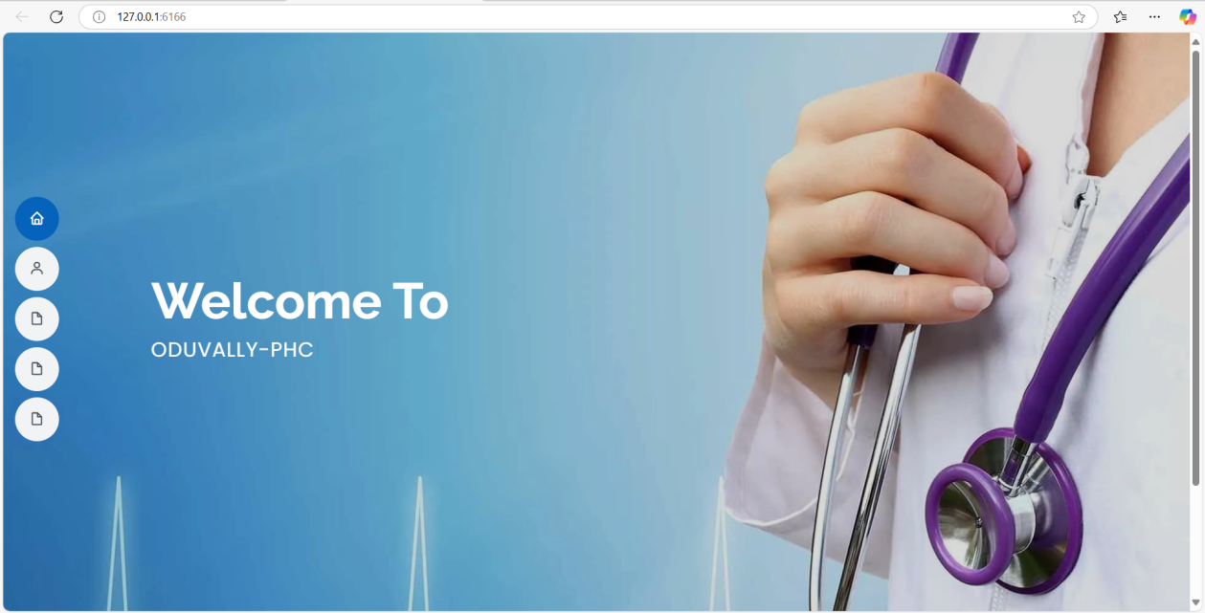

Loginpage

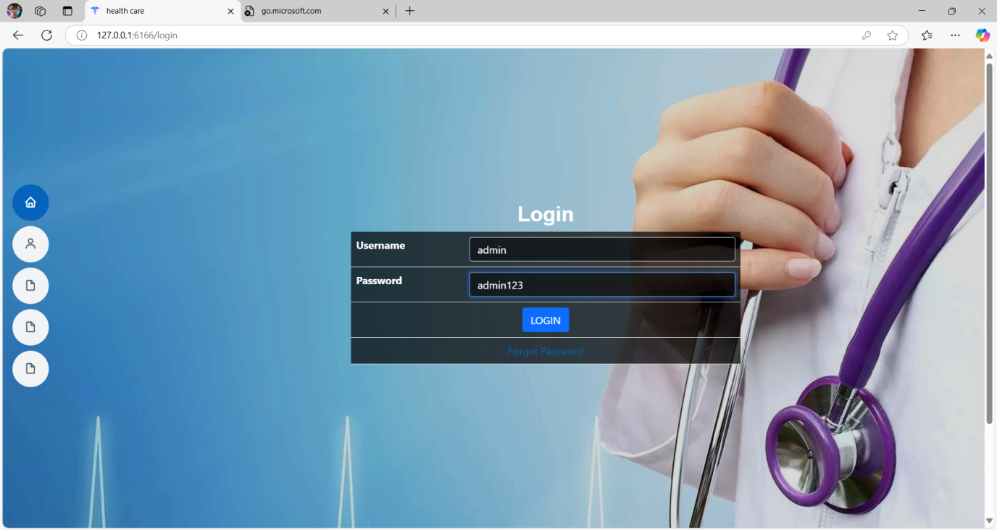

Booking page
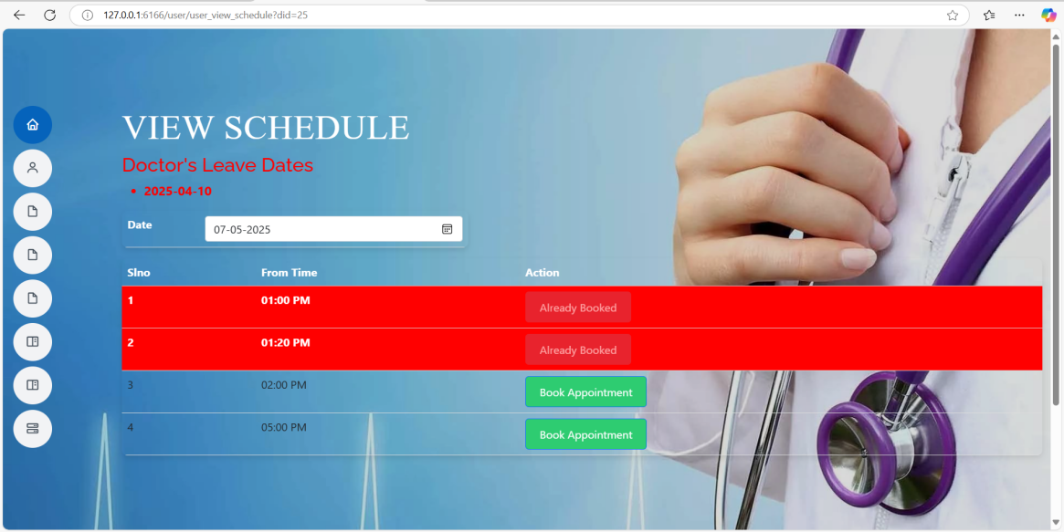

Complaint registration

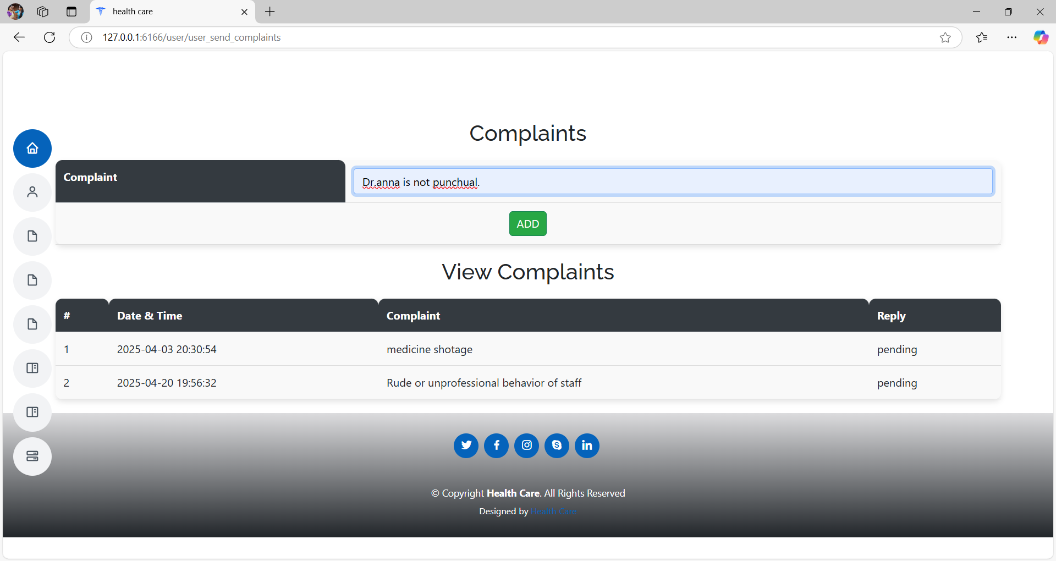

Doctor Dashboard
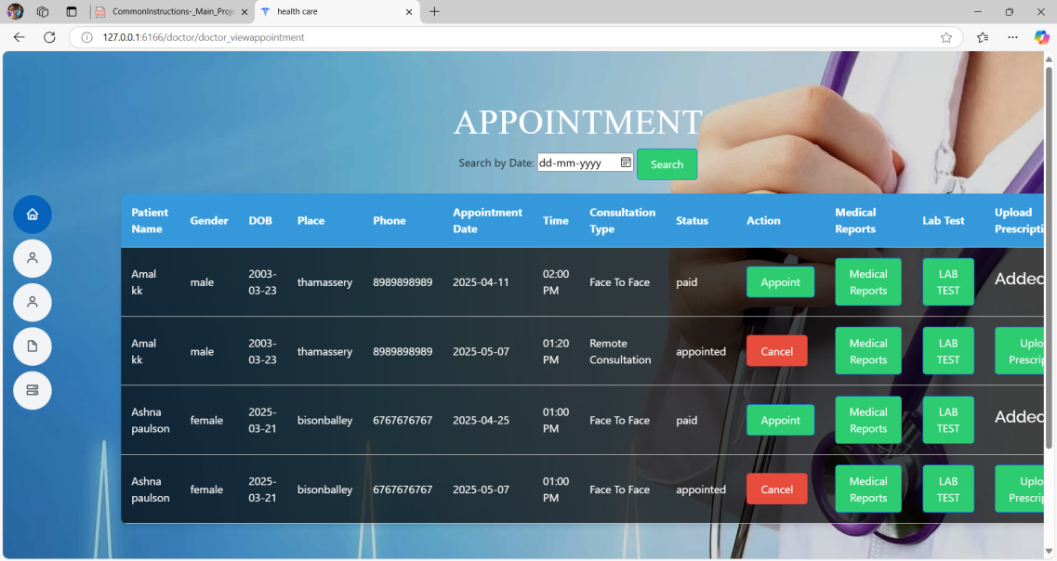

Emergency Alert message page

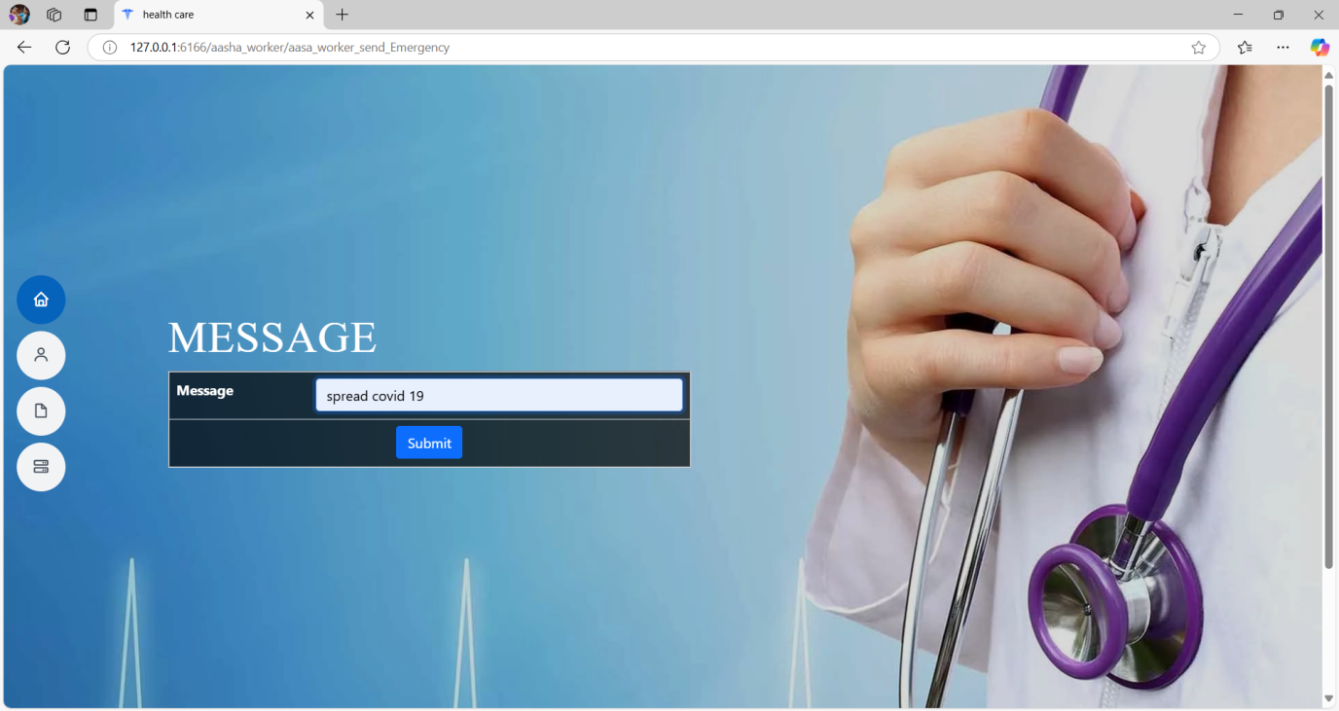
Add Event Page

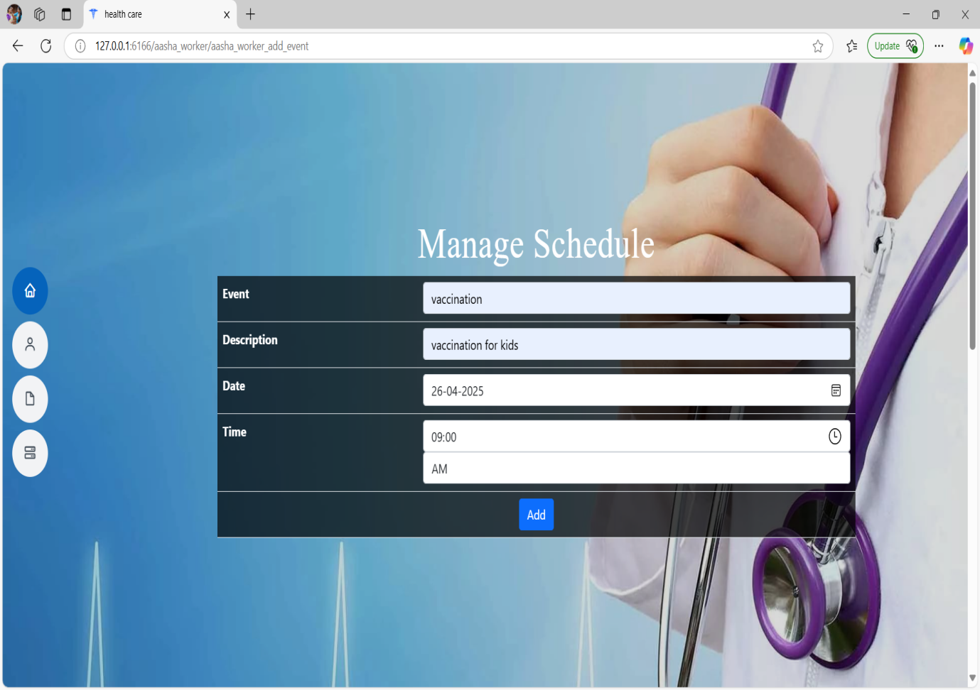

CHAPTER 6
REFERENCES
1. J. Smith et al., “Automated Health Care Management System Using Big Data Technology,” Journal of Health Informatics, vol. 12, no. 3, pp. 210-225, 2021. https://doi.org/10.xxxx/healthinformatics.2021.03210
2. A. Brown and M. Green, “A Systematic Literature Review of Health Information Systems for Healthcare,” International Journal of Medical Informatics, vol. 98, no. 2, pp. 145-160, 2020. https://doi.org/10.xxxx/ijmi.2020.98145
3. L. Wang, “The Use of Automated Health Information Systems in the Health Services,” Health Services Research Journal, vol. 15, no. 4, pp. 301-315, 2022. https://doi.org/10.xxxx/hsr.2022.15301
4. R. Patel et al., “A Literature Review of Current Technologies on Health Data Integration,” BMC Health Informatics and Decision Making, vol. 20, no. 5, pp. 567-580, 2021. https://doi.org/10.xxxx/bmchealth.2021.20567
5. D. Johnson and K. Lee, “Patient Health Record Systems Scope and Functionalities: Literature Review and Future Directions,” Journal of Medical Internet Research, vol. 23, no. 6, pp. 112-128, 2023. https://doi.org/10.xxxx/jmir.2023.23672

