Swiggy: Data Analysis – End-to-End Workflow (Industry Process)
Scenario
You are working as a Data Analyst / Data Management Executive in a startup(Food).
Sales team sends daily/weekly Excel files via email containing sales or customer data.
Your responsibility is to validate, clean, integrate, analyze(Query /Viz), visualize, and share insights with stakeholders (CEO / Director/business leaders ).

1️⃣ Data Receipt from Sales Team
Email Monitoring
- Check sales mailbox every day
- Identify new data files received from:
  - Sales team
  - Marketing team
  - Operations
Downloading Data
- Download Excel files from email
- Save files in a structured folder system
Example:
Data_Analysis/
├── Raw_Data/
│ ├── Sales_2024_01.xlsx
│ ├── Sales_2024_02.xlsx
├── Cleaned_Data/
├── Processed_Data/

2️⃣ Initial Data Validation (Excel)
Before touching the database:
✔ File Validation Checks
- Correct file format (.xlsx)
- Expected columns available
- Data type check (date, number, text)
- No broken or corrupted files

3️⃣ Data Cleaning (Excel)
Cleaning Activities
- Remove unwanted rows (headers repeated, totals)
- Fix spelling issues (Country names, Product names)
- Standardize formats:
  - Date format
  - Text case (UPPER / Proper)

4️⃣ Data Profiling (Understanding Data)
Profiling Tasks
- Number of rows & columns
- Unique values per column
- Min / Max values
- Distribution of data
Helps answer:
- Is data usable?
- Is something missing?
- Any abnormal values?

5️⃣ Data Integration & Mapping
Data Integration
- Combine multiple Excel files into one dataset
- Merge data from:
  - Sales file ( from 4 branch/store )
  - Customer master
  - Product master
Data Mapping
Source Column | Target Column
City | City_Name
Or_Date | Order_Date
Rest_Name | Restaurant_Name
- Ensures consistency before database loading.

6️⃣ Data Quality Checks (Critical Step)
Missing Values (null check )
- Identify empty cells
- Decide:
  - Fill with default value
  - Remove record
  - Keep as NULL
Null Values
- Check mandatory fields:
  - State
  - City
  - Order_Date
  - Restaurant_Name
Duplicate Records
- Blank/Empty string
- Duplicate Detection
- Duplicate Removal
- All issues must be fixed BEFORE loading into database

7️⃣ Data Loading into Database
Database Upload
- Import cleaned Excel data into SQL tables
- Tables like:
  - Order_Name
  - Food_items
  - Sales(4 file)
This is part of the ETL process.

8️⃣ ETL Process (End-to-End)
ETL Explained
- Extract → Excel files from email
- Transform → Cleaning, validation, mapping
- Load → Insert into SQL database
This ensures centralized & trusted data. (single truth? Enterprise data ?)

9️⃣ SQL-Dimensional Modelling(Star Schema)
Dimensional modelling helps organize data in a way that makes analysis simple, consistent, and extremely efficient. Instead of keeping all information mixed in one large table, the Star Schema separates descriptive information into dimensions and keeps all measurable values in a central fact table. This structure reduces data duplication, improves clarity, and makes the entire dataset easier to understand. It also supports faster reporting because queries can access small, focused tables rather than scanning a single bulky dataset. Most analytics and BI tools are designed to work best with star schemas, so this approach ensures smooth dashboard creation, accurate aggregations, and reliable insights. Overall, dimensional modelling provides a clean, scalable, and performance-optimized foundation for any analytical system, regardless of the industry or data source.
To optimize analytics and reporting, build a Star Schema with the following dimension tables:
- dim_date → Year, Month, Quarter, Week
- dim_location → State, City, Location
- dim_restaurant → Restaurant_Name
- dim_category → Cuisine/Category
- dim_dish → Dish_Name
Central fact table:
- fact_swiggy_orders → Price_INR, Rating, Rating_Count, foreign keys to all dimensions
Populate each dimension with distinct data from the cleaned source and load fact table with all keys resolved.

ERD-Diagram: Star Schema
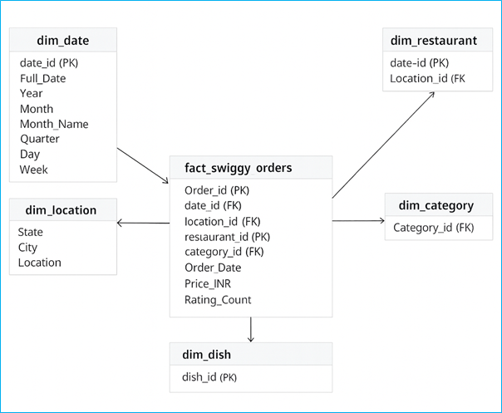

🔟 SQL-Based Data Cleaning & Validation
After loading data:
✔ SQL Validation Checks
- Row count verification
- Foreign key validation
- Null checks
Example:
SELECT COUNT(*) FROM sales WHERE customer_id IS NULL;
✔ Remove Duplicates
DELETE FROM sales
WHERE order_id IN (
SELECT order_id
FROM sales
GROUP BY order_id
HAVING COUNT(*) > 1
);

SQL-Based Data Masking
Sales data contains sensitive customer information such as:
(If it is available do this step, this is very important)
- Email ID
- Customer Name
- Phone (if present)
❗ Not all users should see full customer details
✔ Management needs insights, not personal data
✔ This ensures data privacy & compliance
Eample:-
ALTER TABLE Swiggy_data
ALTER COLUMN Email ADD MASKED WITH (FUNCTION = 'email()');
Example output:
- Original: john.doe@gmail.com
- Masked: jXXXX@XXXX.com
From where business leaders (marketing /Sales/HR/Opr?

1️⃣1️⃣ SQL Data Analysis
KPI Development
- Total Orders
- Total Revenue (INR Million)
- Average Dish Price
- Average Rating
Example:
SELECT country, SUM(quantity * price) AS revenue
FROM sales s
JOIN customers c ON s.customer_id = c.customer_id
JOIN products p ON s.product_id = p.product_id
GROUP BY country;
Deep-Dive Business Analysis
Date-Based Analysis
- Monthly order trends
- Quarterly order trends
- Year-wise growth
- Day-of-week patterns
Location-Based Analysis
- Top 10 cities by order volume
- Revenue contribution by states
Food Performance
- Top 10 restaurants by orders
- Top categories (Indian, Chinese, etc.)
- Most ordered dishes
- Cuisine performance → Orders + Avg Rating
Customer Spending Insights
Buckets of customer spend:
- Under 100
- 100–199
- 200–299
- 300–499
- 500+
With total order distribution across these ranges.
Ratings Analysis
Distribution of dish ratings from 1–5.

1️⃣2️⃣ Export Data to Excel
- Export SQL query results
- Use Excel for:
  - Pivot tables
  - Summary sheets
  - Charts
This step bridges technical → business.

1️⃣3️⃣ Data Visualization (Excel)
Charts Used
- Bar chart → Sales by Country
- Line chart → Monthly Sales Trend
- Pie chart → Category-wise Sales
- KPI cards → Total Sales, Orders, Customers

1️⃣4️⃣ Reporting to Stakeholders
Final Output Shared With:
- CEO
- Director
- Sales Head
Format:
- Excel dashboard
- Summary insights (bullet points)
- Recommendations

Summary:
“I handle end-to-end data management — from receiving raw Excel files via email, validating and cleaning data, performing ETL, integrating data into SQL databases, running analysis queries, creating Excel dashboards, and finally sharing actionable insights with stakeholders.”

